Potluck Table and/or Cohort Activity: There is much to celebrate here! But, there is also more work to be done. Here is the data from Mark 2 and Mark 3. Take a moment to compare and identify some positive insights ( + ) and some areas of improvement ( $∆$ ). Set a few goals for yourself and your department that will maintain the ( + ) and improve the ( $∆$ ). Write those down below and share with you table/cohort. We are a data driven school!
Quarter 1 Mark 2 | Scholarship Warning Mark 3
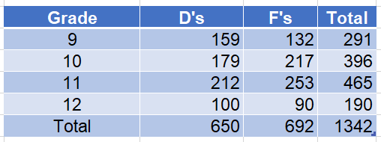 | 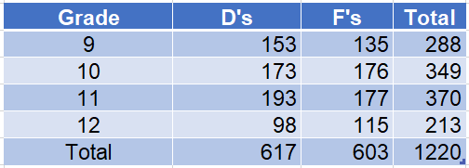
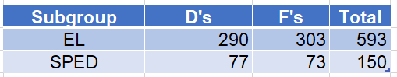 | 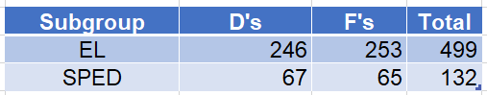
( + ) | ( $∆$ )
Goals:

Quarter 1 Mark 2 | Scholarship Warning Mark 3
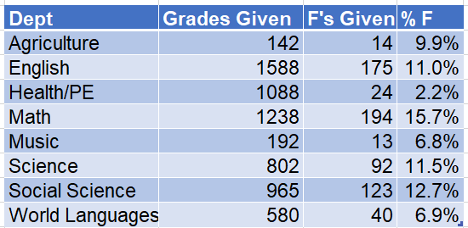 | 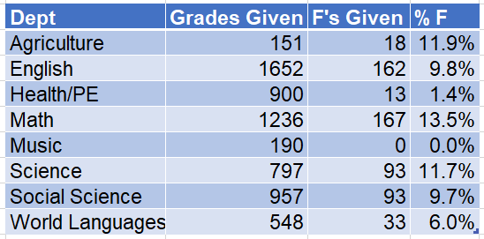
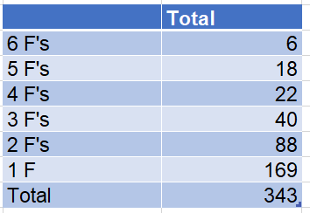 | 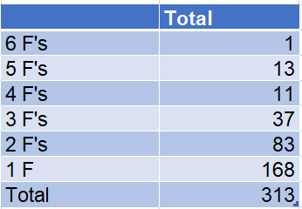
( + ) | ( $∆$ )
Goals:

