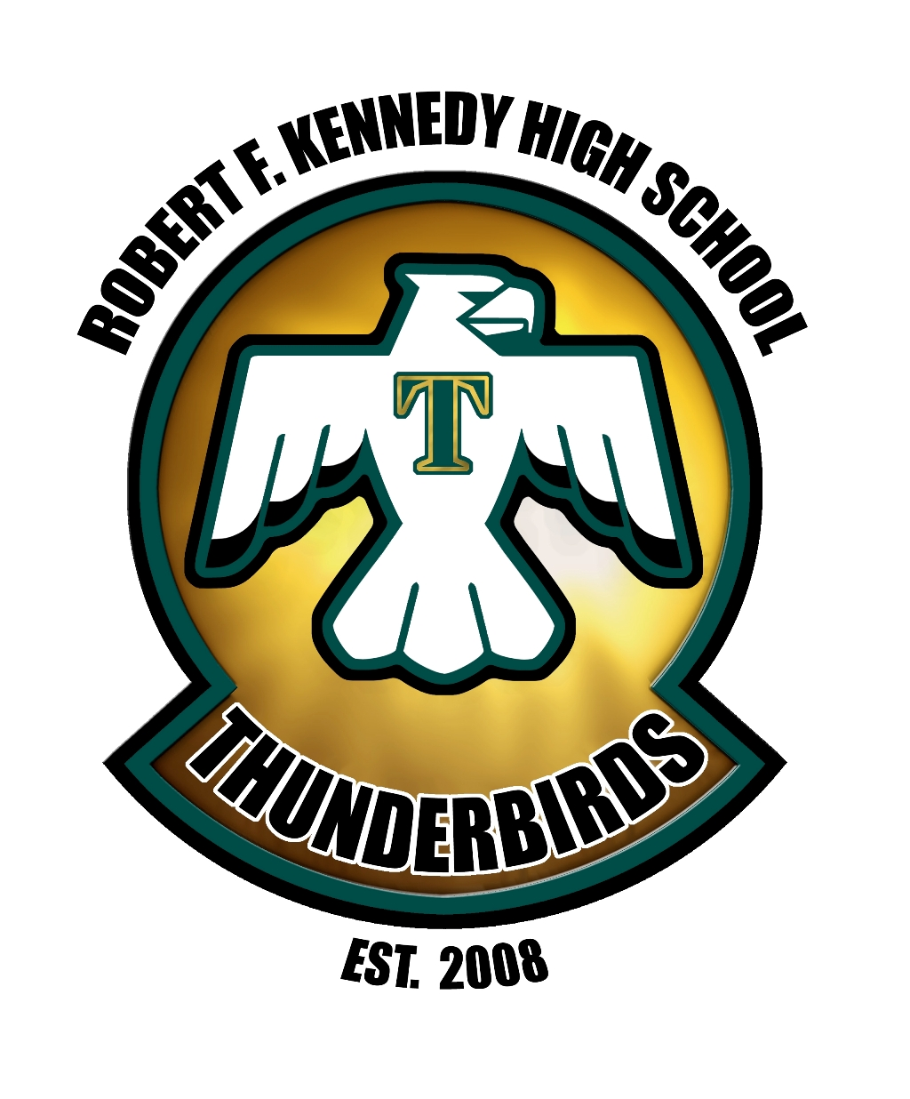

Robert F. Kennedy High School
1401 Hiett Avenue, Delano, California 93215
HOME OF THE THUNDERBIRDS

Four Questions that Drive our Collaboration Time
- What is it we want our students to learn?
- How will we know if each student has learned it?
- How will we respond when some students don’t learn it?
- How can we extend and enrich the learning for students who have demonstrated proficiency?

Department: _____________________

Agenda Item | Target/Department Goal  Who and Where | Outcome (What exactly took place) | Action Items  Who and What? | Timeline: By When? | Follow Up

