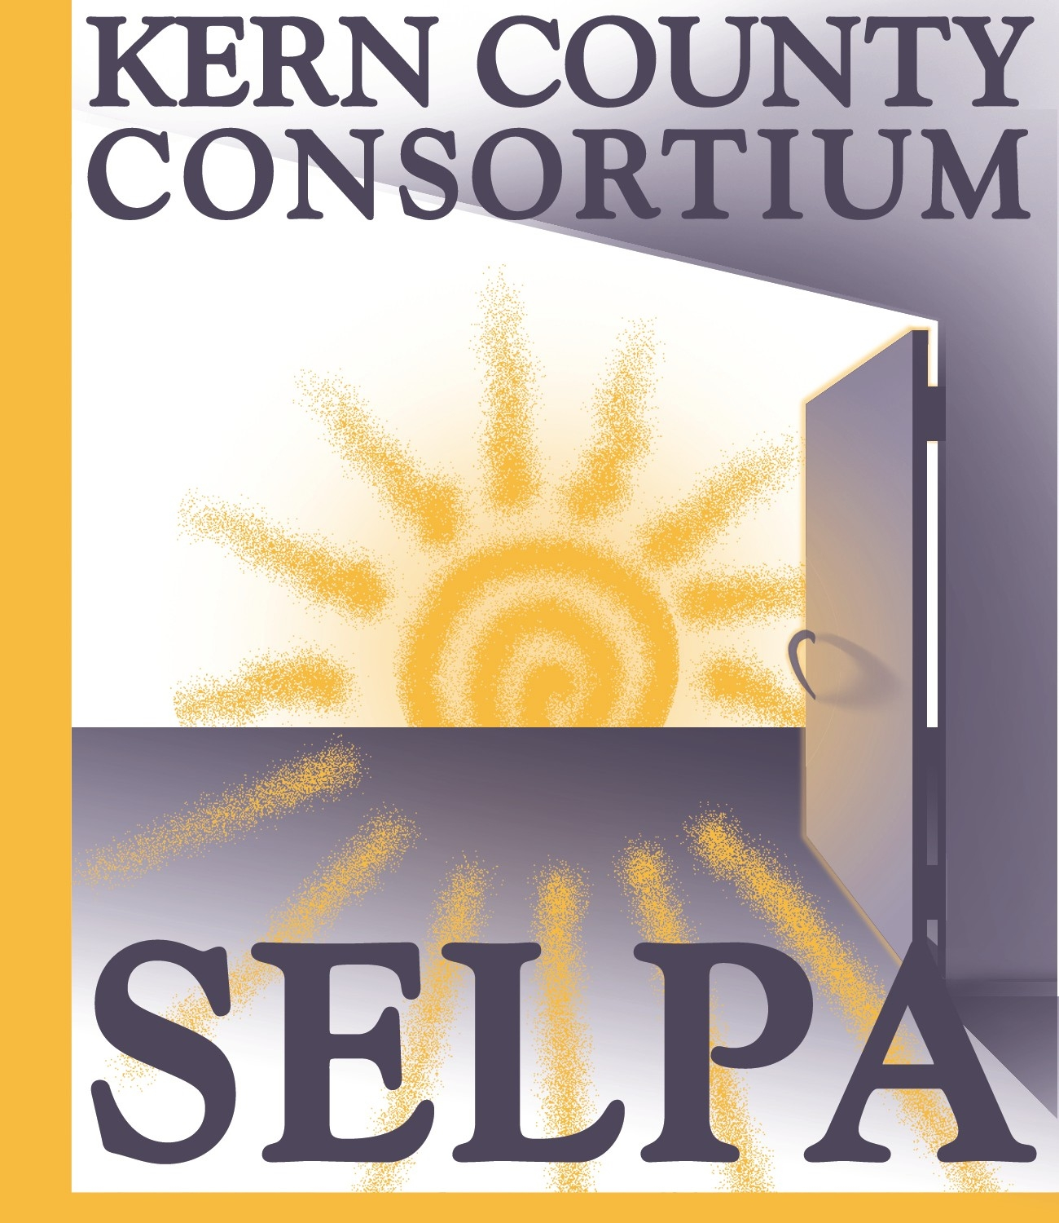
KERN COUNTY CONSORTIUM SELPA

SUPERINTENDENTS’ EXECUTIVE COUNCIL

November 26, 2018
AGENDA
1300 17th Street – CITY CENTRE
3rd Floor, Room 318
Bakersfield, CA 93301

CORRESPONDENCE

None

APPROVAL OF MINUTES

Review and approval of October 15, 2018 minutes

PUBLIC COMMENT

The Kern County Consortium SELPA Superintendent’s Executive Council (“Council”) welcomes comments from the public at appropriate times during the meeting. The public may address the Council concerning items on the agenda as those items are taken up prior to discussion and deliberation by the Council. The public may also address the Council on items not on the agenda, but within the jurisdiction of the Council, at the time designated.

To conduct Council business in an orderly and efficient manner and allocate available time, each speaker must fill out a speaker card at the beginning of the meeting stating the speaker’s name and the subject to be addressed.

Please wait to be recognized by the meeting Chair. Comments should be addressed to the Council as a whole and not to individual Council members or staff. Unless otherwise determined by the Council, each person is limited to 3 minutes per item. If multiple speakers wish to speak on a specific item, the total time allotted will be 20 minutes.

Speakers should be aware that they may incur legal liability for statements made at a Council meeting, particularly if the comments are not related to Council business.

INFORMATION ITEMS

- CCEE/CDE SELPA Lead Grant: We were not chosen as one of the finalists.

- SELPA Fiscal Reports were submitted on time.

- Compliance Monitoring Update:
DINC – Only 4 Districts involved
PIR – Won’t know until after Dashboard Release
Disproportionality – May have a challenge as some districts did not turn in their information on time
- Low Incidence Funds Information
- Community Advisory Committee (CAC) Update
- CASEMIS Due Date: 11/29/18 – Remember the data informs all of the Monitoring Reporting to the State

Discipline Reporting through CALPADS – LEAs must now report all incidents in which a statutory offense is committed, regardless of suspension or expulsion. (i.e. LEAS are required to report incidents that result in “other means of correction” as outlined in CA Ed. Code Section 48900.5.)

- CASEMIS to CALPADS (C2C) – moving forward; Data Validation Tool available to compare:
https://c2c.shapemydistrict.com

ACTION ITEMS

- Review and action on Excess Legal Costs reimbursement for the 2017-18 school year.

- Review and action on NPS/NPA & Extraordinary Health Care Costs Reimbursement pool funding for the 2017-18 school year.

- Review and action on balances in the SELPA Special Account Reserves.

- Review and action on summary of MOE calculations (Prior Year Actuals vs. Second Prior Year Actuals – SEMA) and (Grant year Budget to Prior Actual Expenditures – SEMB) for SELPA member districts.

- Review and action on reallocation of 2017-18 Excess Moderate Interventions funding to member districts.

- Review and action on the Fiscal Advisory Committee’s recommendations for changes to the SELPA Procedural Manual regarding SELPA Allocations.

COMMITTEE MEMBER COMMENTS

ADJOURNMENT

NEXT MEETING

January 14, 2019 or February 25, 2019, 9:00 a.m.
KCSOS Conference Room 318

An individual who requires disability-related accommodations or modifications, including auxiliary aides and services, in order to participate in the Superintendents’ Executive Council meeting
should contact the SELPA Office. (Government Code 54954.2)

Any materials required by law to be made available to the public prior to a meeting of the Superintendents’ Executive Council can be inspected at the following address during normal business hours:
Kern County Consortium SELPA Office, 3rd Floor, KCSOS Building
1300 17th Street – CITY CENTRE, Bakersfield, CA 93301

