Comprehensive School Safety Plan (CSSP)
Ed Code 32280-32289

[School Name]
[School Logo]
[School District Name]

[Name], Principal
[School Address]
[Phone]
[Email]

This document is available for public inspection during regular
business hours at [enter location]

NOTE: Tactical information is excluded from the public inspection document.

[School Name]
Comprehensive School Safety Plan Roster

(name), Principal (or Designee)
(name), (Teacher’s Association Representative)
(name), Parent
(name), (Classified Employee Association Representative)
(name), (Student - Optional)
(name), (Other)
(name), (Other)
(name), (Other)

A meeting for public input was held on [DATE]

Plan Revised on [DATE]

Plan approved by [Name of District or County Office of Education Governing Board] on [DATE]

Table of Contents

- Child Abuse Reporting Procedures page

- Emergency/Disaster Response Procedures page

- Suspension & Expulsion Policies page

- Procedures for Notifying Teachers about Dangerous Pupils page

- Discrimination & Harassment Policy / Bullying Prevention page

- School-wide Dress Code page

- Safe Ingress and Egress page

- Safe and Orderly Environment

Policies & Procedures on Positive School Climate page

Assessment of the Current Status page

Component 1: Social Climate: People and Programs page

Component 2: Physical Environment: Place page

- Rules and Procedures on School Discipline page

- Tactical Responses to Criminal Incidents page

- Child Abuse Reporting Procedures

Use this section to outline the your policies and procedures for reporting cases of suspected child abuse or neglect.

IMPORTANT NOTE: With the passage of AB 1432 in September, 2014, all school districts, county offices of education, and charter schools are required to:

- Annually train, using the online training module provided by the State Department of Social Services, or other training, employees and persons working on their behalf who are mandated reporters, as defined in Penal Code 11165.7, on the mandated reporting requirements.
- Develop a process for all persons required to receive training under the bill to provide proof of completing this training within the first 6 weeks of each school year or within 6 weeks of that person’s employment.

The training method and process used to assure compliance with AB 1432 should be outlined in this section, in addition to the procedures your school uses for reporting cases of suspected child abuse or neglect.

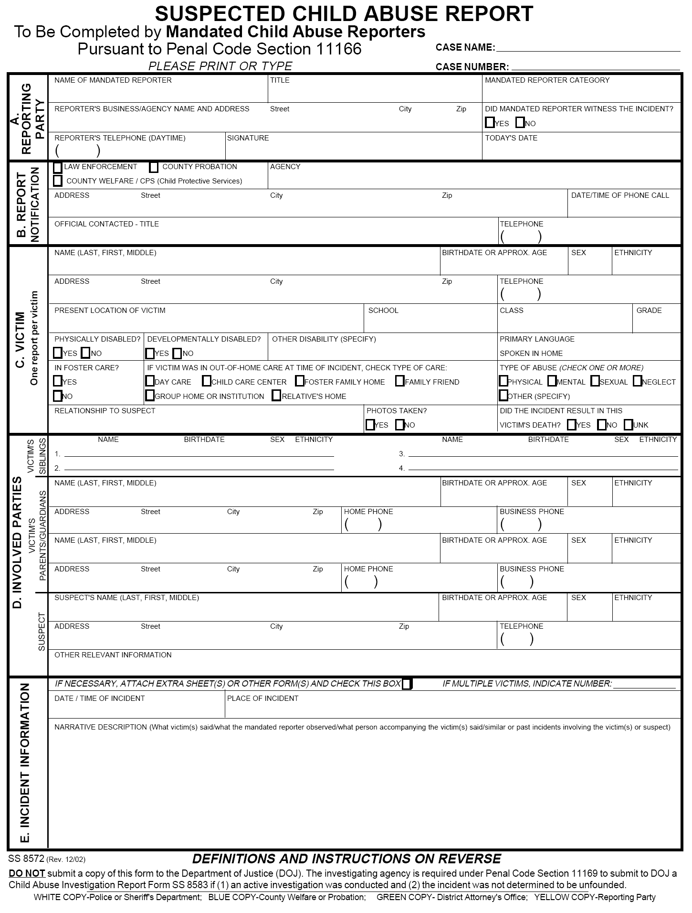
- Emergency/Disaster
Response Procedures

Insert your disaster preparedness plan and emergency procedures in this section.
NOTE: Parts of this section may not be for public viewing as they may
contain sensitive safety information
Include:
- Emergency procedures for the following types of events, at a minimum, using the principles outlines in the Standardized Emergency Management System (SEMS) and the Incident Command System (ICS).
- Fire on or off school grounds which endangers students and staff
- Earthquake or other natural disasters
- Environmental hazards
- Bomb threat or actual detonation
- Weapons
- Power failure
- Flood
- Gas leaks
- Biological, radiological, chemical, and other activities, or heightened warning of such activities
- Medical emergencies and quarantines, such as a pandemic influenza outbreak
- Procedures to allow the use of school facilities for mass care and welfare shelters during disasters or other emergencies
- Incident Command Systems (ICS) assignments
- Evacuations procedures
- Parent reunification procedures
- Crisis communication plans / procedures
Special consideration must be made for emergency preparedness for students with special needs.

Describe information on training and exercise drills.

- Suspension & Expulsion Policies

Insert your Board Policy, Administrative Regulation and procedures related to Suspensions & Expulsions.

- Procedures for Notifying
Teachers of Dangerous Pupils

Insert your Board Policy, Administrative Regulation and procedures and sample notification used for notifying teachers of dangerous students.

Examples:

The ____ School has incorporated this notification into the existing “Attendance Reporting screen”. On the daily attendance report, when a student is suspended, will show an “*” next to the students name. The teacher can access the suspension by looking at the student’s discipline screen. The information provided is for the student’s current teachers only. All information regarding suspension and expulsion is CONFIDENTIAL, is not to be shared with any student(s) or parent(s). Teachers are asked to secure the list so students and others may not view it.

Pursuant to Welfare & Institution Code 827(b) and Education Code 48267, the Court notifies the Superintendent of the ____ School District regarding students who have engaged in certain criminal conduct. This information is forwarded to the site Principal. The site Principal is responsible for prompt notification of the student’s teachers. Per Education Code 49079, this information must be kept confidential. This information is also forwarded to all administrators and the student’s counselor.

- Discrimination & Harassment Policy /
Bullying Prevention

Insert your Board Policies, Administrative Regulations and procedures related to Discrimination, Harassment and Sexual Harassment in this section.

This section should also address procedures and policies for bullying prevention.

Include complaint and investigation procedures.

- School-wide Dress Code

Insert your Board Policies, Administrative Regulations and procedures related to your school-wide dress code in this section.

Note on Education Code Requirements for this section

This requirement comes from 32282(a)(2)(F). It reads:

The provisions of any schoolwide dress code, pursuant to Section 35183, that prohibits pupils from wearing "gang-related apparel," if the school has adopted that type of a dress code. For those purposes, the comprehensive school safety plan shall define "gang-related apparel." The definition shall be limited to apparel that, if worn or displayed on a school campus, reasonably could be determined to threaten the health and safety of the school environment. Any schoolwide dress code established pursuant to this section and Section 35183 shall be enforced on the school campus and at any school-sponsored activity by the principal of the school or the person designated by the principal. For purposes of this paragraph, "gang-related apparel" shall not be considered a protected form of speech pursuant to Section 48950.

State whether the school has adopted schoolwide dress code that prohibits pupils from wearing gang-related apparel pursuant to EC 35183.

- If the school has a dress code prohibiting gang attire, include the following in the section.
  - A copy of the school’s dress code. Confirm that the definition of gang attire is included in the document.
  - A copy of your district Board Policy and Administrative Regulation on student attire.
- If the school does not have a dress code prohibiting gang attire, use the cover sheet to explain why it does not.
  - Include a copy of the school dress code if one exists.
  - Include a copy of your district Board Policies & Administrative Regulations on student attire if one exists.

- Safe Ingress and Egress

Describe procedures for safe entry and exit of staff and students. Include maps, diagrams and schedules as outlined in the example below.
Example:
The following maps and materials outline the procedures for safe ingress and egress from ______ School. Items marked with an * are considered to be “tactical information” that will be withheld from the public view version of this plan.
- A map indicating student drop off and pick-up locations and the traffic flow patterns during arrival and dismissal from school.
- *A map indicating the supervision postings during arrival and dismissal from school.
- *A map and supervision schedule outlining supervision posts during school hours.
- *A description of the procedures required for campus access by visitors including any measures to ensure that visitor badges are not counterfeited.
- A description of the procedures required for campus access by visitors (excluding the security measures considered to be tactical information).
Other items that might be outlines here are:
- Parking guidance
- Student valet programs
- Safe routes to and from schools
- Pedestrian crossings
- Crossing guard programs
- Bicycle policies

- Safe and Orderly Environment

Use this section to assess the current status of school culture and climate. Include data from the following sources:

  - Local law enforcement crime data
  - Suspension/Expulsion data found in the California Longitudinal Pupil Achievement Data System
  - Behavior Referrals
  - Attendance rates/School Attendance Review Board data
  - California Healthy Kids Survey data
  - School Improvement Plan
  - Property Damage data
  - Threat and Risk Assessment
  - Hazard and Vulnerability Assessment

Describe the data reviewed, key findings, conclusions and action steps for improvement.

This section should also include guidelines on the roles and responsibilities of those in roles who are employed to maintain a positive school climate.

Those roles included:

- Mental health professionals
- School counselors
- Intervention specialists
- Campus security or School Resource Officers

Component 1 – People and Programs
Goal 1:
 | Strategies to be Used | Person Responsible
Objective 1:
Objective 2:
Objective 3:
Objective 4:
Goal 2: (If necessary)
Goal 2 Objectives

Component 2 - Place
Goal 1:
 | Strategies to be Used | Person Responsible
Objective 1:
Objective 2:
Objective 3:
Objective 4:
Goal 2: (If necessary)
Goal 2 Objectives

- Rules and Procedures on School Discipline

In this section you will outline school rules and policies and procedures for
non-compliance.

If your school has a parent/student handbook, it should be included in this section.

- Tactical Responses to Criminal Incidents

NOTE: This section is not for public viewing as it will
contain sensitive safety information

Use this section to outline tactical responses to criminal incidents occurring on or in the vicinity of your campus. This includes procedures related to individuals with guns on school campuses. Age-appropriate procedures, drills and exercises should be considered to prepare for and respond to active assailants or hostile persons on or near campuses.

The Safer Schools Coalition of Kern and local law enforcement endorses the use of the Standard Response Protocol (SRP) and the Run, Hide, Fight model. More on each of these programs can be found at www.kern.org/safer-schools.

