

ETO Software
User Guide
2009/2010


ETO Software is a user-friendly, web-based program management tool for DR case management services that allows you to record information and generate reports on the efforts of your program and the outcomes of your clients.

The goal of Kern County DR ETO Software is to not only create a data entry system that will efficiently and accurately collect diverse information from the families you serve, but to do it in a way that eliminates duplication, increases efficiency of services delivered, shares information between programs and makes as significant an impact on child welfare services as possible in Kern County!

Preparing to Use ETO Software

Social Solutions, ETO Software is web-based and accessible from SPECIFIC Internet Connected Computers.
- 􀂾 Internet Explorer 7 or greater
- 􀂾 Windows 95b/98, NT4, ME, 2000, or XP (ME, 2000, XP and Vista recommended)

The Software DOES NOT currently support Mac Computers, nor the Firefox Web Browser.

Confirm Browser
To use all the features of your site, you will need the Internet Explorer browser If Internet Explorer (IE) is already on your computer, confirm that it is Version 7.0 or newer. The simplest way to check is to go to any website using Internet Explorer. Click on Help at the top of your screen. Then click on About Internet Explorer. The resulting window will tell you which version you have. If you have 6.0 or lower, go to www.microsoft.com and download the latest version of Internet Explorer. In addition, ETO Software will inform you if your browser is incompatible.

Internet Toolbars
Special Internet toolbars such as the Yahoo! Companion, Google Search Bar, etc., can cause minor problems with ETO Software. You need not disable them, but verify that the Autofill and Popup Blocker features are disabled (turned off). Autofill interferes with your ability to distinguish between required and non-required fields. Popup blockers prevent you from viewing many ETO Software reports.

Security: Authorized Access
- ETO Software is secured against unauthorized use by VeriSign® 128-bit Security Encryption, the industry standard in Internet site protection.
- To gain access, you must have an ETO Software user account. User accounts are created by Social Solutions and customized by the Research and Evaluation Manager.
- After entering your User Name, Password and Site, you may be presented with Auto Recall and Security Confirmation Screens. We do not recommend using the Auto Recall feature (which saves your password), as this might allow someone to gain unauthorized access. Also, if a Secure Network announcement arrives, please confirm that you do wish to continue.
- A small gold padlock icon will appear in the lower right corner of your screen. This confirms your presence on a secured site.
- There is a security feature built into ETO Software that shuts down your session if you have not interacted with the database in 60 minutes. When five minutes remain, a message box pops up to alert you. Information you have not already saved on the database will be deleted if your session is automatically ended.

Back-up
Social Solutions automatically backs up ETO Software three times a day to protect your data.
KCNC DR ETO Software Site Support & Training

- KCNC Staff Support
KCNC staff is available to answer your questions and help you take full advantage of ETO Software with support. If there ever is an issue with the software or you need assistance performing a task, do not hesitate to call Monday –Friday 8 am to 5 pm:

Kim Silva
Research Associate
kisilva@kern.org
661.636.4248

Alicia Garcia
Special Projects Facilitator
algarcia@kern.org
661.636.4249

- DR ETO Software Annual Orientations
Each year, there will be a mandatory DR ETO Software Orientation in which all the ETO basics will be covered including:
- Downloading web browser and logging into ETO
- Entering families into ETO
- Checking entries accuracy and meeting KCNC data requirements
- Enhancing case management practices
- Creating reports
- Updating family information
- Sharing tips from fellow sites
- KCNC Additional Site Trainings & TA
KCNC staff will also be providing DR site staff trainings and technical assistance as needed to accommodate staff changes and program expansion.

- KCNC ETO Software Support Center Website
Visit the KCNC ETO Software Support Center which post DR procedure manual, ETO software user manuals, DR forms, Matrix guides, FAQ and much, much more!
http://www.kcnc.org/etosupport

- Social Solutions ETO On-Line Trainings
Social Solutions brings decades of experience to the support of ETO Software. For those of you who wish to learn more about the capabilities of the software, please feel free to sign up for the online trainings Social Solutions holds on a daily basis on specific functions within the software.

http://www.socialsolutions.com/index.php?option=com_events
- KCNC DR ETO E-Blasts
KCNC will also provide DR Site staff and supervisors with monthly DR ETO E-Blasts via their e-mail that will cover specific questions and concerns from the sites to provide uniformity in procedures and enhance the quality of data.

Understanding Social Solutions Terminology

Getting started in the DR ETO software requires a brief overview of the terminology in the software that is different from the vocabulary used in your daily duties.

Site
Site refers to the site you work for in the DR Service Area. KCNC has the ability to work within different sites, and to view information from individual sites. Individual DR sites can view ONLY the information within their site. KCNC can provide countywide DR program demographic and outcome data for any site that requests it. However, your individual site information can only be viewed by the staff members at your site and KCNC staff.

Program
ETO Software Sites have one or more Programs operating within them. Program refers to the placement of families you serve. Each Program holds information for all students, within that program, who receive those services. This Program structure is also key in maintaining the confidentiality of Participants by Program. We have two programs: KCNC Data Intake and KCNC DR Agency Template.

Kern County DR Data Intake - This Program is where data entry staff will enter demographic data and primary information from the DHS referral and the Family Member Assessment. Data entry staff will also enter data from the Client Satisfaction Survey

Kern County DR One Stop Services - This Program will be launched in July, 2009 and used by data entry staff.

Kern County DR Parenting - This Program will be launched in July, 2009 and used by data entry staff.

Kern County DR Case Management - This Program is where case managers store information about the head of household they are assigned by the Site Supervisor. Case managers will track status of the case, services and referrals provided, case notes, Family Care Plan, Matrix assessments and other related case management procedures.

Participant = Head of Household
Members of the target population. Your organization may use terms such as clients, consumers, patients, members, students, etc., to refer to what ETO Software considers participants. Participants refer to clients in any of the Programs. When you want to add a new client to the database, you will “Add a New Participant.”

Entities = Program Partners
Entities are individuals, service providers, educational institutions and other community services that support or work in tandem with your site.

Groups = Designated Groupings of Clients
Participants (clients) can be organized into Groups with the Manage Groups feature. Groups are essentially a subset of Participants currently enrolled in a Program like Parenting Classes. The most common use of Groups is to more easily record and track attendance of participants that meet together with some regularity, where there is an expectation that they attend like a parenting class or a therapy session. The general rule is that Groups work well if a subset of Participants have relatively stable membership in a Group and will be together long enough for it to be worth managing the membership of the Group.

Participant Assessments = DR Household Members, Social Conditions Matrix, Service Delivery Form, Family Care Plan, etc.
When a case manager wants to record information outside of demographic data such as family members, services provided, the Social Conditions Matrix and Family Care Plan, this is the place to go. Think of assessments as documents to store all the info you need on evaluating the progress of your families. ETO has several pre-made assessments that mirror the current documents you use, but you can create your own as needed with the assistance of KCNC.

General Assessments = Client Satisfaction Survey
General assessments are typically about administrative, organizational, and strategic issues such as general outreach activities, program marketing materials, and administrative tasks. The Client Satisfaction Survey is one example of a general assessment is housed in the data entry staff section of the database.

Enroll Participants = Accept a client into Intake or Case Management program
Using this function, case managers can add Participants (clients) who have been entered into the Software but are not yet enrolled or assigned to your particular case manager. Once you submit the Participant, the subsequent screen will give you an opportunity to set a Start Date and Projected Termination Date (when applicable).

Dismiss = Close A Case/Archive
You may Dismiss Participants (family members) from your current program using this feature. Participant records are not deleted, but archived and a Participant may be re-enrolled at a later date.

Record An Effort = Client Contact (case notes)
This is the most utilized feature in ETO Software, as it allows you to record efforts with single Participants or Groups. Most often this is used to document your case notes on a client.

To Do Lists
ETO Software has a number of To Do Lists driven by the Date of Next Contact when a user records an Effort with a Participant. These To Do Lists allow a user to manage their caseload in a variety of ways. This is your personalized section of ETO Software™. Your To Do Lists provide snapshots of your last contacts towards specific outcomes with Participants (and with General activities), and provide real-time data management tools and shortcuts directly to the Record Efforts section of ETO Software™.

My Favorites
This much requested component allows you to create your own shortcuts to the features of ETO Software you use most. If you choose, this component can totally replace the full navigation bar.

Crystal Viewer
Crystal Reports Viewer is a free, standalone RPT file viewer that allows you to open, view, and explore interactive ETO reports straight from your desktop.

Logging In to ETO DR Software

- Access your ETO Software as follows: kern.etosoftware.com
- Enter your User Name, Password, and Site (your DR Site location)

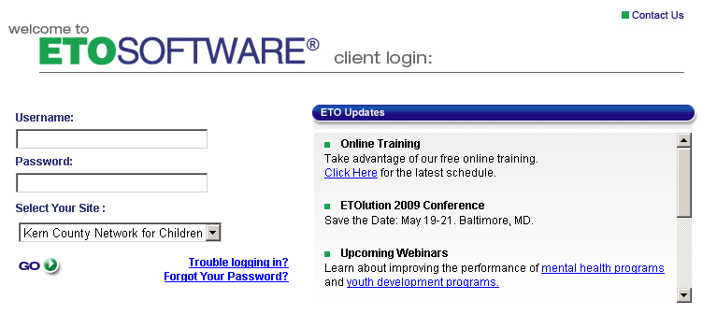

Kern County DR is divided into seven Service Delivery Areas. Their corresponding numbers are:

Service Area 1 = Kern River Valley
Service Area 2 = Indian Wells Valley
Service Area 3 = East Kern
Service Area 4 = South Kern
Service Area 5 = Taft
Service Area 6 = Richland School District
Service Area 7 = Metro Bak/NOR/Southeast
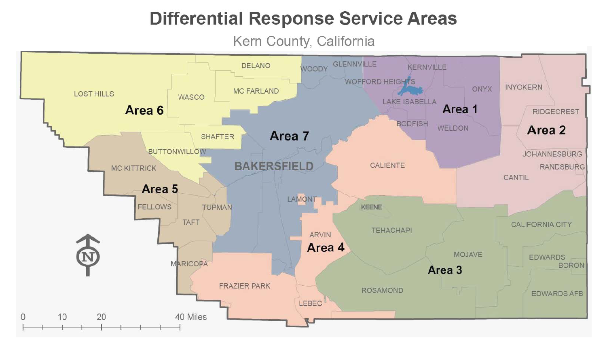

Managing Your Account

Upon logging in to the ETO Software home, page you’ll see the following buttons in the upper right corner:

- Log Off – Click this button to leave ETO Software.
- Home – This will bring you back to the opening screen.
- My Account – This feature allows you to manage your user account in the following ways:

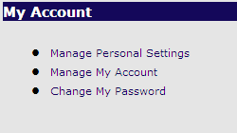

Change My Password – This allows you to change your password at any time:

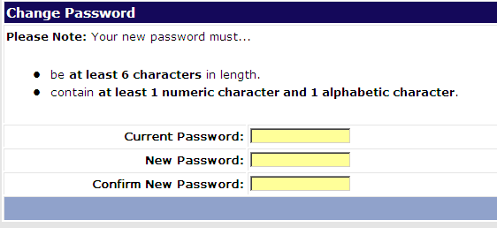

Manage Personal Settings – This feature lets you to decide how you’d like to customize how you use ETO Software.

- Change Site – This is a feature only used by users with accounts at more than one Site in the Enterprise.
- Help – This link provides access to a PDF (Adobe Acrobat) version of the ETO Software User Manuals that may be of help.

Navigating in ETO Software

ETO Software provides you with two navigation options:

- Traditional Navigation bar – This is at the right of your screen and contains all the necessary components.
- QuickNav – This appears along the top left of your screen and consists of the following five components. Clicking on any of them reveals a menu of options:
New – This QuickNav component speeds your ability to Add New Participant or Add New Entity. You can also add or update information in the following areas, all from one easy-to-use page: Click here to view and use a wide range of ETO Software features to add information to your database in the following areas: New Efforts, New Participants, New Entity, Site Management, and General.
Quick Search – This new component makes it much faster to locate specific Participants, Entities, Reports or Staff in ETO Software. You can search across the Site. It’s an easy three-step process.
- Enter Search Term(s) (See below for search criteria) *Leave this field blank to get a list of all participants within the field you select.
- Within:
  - • Participants (Enter all or part of a Participant’s Last Name, SSN, or Case Number)
  - • Entities (Enter all or part of an Entity’s Name, Type, or Sub-Type)
  - • Reports (Enter all or part of a Crystal Report© name or custom search term)
  - • Staff (Enter all or part of a user’s Name).
- In:
  - • Program
  - • Across Your Individual Site
To Do List – This gives you quick access to a range of ETO Software™ To Do lists to help you best manage your work. Click here to go directly to your To Do List:
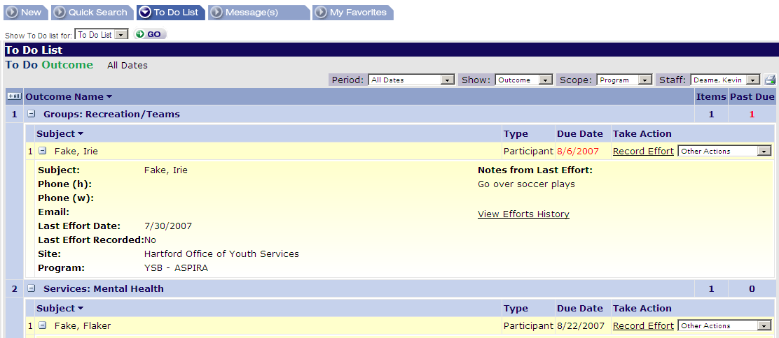

When you click on this component the following header appears:

Welcome Carlos Alvarado – DR Site
Show To Do list for:

To access one of your To Do Lists, choose one of the options to the right of To Do List for: from the following list:
  - • Participants
  - • Entities
  - • General
  - • Today
• Dates

Messages – This allows quick access to create and read messages. This facilitates secure communication between you and other ETO Software™ users. It provides quick links to the following:
- Create Message
  - • Send to One or More Staff Members
  - • Send to Entire Program (limited to Program Managers and above)
  - • Send a Marquee Message (limited to Site Administrators)
  - • Enterprise Messaging (limited to Enterprise Administrators)
- Read Message
  - • Ability to view, delete, or print messages received
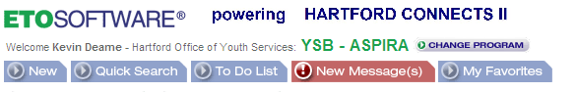
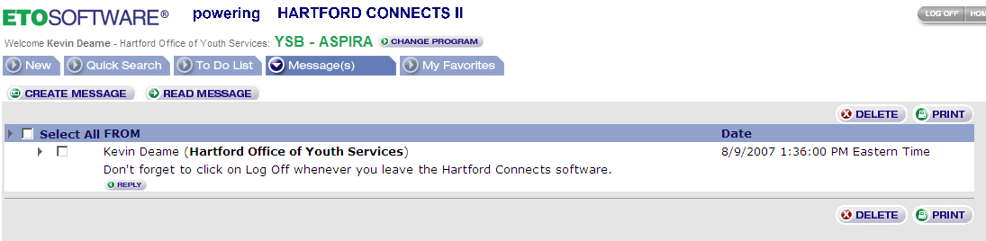
My Favorites – This exciting enhancement allows you to create your own shortcuts to the ETO Software features or reports you use the most. You can add features for your Personal use to create a consistent list of Program favorites (as described below).

You can create three kinds of Favorites – Navigation Bar Features, Custom Reports and Queries, and Standard Reports. You can start adding Favorites as follows:
- Adding Features or Reports in My Favorites
- Click one of the following and select any or all of the traditional navigation bar features to create your personal list of Favorite shortcuts. Note: If you wish to add all the features in a particular category, click the box (for example, Participants) to the left of the listed items.
  - Add Feature
  - Add CxReport/Query displays all categories (Custom Reports (Cx) and Shared Queries)
  - Add Standard Report
- In addition, each user can rename features or reports to ensure that they clearly represent the functionality they use most frequently. Simply click on the name of the feature or report and adjust the name.
- After creating your Favorites lists, click Submit at the bottom of the screen..
- Adding Program or Site-Wide Links to My Favorites
- Category – It’s possible for a user or Site Administrator to add all features or reports from a category (e.g., all features under the Participants navigation bar component) with a single check in that category’s box.
- Link/Name – It will be more common for a user or Site Administrator to check certain features or reports in a category that they wish to add.
- Status – Any feature on My Favorites can be assigned one of two statuses:
- Personal – These are favorites chosen by the individual user, and can only be adjusted by that user.
- Program – These are favorites set by the Site Administrator for particular Programs, and can only be adjusted by the Site Administrator.
On the My Favorites home page, click Delete to the right of any feature or report to remove only that feature.

Using The DR ETO Software

General
The Kern County DR ETO software system is made up of four current programs:
- Intake (Data Entry & Supervisor)
  - Intake Demographics
  - School Referral Form
  - Client Satisfaction Survey
  - Dismiss Clients (Supervisor)

- Parenting (Data Entry)
  - Demographics
  - Class attendance
  - Pre and post test scores

- One-Stop Services (Data Entry)
  - Demographics
  - Service Delivery Form

- Case Manager (Case Manager)
  - Case management services
  - Social Conditions Matrix (Baseline, Updates, Exit)
  - Family Care Plan Agreement
  - Outside Agency Referral Tracking System
  - Case Notes

DR Intake (Data Entry & Supervisors)

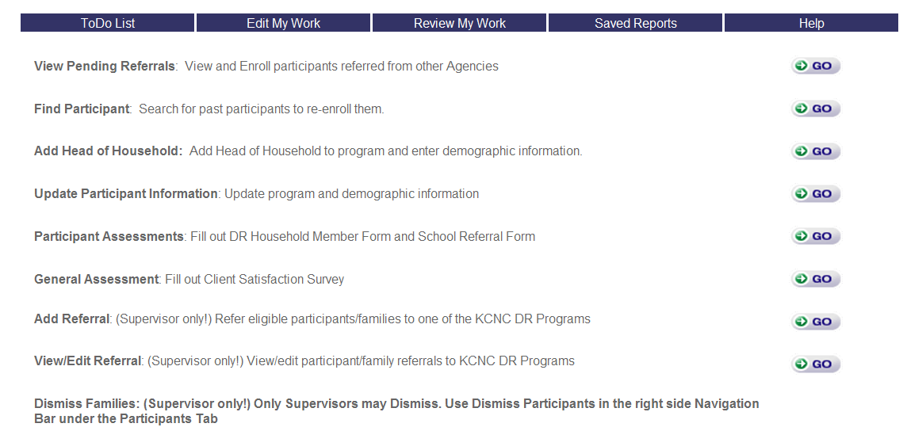

Homepage Navigation

- View Pending Referrals: Data entry staff and supervisors can access referrals from partner DR sites and other Kern County ETO entities such as Project 180 programs, Haven Counseling and Foster Youth Services.
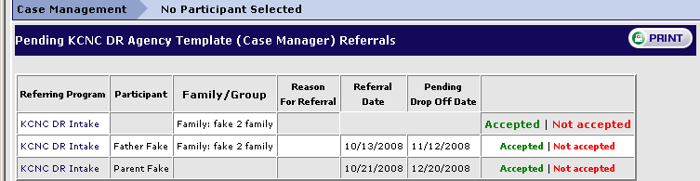
- This functionality allows Data Entry staff and Supervisors to see any participants who have been referred to your Program by another Program in your Site. For example, if you have an Intake Program that manages enrollments for all Programs, when a Participant completes the enrollment process, she can be referred to your Program by the Intake Program.
- To View Pending Referrals, a Supervisor can choose either the Site or Program option or and the next page will be a list of all Referring Programs and Participants referred, with other pertinent data.
- For each Participant, you have the option to Accepted or Not Accepted the Participant. If you do the former, the Participant is enrolled in your Program as of the date you accept them; if you do the latter, a new page will appear that allows you to choose a Rejection Reason (the same as your universal Dismissal Reasons) and click.
- The next page will allow you to select the program start date for the participant. This can be backdated if the participant arrived in your program prior to today’s date.
- Click Add Participants to Program to complete. Click Not Accepted if you do not wish to enroll them in your program
- A pop-up window will appear that allows you to choose a Rejection Reason and Submit.
- When you submit that you Accepted or do Not Accepted the referral, it automatically updates the View/Edit Referrals record of the Participant in the referring program so your Programs can most effectively communicate referral information.

- Find Participant: This functionality allows you to find any Participant in your site, whether Currently Enrolled or Currently Dismissed in any Program. You can search for past participants to re-enroll them. This feature is an excellent way to limit duplication of clients in your system. Also, be aware of the spelling of names to limit data entry error.
- Use the Search functionality to find your Participant by typing in at least a partial last name, last name (space) first name, or a partial SSN.
- One or more Participant matches will appear showing Name, DOB, SSN, and whether the Participant is Currently Enrolled or Currently Dismissed in any Program within your Site.
- Click on the Participant’s name (in blue) to access their read-only demographics record. You will notice at the top of the selected participant’s demographic page, the last staff person to update the participant’s record, including a time/date stamp.
- Click on the Participant’s Program History link (in blue) to access a full record of Program Enrollments, Start Dates, Termination Dates, and Termination Reasons. Click on Enroll button on top if you want to enroll the Participant in your DR Intake Program.
- Go to Home and select Update Participant Information to update his/her information as well as the form DR Household Members under Participant Assessments (See below).

- Add Head of Household: Add client (Head of Household) to program and enter demographic information on he/she. In most cases, add Mother as the primary family member. This is the primary interface for capturing standard demographic and contact information for clients in your program.
  - Household Name or Family Name is the name of the household entered by Data Entry Staff taken from the mother’s name on DHS even if the parent is not in the home or is deceased. The Family Name must have a first and last name followed by “Family.” Example: Jane Fake Family
  - Head of Household - Check Head of Household box. In case management, all assessments, referrals, case notes and family care plans will be linked to this individual. Traditionally, Data Entry staff will mark the Head of Household as the mother/name on the DHS referral. In cases when the mother/name on referral in not in home or will not be taking part in case management services, please use the primary adult that the Case Manager will be working with during services.
  - Continue to use your DR Site Family ID (Case Number) system with ETO software Case Number ETO Software will automatically generate a number. This number will rarely be used by any of the sites.
  - Kern County DR has set 4required fields. Required fields appear in yellow on the interface. These fields are First Name, Last Name, Case Status and Path Type. If the client is self-referred or school referred, select Non-DR for DR Path Type. Select also how the client heard about the services offered by your site.
  - Case Status is now a required field to ensure accurate count on active clients. Data Entry Staff will mark the data field “Case Status” as “Pending” when entering in new clients. Case Managers will be responsible for updating the field when a case is open, closed or never opened.
  - Ignore the Date Case Opened field; this will be filled in by case managers if the case opens.
  - If the address is unknown just type Unknown in the address bar.
  - Social Security Numbers are optional for individual DR sites.
  - Check all Allegation fields that apply.
  - Case Comments box is for Scar summary.
IF YOU DO NOT HIT SUBMIT YOUR INFORMATION WILL NOT BE SAVED.

Split Referrals
A split referral occurs when one or more members of a household with DR referral relocate outside the household and continue to receive services as another household. The new household may even have other household members and children receiving services from your site.
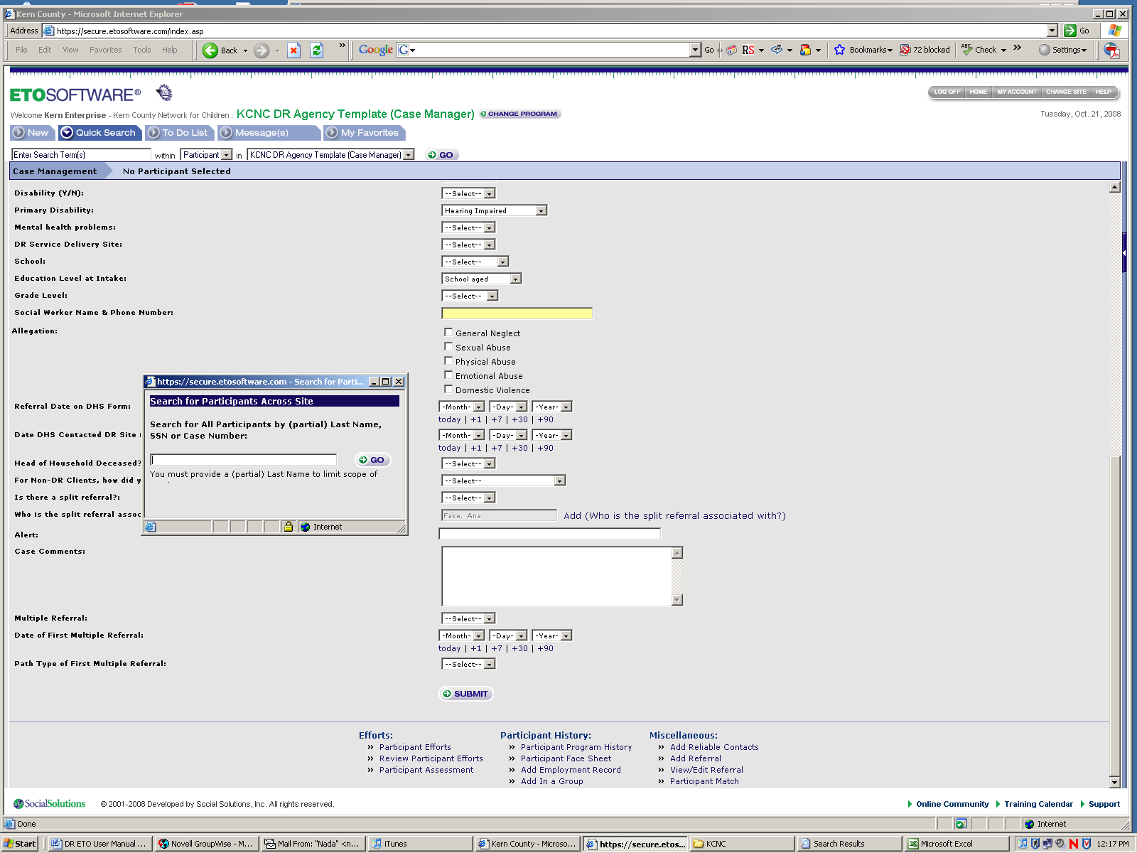
- If the household member with the split referral is not in the system, first have Data Entry staff add the new household members as new participants in the software or add the new household members to the new household.
- Once entered, the new members must be sent to the case manager by the Supervisor
- When completed,
- Click “Yes” for Is there a split referral? and for the field Who is the split referral associated with?, click Add (Who is the split referral associated with?) View (Who is the split referral associated with?). Search for name of split referral and click Go
- You can also join household members to the split referral household member

Multiple Referrals
A household can receive additional DR referrals during their case management with your site. It is important to track the number and type of DR path for outcome evaluation.
- Data Entry staff will first use the Find Participant feature to locate existing client and identify the case manager working the caseload
- Case Manager will update the client information regarding the new DR referral, date and path type
- Additional information about the DR referral can be placed in the case notes about the head of household.

- Participant Assessments: Adding family member information and information about referrals from school sites (for applicable sites).

DR Household Member Form
Add family member information after submitting the head of household information. Find and select the client by clicking the Go button and clicking the green button and selecting View/Record Assessment. Then click Take A New Assessment and select the DR Household Member assessment form. Here you will place information about all other household members including age, school info, disability, etc. When completed, click submit.
- The remaining family members should be classified in the context of their relationship to the DR Head of Household.
- Children of the Head of Household who are 18 or older will be classified as Other Adult. If child in home turns 18 during case management, you may edit their relationship by editing your DR Household Member assessment form

School Referral Form
Fill out School Referral Form when the referral came from a school district. Optional form for DR sites. Form can be used with referrals from schools to the DR site.

- Update Participant Information: Update program and demographic information. Search for family name or household member last name. You can include inactive/dismissed families in the search.

- General Assessment: Fill out Client Satisfaction Survey.
- Click the General Assessment Go button to fill out the Client Satisfaction Survey.
- Client Satisfaction Survey is completed with a family every six months and/or when the family exits the program. IF YOU DO NOT HIT SUBMIT YOUR INFORMATION WILL NOT BE SAVED.

Once the household has been dismissed from the Intake Program and received by the Case Manager Program, the data entry staff can no longer make changes to the data, only the case manager.
One-Stop Services (Data Entry)
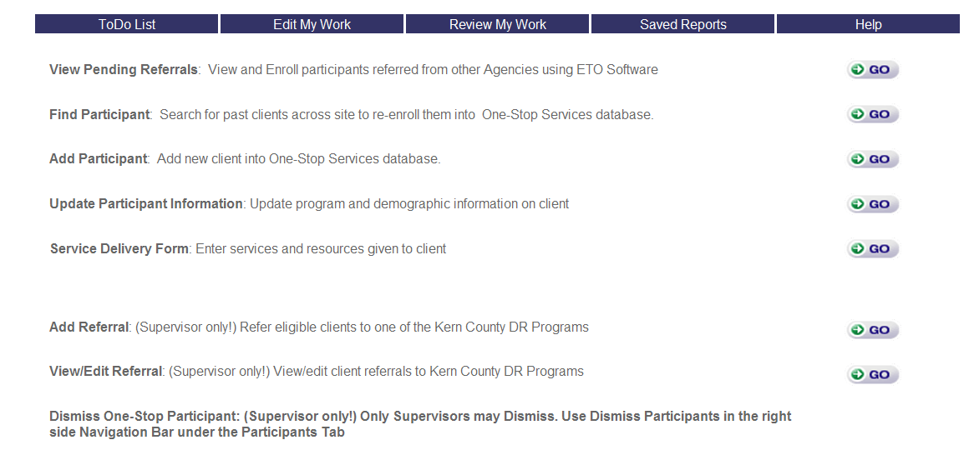

For sites who need to gather information on clients accessing services and/or goods at their DR site. These can also include DR referred families who decline services but who may receive one time services.
Data entry staff will be responsible for this database. Select One-Stop Services in the Program drop down box. The system follows the DR Intake when adding and updating client information. In the demographics screen, staff will be asked if the client has received services before, what funding provided the services and resources (can be more than one) and if the client has children between the ages of 0 – 5 years.
Use the Service Delivery Form link to enter what services and resources were given to that client. Do a new Service Delivery Form assessment each time a client receives resources through the site.

Parenting (Data Entry)
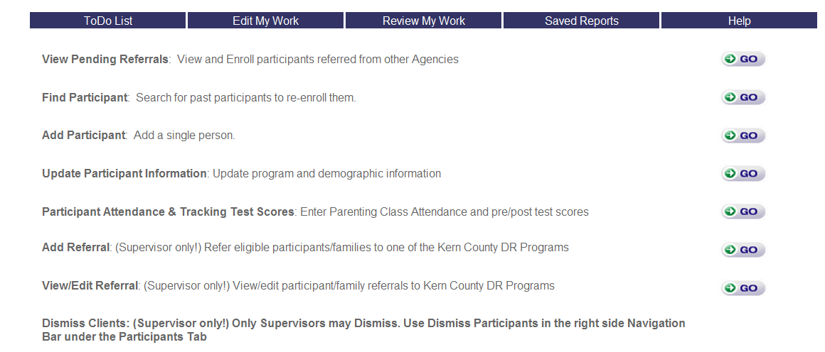

Parenting database is for sites only who offer Parenting Classes through their funding with KCNC. Attendance and pre/post test scores can be stored within this system. A client can receive services simultaneously through DR Case Management and Parenting. Data entry staff will be responsible for this database. The system follows the DR Intake when adding and updating client information. A client can also be referred from Case Management to Parenting and enrolled into the system via View Pending Referrals.
Select Parenting Classes in the Program drop down box. Individual clients will be entered into the system and can be DR referred or community referred.
Creating Groups (Classes)
Classes will be tracked by Groups. A group is a defined subset of participants active in the selected program. Groups can be set up to start and end on specific dates (such as seasonally occurring activities/classes), or to be continually active (such as support groups), with participants rotating in and out of the group. The Manage Groups feature under the Participants on the right hand side bar allows for the creation of rosters of individual participants that meet together regularly over time (names of classes).
To add a new group, follow the following steps:
- Click the Add button on the bottom of the Manage Groups page.
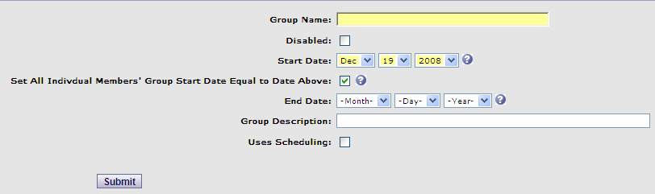
- Name: Enter a name for the group.
- Disabled: Select if this group is not yet active. This option is rarely used at the time of a group's creation. Groups can easily be disabled and re-enabled once created.
- Start Date: Note that ETO will prevent attendance data for the group from being entered prior to the group start date. For this reason, it is important if the group started in the past, the start date is backdated.
- Set All Individual Members' Group Start Date Equal to Date Above: If this box is not checked, member start dates will default to the date they are added to the group (today). Member group start date can be edited individually if this box is checked. NOTE: If this box is checked for an existing group, the start date for the current members will not change. Checking this box will only impact new members added to the group.
- End Date: The group will not be available for recording efforts after it's end date (including for back data entry).
- Group Description: Text will show up under the title of the group on the Manage Groups screen.
- Uses Scheduling: Linked to the Manage Scheduling feature. Few customers utilize this option. There is a Standard Report under the Family/Group heading called Participant Schedule. This report is generated for one participant at a time, and includes schedule information for any groups where the participant is enrolled.
Adding Participant Members to a Group:
Once you’ve added a new group, click on Members, where you can add active participants in the selected Program.
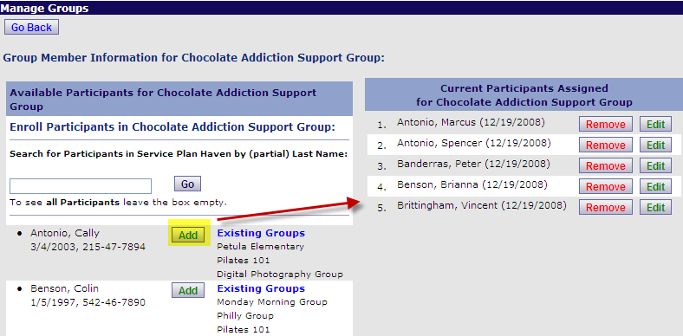
Use the search bar to search for specific participant names or click Go to view a list of all available participants in your program. Click Add next to the desired participant(s). (If a participant is already a member of another group, you will see their Existing Groups below their name. You may not want participants to be in more than one group at a time to simplify attendance entry in ETO). Each participant's start date in the group appears next to his name. This start date may or may not match the group start date, depending on the setting on the Add New Group page, and whether the date has been edited.
Click Edit to change the Start Date, Termination Date, or Termination Reason.
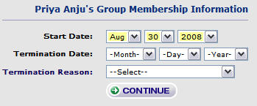
Class Attendance
To enter class attendance into the system, click Participant Attendance & Tracking Test Scores and select Group/Family then click the class you need under Select Group. Select Track Attendance At parenting Classes and click Submit. Select Contact Location, Date, Time Spent in Class and click those members attending. You many also insert any notes.
Pre and Post Test Scores
To enter pre and post test scores into the system. To enter pre or post test scores into the system, click Participant Attendance & Tracking Test Scores and select Group/Family then click the class you need under Select Group. Select Track Parenting Pre Scores or Track Parenting Post Scores click Submit. Select Contact Location, Date, Parenting Pre/Post Test Type and enter appropriate scores for each client. You many also insert any notes.

Case Managers
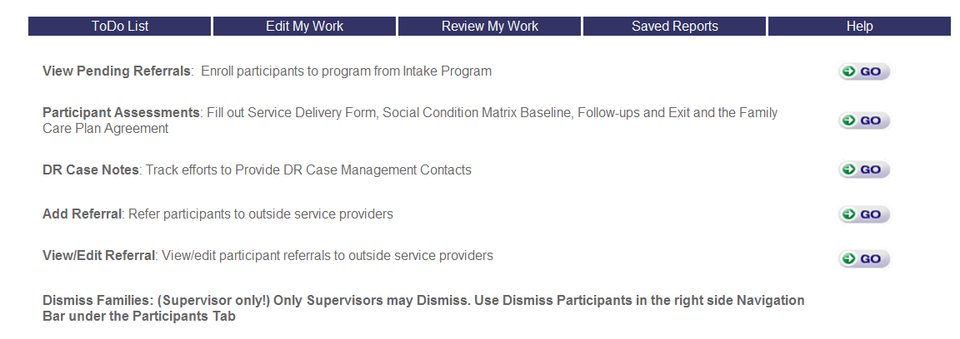

Homepage Navigation

- View Pending Referrals: Enroll participants to program from Intake Program (Supervisor). Use this feature to accept or decline cases sent to you by your Supervisor.
  - To View Pending Referrals, click Go button to see if there are any new client households that have been assigned to you by your supervisor.
  - Select the radio button for A Different Program Within My Site and press Submit.
  - The next page will be a list of all Participants referred, with other pertinent data such as any notes from the Supervisor. For each Family, you have the option to Accept or Not Accept the Household. If you do the former, the Household is enrolled into your Program as of the date you accept them; if you do the latter, a new page will appear that allows you to choose a Rejection Reason and click.
  - When you submit that you Accept or do Not Accept the referral, it automatically updates the View/Edit Referrals record of the Participant in the referring program so your Programs can most effectively communicate referral information.
When you open a case, go to View/Edit on the Head of Household and change Case Status and Date Case Opened.
  - To accept the client, click Accepted on the row with the and click Yes on the Confirm Referral Status pop-up box
  - Find the participant by clicking the Go button; Find name, click green button and select View/Edit to review information on the participant.

- Participant Assessments: Fill out Social Condition Matrix Baseline, Service Delivery Form, Follow-ups and Exit and the Family Care Plan Agreement.

Social Conditions Matrix
  - Schedule one visit each month as an Assessment appointment.
  - Complete Matrix for household on the Head of Household’s name.
  - Access the Matrix by clicking the Add Intake, Matrix, Assessments link on the upper page bar and via the home page at the Participant Assessments link.
  - Click Take New Assessment.
  - Select in the dropdown box either Social Condition Matrix Baseline (new client), Social Condition Matrix Follow Up (update client) or Social Condition Matrix Exit (exiting client) and click Continue
  - All life domains in a Matrix should be assessed except “Child Care.” Child Care can be left as “Select” (default) when the family has no need for child care so the family can attend work or training (i.e., stay at home parent, teenage children, etc.)
  - Select a number of Family Conditions you are working on with the family in order to create an average with the Calculate button. If you skip Child Care, then you will select 11. The Matrix is set up so all domains have an evaluation except Child Care.
  - Case Managers mark how many conditions the family is 11 or 12 to collect average scores.
  - Click the calculate button to generate Score and the calculate button to generate Average Score
  - If you have closed a case, the case manager should conduct an Exit Matrix Assessment. If unable, to complete an exit Matrix, then use the scores from the last Matrix assessment as the exit Matrix.
  - If you make changes to scores, just hit calculate again to re-calculate.
  - Schedule a Follow-Up Alert.
  - When updating, you can pre-populate with the last Matrix selections.
  - If you have closed a case, the case manager should conduct an Exit Matrix Assessment. If unable, to complete an exit Matrix, then use the scores from the last Matrix assessment as the exit Matrix.

Family Care Plan Agreement
- Family Care Plan Agreement can be found under Assessments via the Participant Assessments Link on Home page, the Add Matrix, Assessments link in Case Management bar or View/Record an Assessment link on the Head of Household name’s shortcut box. This form no longer needs to be handwritten by case manager and can be printed out to the client.
- For first Family Care Plan Agreement, use the Family Care Plan Agreement and for additional Family Care Plan Agreements, please use the Family Care Plan Agreement Follow Up selection.
- New to the Family Care Plan Agreement is the addition of Social Condition Matrix life domains to better link the Family Care Plan with the Matrix. Please select at least one Matrix life domain that best fits the goal the family has set. If it is a personal goal that does not fit within the Matrix, select “Other.”
- Please remember to use family friendly language.
- Case manager can pre-populate with the last Matrix selections.
CSV Staff: Long term and short term family goals will continue every six months. Select two personal goals and three goals that match family needs based from the Matrix assessment.

Service Delivery Form
- Traditionally this form was used at all home visits to documents any referrals, linkages and/or services provided to the case managed household.

DR Household Member
All assessments, case notes and efforts about the family should be done on the Head of Household’s name to centralize the measures. Do not move to another family member during case management.
- Data entry staff will enter the family member information and a case manager can access this assessment to make updates. Be sure to change the number of household members on the demographics page when needed.

- DR Case Notes: Track efforts to provide DR Case Management Contacts (Case Notes)

DR Case Notes
- Find Head of Household participant with the Go button.
- To record efforts/contact, use the Case Management link in the dialog box in the Show All Participants section or the Add Case Management Contact link on the upper page bar
- To add case notes, use the DR Case Notes.
CSV Staff: On the first entry to the Head of Household’s case notes, begin with “Received Referral On” and continue your notes from there. This is only on the first entry. When inputting case notes, use the following format:
Date of referral received:
Goal:
Status:
Progress:
Intervention:
Plan:
- When entering the Time Value (how much time spent with client) on the DR Case Notes, DR sites will be following the time recording standards used by the Department of Mental Health. The time you record in the DR Case Notes will include the total amount of “Face-to-face time” (actual time a client is visually in the presence of and interacting in some way with staff) and “Other time” (preparation, nonface-to-face contacts with the client, documentation, and travel time). This time assessment is also completed for clients you cannot contact.
- If you delivered services, use the Service Delivery Form link in the Participant Assessments.

- Add Referral: Refer participants to outside service providers.
- Access the DR referral tracking system by clicking the Add Referral link on the upper page bar.
- You can review previous referrals and update the status of the referral (View/Edit) and/or add a new referral for your client (Add Referral).
- To add referral, click Add Referral and select Entity (Service Providers) for community based organizations, Entity (Employers) for job services, or Entity (Education Institution) for schools
- If the name of agency is not in the Service Providers, you can click Add New Service Providers Entity and enter name.
- Select Reason for Referral, Referral Drop Off Date and Pending Drop Off Date.
- Click Release Participant Information if applicable.
- Click Referral Status and select Referred and click Continue.
- If you want to do a follow up on client to see if s/he got the referred service, the case manager can do a Date of Next Contact and the scheduled date will go on the To Do List.
- This form can printed out and faxed to the referred agency or given to the client.

- View/Edit Referral: View/edit participant referrals to outside service providers

- Dismiss Families: Clients with a Case Closed or Case Never Open
- Sites can dismiss a case if it is either closed or a case was never opened. The Supervisor is only staff at site who can dismiss case; please review case with supervisor before it will be dismissed.
- For cases never opened or closed, put any case notes into the DR Case Notes section.
- Go to the Head of Household’s View/Edit page and select Case Closed or Case Never Open in Case Status field
- If closed, case managers should conduct an Exit Matrix Assessment. If unable, to complete an exit Matrix, then use the scores from the last Matrix assessment as the exit Matrix. In addition, case managers will need to conduct a DR Client Satisfaction Survey.
CSV Staff: When closing a chart, be sure to complete case notes and feedback form to DHS.

Supervisors

Homepage Navigation

- View Pending Referrals: Data entry staff and supervisors can access referrals from partner DR sites and other Kern County ETO entities.
- This functionality allows Data Entry staff and Supervisors to see any participants who have been referred to your Program by another Program in your Site. For example, if you have an Intake Program that manages enrollments for all Programs, when a Participant completes the enrollment process, she can be referred to your Program by the Intake Program.
- To View Pending Referrals, a Supervisor can choose either the Site or Program option or and the next page will be a list of all Referring Programs and Participants referred, with other pertinent data.
- For each Participant, you have the option to Accept or Not Accept the Participant. If you do the former, the Participant is enrolled in your Program as of the date you accept them; if you do the latter, a new page will appear that allows you to choose a Rejection Reason (the same as your universal Dismissal Reasons) and click.
- When you submit that you Accept or do Not Accept the referral, it automatically updates the View/Edit Referrals record of the Participant in the referring program so your Programs can most effectively communicate referral information.

- Add Referral: Refer eligible participants/families to one of the KCNC DR Programs

Assigning A Case To A Case Manager
  - Go to Change Program and select DR Intake Program and click Go
  - You will be at the Home page in the DR Intake Program
  - Find at the bottom of the homepage Add Referral (Supervisor only!) Refer eligible participants/families to one of the KCNC DR Programs and click the Go
  - Select the radio button for Group and click Submit
  - Click the plus sign next to Families to expand all the family households that are currently in the DR Intake Program.
  - Select name of household you are referring to a Case Manager by checking the checkbox and click Submit
  - In the Select Type of Referral box, select To Program radio button and click Submit
  - Select Program drop down box and select the case manager’s caseload number that you want to assign this referral to (this is a required field)
  - Do not indicate a reason for referral (it is an internal site referral)
  - Pending Drop Off Date is how long a supervisor wants a family case to remain on a Case Manager’s list before the Case Manager views and accepts it
  - Referral Status, Time Spent on Contact and Date of Next Contact is not used for internal program referrals
  - Click the Dismiss From Program checkbox allowing additional fields to appear
  - Select Reason for Dismissal drop down box and select Referred
  - Ignore the Successfully Completed at this stage of the program
  - Click the Submit button
  - A Print Referral will appear if you would like to print
  - Dismiss from Program means the supervisor will send them out of the Intake Program into the Case Manager Program Be sure to check “Case Dismissed” when referring a family to a case manager so there are not duplicate families in Intake and Case Management Programs.

Assigning A Case To DR Program (Parenting/One-Stop Services) or Another DR Site
First you would go to the homepage and click on “Add Referral”. Then select whether you are referring a group or an individual. Check mark all that apply and click on submit. Then select “to site” for another DR site or “to program” for Parenting or One-Stop Services and click on submit. Select the site/program that you want to refer to and complete the referral information make sure to mark on dismiss from program and then click on submit. If you are dismissing the client from case management, click Dismiss From Program.

- View/Edit Referral:
- View/edit participant/family referrals to KCNC DR Programs and programs outside your site
- You have the ability to view referrals as follows:
- Show Single Participant – Allows you to search for one participant.
- Show all Participants Enrolled in Program – Shows all Participants enrolled in the program you are currently in.
- Show all Participants across site – Shows all Participants across your entire DR site.
- Once you’ve made your choice, you will have the ability to do the following per referral:
- Details – This allows you to view the details of the referral and to update the Referral Status of the Participant by clicking on the green Add Details towards the bottom of the record and clicking on Add Referral Details. For example, if you refer a Participant to a Service Provider and she is accepted, you would change her status from Awaiting Admission to Accepted (Note: these are examples of Referral Status that your authorized users will define);
- Edit: This allows you to edit any of the initial information you submitted;
- Delete: This allows you to completely delete the referral record. Please be very careful with this functionality.
- Print: Provides a Printable Summary Screen of all referrals pertaining to that participant.

- Dismiss Families: (Supervisor only!) Only Supervisors may dismiss. Use Dismiss Participants in the right side Navigation Bar under the Participants Tab.

How To Dismiss A Client From The Program
- Go to the Case Manger’s program and go to his/her home page
- Use Dismiss Participants in the right side Navigation Bar under the Participants Tab
- Search by participants by (partial) Last Name, SSN, Case number or Family Name
- Select name of client you are dismissing by checking his/her checkbox and click Dismiss (Different Dates + Reasons) or Dismiss (Same Date + Reasons)
- When completing the reason why a client is being dismissed from case management, be sure to mark the most appropriate Reason for Dismissal (e.g., CC-Family moved, CNO-Ineligible for Referral Services, CNO-No Contact Made, CNO-Stable per Family, CC-Children Removed From Home).
- Select End Date, Dismissal Reason (Case Closed Or Case Never Opened) and/or Successfully Completed checkbox (only if case was successfully completed) and click Dismiss button.

