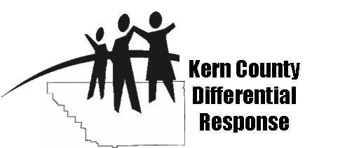
Kern County DR
Commonly Used Acronyms

Referral Lingo:
CAI: Caretaker absence or incapacity
DV: Domestic Violence
GN: General neglect
EA: Emotional abuse
EO: Evaluate out
PA: Physical abuse
SA: Sexual abuse
SN: Severe neglect
W&I Code: Welfare and Institutions code

24hr: 24 hour response time for referral
10-day: 10 day response time for referral

Departments/Programs:
DR: Differential response
ER: Emergency response
JCC: Jamison Children’s Center
CIU: Court intake unit
VFM: Voluntary family maintenance
FM: Court ordered family maintenance
FR: Family reunification services
FS: Family services (includes FR and FM)
PP: Permanency placement
KITE: Kern integrated team effort
EFS: Employment and financial services
AB429: Case plan linkage with CalWORKs and Family Services

Services/Systems:
FDM: Family decision meeting
SDM: Structured decision making system
Matrix: Social Conditions Matrix assessment tool
CWS/CMS: Child welfare service case management system
CJIS: California Justice information system
DOJ: Department of justice
SCAR: Suspected children abuse report

Agencies:
LEA: Law enforcement agency & Local education agency
KCSO: Kern county sheriffs office
BPD: Bakersfield police department
DHS: Kern County Department of Human Services
KCMH: Kern County Mental Health (Children’s System of Care)
KCPH: Kern County Department of Public Health
KCPD: Kern County Probation Department
CBO: Community Based Organization
KCNC: Kern County Network for Children
FRC: Family resource center
- IWV-Indian Wells Valley FRC (Ridgecrest)
- KRV-Kern River Valley FRC (Lake Isabella)
- EK-East Kern FRC (Mojave)
- SE-Southeast FRC (Southeast Bakersfield)

Miscellaneous:
CM: Case Manager
FA: Family Advocate
SW: Social Worker
PSSF: Promoting Safe and Stable Families funding
CAPIT: Child Abuse Prevention Intervention and Treatment funding
MDT: Multi-Disciplinary Team
FAST: Family Assistance Service Team
ACT: Administrators and Coordinators Team
OIP: Outcome Improvement Project

