Intake Reports

Intake Reports are there to help check the accuracy of data.

- Prints a Blank Intake Form (Demographics and Custom Demographics) – Print this report to hand out to have a hard copy version of all the demographic information Breakthrough National is looking for.
- Participant Face Sheet - This functionality provides you with a different look at the demographic and contact information for each Participant. In addition, on each Face Sheet there is a link so you can “Print No. 10 Envelope” for any single Participant.
- Participant Profile – Much like the Participant Face sheet, this report provides a printable sheet of all demographic information for a student.
- Participant Service Template - The participant service template is a blank form that includes demographic and custom demographic fields, all available assessments and outcomes, including descriptions of the types of outcomes.
- Birthday List - This report provides you with a Birthday List by Program that includes each Participant’s Date of Birth and Age.
- Participant List for (your DR Site) - This component creates a Participant List that can be exported to Microsoft Excel or Word. The list includes address, phone numbers and date of birth. (Exporting this report is one step towards printing labels other than 8160 mailing)
- Avery 8160 Mailing Labels for Participants (Head of Household clients) - This function automatically creates mailing label templates for all Participants (Head of Household clients) in your system. Like Entities above, Participant addresses are broken down by those who have zip codes in the Software and those who do not.

Demographic Report: Used to show how all participants who were in the selected program or site during the date range compare with demographics.

Click on Right side Navigation Bar
Click on Reports
Click on Demographics

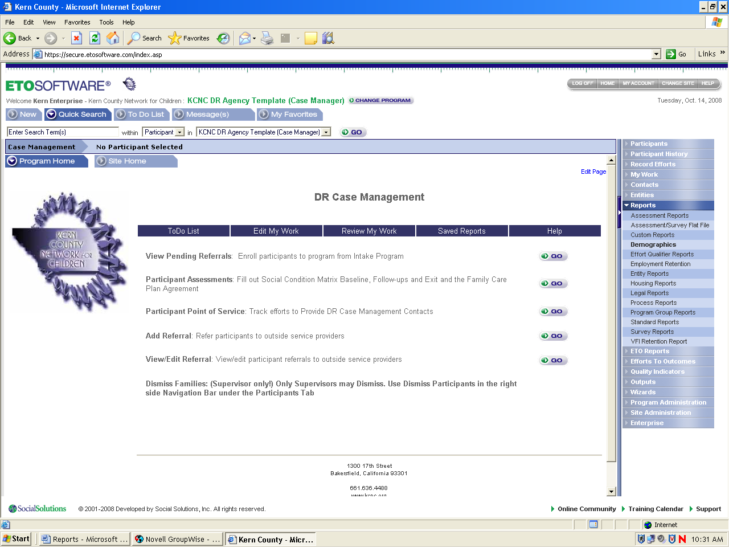

Click on Standard & Custom Demographics: Active participants within a date range –by program

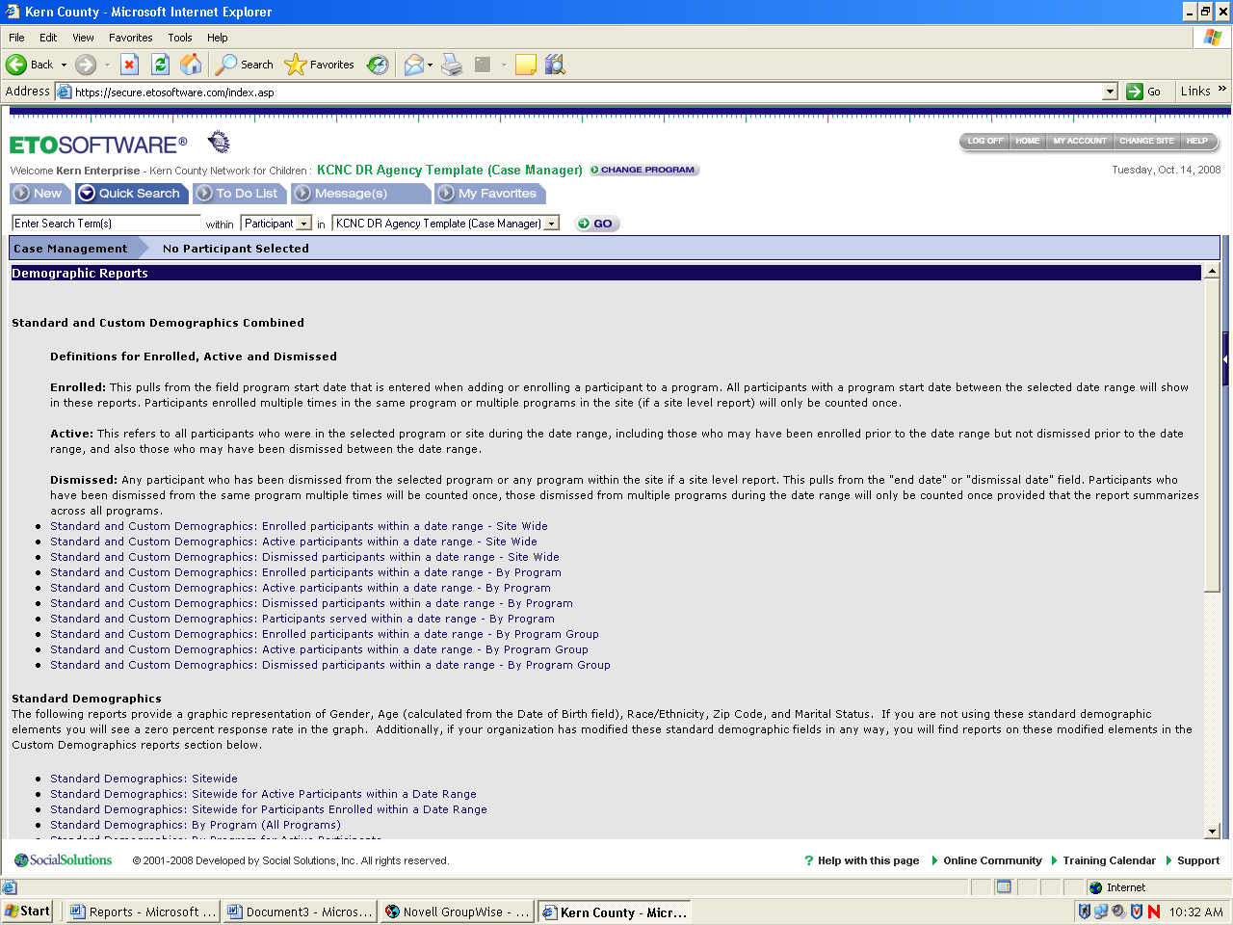

Select Dates and click on submit
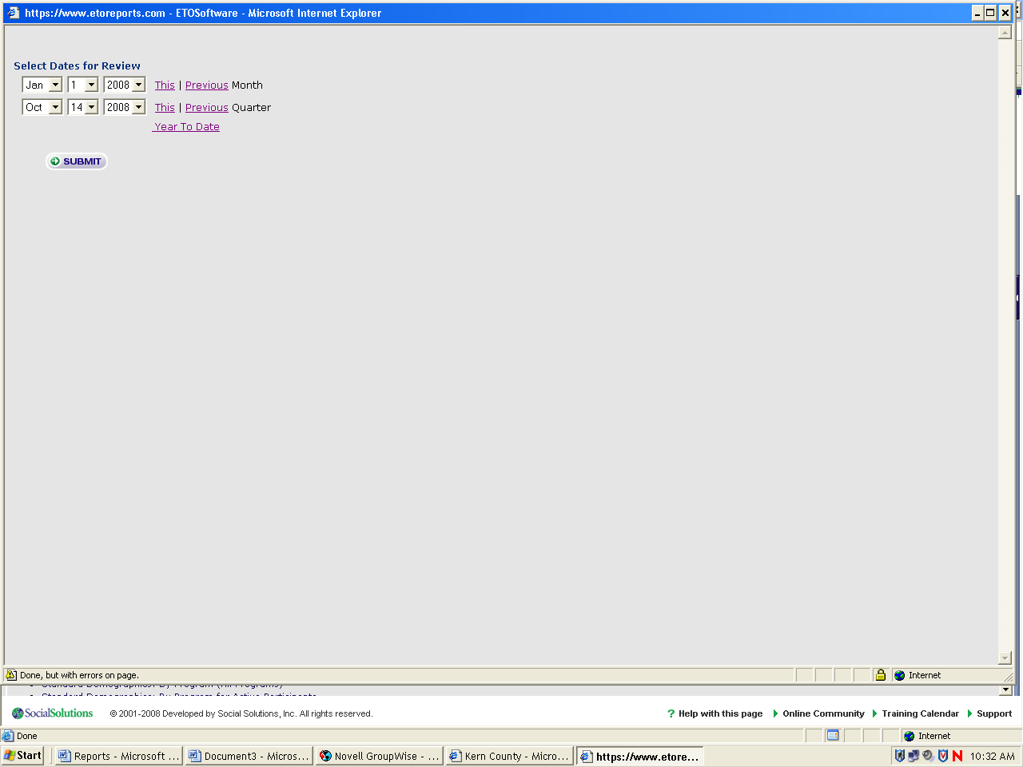

Example of actual demographics report

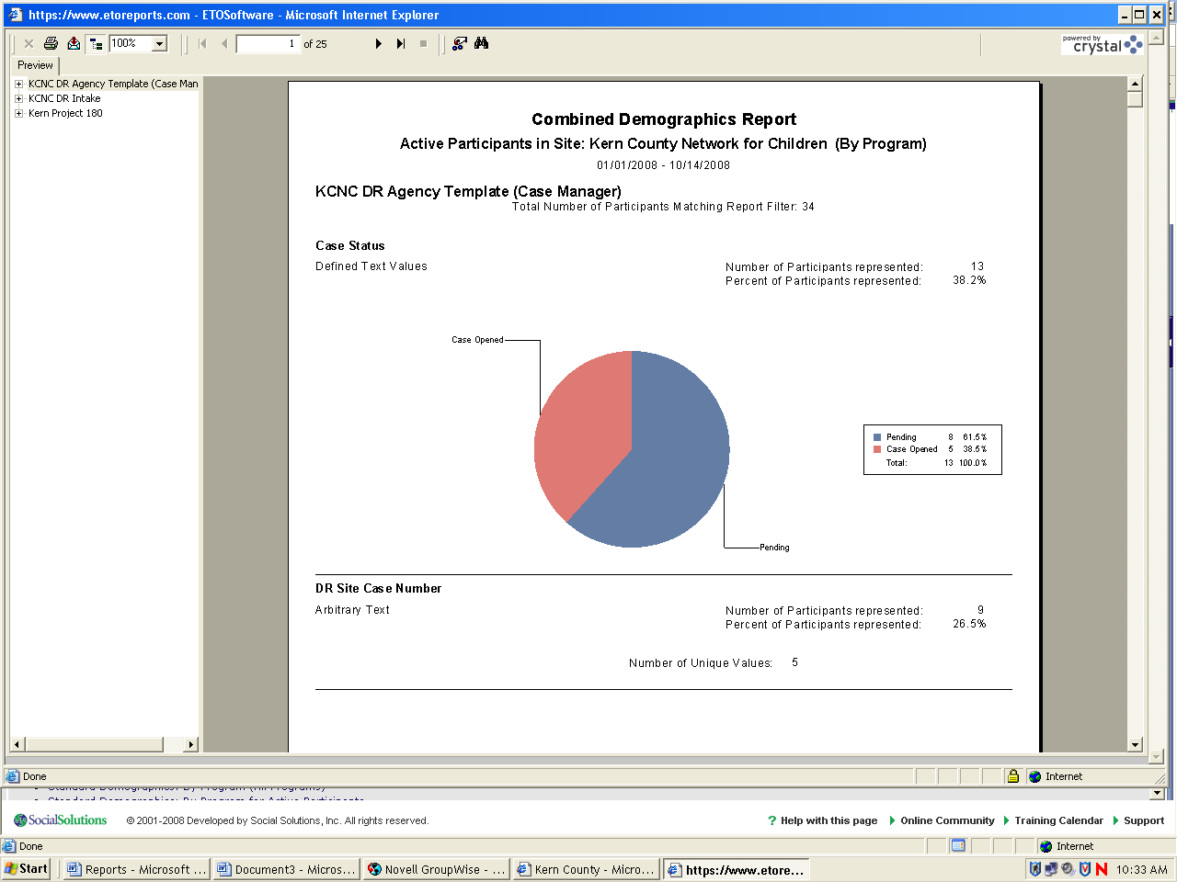

Avery 8160 mailing labels for participants: Creates mailing label templates for all participants in your system. Participant addresses are broken down by those who have zip codes in the software and those who do not.

Click on Right side Navigation Bar
Click on Reports
Click on Standard Reports

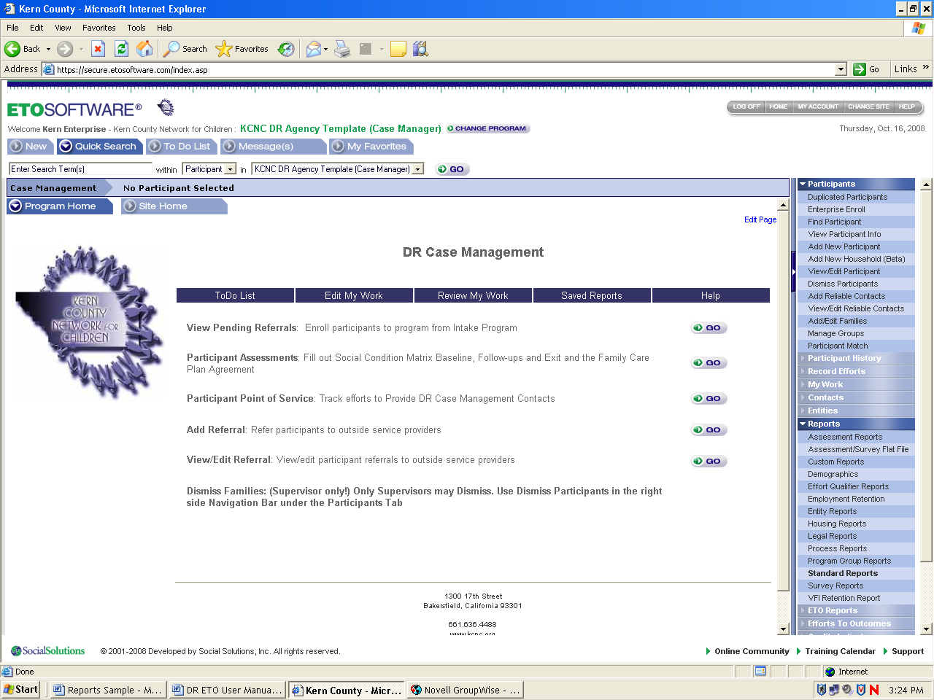

Look under “Intake Reports” and click on the “Avery 8160 mailing labels for participants”

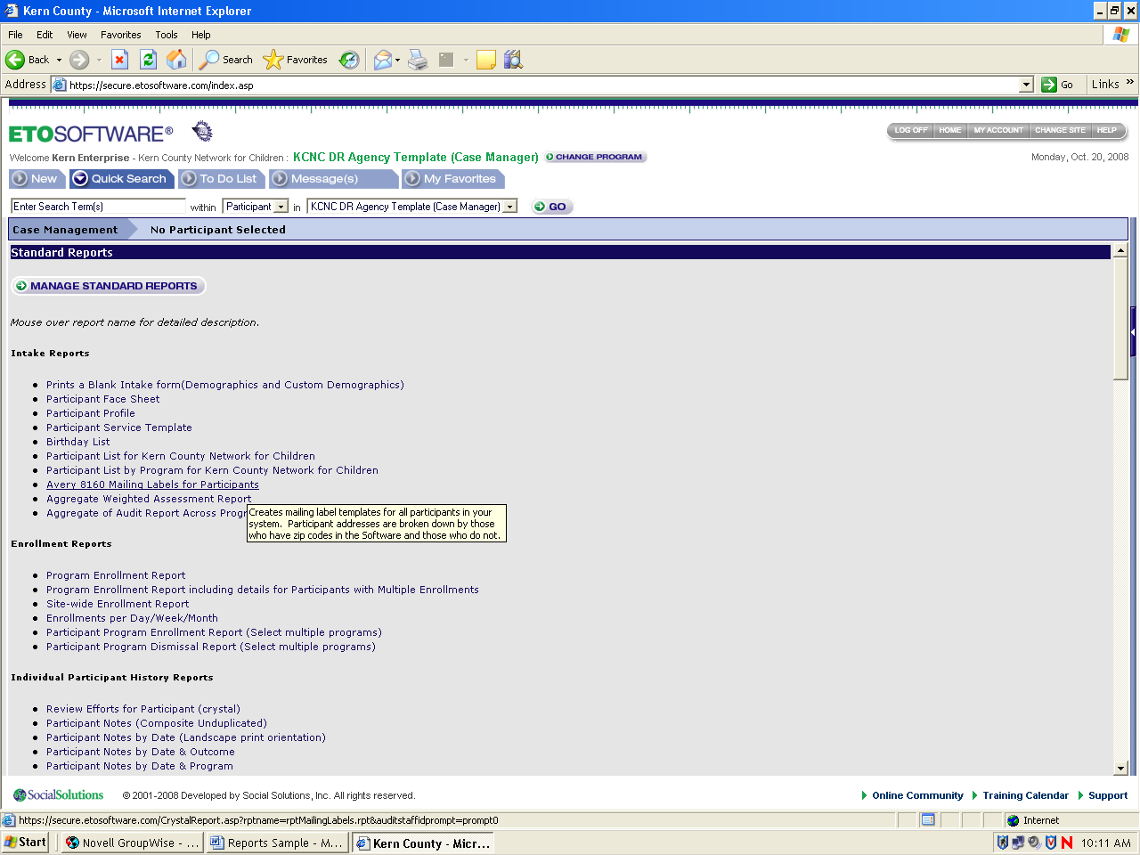

Example of actual Avery 8160 mailing labels for participants

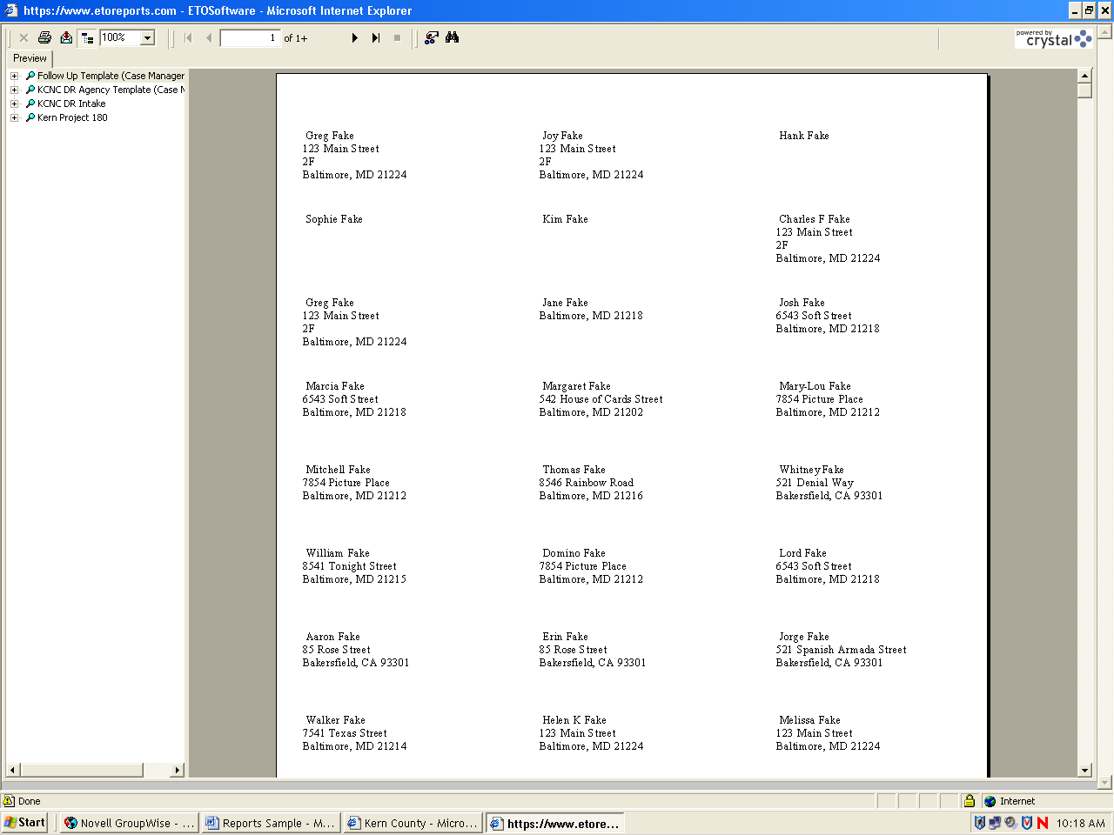

Aggregate of audit report across program: This aggregate report generates a list of all changes made to demographics within a date range.

Click on Right side Navigation Bar
Click on Reports
Click on Standard Reports

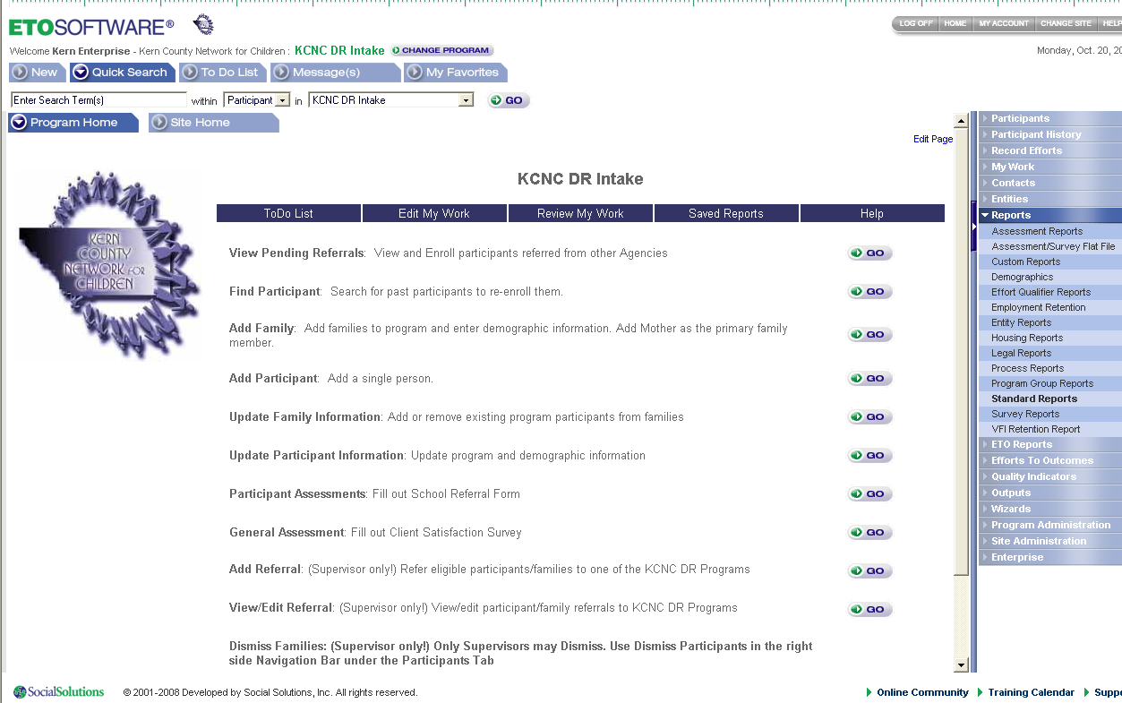

Look under “Intake Reports” and click on the “Aggregate of audit report across program”

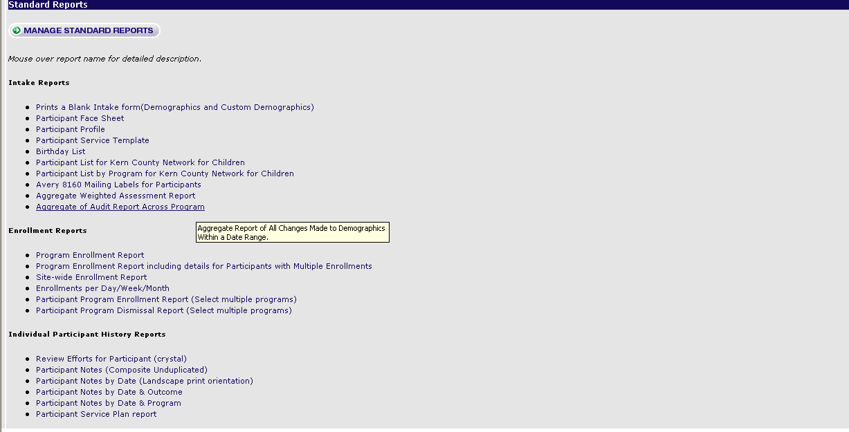

Select Dates and click on submit

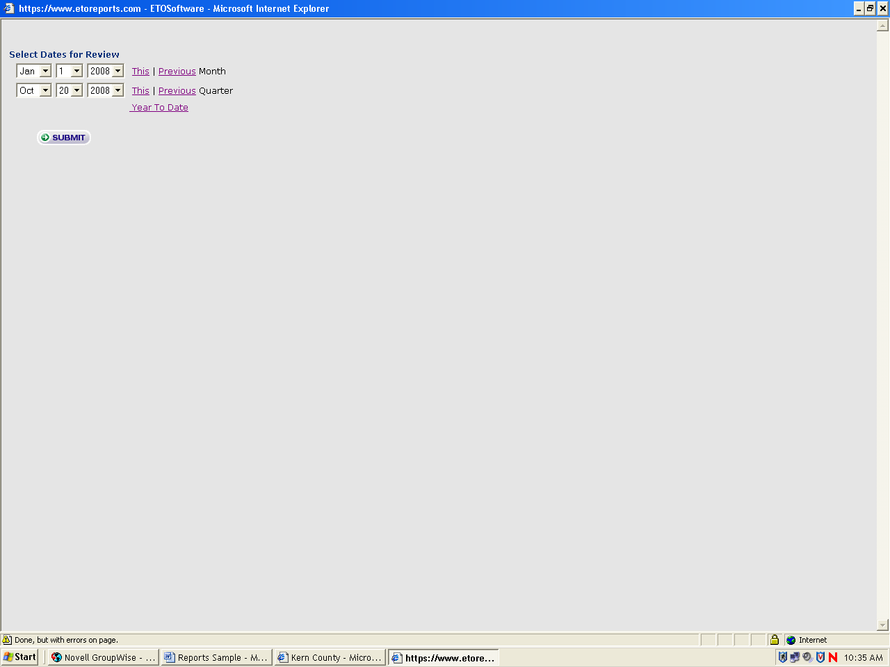

Example of Aggregate of audit report across program

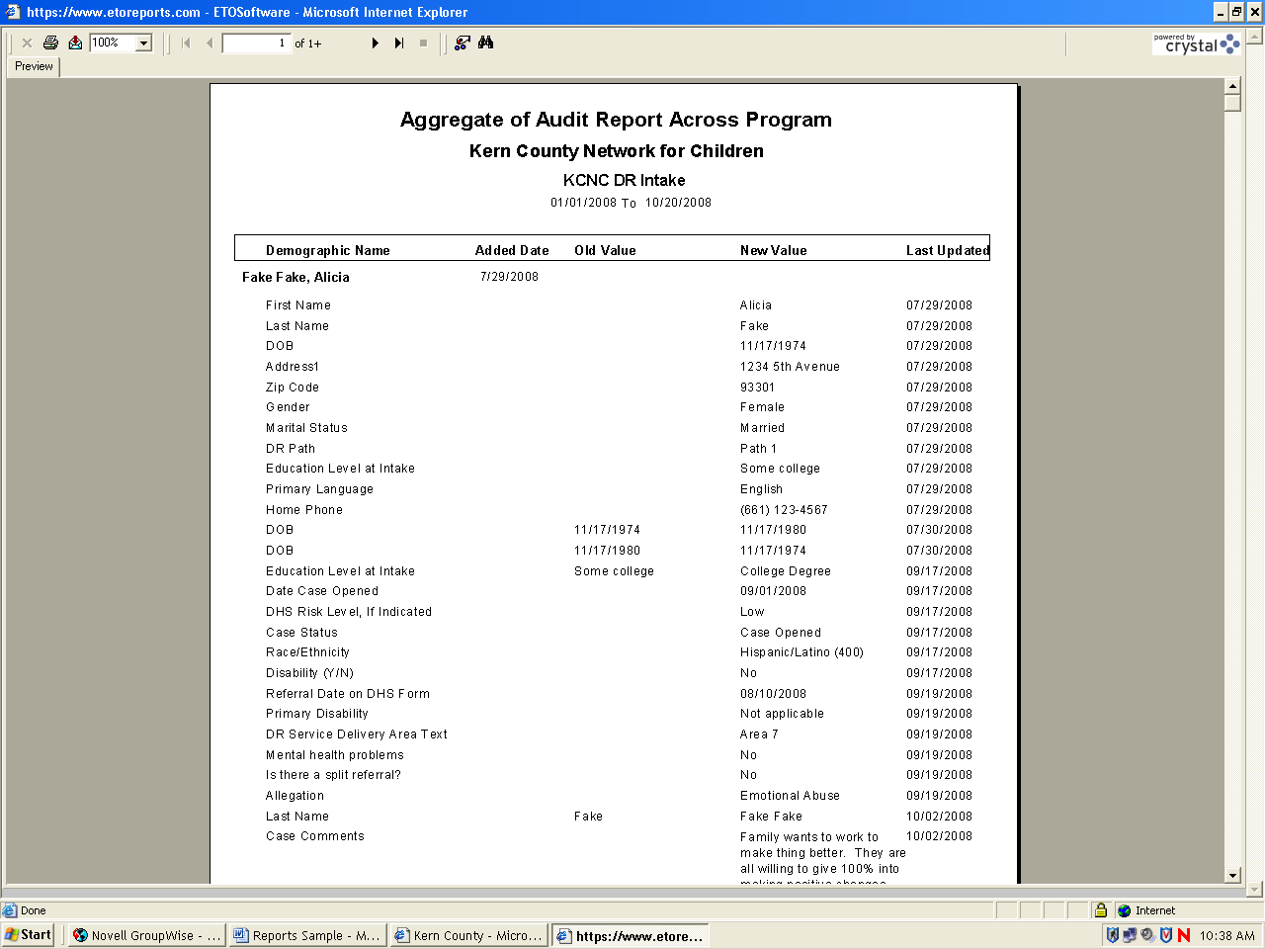

Avery 8160 mailing labels for entities: Allows you to print labels of all entities in your site.

Click on Right side Navigation Bar
Click on Reports
Click on Entity Reports
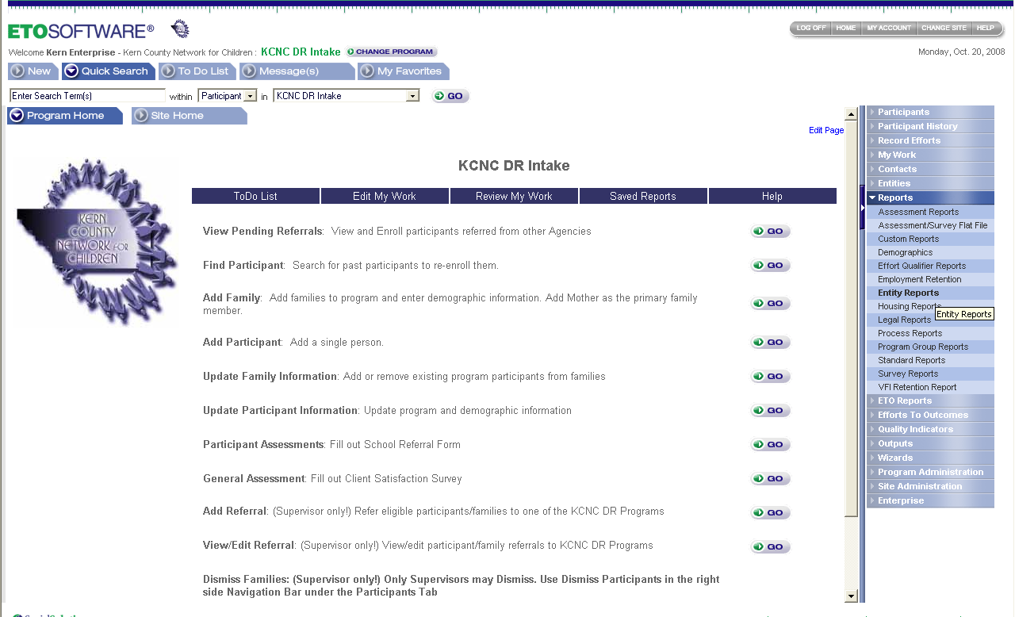

Look under “Mailing lists & exportable entity lists” and click on “Avery 8160 mailing labels for entities.”

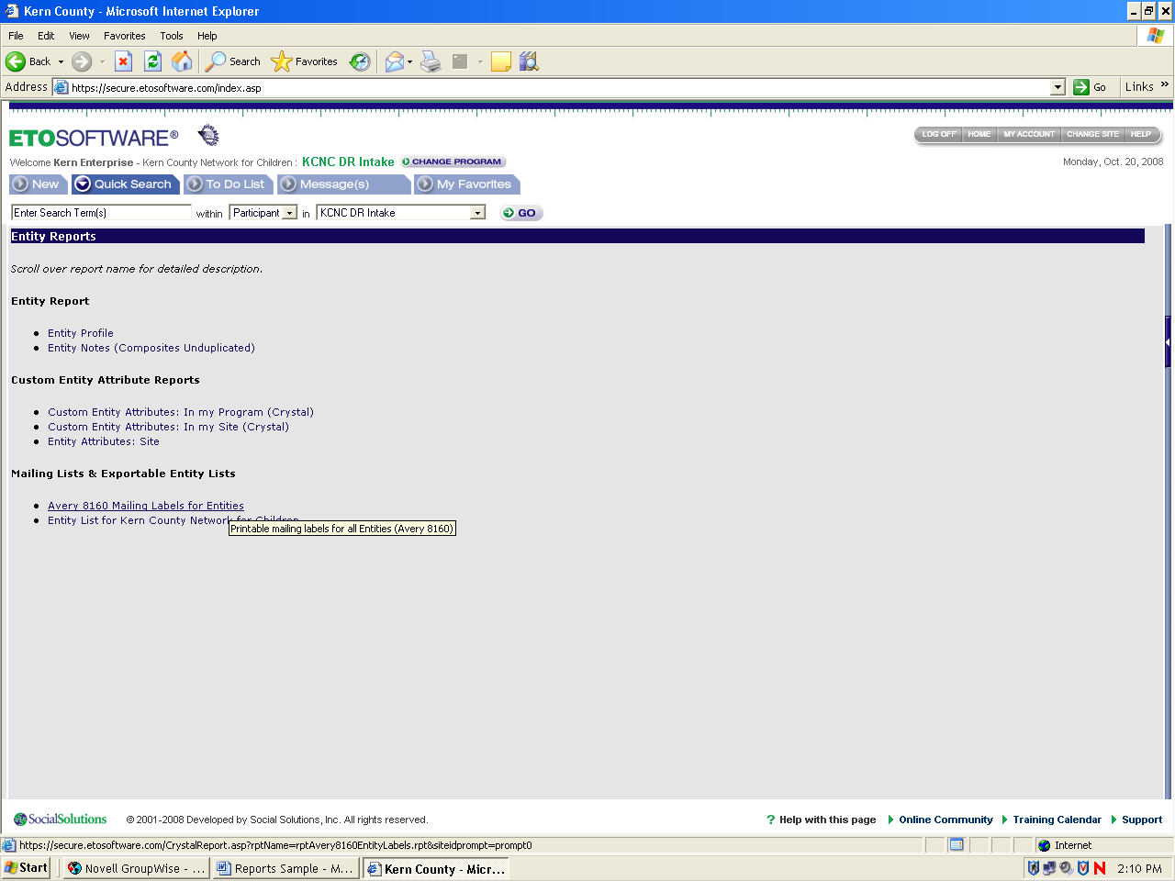

Actual example of 8160 mailing labels

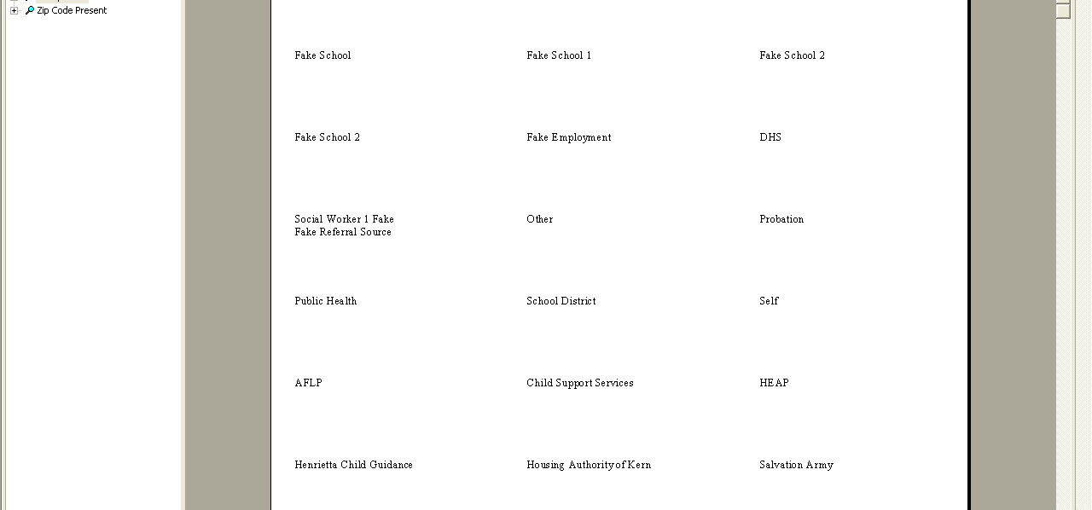

Avery 8160 mailing labels for entities: Allows you to print labels of all entities in your site.

Click on Right side Navigation Bar
Click on Reports
Click on Entity Reports

Look under “Mailing lists & exportable entity lists” and click on “Entity list for (your site)”

Actual example of entity list

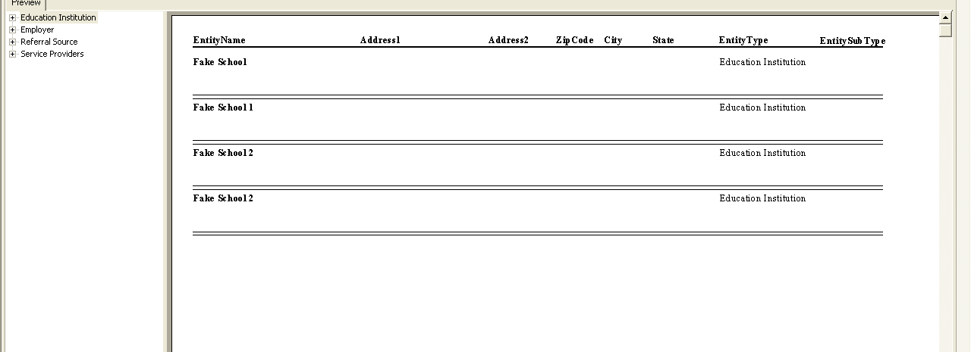

Case Managers Reports

Case managers reports are created to help with keeping data clean for the case managers.

Case note only Report: This report shows all case notes recorded in your program within a specific date range. It is broken down by individual participant.

Click on Right side Navigation Bar
Click on Reports
Click on Standard Reports

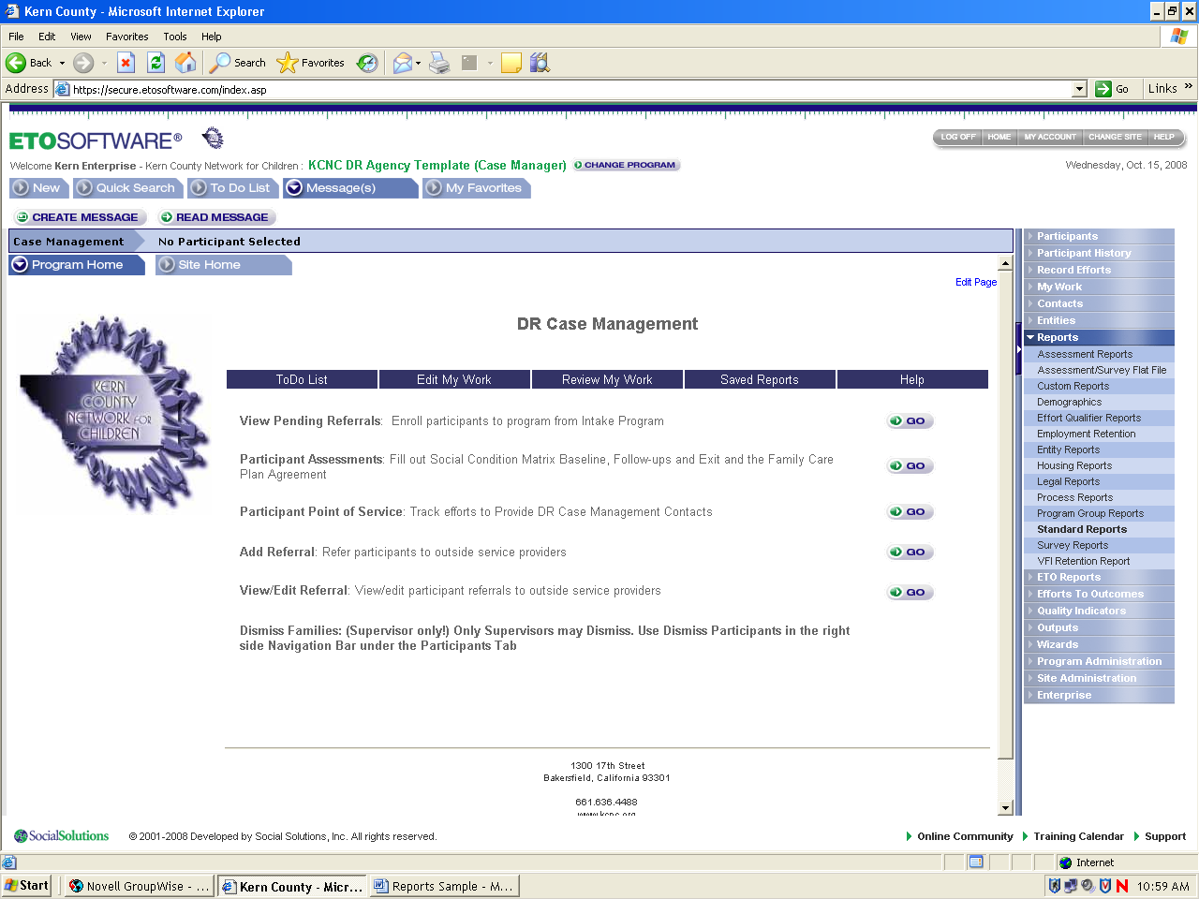

Look under “Participant service reports” and click on the “case note only – all participants”

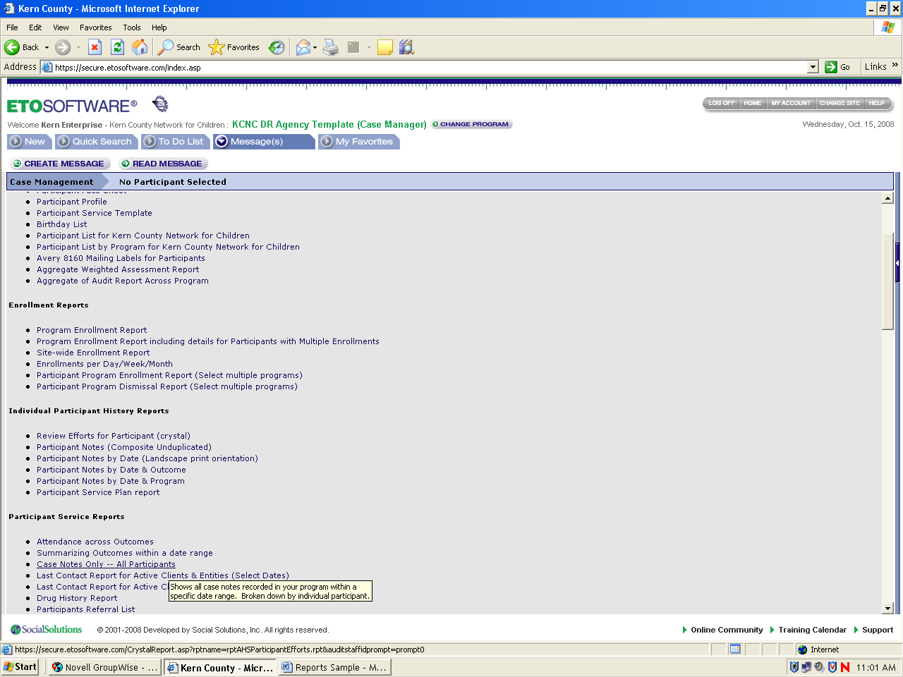

Select Dates and click on submit

Example of actual case-notes only report

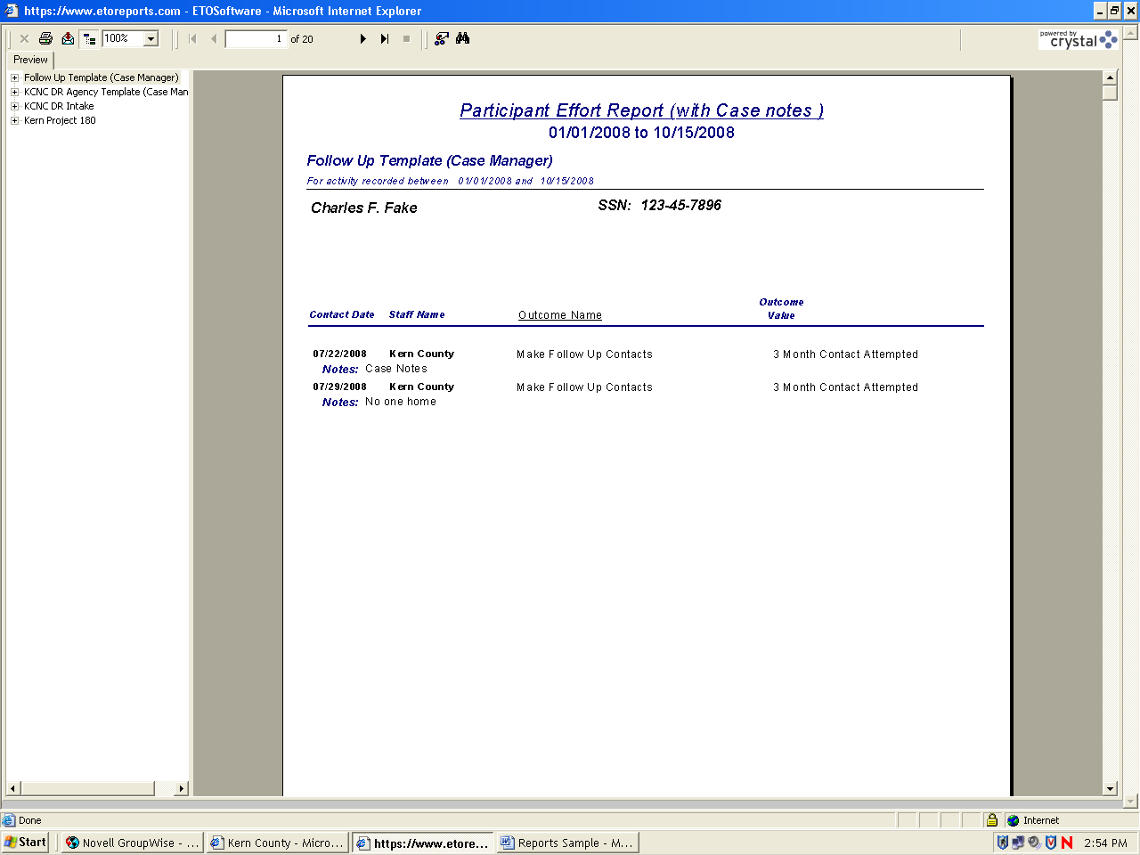

Match Efforts for all participants: This report shows all efforts made by entity contact for all participants in a date range organized by participants.

Click on Right side Navigation Bar
Click on Reports
Click on Standard Reports

Look under “Participant/Entity match reports” and click on the “Match efforts for all participants”

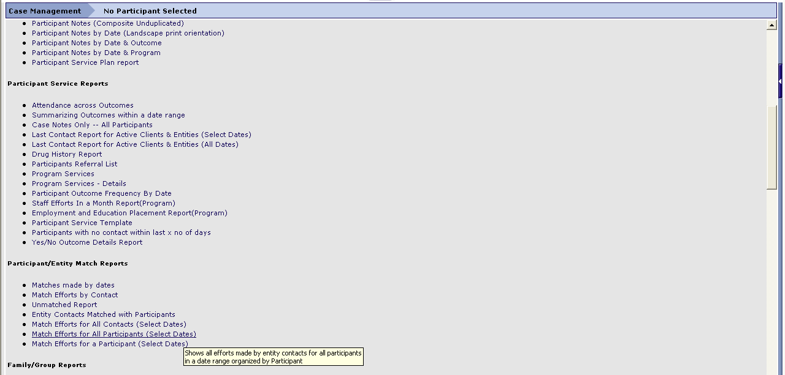

Select Dates and click on submit

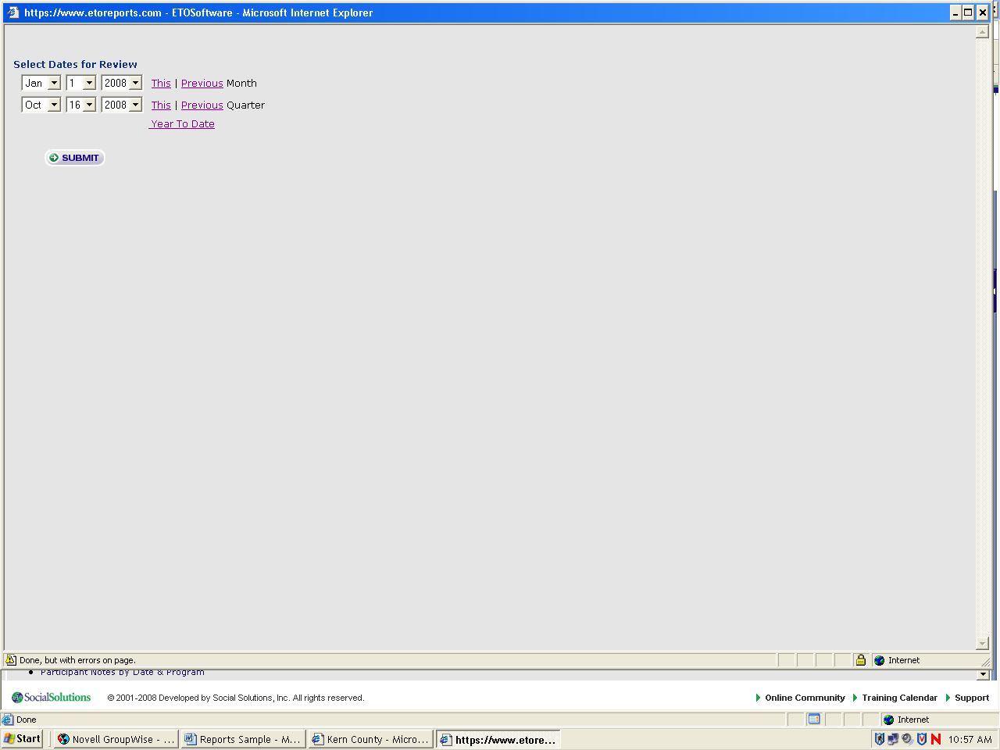

Example of actual report for Match efforts for all participants

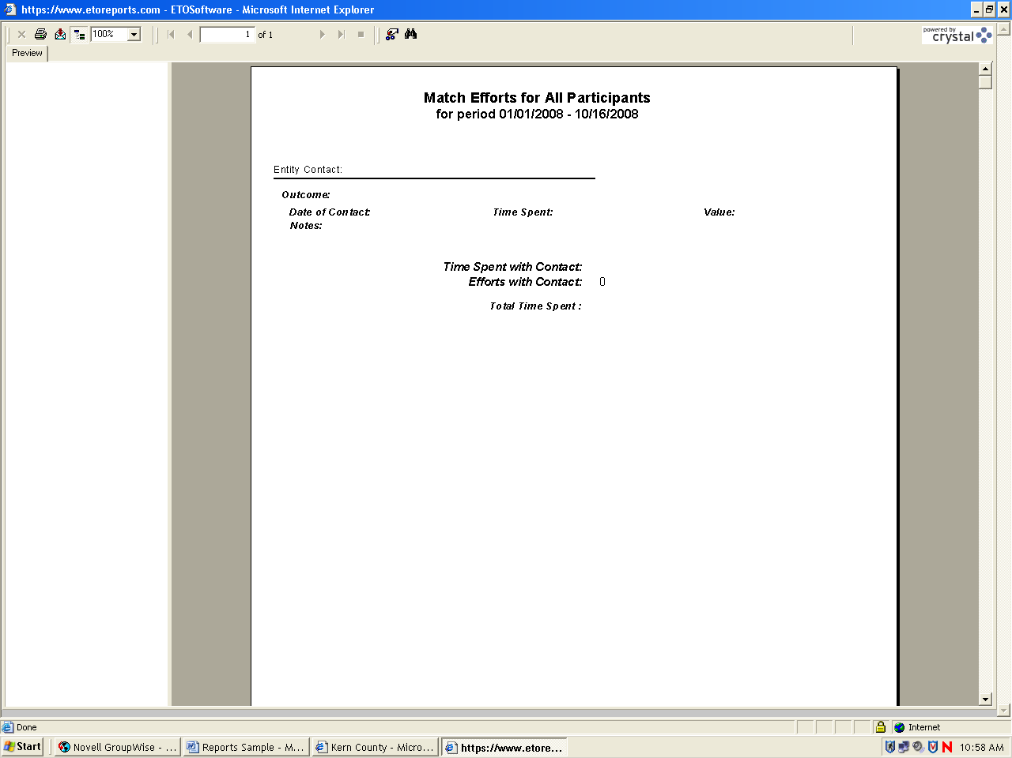

Families and their members report: This report shows all families in a site, and by clicking on the family, all family members with head of household, DOB and SSN notes.

Click on Right side Navigation Bar
Click on Reports
Click on Standard Reports

Look under “Family/Group Reports” and click on the “Families and their members”

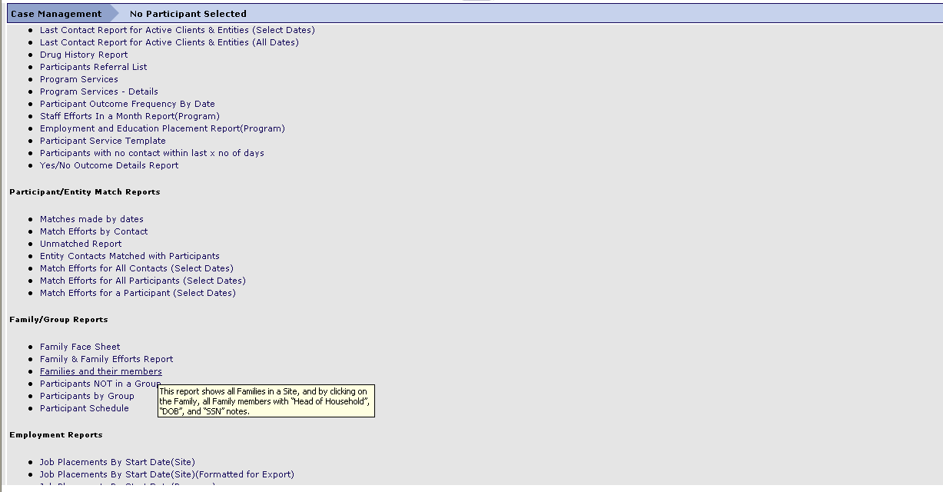

Example of actual family report

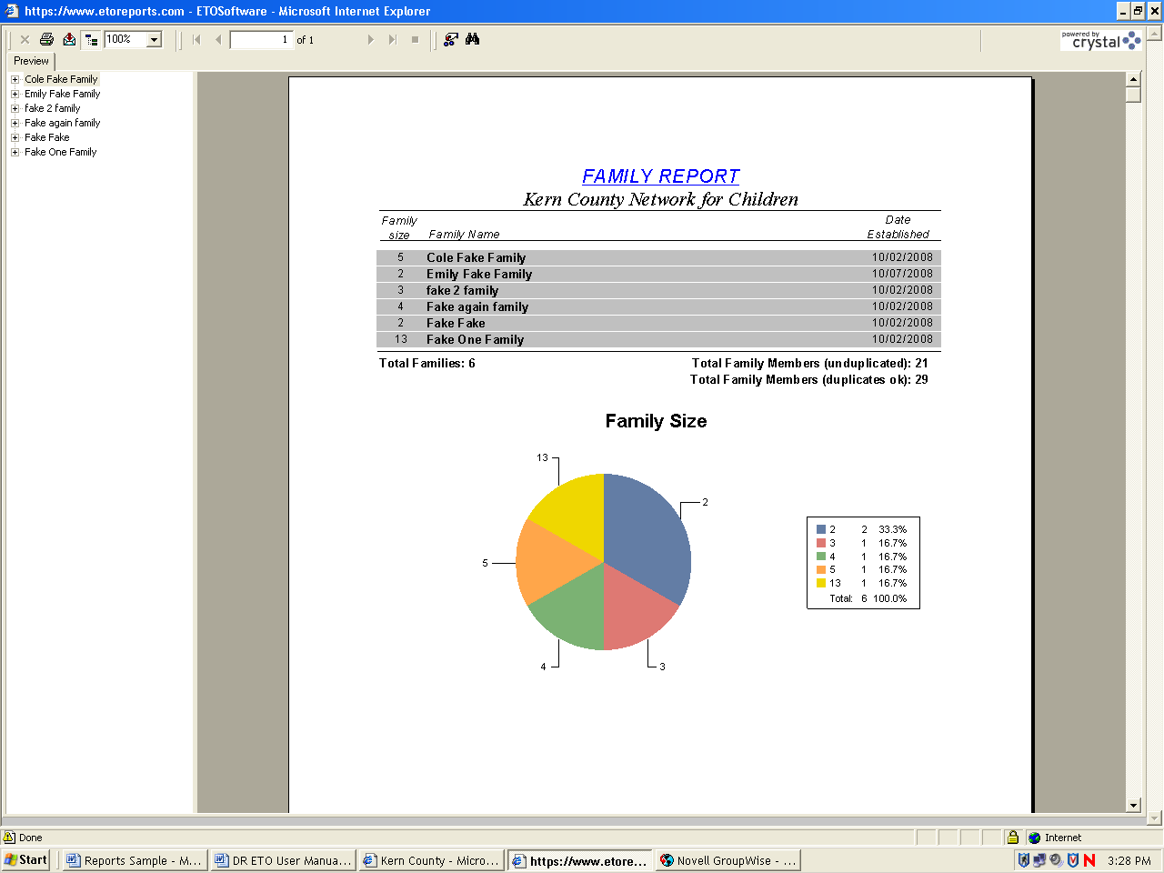

If you click on a certain family name then you will be able to view all family members that are in the family.

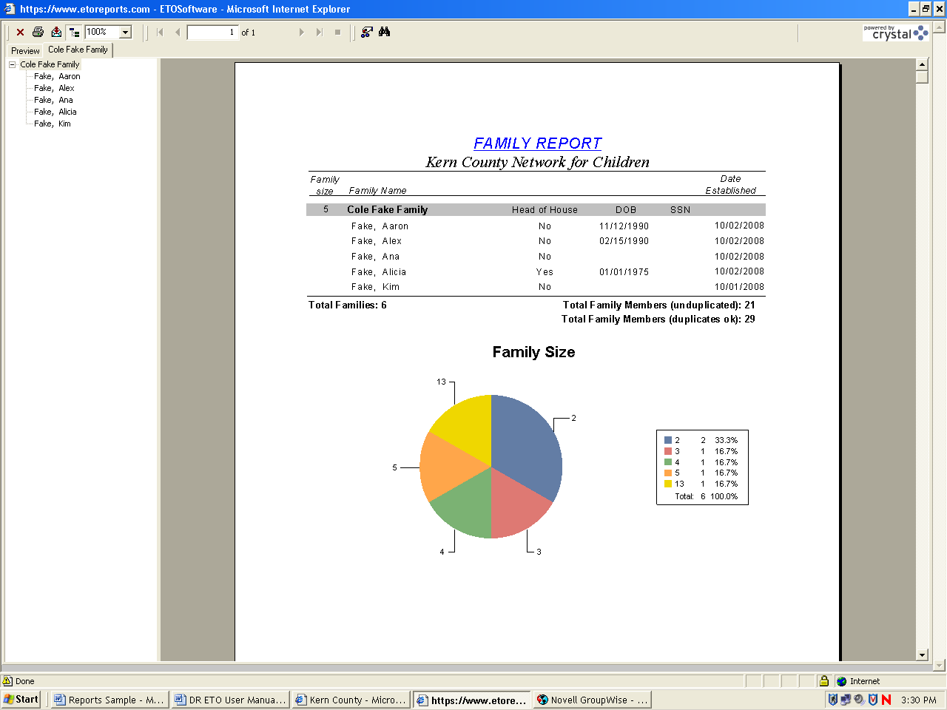

Supervisor Reports

Supervisor reports are created to help supervisors verify if data is accurate, participant outcomes and staff performance.

Participants Referral List: This report provides a list of all entities to which you have referred participants in a specified date range. By clicking on entity’s name, you will see the names & information of those referred to that particular entity.

Click on Right side Navigation Bar
Click on Reports
Click on Standard Reports

Look under “Participant service reports” and click on the “Participant referral list”

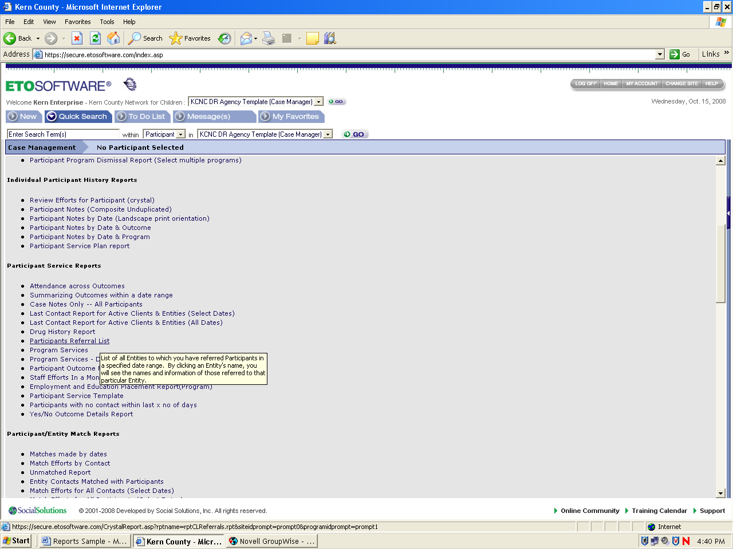

Select Dates and click on submit

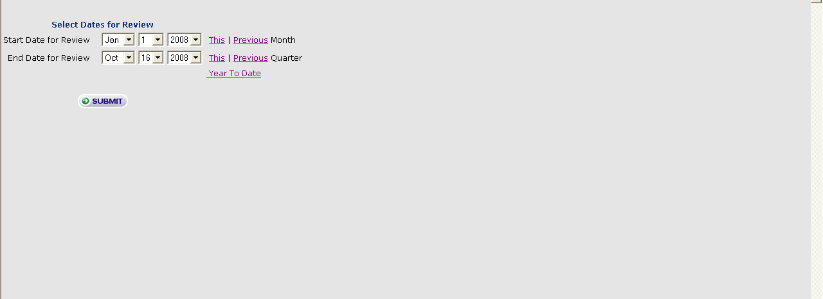

Example of actual participant referral list

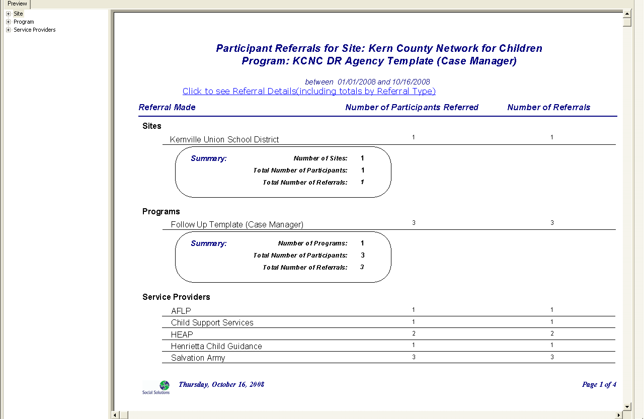

Participant list for (your site): This report generates a list of all participants in your site, including: address, city, state and zip code.

Click on Right side Navigation Bar
Click on Reports
Click on Standard Reports

Look under “Intake Reports” and click on the “Participants list for (your site)”
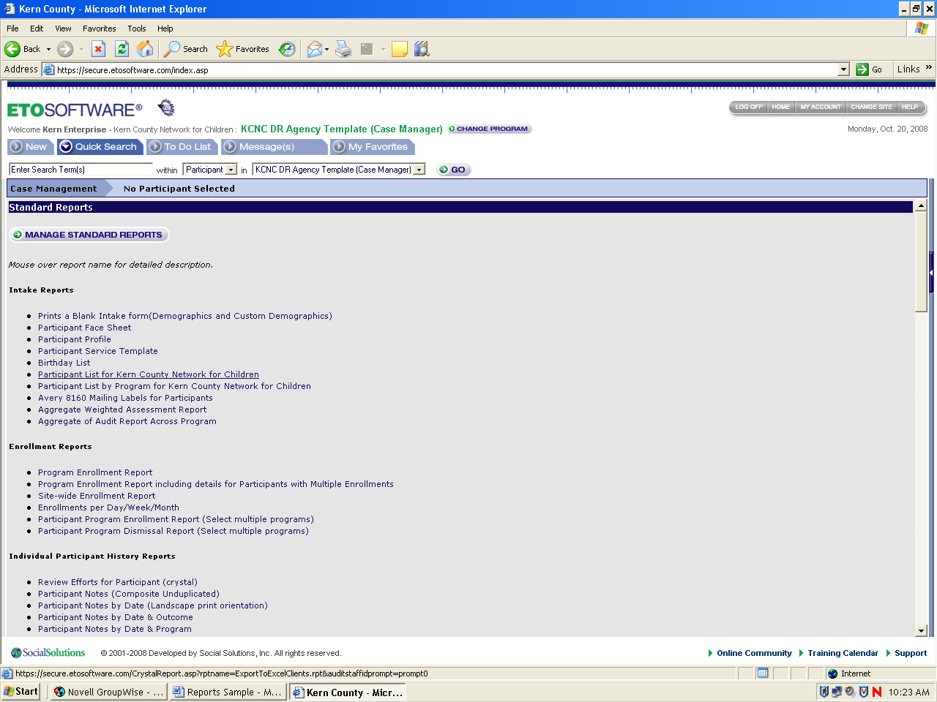

Example of actual list of participants for your site

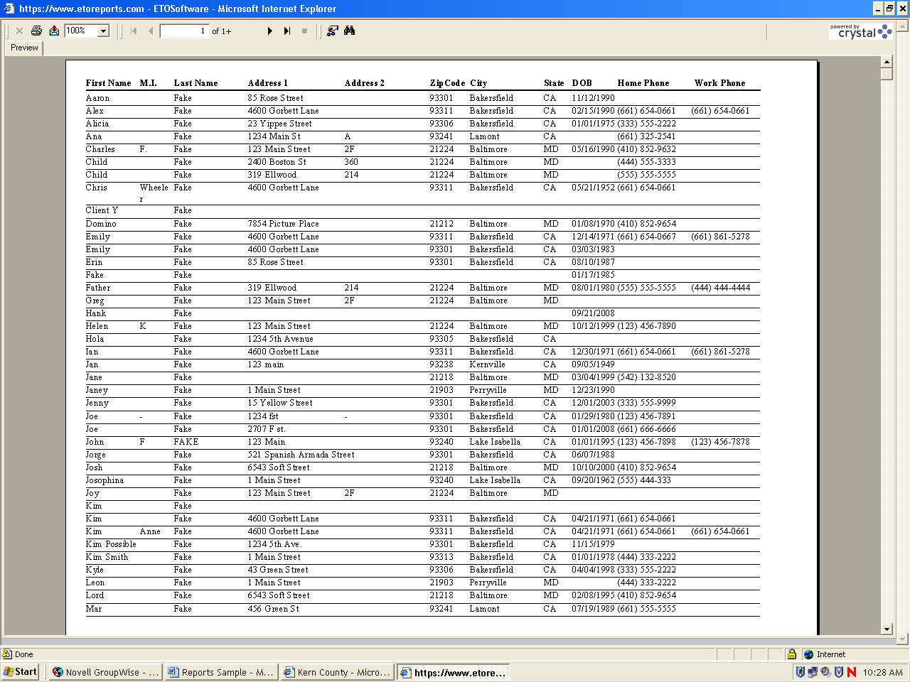

Site-wide enrollment report: Shows active, and dismissed participants by selected dates. Also shows charts that can be clicked on for further information.

Click on Right side Navigation Bar
Click on Reports
Click on Standard Reports

Look under “Enrollment Reports” and click on the “Site-wide enrollment report”

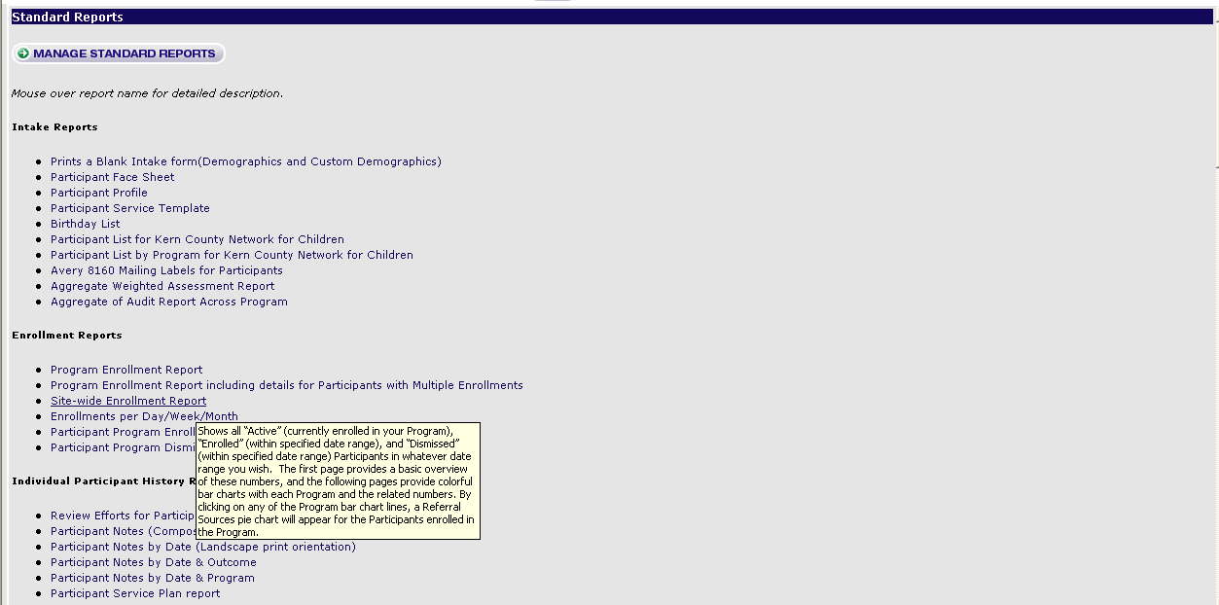

Select Dates and click on submit
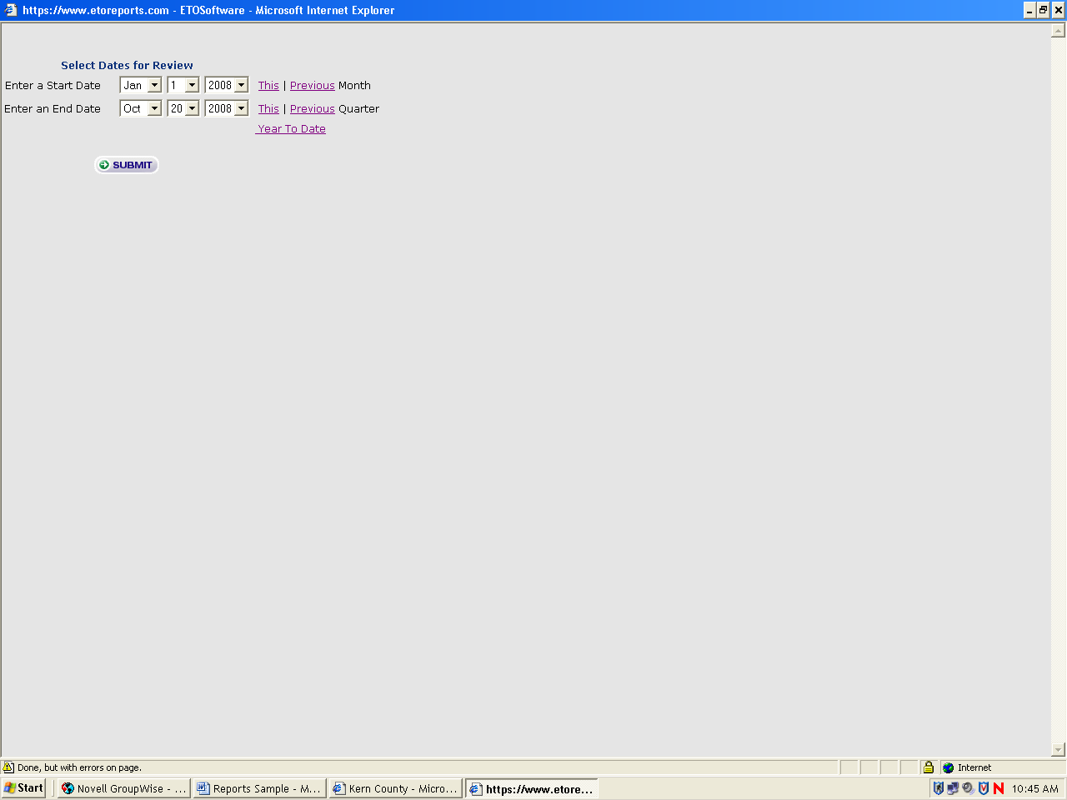
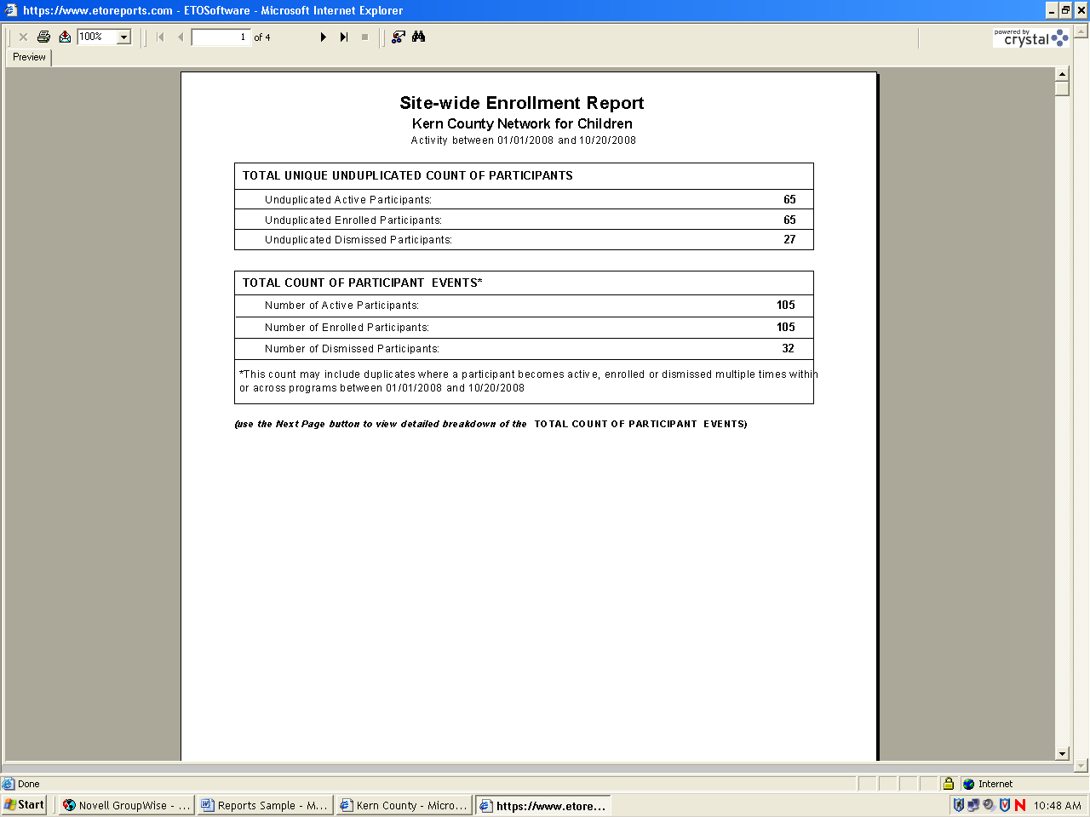
Actual report of site-wide enrollment

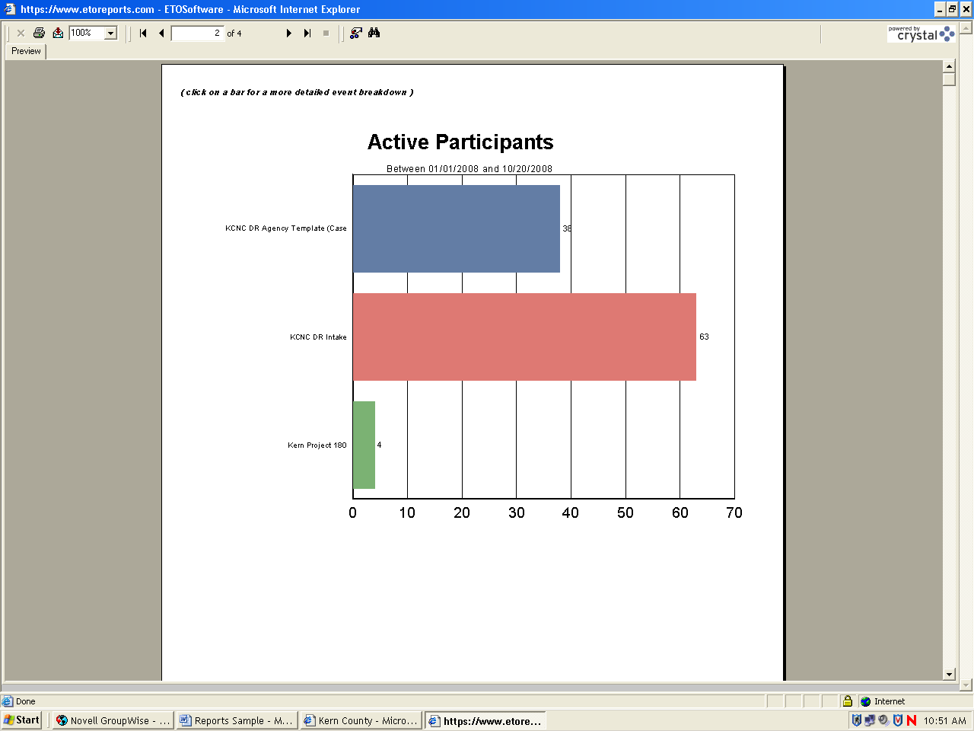

Staff efforts site: Allows you to look at each authorized user (below your authorized level) in the software to review their efforts toward outcomes.

Click on Right side Navigation Bar
Click on Reports
Click on Standard Reports

Look under “Staff Management Reports” and click on the “Staff efforts (site)”

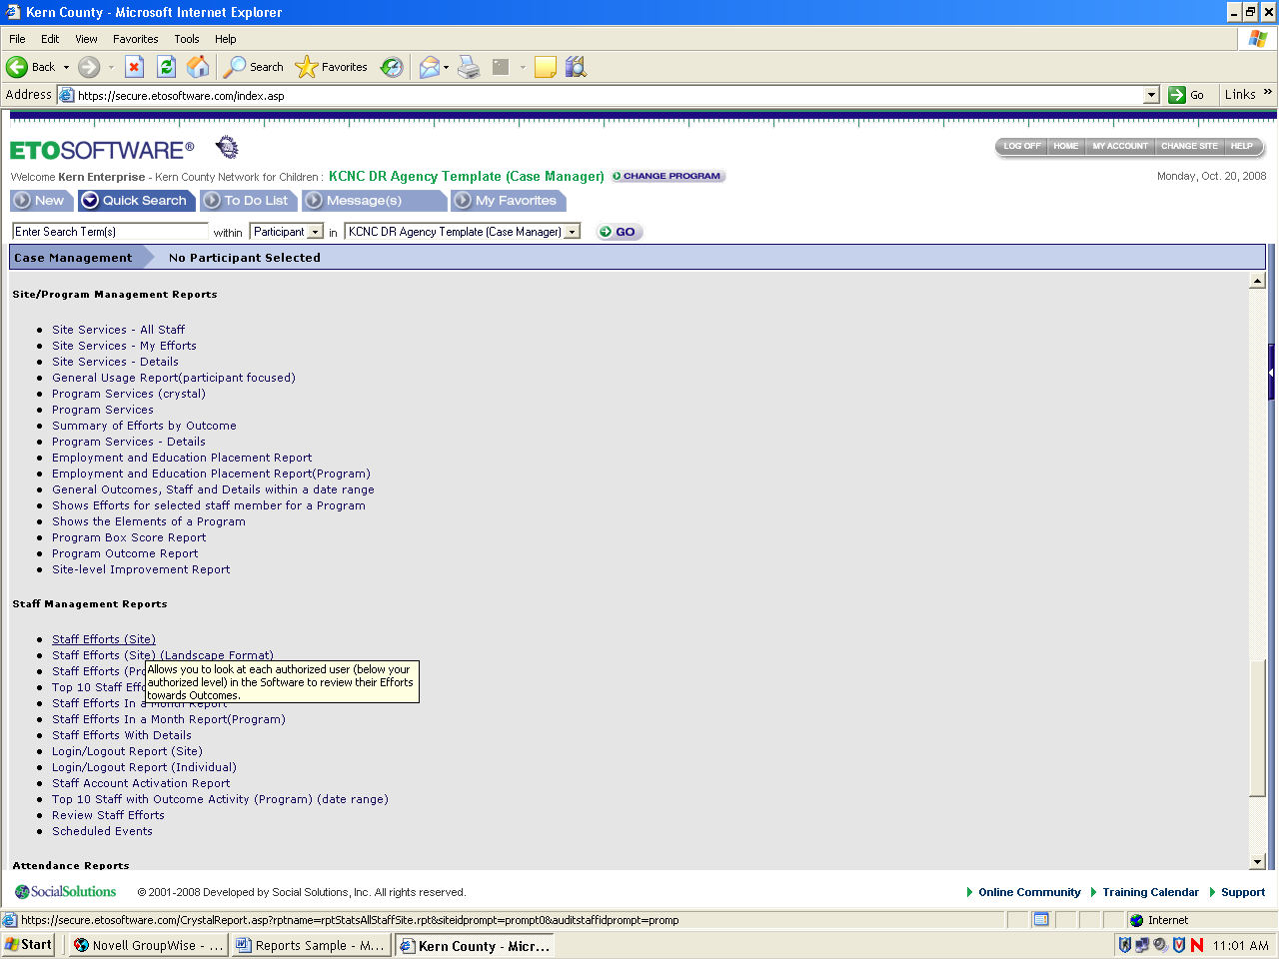

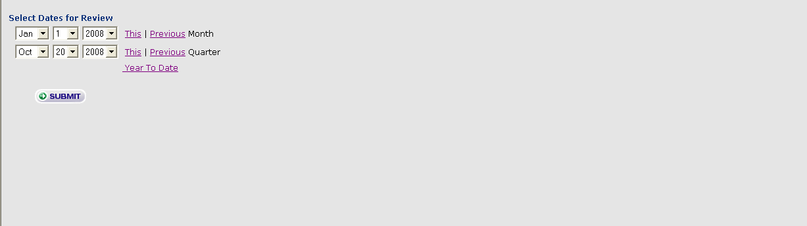
Select dates and click on Submit

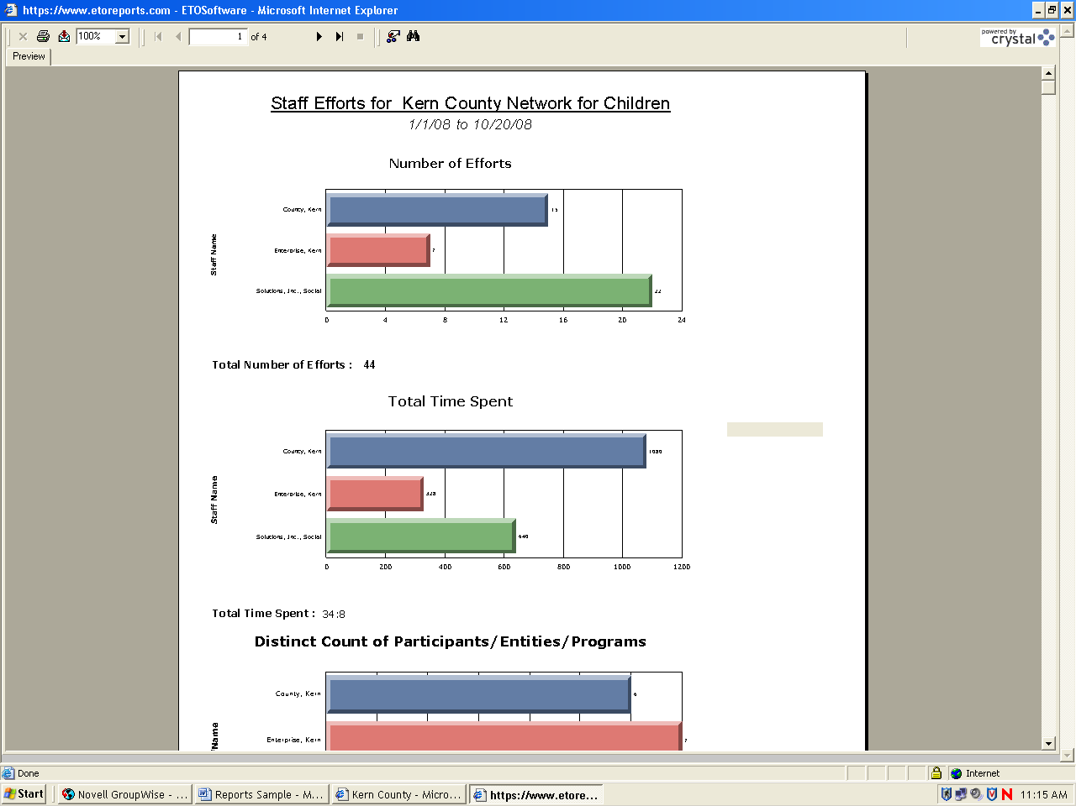
Actual report of staff efforts

Compare weighted assessment: Allows you compare assessments

Click on Right side Navigation Bar
Click on Reports
Click on Assessment Reports
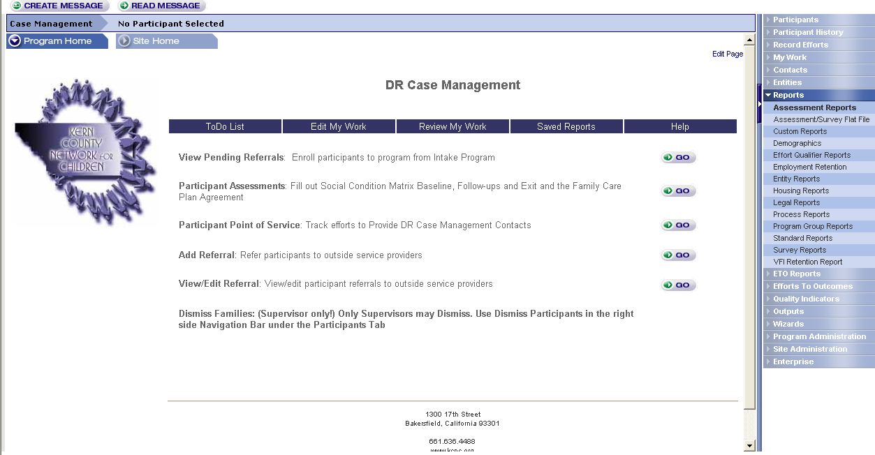

Look under “View compared assessment reports” and click on the “Compare weighted assessment”
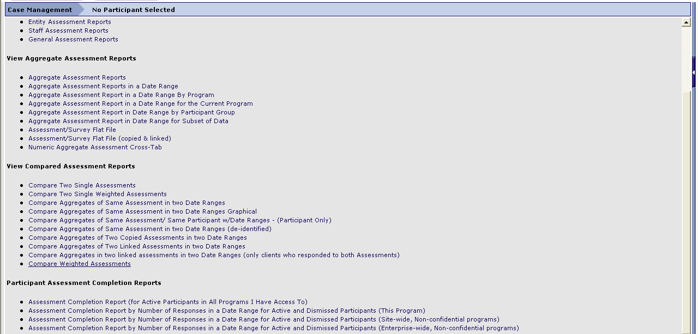

Select assessment reports and click on submit

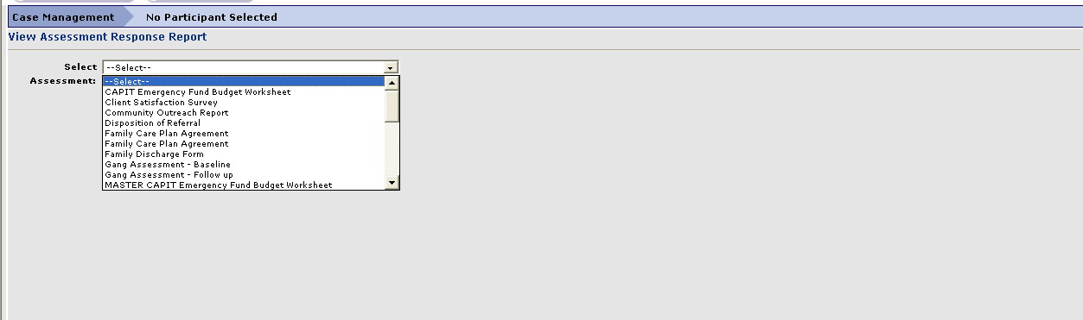

Select date range and click on submit

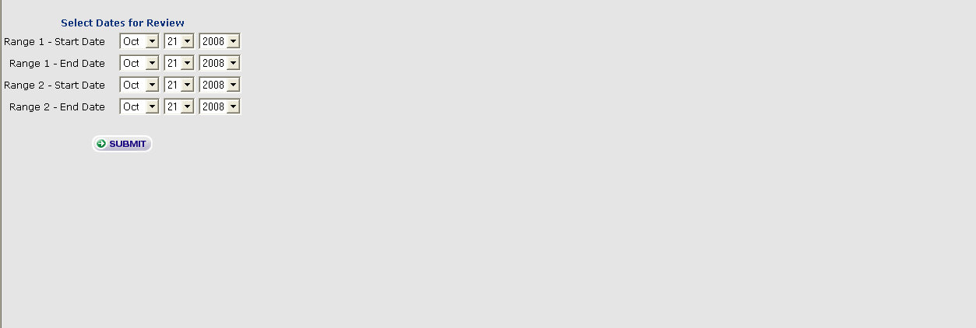

Example of actual aggregate weighted report
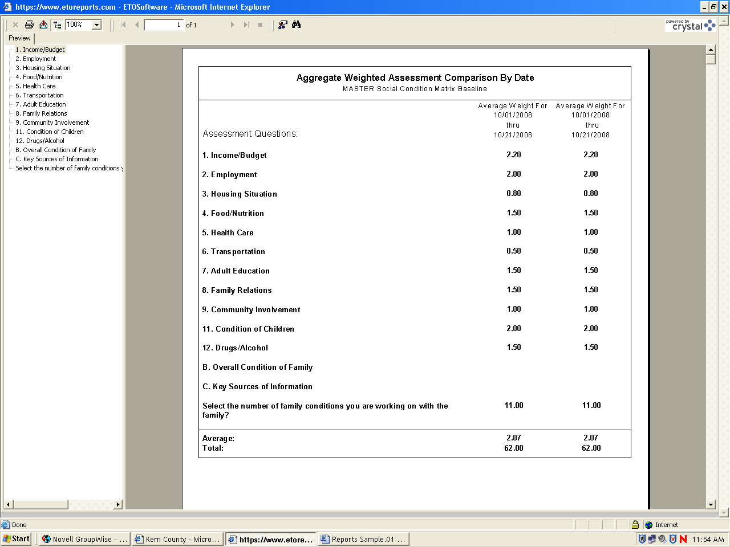

These types of reports primarily ensure that individuals are using the Software, and can be found on the Standard Reports page, below the Staff Management Reports header toward the bottom of the page. It is recommended that these reports are run weekly upon launch of the Software and monthly after Site Administrator is comfortable with compliance by all Staff.

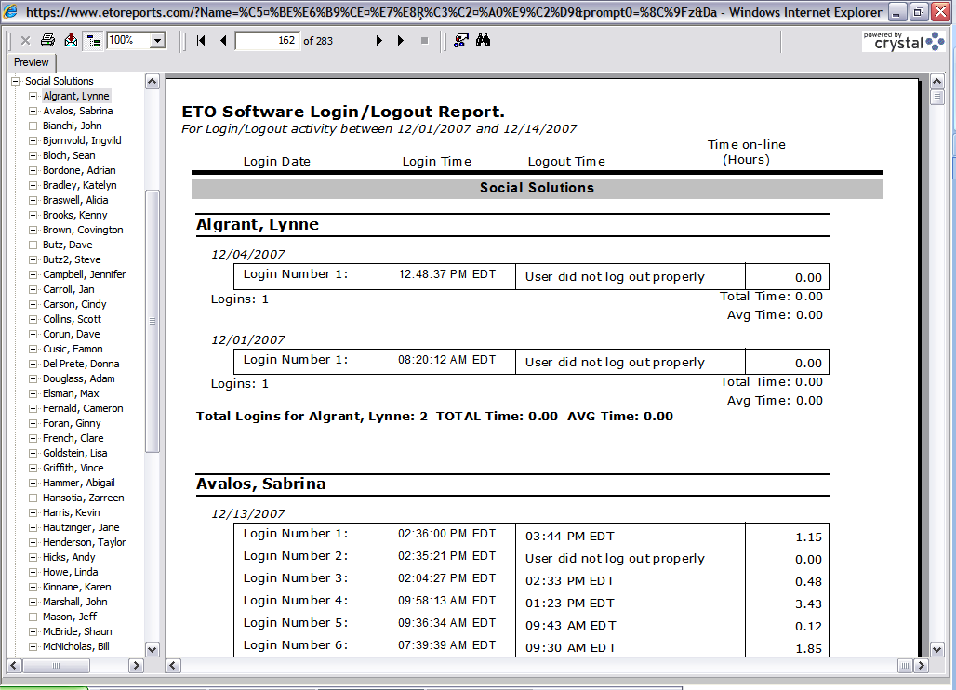
- Login/Logout Report: A very quick look at who is actually using the software and trying to log in- does not show today’s logins Reports→Standard Reports→Staff Management Reports section

- Staff Efforts (Site): A comparative analysis of how much work staff are documenting in ETO Software®. Page through the report to see details for Efforts, Assessments, Referrals, and Employment Placements. Reports→Standard Reports→Staff Management Reports section
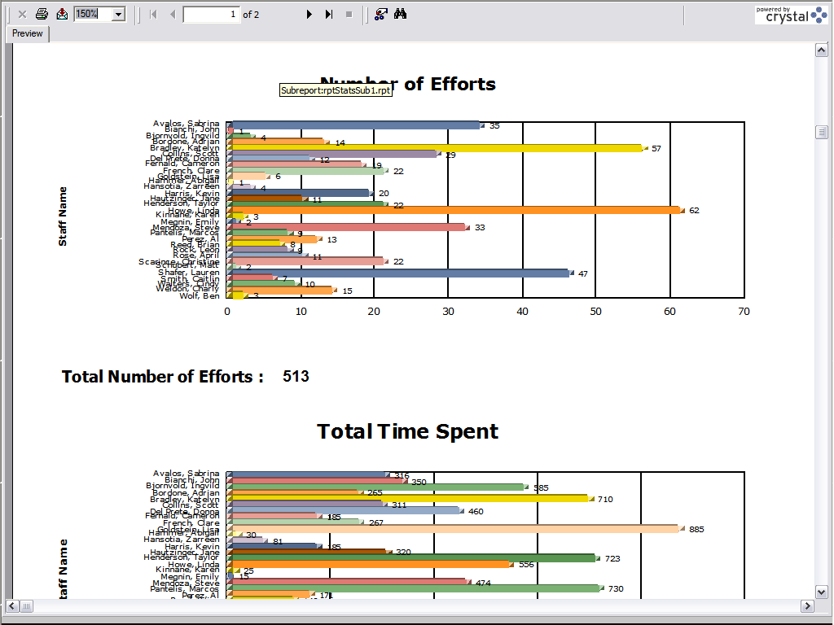

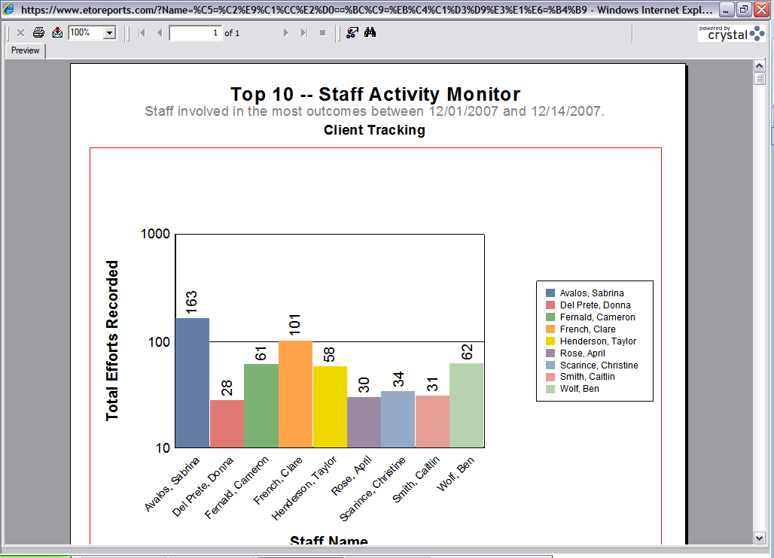
Top 10 Staff with Outcome Activity Report: A report, by program, of the people most frequently using the software. Reports→Standard Reports→Staff Management Reports section

- Staff Efforts in a Month: A very graphical look at the amount of entries staff are putting in through a given date range. Reports→Standard Reports→Staff Management Reports section
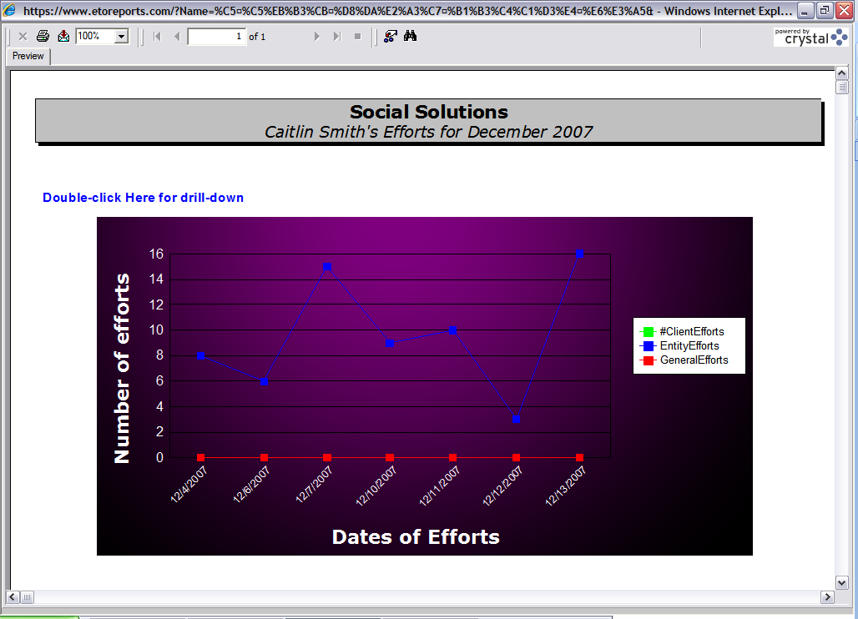

What are we recording in ETO Software?

- Review Staff Efforts: Similar to Review Participant Efforts, this is a comprehensive summary of all work completed by a staff person which can be expanded to allow a view of case notes. Administration→Review Staff Efforts

- Review Outcome Efforts: Similar to the Review Staff Efforts report but focused on a particular outcome Administration→Review Outcome Efforts

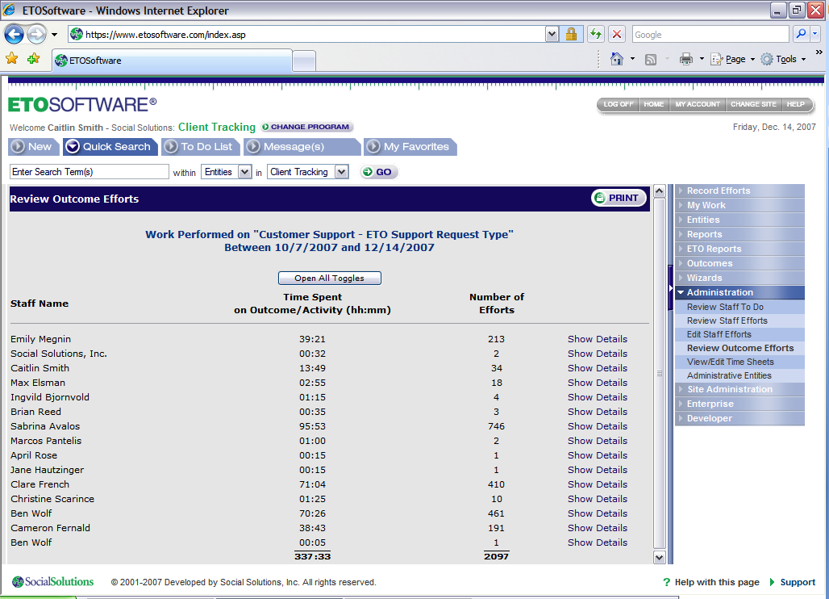

- Review Staff To Do List: Helps administrators to answer: Are staff using the software as a “daily use” tool? You can review your staffs’ to do lists directly from your own if you’d like. This functionality is turned on via the Manage Programs page. Administration→Review Staff To Do

It is recommended that these types of reports, which begin to lay the groundwork for actual analysis of the data, are run by management monthly. Meetings with Staff to resolve data quality issues should be centered around these reports.

How effective are we? How does our Effort relate towards our Outcome?

- ETO: Reports: Can be run for any given outcome- there are two versions, a “regular” and a Crystal version of the report. ETO Reports→Participant, Entity, or General, regular and Crystal for each

  - These reports run exceptionally well for Outcomes that were built to measure an increase or decrease on Step 4 of the Outcome Wizard.
  - Reports vary based on Outcome measurement (yes/no, yes/no attendance, numeric, values, hrs of attendance)
  - New Parameters Available on the Participant ETO Allow For More Advanced Reporting:
    - Select 1 or more Groups or Families
    - Select Date of Contact, or allow for all dates
    - Select a Program Start Date

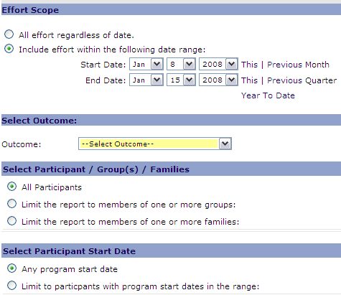

- An Individualized ETO Report that produces a line chart can be generated from the ETO Report link in the upper left corner of the Review Participant Efforts report. A line will only be generated for Outcomes that were built to measure an increase or a decrease. Participant History→Review Participant Efforts→link in the upper left corner “ETO Report”

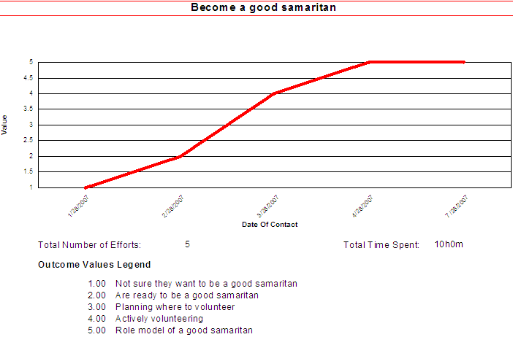

- ETO: Staff: Also known as the “box score report,” this ASP version of the report provides additional functionality that the Crystal version does not. These reports work best with Outcomes that were built to measure an increase or decrease. ETO Reports→ETO: Staff

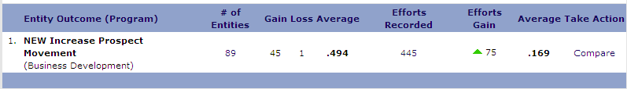

Click Compare:

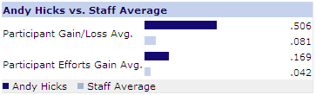

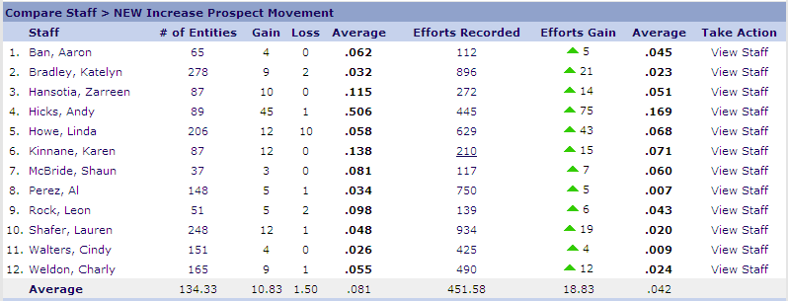

- ETO: Assessment: A brand new report that allows for “efforts” to be measured against outcomes that are being tracked on assessments. ETO Reports→ETO: Assessment

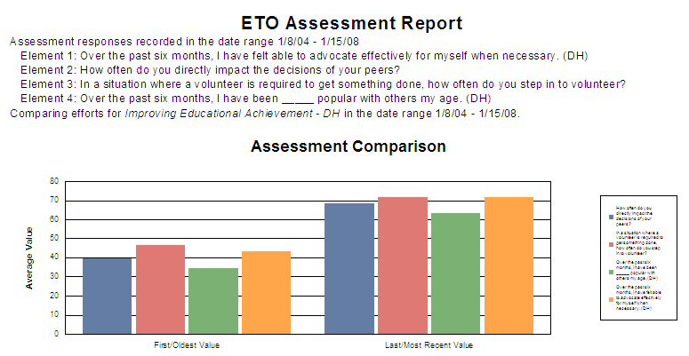
It is recommend that these reports are run monthly and/or quarterly, depending on the Outcome. These reports are most effective when they are compared against each other between time periods so that trends can be detected and analyzed.

Common/General Reports

Enrollment Reports
- Program Enrollment Report - This report allows you to show enrollments in any of your programs by date parameters you determine. The report includes the number of Participants enrolled, successfully completing the program, and dismissed, with a pie chart representing the “Reasons for Dismissals” from the Program.
- Site-Wide Enrollment Report - This report shows the unduplicated and duplicated number of Participants active, enrolled and dismissed across programs in the entire site. The unduplicated count includes the total number of Participants active, enrolled and dismissed, regardless of the number of programs the Participants were associated with. The duplicated numbers include the total number of Participants counted the number of times they were enrolled in each program.
- Participant Program Dismissal Report (Select Multiple Programs) - This report shows the participants enrolled in up to three programs during the date ranges selected for each. It includes enrollment and dismissal dates for each program.

Individual Participant History Reports
Participant Notes (Composite Unduplicated) - Displays all efforts for a given participant within a date range, including case notes. Composite outcome efforts are displayed together.

Participant Service Reports
a. Summarizing Outcomes Within a Date Range - Shows date of contact, time spent, contact method, outcome value and case notes by a selected outcome and date range. Includes summary of time spent and value for each participant and in total.
b. Case Notes Only --All Participants - Shows all notes made about Participants in all programs during a selected date range. This report is organized by program and participant. The report includes details like contact date, staff name, and outcome/employment details.
c. Last Contact Report for Active Clients and Entities (All Dates) - Displays the last, if any, contact with active Participants and entities on a selected outcome during all dates.
d. Program Services –
e. Staff Efforts in a Month Report (Program – This report shows the number of participant, entity and general efforts per day in a selected date range for individual staff.
f. Participants with no contact within last 90 days – This report shows all Participants in the program from which the report is run who have not had any contact within the last 90 days. It includes the last date of contact and outcome recorded for each of the Participants.

Site/Program Management Reports
a. Site Services – My Efforts – This real time report lists all participants who received services from you within a given date range, and includes number of outcomes, total efforts and time spent, with drill down details for each participant.
b. General Usage Report (participant focused) – This report shows all services provided by your site: enrollments, dismissals, efforts recorded, number of logins, entities added, entity efforts recorded, etc..

Staff Management Reports
a. Staff Efforts (Site) - This comprehensive report allows you to look at each authorized user (below your authorized level) in the Software to review their Efforts towards Outcomes.
b. Staff Efforts (Site) (Landscape Format) - This report is the same as the above, but at the program level.
c. Top 10 Staff With Efforts - This report shows the ten staff with the most participant or entity activity within a date range.
d. Login/Logout Report (Site)- This report shows Login’s and Logout’s for each staff member across your site for a selected date range. It also gives you the estimated time (in hours) each user was logged into the system and if they logged out properly.

Attendance Reports
a. Attendance Daily Report (Site)(date range) - This report consists of a grid showing the number of Participants who attended across the site by date and outcome within a selected date range.
b. Attendance Report (Site) - (days with no records shown as blank) – This report is like the one above, the only difference is that with the participants with no records for attendance will be shown as blank.

Assessment Reports
View Single Assessment Reports
- Print Blank Assessment or Survey - This is a printable version of a blank survey or assessment that you select.
- Participant Assessment Reports - This report will show any single assessment taken by any individual participant.
- Entity Assessment Reports - This report will show any single assessment taken by an individual entity.
- Staff Assessment Reports This report will show any single assessment taken by an individual staff member. This report is only available to site administrators.
- General Assessment Reports - This report will show any single general assessment.

View Aggregate Assessment Reports
- Aggregate Assessment Reports - This report provides a summary of all respondents’ answers to each question in the selected assessment, along with pie charts where appropriate. By clicking on any question, you drill down to the list of individual answers.
- Aggregate Assessment Reports in a Date Range - This report provides the same as the above, but only for participants in a selected date range.

View Compared Assessment Reports
- Compare Two Single Assessments - This report allows you to compare two single assessments taken by the same participant, family, entity or general. The comparison is only allowed between to of the same assessment taken at different times and two assessments that are build precisely the same way.
- Compare Two Single Weighted Assessments - This report allows you to compare two single weighted assessments taken by the same participant. The comparison is only allowed between two of the same assessments taken at different times and two assessments that are built precisely the same way.
- Compare Aggregates of Same Assessment in two Date Ranges - This report compares aggregates of the same assessment in two date ranges, and includes graphics where appropriate. You can drill down to the participants and their individual responses. The report is useful in cases where everyone takes the assessment at the same time, twice, such as at the beginning and end of the school year.
- Compare Aggregates of Same Assessment/ Same Participant w/Date Ranges - (Participant Only) - This report is the same as the above, but it includes only participants who took the assessment twice. Participants who took the assessment only once are excluded.
- Compare Aggregates of Same Assessment in two Date Ranges (de-identified) - This report is the same as the above, but the drill-down does not include participant names.
- Compare Aggregates of Two Copied Assessments in two Date Ranges - This report compares aggregates of the two copied assessments in two date ranges, and includes graphics where appropriate.
- Compare Weighted Assessments - This report allows you to compare two weighted assessments for a Participant.

