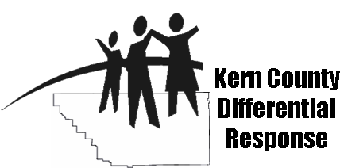
DR Client Satisfaction Procedures
2008-2009
Revised 8/14/2008

- The survey will be one page long with English on one side and Spanish on the other side.
- The survey will only be given to clients at every six months of case management services and at the close of their cases during their exit visit at the client’s home or the case manager/family advocate’s office.
- The client will be told that their responses to the survey will be anonymous and the results will be shared with program supervisors and staff for program improvement and funding purposes. The clients do not need to put their names on the survey.
- After receiving survey instructions from case manager/family advocate, the client will be given the opportunity to take the questionnaire in privacy. The client will be given a survey and a sealable envelope labeled with the program name, data clerk name, client identification number and program address.
- If the client is unable to read and/or write, the case manager/family advocate may complete a “face-to-face” interview using the survey. To make the client feel more at ease and honest in their answers, sites can choose to have another case manager or staff member conduct the “face-to-face” interview.
- The case manager/family advocate may only answer questions from the client to clarify survey questions.
- Once the survey is completed, the client will fold the survey, placed inside envelope, seal the envelope and give it to the case manager/family advocate. The case manager/family advocate will hand deliver envelope to data clerk to enter into an Excel database (please note: satisfaction survey database will be part of Social Solutions software).
- Once entered into database, data clerk will use the client ID number on envelope to return the satisfaction survey to the client’s case manager/family advocate so it can be filed in the client’s folder.
- Supervisors will only report satisfaction rates in the QPR to KCNC from those surveys received from closed cases during that reporting quarter. Spreadsheet will have summary tables at bottom that will report out satisfaction rates for each question. These summary tables can also provide data useful for program planning, needs assessments and grant applications.
- Supervisors will use for the satisfaction rate from the survey question, “Overall, clients satisfied with services received” for the QPR outcome "Families receiving case management will be satisfied with services at close of cases."
- Click print to print a table summary of the database information.
- At the end of the year, spreadsheet with total data will be sent to KCNC as part of their report to KCNC Governing Board and community (please note: Spreadsheet will be incorporated into Social Solutions software, once online, and sites will not longer need to send spreadsheet to KCNC.)

Option #1: Envelopes with pre-paid postage were discussed by DR Task Force as an option to protect client’s confidentiality, especially for outlying communities. This could be a financial challenge if implemented on a wide scale.

Option #2: To improve response rates, sites can offer an incentive for completed surveys. Along with the survey, clients will be given a coupon ticket to complete so their name can be entered into a drawing for a prize (e.g., gift card, children books, movie tickets, etc.). This could be a financial challenge for some sites.

