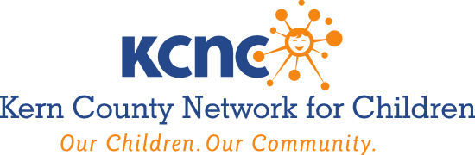

AGENDA
Wednesday, April 3, 2024
7:30 A.M. – 9:00 A.M.

Larry E. Reider Education Center
2000 ‘K’ Street, Bakersfield, CA
Room 204, 2nd Floor

- Roll Call, Member Updates & Public Announcements

- Approve Minutes of the December 6, 2023 Governing Board Meeting. Recommended Action – Review, Discuss and Approve

- Presentation of FY 2022-2023 County Children’s Trust Fund Annual Report. Recommended Action- Discuss, Receive, Approve, Receive and File

- FY 2024-2025 Agreements with Sub-Contract Providers: Authorize Executive Director to sign agreements, subject to approval as to form by County Counsel, for the provision of child abuse prevention services funded Promoting Safe and Stable Families (PSSF); Child Abuse Prevention, Intervention and Treatment (CAPIT); Community Based Child Abuse Prevention (CBCAP); First 5 Kern (F5K); County Children’s Trust Fund (CCTF); Families First Transition Act (FFTA); Child Welfare Services (CWS); County General Fund (CGF); CalWORKS Family Stabilization Services (FSS); and Families First Prevention Services Block Grant (FFPS) Funds for:
- Differential Response Central Hub - Clinica Sierra Vista $2,944,663.
- Parents As Teachers Central Hub - Henrietta Weill Memorial Child Guidance Clinic $870,796.
- Parents As Teachers Post Reunification - Henrietta Weill Memorial Child Guidance Clinic $478,364.
- Differential Response & Parents As Teachers East Hub - Clinica Sierra Vista $601,946 (DR); $478,364 (PAT) = $1,080,310.
- Behavioral Health, Mental Health Services - Henrietta Weill Memorial Child Guidance Clinic $348,153.
Total compensation amount will be $5,722,286. Recommended Action – Discuss, Approve, Receive and File.

- Dream Center Services / Program Update. Recommended Action – Discuss, Receive and File

- Foster Youth Services Coordinating Program Update. Recommended Action – Discuss, Receive and File

- Child Abuse Prevention Activities & Council Update. Recommended Action – Discuss; Receive and File

- Adjourn
Next Meeting: Wednesday, August 7th @ 7:30 A.M.

AMERICANS WITH DISABILITIES ACT (Government Code §54953.2)
Disabled individuals who need special assistance to attend or participate in a meeting of the Kern County Network for Children may request assistance at the Kern County Network for Children, 1801 19th Street, Bakersfield, California, or by calling (661) 636-4488. Every effort will be made to reasonably accommodate individuals with disabilities by making meeting material available in alternative formats. Requests for assistance should be made five (5) working days in advance of a meeting whenever possible.

