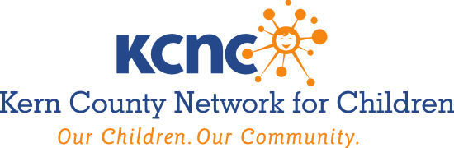

AGENDA
Wednesday, August 2, 2023
7:30 A.M. – 9:00 A.M.

Larry E. Reider Education Center
2000 ‘K’ Street, Bakersfield, CA
Room 101, First Floor

- Roll Call, Member Updates & Public Announcements

- Minutes of the April 5, 2023 Governing Board Meeting. Recommended Action – Discuss and Approve

- Approve the Nomination of John Mendiburu to fill vacant KCNC Officer Position of KCNC Board Treasure. Recommended Action – Discuss and Approve; Receive and File

- 2023 KCNC Leadership Class Graduates to present their Community Projects. Recommended Action – Discuss; Receive and File

- Report Out On The Restructuring of the FY 2023-2027 Differential Response Services and Parent As Teachers Countywide. Recommended Action – Discuss, Receive and File

- Families First Prevention Services Act Comprehensive Planning Process Update.
Recommended Action – Discuss, Receive and File

- Parent Advisory Board Update. Recommended Action – Discuss, Receive and File

- Dream Center Update. Recommended Action – Discuss, Receive and File

- Foster Youth Services Coordinating Program Update. Recommended Action – Discuss, Receive and File

- Child Abuse Prevention Activities & Council Update. Recommended Action – Discuss; Receive and File

- Adjourn

Next Meeting: Wednesday October 4, 2023 @ 7:30 A.M.

AMERICANS WITH DISABILITIES ACT (Government Code §54953.2)
Disabled individuals who need special assistance to attend or participate in a meeting of the Kern County Network for Children may request assistance at the Kern County Network for Children, 1801 19th Street, Bakersfield, California, or by calling (661) 636-4488. Every effort will be made to reasonably accommodate individuals with disabilities by making meeting material available in alternative formats. Requests for assistance should be made five (5) working days in advance of a meeting whenever possible.

