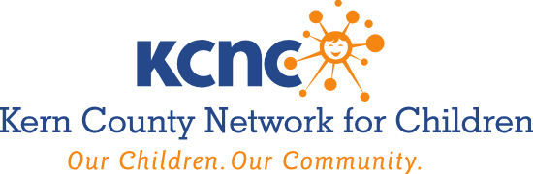

AGENDA
Wednesday, August 3, 2022
7:30 A.M. – 9:00 A.M.

Larry E. Reider Education Center
2000 ‘K’ Street, Bakersfield, CA
Room 101, 1st Floor

- Roll Call, Member Updates & Public Announcements

- Minutes of the April 6, 2022 Governing Board Meeting. Recommended Action – Discuss and Approve

- Approve the Nomination of Lito Morillo to fill vacant KCNC Officer Position of KCNC Board Secretary. Recommended Action – Discuss and Approve; Receive and File

- Approve the Nomination of Brynn Carrigan to fill vacant KCNC Officer Position of Vice President. Recommended Action – Discuss and Approve; Receive and File

- Approve $109,271 Increase in Compensation for FY 2022-2023 Agreement Henrietta Weill Memorial Child Guidance Clinic (HWMCGC) to provide Parents As Teachers (PAT) Evidence Based Practice Post Reunification Services: Authorize Executive Director to Execute Amended Agreement Subject to Approval as to Form by County Counsel. Total Compensation Amount will be $426,825 for HWMCGC. Recommended Action – Approve; Authorize Executive Director to Sign; Receive and File

- Overview The California Community Schools Partnership Program (CCSPP) and Ways KCNC Governing Board Agencies can Support Schools’ Efforts to Partner with Community Agencies and Local Government to Improve Outcomes for Students Presented by Superintendent Mary Barlow, Ed.D., and Associate Superintendent John G. Mendiburu, Ed.D., Kern County Superintendent of Schools. Recommended Action – Discuss, Receive and File

- Presentation of California’s Pre-K For All. Planning for Universal Transitional Kindergarten (UTK) Presented by Lisa Gilbert, Ed.D., Deputy Superintendent, Kern County Superintendent of Schools. Recommended Action – Discuss, Receive and File

- Approve KCNC Governing Board to serve as the Advisory Body for HWMCGC’s PAT program. Recommended Action – Discuss and Approve; Receive and File

- Families First Prevention Services Act Comprehensive Planning Process Update.
Recommended Action – Discuss, Receive and File

- Parent Advisory Board Update. Recommended Action – Discuss, Receive and File

- Dream Center Update. Recommended Action – Discuss, Receive and File

- Foster Youth Services Coordinating Program Update. Recommended Action – Discuss, Receive and File

- Child Abuse Prevention Month Activities & Council Update. Recommended Action – Discuss; Receive and File

- Adjourn

Next Meeting: Wednesday October 5, 2022 @ 7:30 A.M.

AMERICANS WITH DISABILITIES ACT (Government Code §54953.2)
Disabled individuals who need special assistance to attend or participate in a meeting of the Kern County Network for Children may request assistance at the Kern County Network for Children, 1801 19th Street, Bakersfield, California, or by calling (661) 636-4488. Every effort will be made to reasonably accommodate individuals with disabilities by making meeting material available in alternative formats. Requests for assistance should be made five (5) working days in advance of a meeting whenever possible.

