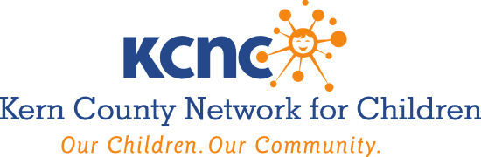

AGENDA
Wednesday, February 2, 2022
8:00 – 9:00 A.M.
Join Zoom Meeting
https://kcsos.zoom.us/j/98279099378
Meeting ID: 982 7909 9378
(Access via Videoconference / Teleconference)

- Roll Call, Member Updates & Public Announcements

- Minutes of the December 1, 2021 Governing Board Meeting
Recommended Action – Discuss and Approve.

- The KCNC Board due to AB 361 Brown Act Modifications Will Continue to Meet Virtually
- Reconsider the circumstances of the state of emergency; and
- Finds that either of the following circumstances exist:
  - The state of emergency continues to directly impact the ability of the members to meet safely in person; or
  - State or local official continue to impose or recommend measures to promote social distancing.
Recommended Action – Discuss and Approve.

- Overview of California State Board Education California Schools Partnership Program Recommended Action - Discuss; Receive and File.

- KCNC Lessons Learned During a Global Pandemic
Recommended Action - Discuss; Receive and File.

- Dream Center Update and Briefing on Current Trends of Youth At-Risk of Homelessness. Recommended Action – Discuss, Receive and File.

- Foster Youth Services Coordinating Program Update.
Recommended Action – Discuss, Receive and File.

- Child Abuse Prevention Council Update.
Recommended Action – Discuss; Receive and File.

- Adjourn

Next Meeting: Wednesday, April 6, 2022 @ 8:00 A.M.

AMERICANS WITH DISABILITIES ACT (Government Code §54953.2)
Disabled individuals who need special assistance to attend or participate in a meeting of the Kern County Network for Children may request assistance at the Kern County Network for Children, 1801 19th Street, Bakersfield, California, or by calling (661) 636-4488. Every effort will be made to reasonably accommodate individuals with disabilities by making meeting material available in alternative formats. Requests for assistance should be made five (5) working days in advance of a meeting whenever possible.

Kern County Network for Children Governing Board Meeting Council Public Meeting Protocol and Instructions for providing Public Comment during Council Meetings due to Coronavirus (COVID-19) Pandemic.
On March 18, 2020, Governor Gavin Newsom issued Executive Order N-29-20 (https://www.gov.ca.gov/wp-content/uploads/2020/03/3.17.20-N-29-20-EO.pdf), which includes a waiver of Brown Act provisions requiring physical presence of the Governing Board members or the public to attend and participate at Board meetings in light of the COVID-19 pandemic.
The County of Kern hereby provides notice that as a result of the declared federal, state, and local emergencies due to the COVID-19 pandemic, and in light of the Governor’s order, this Kern County Network for Children meeting will not be physically open to the public. You may observe the meeting and address the Board via email or telephonically as outlined below. Consistent with the Executive Order, Board members will attend the meeting by videoconferencing and or telephonically and participate in the meeting to the same extent as if they were physically present.
Based on guidance from the California Governor’s Office and Department of Public Health, as well as the County Health Officer, in order to minimize the potential spread of the COVID-19 virus, the meeting will be held via videoconferencing. The meeting agenda, documents and instructions for members of the public to comment on items can be accessed at https://kern.org/kcnc/

