PROGRAM REQUIREMENTS

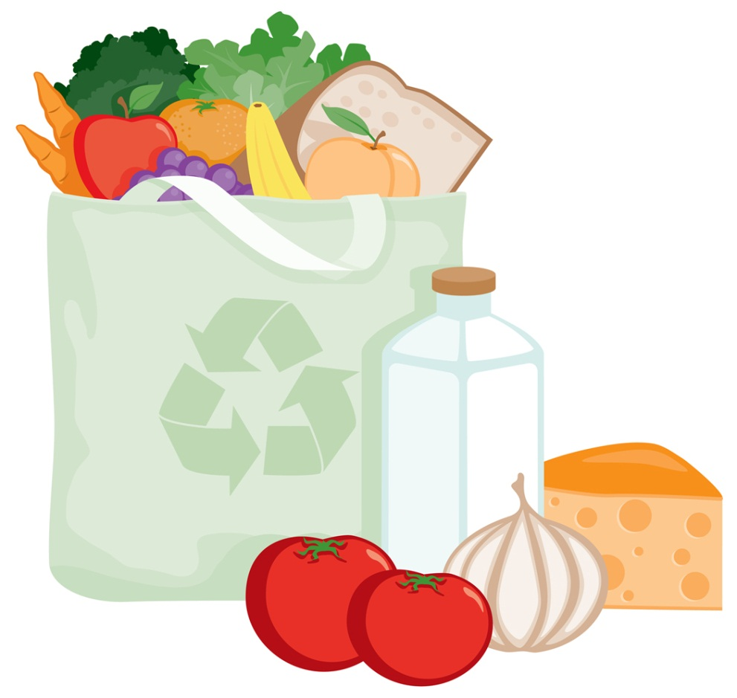
Service Styles

The two meal service styles that can be used in CACFP are pre-portioned and family style. Pre-portioned means that the minimal requirement (or more) of food for each required component is prepared by an adult and given to each child on a plate or tray.

Family style meal service means that the food is placed on each table for each child to help him/herself. Children may then select the foods they want and the amount of each food they want.

During your review, you must ensure that minimum portions (or more) of each required component for all children are available for the children at the table. During the meal, it is the responsibility of the provider to encourage each child to accept the full required portion for each food component of the meal pattern. For example, if a child does not want a food component, or does not want the full required portion of a meal component, the provider should offer the food component to the child again. If minimum portions are not available to each child, the meals would be disallowed [7 CFR §226.20(p) and FNS Instruction 783-9, Rev. 2].

The Division of Responsibility

- The parent/adult is responsible for what, when, where.
- The child is responsible for how much and whether.

Fundamental to parent’s/adult’s job is trusting children to determine how much and whether to eat from what parents provide. When adults do their jobs with feeding, children do their jobs with eating:

Parent’s/Adult’s feeding jobs:
- Choose and prepare the food.
- Provide regular meals and snacks.
- Make eating times pleasant.
- Step-by-step, show children by example how to behave at family mealtime.
- Be considerate of children’s lack of food experience without catering to likes and dislikes.
- Do not let children have food or beverages (except for water) between meal and snack times.

Children’s eating jobs:
- Children will eat.
- They will eat the amount they need.
- They will learn to eat the food their parents eat.
- They will grow predictably.
- They will learn to behave well at mealtime.

Young children need nutritious food at frequent intervals. Serving food frequently keeps children from becoming overtired and irritable. However, it is important to allow sufficient time between meals and snacks.
Pleasant eating experiences are as important as nutritious foods. They provide pleasant associations with food and eating. Food habits and attitudes that form during the preschool years remain with most people throughout their life.

Introducing New Foods
- Introduce only one new food at a time. Offer a very small amount at first. Allow plenty of time for children to look at and examine the foods.
- If children turn down a new food, wait a few days and allow them to try it again.

Encouraging Good Eating Habits
- Encourage children to help by setting the table, bringing food to the table, or cleaning their own space after eating
- Let children do as much for themselves as they are able to do. First efforts may be awkward but should be encouraged.
- Children may be in no hurry to eat once the first edge taken off their hunger. They do not have adults’ sense of time. Urging them to hurry may spoil their pleasure in eating.
- Deemphasize the “clean plate” idea. Children may rebel if forced to eat unwanted food. Children may also learn to over eat if told too often to finish their meals.
- Children may go on food “jags” and eat two or three servings of one food at one meal. Given time they will settle down and eat a complete meal.
- Do not let children use food to gain attention, such as by refusing to eat or making special demands.

Water Availability in the CACFP

Throughout the day, including at meal times, water must be made available to children to drink upon their request, but does not have to be available for children to self-serve. While drinking water must be made available to children during meal times, it is not part of the reimbursable meal and may not be served in lieu of fluid milk.

Basic Meal Requirements

The child care food program meal requirements come from five food groups.

- MILK (fluid only)
- GRAINS, CEREALS & BREAD
- PROTEIN FOODS (Meats and meat alternates)

- VEGETABLES
- FRUITS

The minimum meal requirements for the food program are set by the United States Department of Agriculture (USDA). (CACFP Meal Pattern)

To be sure that your purchases will meet the basic minimum meal requirements for the food program, let’s look at each food group and at the foods within each group which were chosen by the USDA to meet food program requirements.

Food Safety and Sanitation

All providers participating on the CACFP must follow all safety and sanitation regulations while preparing and serving meals to ensure the health of the children in your care. Providers and children must wash their hands with soap and water: before preparing, handling or serving food; after toileting or changing diapers; before any food service activity (setting the table); before and after eating meals and snacks.

Pets (including caged animals or birds) should not be present in food preparation, food storage, and eating areas. All food preparation, food service and dining areas should be cleaned and sanitized between uses and before and after each meal

Milk

Milk and dairy products help provide calcium and protein, which are important to growing bones. Fluid, not powdered milk products have been chosen by the USDA as the only food from the milk and dairy group which can be used to meet minimum food program requirements. In order to meet the milk requirement, Infants under one year have different meal requirements (refer to infant section).

Children 12 months (1 year) thru 24 months (2 year) old may only be served unflavored whole milk.

Children 2 years of age or older, who are enrolled in the CACFP, may only be served fat-free (skim) milk, also called non-fat milk, or low-fat (1%) milk. They may NOT be served reduced fat (2%) or whole milk.

This applies to any type of fluid milk (lactose reduced milk, lactose free milk, buttermilk, or acidified milk)

As before, liquid milk must be pasteurized and meet state and local standards

- Liquid milk must be served at breakfast, lunch and dinner (milk used in cooking, like in puddings, will not count toward the milk requirement).

- Breast milk or iron fortified infant formula must be served to infants under one year.

- Milk allergies for infants and older children must be verified by a physician’s statement to the program. The doctor must recommend a substitute.

Non-Dairy Beverages as Milk Substitutes
In the case of children who cannot consume fluid milk due to medical or other special dietary needs, other than a disability, the caregiver may serve non-dairy beverages in lieu of fluid milk. Non-dairy beverages must be nutritionally equivalent to milk and meet the nutritional standards for fortification of calcium, protein, vitamin A, vitamin D, and other nutrients to levels found in cow’s milk, as outlined in Title 7, Code of Federal Regulations, Section 210.10 (m)(3).
Parents or guardians may now request non-dairy milk substitutions in writing, as described above, without providing a medical statement. As an example, if a parent has a child who follows a vegan diet, the parent can submit a written request to the child’s caregiver asking that soy beverage be served in lieu of cow’s milk. The written request must identify the medical or other special dietary need that restricts the diet of the child. Such substitutions are at the option and the expense of the facility. This form is available from your monitor.

Grains, Cereal, and Bread

The Dietary Guidelines state that Americans currently consume too many refined grains and recommends that half of the total grains consumed should be whole grains. Whole grains offer a variety of vitamins and minerals, including magnesium, selenium, iron, zinc, B vitamins, and dietary fiber. Therefore, this final rule adopts the proposed requirement that at least one serving of grains per day must be whole grain-rich. This requirement will help children increase their intake of whole grains and benefit from the important nutrients they provide

This group of foods has great variety. There are many choices available at the local market and many good recipes for providers who bake. The bread group provides mainly carbohydrates (good for energy), but also contributes protein, some minerals and vitamins. Try to make half your grains whole grains, substitute a whole-grain product for a refined-grain product. For example, eat 100% whole-wheat bread or bagels instead of white bread or bagels, or brown rice instead of white rice.

Any food made from wheat, rice, oats, cornmeal, barley, or another cereal grain is a grain product. Bread, pasta, oatmeal, breakfast cereals, tortillas, and grits are examples. Grains are divided into two subgroups, whole grains and refined grains. Whole grains contain the entire grain kernel—the bran, germ, and endosperm. People who eat whole grains as part of a healthy diet have a reduced risk of some chronic diseases.

- Bread or an alternate must be served for breakfast, lunch and dinner.

- Breakfast cereals may contain no more than 6 grams of sugar per dry ounce and codifies the requirement under 7 CFR 226.20(a)(4)(ii).

- At least one serving of grains per day must be whole grain-rich. Foods that qualify as whole grain-rich are foods that contain a blend of wholegrain meal and/or whole grain flour and enriched meal and/or enriched flour of which at least 50 percent is whole grain and the remaining grains in the food, if any, are enriched; or foods that contain 100 percent whole grain.

- Choices from the bread group must be made with enriched or whole grain flour. Look for terms “enriched”, “whole wheat”, “enriched flour”, “stone ground wheat”, “medium or whole grain rye”, on the package label.

- Remember, potatoes are a vegetable, not bread.

- If you aren’t sure if something is in this group, don’t guess. Check the list, if it’s not there; call your monitor to be sure.

Deﬁnition of Whole Grain Rich

According to regulations, foods qualify as whole grain rich if they meet qualiﬁcations for both elements:

Element 1: A serving of the food item must meet portion size requirements for the Grains/Bread component as deﬁned in FNS guidance

Element 2:
The food must meet at least one of the following:
- The whole grains per serving (based on FNS serving sizes) must be ≥ 8 grams.
- The product includes the FDA-approved whole grain health claim on its packaging, which says “Diets rich in whole grain foods and other plant foods and low in total fat, saturated fat and cholesterol may reduce the risk of heart disease and some cancers.”
- Product ingredient listing lists whole grain ﬁrst, speciﬁcally:
- Non-mixed dishes (e.g., breads, cereals): Whole grains must be the primary ingredient by weight (a whole grain is the ﬁrst ingredient in the list)

The Whole Grain Stamp
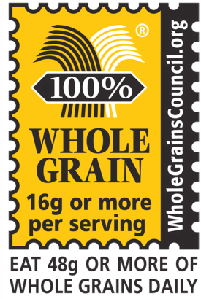
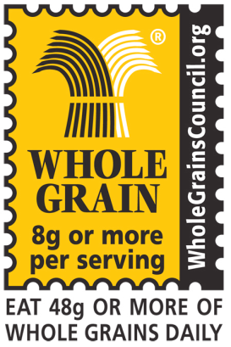

If a product bears the Whole Grain Stamp, it contains at least 8g (8 grams) – a half serving – of whole grain, but may also contain some reﬁned grain. Even if a product contains large amounts of whole grain (23g, 37g, 41g, etc.), it will use the Basic Stamp if it also contains extra bran, germ, or reﬁned ﬂour.
If a product bears the 100% Stamp (shown on left), then all its grain ingredients are whole grains. There is a minimum requirement of 16g (16 grams) – a full serving – of whole grain per labeled serving, for products using the 100% Stamp.

Sweet snack foods may not be served as part of any meal.
Please note this list is not exhaustive and only includes an example of sweets not allowed

- Sweet crackers (graham crackers – all shapes, animal crackers)
- Cookies (all types, including vanilla wafers)
- Pie crusts (dessert pies, cobblers, fruit turnovers)
- Doughnuts
- Granola bars, breakfast bars, cereal bars
- Sweet rolls
- Toaster pastries
- Cake
- Coffee cake
- Brownies

Ounce Equivalents: (implementation October 1, 2019)

According to USDA guidance, all grains offered are counted towards meeting the minimum grains requirements using ounce equivalent criteria. An ounce equivalent is the amount of food product that is considered equal to one ounce from the grain or protein food groups. An ounce equivalent for some foods may be less than a measured ounce if the food is concentrated or low in water content (e.g., nuts, peanut butter, dried meats, flour) or more than an ounce if the food contains a large amount of water (tofu, cooked beans, cooked rice, or cooked pasta).

The CACFP will adopt the same ounce equivalency requirements as the National School Lunch Program (NSLP). This will allow the CACFP to be consistent with other Child Nutrition Program’s (CNPs), by using ounce equivalents to determine the quantity of creditable grains Food and Nutrition Services (FNS) can ensure that the CACFP grains component requirement reflects current nutrition science.

FNS agrees that using ounce equivalents to credit the quantity of grains needed to meet the grains component requirement would increase consistency between CACFP and other CNPs, and that it is cumbersome to maintain two different grain serving size requirements. Furthermore, the Dietary Guidelines, USDA MyPlate Food Guidance System, and the National Academy of Medicine (NAM) report use ounce equivalents to determine the recommended intake for grains.

To ensure children and adults are served the recommended amount of grains, this final rule uses ounce equivalents to determine the minimum serving sizes for the grains requirement. FNS is mindful that this requires an operational change, including increasing the minimum serving size for ready-to-eat breakfast cereals, and CACFP operators will need time to become familiar with ounce equivalents and successfully comply with the new grains serving size requirements. Therefore, this final rule delays the implementation of the use of ounce equivalents to credit grains, and consequently the adjusted grain serving sizes, until October 1, 2019, two years after all other meal pattern requirements must be implemented.
Meat and Meat Alternates
(Protein Group)

Protein foods are important for children, since they help build and repair tissues; they are especially needed during the growing years.

There are many ways to meet the protein requirement for the program. One is by serving meats, and another is by using meat alternates. Red meats are high in fats and are also one of the most expensive choices in this group. So when you think of protein choices, remember that poultry, cottage cheese and eggs are all less expensive and sources of high quality proteins.

Since this group is so important, a serving is required for lunch and dinner meals. It is also a possible selection at snack time and an encouraged “option” food for breakfast meals.

Types of food in the protein group include:

- red meats (all types)
- veal
- fish
- poultry
- dried beans or peas
- cottage cheese
- tofu
- lamb
- hard cheese
- peanut butter
- yogurt – must contain 23 grams or less of sugar per 6 oz. serving

Meat and meat alternates may be served in place of the entire grains component at breakfast a maximum of three times per week.

Vegetables and Fruits

Fruits and vegetables are an important part of any balanced diet. They contribute vitamins, some carbohydrates (quick energy) and fiber (roughage). Fruits and vegetables are a major source of vitamins. Vitamins are important since they help keep the skin healthy and smooth, help normal bone and tooth formation, maintain a healthy nervous system and help the body get energy from carbohydrates and fat. One of the best ways to get high quality vitamins is through fruits and vegetables; eaten in sufficient quantity and variety, there is no need for additional (and expensive) vitamin supplements.

Fruits and vegetables are in plentiful supply year round. They are delightful and nutritious fresh, raw, canned or cooked.

Separate Vegetable and Fruit Components
Vegetables and fruits prepared without added solid fats, added sugars, refined starches, and sodium are nutrient-dense foods and, according to the Dietary Guidelines, are under consumed by Americans. In the updated CACFP meal pattern, there is now a separate vegetable component and fruit component at lunch, supper, and snack. This change means children are offered a serving of vegetables and a serving of fruit or a second different vegetable at lunch and supper (two fruits may not be served together. In addition, a snack with a vegetable and fruit in the appropriate minimum serving sizes is now reimbursable. Separate vegetable and fruit components will help increase the variety of vegetables and fruits served and consumed by children.
To increase flexibility in menu planning, providers may choose to serve two vegetables at lunch and supper, rather than a serving of vegetables and a serving of fruit. This means that the fruit component at lunch and supper may be substituted by an additional vegetable. The substituted vegetable must be at least the same serving size as the fruit component it replaced. To be consistent with the Dietary Guidelines’ recommendation that all Americans should eat a variety of vegetables, when two vegetables are served at lunch or supper, they must be two different kinds of vegetables. in lieu of fruit. Providers cannot serve two fruits at lunch or supper meals under the updated meal patterns.
Juice is permitted as a choice at snacks or breakfast only. A maximum of one serving (4 to 6 ounces for 1 to 6 year olds*) of 100% juice will be allowed per day.

All fruit and vegetable juices must be full strength (100% pure) juices; such as orange, apple, grapefruit, grape, and pineapple. If you are buying canned juices, check the label for the content of the juice. Frozen concentrates may be used if made according to the directions on the can.

Common Menu Problems

- A fruit/vegetable or juice must always be served at breakfast.

- Grains, cereal or bread is always served at breakfast, lunch and dinner. See the “grains, cereal or bread” list for ideas on what to serve.

- Potatoes are a vegetable. Rice, noodles, and pasta are bread alternates.

- Certain commercial or canned soups offer very little nutrition. Even the “chunky” types contain little meat. So, canned vegetable soups can only count towards meeting one component of the fruit/vegetable requirement when served in lunches or dinners.
- Processed foods: It is very difficult to determine the amount of bread, meat, fish, fruit or vegetable in commercially processed goods (i.e., pizza, chicken nuggets and fish sticks); therefore, these food items are not eligible for reimbursement unless a product analysis sheet (Child Nutrition or CN Label) is approved and on file with the CCCC/CCFP. These CN Labels (analysis sheets) must be obtained by the manufacturer of the food item or from the product packaging if provided.

- Homemade items: some foods which do not qualify for the program if they are bought in a store (commercially prepared) do count if they are homemade. An example is macaroni and cheese or beef soups.

- If the “identical” meal or snack is served more than once in the same day, to the same children it will be disallowed.

Infant Participation

All child care providers participating in a Child Nutrition Program (CNP) are required to offer at least one (house) infant formula which meets the definition of infant formula according to State and Federal guidelines, unless breast milk is being provided by the infant's mother.

If a parent or guardian declines the provider's offered formula and will furnish a formula that meets the CNP requirements for iron fortification and nutritional content, unless your doctor has prescribed a special formula. The parents must complete a formula declining form.

If a doctor's prescribed formula does not meet the CNP requirements, you must have a medical statement completed by a Medical Professional.

Solid Foods for Infants

Introducing Solids - Solid foods should not be introduced until the infant is developmentally ready when the child’s pediatrician advises the parent to start solid foods. Infant cereals, vegetables, fruits, and meats (often in that order) should be introduced gradually to infants as they are developmentally ready. Be sure to work closely with the infant’s parent in introducing new foods.

Texture and Consistency – The solids served should be appropriate for the child’s age. The first solids introduced at four months should be strained. Gradually increase the texture and consistency of food as the infant grows older.

Special diets – The infant Meal Patterns show the required kinds and amount of foods which must be served in the Child and Adult Care Food Program. The only exception is when the infant is on a special, modified diet prescribed by a physician. In that case, a statement of the prescribed diet, signed by the physician, must be on file.

There are age ranges given in the meal pattern to allow for flexibility in how much food is served to the baby, based on his or her appetite and development. The amounts listed are minimum portions required to meet the meal pattern requirements. Some babies may need more than these amounts. Babies can be served larger portions or additional foods.

To claim infants on the CCFP the provider must be providing the appropriate components for the infant on the food program including formula.

Food served should always be appropriate texture and consistency. Solid foods can be introduced gradually to infants who are developmentally ready.
The decision to introduce solid foods should always be made in consultation with the parents.

Babies may have small appetites. They may not be able to eat a complete meal at one time. Foods may be served over a period of time, rather than at one time. For example, the food items shown for lunch can be served at two or more feedings, perhaps between 12:00 noon and 2:00 p.m.

Breast Milk

Breast milk may be served as part of the infant meal pattern. Infants, mothers and child care providers benefit when infants are breastfed. Many mothers wish to continue breast feeding after they return to work. Providers can help mothers continue to breastfeed by letting them know that breastfeeding is a good idea and that they are happy to feed their babies’ breast milk.

Iron-Fortified Infant Formula

Iron-fortified infant formula is the best food for the baby when baby is not being breastfed or when a supplement to breastfeeding is needed. Commercially prepared iron-fortified infant formula is specially formulated to have the right balance of nutrients and to be easily digested by the baby.

Program rules require that formula be an iron-fortified infant formula, intended for dietary use as a sole source of food for normal, healthy infants served in liquid state at the manufacturer’s recommended dilution.

The formula label must state “with iron” or “iron fortified.” Formula labels which say “low iron” do not meet the meal pattern requirements. Low iron or other formulas may be served only as a dietary substitute when a note from a medical doctor or other recognized medical authority, requiring its use, is on file.

Preparing Formula

Follow the steps below when preparing formula for infants.

- Wash hands with soap and water.

- Wash all equipment (nipples, bottles, rings and caps) in hot soapy water and scrub with a brush.

- Rinse all equipment thoroughly in hot water.

- Put nipples, bottles, rings and caps in a pot with enough water to cover them.

- Boil for five minutes.

- Wash hands with soap and water.

- Wash the top of the formula can, then open.

- Pour formula for one feeding into each clean bottle.

- Put clean nipple on bottle and cover with snap-on cap.

It is preferable that cold tap water or bottled water be used in the preparation of infant formula. Using hot tap water in the preparation of formula may lead to a high risk of lead exposure. Severe lead exposure can cause coma, convulsions and even death in children. Lower levels of lead exposure can cause adverse effects on child’s central nervous system and kidney. Lower levels of lead exposure also have been associated with decreased intelligence, growth, stature, hearing and a difficulty in maintaining a steady posture.

Storing Formula and Breast Milk

- Refrigerate prepared bottles of formula for up to 24 hours.
- Open cans of formula should be covered, refrigerated and used within 48 hours.
- Expressed breast milk may be stored in the refrigerator or freezer in either sterilized bottles or disposable plastic nursing bags.
- Expressed breast milk will keep in the refrigerator for up to 48 hours or in the freezer for up to 2 weeks after the time it was collected. Be sure the milk is protected in an airtight container while in the freezer. Once the milk is thawed, do not refreeze.
- Portions of breast milk or formula remaining in the bottle after feeding should be discarded.

Warming Bottles

For babies who prefer a warm bottle, warm bottles of breast milk, formula or whole milk immediately before serving.

To thaw frozen breast milk, hold bottle under cool water to warm water. Shake bottle gently to mix. Do not refreeze breast milk.
Bottles may be warmed by setting them in a bowl of warm water or by holding under warm tap water. Test the temperature of milk or formula on the inner wrist before feeding to infants. If milk is too hot, wait a few minutes and repeat this test. Do not serve milk to infants that is too hot.

Never use a microwave to warm bottles. This practice is potentially dangerous for several reasons. Liquid in the bottle may become very hot when microwaved and get hotter after removing from the microwave even though the bottle feels cool. The hot liquid could seriously burn babies. Also microwaving can destroy some of the nutrients in breast milk. Covered bottles may explode when heated in a microwave.

Baby Foods

Purchasing Commercially Prepared Baby Foods

For babies 6 to 12 months of age, choose baby foods that increase in thickness and consistency to challenge the baby to learn new mouth skills.

To meet the meal pattern requirements, avoid combination foods or dinners because it is difficult to determine the amount of each component in combination foods. Also, they generally have less nutritional value by weight than single-ingredient foods and cost more than items purchased separately.

Read the ingredient list on the food label carefully. Avoid those with added fat, salt, sugar, modified cornstarch or modified tapioca starch.

Desserts, such as baby puddings, custards, cobblers and fruit desserts should be avoided because they are high in sugar. Babies do not need added sugar. They should be given the opportunity to eat naturally sweet foods, such as fruit.

Fruit juices are not creditable for infants through eleven months old.

Iron-fortified infant cereals must be provided until the infant turns one year of age. Other non-infant cereals can be served as additional foods.

Serving Commercially Prepared Baby Food

- Be sure the vacuum seal has not been broken before using. The jar should “pop” when opened.

- Do not use the baby food jar as a serving dish. Remove the amount of food as needed to feed the baby from the jar and put it in a dish for serving.

- Throw away any leftover food. Do not put it back into the jar because it could cause contamination.

- Once the jar is opened, store it in the refrigerator. Food should be used as soon as possible, but at least within two to three days.

Preparing Baby Food at Home

Preparing homemade baby food has several advantages. It is more economical and the provider can ensure the quality of the food.

Commercial baby foods may lack enough texture for the older baby. The texture can be modified when homemade baby food is prepared.

When preparing homemade baby food, follow these steps.

- Make sure hands, utensils; workspace and the food are all very clean.
- Begin with good quality food. Use fresh food whenever possible.
- Remove skins, pits and seeds from fruits and vegetables. Cut away all fat, gristle, skins and bones from meat poultry and fish.
- Cook foods until they are soft and tender. To minimize vitamin loss steam fruits and vegetables. Roast, simmer or braise meat.
- Modify the texture by mashing food with a fork, grinding with a food grinder or by pureeing in a blender.

Foods That Cannot Be Credited

Foods that cannot be credited toward the infant meal pattern include:
- Foods with water listed as the first ingredient
- Combination foods or dinners
- Baby desserts
- Fruit juice and juice drinks other than 100% fruit juice
- Vegetable juice
- “adult” cereals

Foods to Avoid or Limit

Some foods, which commonly cause allergic reactions in infants, should not be served during their first year. These include: chocolate, citrus fruits, egg whites, honey and shellfish.

Honey should never be served to infants because it may contain botulism spores. The spores can cause severe food poisoning. After digestive systems mature, honey can be tolerated.

Sugar and fat should not be added to infant foods to provide flavor. It is best for children to develop a liking for the natural flavors of foods.

Infants can choke on foods, such as frankfurter rounds, popcorn, grapes, peanut butter or nuts. Furthermore, foods should be cut length-wise, rather than in circles, to prevent choking.

Baby Bottle Tooth Decay

Baby bottle tooth decay can occur when babies regularly fall asleep with bottles in their mouths. To prevent baby bottle tooth decay:

- Feed only breast milk, formula, milk or water from a bottle. Never put juice, soda pop or other sweetened drinks in a bottle. Serve juice in a cup.

- Offer the bottle only at feeding time, not at nap time. If a baby falls asleep during feeding, move the baby around a bit to stimulate swallowing before putting the baby down to sleep.

- Do not use a bottle of cold juice to soothe a teething baby’s gums. Instead, use a clean favorite rattle or teething ring that has been cooled in the refrigerator or freezer.

