Table of Contents
Table of Contents 1
Alternative Education Philosophy 4
Mission Statement 4
Vision Statement 4
School-Wide Learner Outcomes 4
Personnel Code of Ethics 5
California Standards for the Teaching Profession 6
Alternative Education Student Dress Code 8
K – 8 Completion Policy 9
Return to District Letter 10
Grade 8 Graduates: Continuing Enrollment to Earn High School Credits 11
Re-Enrollment Policy 12
Step Policy 12
Academic Performance Policy 13
Attendance Policy 16
Behavior Policy 17
High School Graduation Requirements Board Policy 18
AB 167 Foster Youth Waiver/ District Graduation Requirement 19
9th Grade Repeats (9GR) 20
Awarding Specific Course Credit Policy 21
Classroom Credits 21
Specific Course Needs 21
Grades in Progress 21
Letter Grades 22
Algebra Credit 22
Applied Algebra Credit 23
Classroom Credit Report 23
Independent Study for Classroom Students Policy 25
Minimum Credit Awarded 25
Classroom Credit Table 26
Independent Study Minimum Expectations: Teacher and Student Contact 27
Credit Pacing and Assigning Courses in Independent Study 27
Master Agreement Periods and Maximum Allowable Credits 28
Independent Study Documents 29
Master Agreement Instructions 29
Assignment Sheet Instructions 31
Representative Course Work 33
Course Record 34
Enrollment Agreement 35
Student Transfers 35
Attendance Reporting Independent Study 37
Attendance Reporting Classroom 46
Policy for Concurrent Enrollment 53
Graduation Policy and Process 54
Preliminary Graduation Check 54
Final Graduation Check 54
Graduation Check Process 54
Student Eligibility for Graduation Ceremony 55
Field Trip Policy 55
Outdoor Physical Education Policy 57
School Safety 58
Safe School Vision 58
Radio Codes and Protocols 58
Role of Campus Supervisor 59
Student Movement 59
Students Leaving Campus 59
Students Leaving Campus for Confidential Medical Appointments 60
Before and After School Supervision 60
Handling Complaints from the Community 61
Discipline: Education Code 62
Causes for Disciplinary Action 63
Violations Relating to Persons 63
Violations Relating to Campus Disturbances 63
Violations Relating to Prohibited Items 64
Violations Relating to Property 64
Disposal of Seized Property 65
School Safety Resources: High Emotion/Escalating Behaviors 66
Dealing with Anger and Extreme Agitation 66
Procedures for an Escalating Student 67
Conflict Mediation Guidelines 68
Four Common Reasons Students Fight 69
Suggestions for Breaking up Fights 70
Common Triggers for Threats and Threatening Behaviors towards Staff 71
Handling Threats from Students 72
Resources: Behavior Intervention 73
Classroom Management Tools 73
Behavioral Intervention Techniques 74
Strategies for Providing Attention/Recognition 75
ABC’s of Crisis Intervention / Behavior Response 76
Strategies for Addressing Behaviors 77
School Safety Resources: Behavior Intervention Strategy Matrix 78
Emotional and Physical Well-being 78
Inappropriate Behaviors 79
Interpersonal Relationships 83
Listening 85
Motivation 85
Rules and Expectations 86

Alternative Education Philosophy
Alternative Education is a student centered option that supports and embraces the diverse needs of students by providing an alternative method of delivering instruction and monitoring academic success. Rigorous curricula, intervention programs, extended learning opportunities and safe environments are characteristics of Alternative Education programs. Collaboration with partner agencies and school districts is integral to providing available resources to the students of Kern County.

Mission Statement
The mission of Alternative Education is to meet the unique educational, social, and emotional needs of our diverse student population in a safe and nurturing environment, to encourage students to develop an enthusiasm for life-long learning and pursue post-high school opportunities.

Vision Statement
We empower students to develop skills necessary for success in a 21st century global society. The Alternative Education program focuses on developing the “whole student,” by emphasizing transferable skills leading to academic success and productive citizenship.

School-Wide Learner Outcomes
- Effective communicators who
- analyze and synthesize information in order to effectively communicate findings
- collaborate with peers to develop solutions for real-world challenges
- demonstrate effective and appropriate interpersonal skills in a variety of settings
- utilize technology proficiently in a 21st century culture
- Invested learners who
- actively work toward academic improvement and achievement leading to graduation
- take responsibility for their own academic success
- pursue college and career readiness opportunities
- Responsible citizens who
- make positive contributions to their families, communities, and society
- understand the importance of making healthy choices to promote personal well-being
- get along with peers and respect the ideas and cultural diversity of others
- know how to access appropriate resources when needed

Personnel Code of Ethics
The Superintendent believes that an effective county office of education requires the services of persons of integrity, high ideals, and human understanding in its programs and services. All employees are expected to maintain high standards in their working relationships. These standards include the following.

- Maintain courteous professional relationships with districts, students, fellow staff and the public.

- Maintain efficiency and knowledge of the developments in assigned areas of responsibility.

- Conduct all county office of education related professional activities properly and within established protocol.

- Establish and maintain cooperative working relationships with districts, other agencies and the community.

- Place the welfare of the students as first concern of the county office of education.

- Restrain from using county office of education, school contacts and privileges to promote partisan politics, sectarian religious views or propaganda of any kind.

- Protect and properly use county office of education properties, equipment and material.

The Superintendent expects professional educators to follow the rules of conduct as outlined in the Code of Regulation, Title V, Section 80331-80338.

California Standards for the Teaching Profession
Professional Standards
- Standard One: Engaging and Supporting all Students in Learning
  - Using knowledge of students to engage them in learning
  - Connecting learning to students’ prior knowledge, backgrounds, life experiences, and interests
  - Connecting subject matter to meaningful, real-life contexts
  - Using a variety of instructional strategies, resources, and technologies to meet students’ diverse learning needs
  - Promoting critical thinking through inquiry, problem solving, and reflection
  - Monitoring student learning and adjusting instruction while teaching

- Standard Two: Creating and Maintaining Effective Environments for Student Learning
  - Promoting social development and responsibility within a caring community where each student is treated fairly and respectfully
  - Creating physical or virtual learning environments that promote student learning, reflect diversity, and encourage constructive and productive interactions among students
  - Establishing and maintaining learning environments that are physically, intellectually, and emotionally safe
  - Creating a rigorous learning environment with high expectations and appropriate support for all students
  - Developing, communicating, and maintaining high standards for individual and group behavior
  - Employing classroom routines, procedures, norms, and supports for positive behavior to ensure a climate in which all students can learn
  - Using instructional time to optimize learning

- Standard Three: Understanding and Organizing Subject Matter for Student Learning
  - Demonstrating knowledge of subject matter, academic content standards, and curriculum frameworks
  - Applying knowledge of student development and proficiencies to ensure student understanding of subject matter
  - Organizing curriculum to facilitate student understanding of the subject matter
  - Utilizing instructional strategies that are appropriate to the subject matter
  - Utilizing and adapting resources, technologies, and standards aligned instructional materials, including adopted materials, to make subject matter accessible to all students
  - Addressing the needs of English learners and students with special needs to provide equitable access to the content

- Standard Four: Planning instruction and Designing Learning Experiences for All Students
  - Using knowledge of students’ academic readiness, language proficiency, cultural background, and individual development to plan instruction
  - Establishing and articulating goals for student learning
  - Developing and sequencing long-term instructional and short-term instructional plans to support student learning
  - Planning instruction that incorporates appropriate strategies to meet the learning needs of all students
  - Adapting instructional plans and curricular materials to meet the assessed learning needs of all students

- Standard Five: Assessing Students for Learning
  - Applying knowledge of the purposes, characteristics, and uses of different types of assessments
  - Collecting and analyzing assessment data from a variety of sources to inform instruction
  - Reviewing data, both individually and with colleagues to monitor student learning
  - Using assessment data to establish learning goals and to plan, differentiate, and modify instruction
  - Involving all students in self-assessment, goal setting, and monitoring progress
  - Using available technologies to assist in assessment, analysis, and communication of student learning
  - Using assessment information to share timely and comprehensible feedback with students and their families

- Standard Six: Developing as a Professional Educator
  - Reflecting on teaching practice in support of student learning
  - Establishing professional goals and engaging in continuous and purposeful professional growth and development
  - Collaborating with colleagues and the broader professional community to support teacher and student learning
  - Working with families to support student learning
  - Engaging local communities in support of the instructional program
  - Managing professional responsibilities to maintain motivation and commitment to all students
  - Demonstrating professional responsibility, integrity, and ethical conduct

Alternative Education Student Dress Code
Staff will make case by case judgments regarding appropriateness of attire.
Appropriate dress and grooming contribute to a productive learning environment. Students have the right to make individual choices from a wide range of clothing and grooming styles, but they must not present a health or safety hazard or a distraction which interferes with the education process.
Clothing and personal dress styles change frequently and any dress code which explicitly defines acceptable school wear quickly becomes outdated. Therefore, Alternative Education has utilized the following general guidelines to make case by case judgments regarding the appropriateness of school attire. All clothing items prohibited by this dress code are considered to be contraband and are not to be brought to school.
Guidelines
- Disruptive Clothing and Accessories
Any clothing, hair style or adornments which cause reactions from other students causing the teacher to lose the attention of the students, to modify or cease instructional activities, or to deal with student confrontations or complaints is not allowed.
- Gang Related Apparel
The presence of any apparel that denotes or advocates membership in a group or gang which advocates racial, ethnic or gender disharmony, violence, or other disruptive behavior is prohibited.
- Dangerous or Unsafe Apparel
Attire that may be used as a weapon or that may be unsafe for the person wearing it is not allowed. Footwear with a back strap is required.
- Cleanliness and Condition
All clothing should be clean and odor-free with no holes above the knee.

Items Specifically Not Allowed
- Inappropriate slogans or illustrations on any apparel item or accessory which promotes the use of or glorification of drugs, alcohol, tobacco, sex, or violence
- Tank tops, tights/spandex
- See through apparel
- Exposed undergarments
- Hats or sunglasses in school buildings
- Flip flops, slippers, house shoes, moccasins
- Athletic Team apparel

Consequences of Dress and Grooming Violations
First Violation: Verbal warning will be given.
Second Violation: Student will receive referral, home contact will be made, and parent will be asked to address the violation.
Further Violations: Student may receive a Step, home contact will be made, and parent will be asked to address the violation.

K – 8 Completion Policy
K – 8 Students are encouraged to enroll in classroom programs; however, the independent study program remains an option for students who do not receive Special Education Services and whose 504 plans can be accommodated.
Course Credits are not given for students in Grades K – 8; therefore, course value will be measured in days. Refer to the current year’s Daily Requirements for K – 8 Students and use the guidelines below to determine the number of days needed. List number of days needed on the Individual Learning Plan and the Course Record.
- Grades K – 7 and 8th Graders Returning to District to graduate
Use the enrollment date to calculate number of days required and attendance percentages. The enrollment date will be included on the Return to District Letter. The district will then decide on promotion or retention based on the enrollment history in Alternative Education.
- Grade 7
At the end of the school year, if student has not completed requirements, parents and student need to know that student may have to spend additional time during the summer to complete the courses needed to complete requirements. Student must complete by June 30th.
- Grade 8 Graduating with Alternative Education
The following procedures apply to 8th Graders who will be graduating with Alternative Education and receiving a diploma from The Kern County Board of Education.
- Calculate the number of days needed from the enrollment date. If it is within 30 days from the referral date, follow the normal procedure of using the enrollment date to calculate the number of courses and or days required for completion.
- If the enrollment date is more than 30 days from the referral date (indicating that student has been out of school for an extended period of time), use the referral date to calculate days needed. When these unusual circumstances occur, please contact the transition counselor to provide the necessary intervention at an early stage to increase the 8th grade student’s chance of success. The decision to provide a diploma will be made on the successful completion of the number of courses needed and/or successful days in the program. For example, a student who was out of school for 45 days may be able to complete on time, if the two additional courses required are successfully completed by the end of spring semester. If the courses are not completed, parents and student need to know that the student may need to spend additional time during the summer to complete the courses that were not completed during the days lost between the referral date and the enrollment date. Student must complete by June 30th.
Classroom
Classroom students need to perform satisfactorily and earn a minimum of 70% of the required days, while successfully completing class work.

Independent Study
To determine the approximate number of courses that student will need to complete in Independent Study, divide the number of days required by 20 (the number of days it takes to complete a course listed in the Course of Study.) For example, if student needs to complete 182 days to complete 8th grade, student will need 9 courses with 4.5 courses on Fall Master Agreement and 4.5 courses on Spring Master Agreement. 20 Days per course is just a guide and is not to be solely used in determining successful grade completion since courses such as math may take 20 days or more and other courses may take fewer days. The number of courses assigned to the student upon enrollment is only one factor in determining whether or not student has successfully completed the program by the end of the regular school year.
K-8 Guidelines
- Factors used in determining K – 8 completion
- Successful completion of all courses listed on Master Agreement
- Earned attendance of at least 70% of required days since enrollment (for example if 182 days required, 70% of those days, 127, would meet requirements)
- Students must remain enrolled through the last day of each semester, so additional course work may need to be assigned to students, leading to increased academic proficiency, if students complete courses at a faster rate. The additional student effort many be documented in the Performance Section of the Return to District Letter.
- 7th Grade Courses / Fall and Spring Master Agreements: English, math, life science, world history, physical education and elective courses such as art or life skills
- 8th Grade Courses / Fall and Spring Master Agreements: English, math, physical or earth science, U.S. History, physical education and elective courses such as art or life skills

Return to District Letter
The Return to District Letter is the report sent to the district of residence or home school of the student that is returning to the district. The Return to District Letter gives districts information regarding three factors: Attendance, Performance, and Behavior.
- Attendance should be reported as a percentage and is calculated by determining the number of days earned (see attendance reports) divided by the number of days possible.
- Performance and Behavior are more subjective and are reported as excellent, good, satisfactory or poor.
- In order to provide an accurate report of students’ progress, it is critical that the Return to District Letter provide a summary of the entire enrollment period that includes all community and court school sites during the enrollment period and not just a snapshot of the progress with the last assigned teacher completing the report.
- In order to provide an accurate summary the following can be used.
- Course Records, to review progress on the number of courses or days completed during previous enrollments
- Assignment Sheets
- Attendance Rosters
- Aeries.net Enrollment Information for community and court sites
- Behavior Referrals and Steps
- Aeries.net for Behavior Step Information

Grade 8 Graduates: Continuing Enrollment to Earn High School Credits
At the end of Term 2, the last day of school for the district, all grade 8 students will need a Step/Drop letter and an 8th Grade Completion Letter. Students who continue in Term 3 as incoming 9th graders are allowed to earn a maximum of 10 credits during Term 3, 5 credits in English and 5 credits in math, in accordance with the following procedure.
- Teacher will complete and turn in to the administrator a Step/Drop form for all graduating 8th graders indicating one of the following.
- 8th Grade Graduate: Returning to District
- 8th Grade Graduate: Remaining for 9th Grade Credits
- For #1 the SDAC will drop the student as an 8th grader on the last day of Term 2 with an exit code of 160.
- For #2 the SDAC will drop the student as an 8th grader on the last day of Term 2 with an exit code of 160 and re-enroll the student as a 9th grader on the first day of Term 3.

8th Grade Graduates who are on Probation and continue enrollment to earn High School Credit, may earn up to the 20 credit maximum during summer.

Re-Enrollment Policy
Any eligible student requesting enrollment will be accepted regardless of enrollment history with Alternative Education.
- Each student may be afforded two enrollment opportunities in each Instructional Method at each school site per semester: 2 Classroom and 2 Independent Study enrollments
- Students who exhaust their enrollment opportunities at one site will enroll at another Community School site or may choose to attempt to return to the district of residence, if an expulsion has ended or referral has expired.

Step Policy
The Step Process consists of 3 Steps in order to provide time for teacher and parent intervention to support student improvement.
Classroom

- For each Step issued, teachers will make verbal contact with parent to discuss possible intervention strategies, and if student is on probation, will notify the Probation Officer. If the teacher is unable to make phone contact, a postcard will be mailed notifying parent of the Step. A copy of each Step Letter will be mailed home to the parents.
- Attendance Step may be issued if a student has 2 unexcused absences in a 10 day period or 3 unexcused tardies in a 2 week period.
- Behavior Step may be issued if a student commits a major rule infraction, or accumulates an excessive amount of referrals for the same violation.
- Upon receiving a 4th Step, a student may be dropped from the program. Students who are dropped from the program for poor attendance, performance, or behavior have the opportunity to re-enroll in accordance with the Re-enrollment Policy.

Independent Study

- For each Step issued, teachers will make verbal contact with parent to discuss possible intervention strategies, and if student is on probation, will notify the Probation Officer. If the teacher is unable to make phone contact, a postcard will be mailed notifying parent of the Step. A copy of each Step Letter will be mailed home to the parents.
- A Performance Step may be issued for students not making satisfactory progress in their independent study course work.
- An Attendance Step may be issued for students who miss their scheduled independent study appointments.
- A Behavior Step may be issued if a student commits a major rule infraction, or accumulates an excessive amount of referrals for the same violation.
- Upon receiving a 4th step, a student may be dropped from the program. Students who are dropped from the program for poor attendance, performance, or behavior have the opportunity to re-enroll in accordance with the Re-enrollment Policy.

Removal of Steps
Classroom

- An Attendance Step may be removed if a student attends school on time for 10 consecutive days.
- A Behavior Step may be removed if a student does not earn a step in a 10 day period.
- All steps are removed three times a year, at the end of each semester, fall, spring, and summer, so that students start each new semester with no steps.

Independent Study

- An Attendance or Performance Step may be removed if a student attends scheduled classes with course work completed for four consecutive weeks.
- A Behavior Step may be removed if a student does not earn a step in a 10 day period.
- All steps are removed three times a year, at the end of each semester, fall, spring, and summer so that students start each new semester with no steps.

Junior High

In addition to the above Step Removal Policies, the following apply to junior high students.

- All steps are removed when students enroll or transfer to a new site so that students start at each new site with no steps.
- Performance/Attendance Steps are removed when students transfer from classroom to Independent Study at the same site.
- Behavior Steps are removed following 2 weeks of improved behavior when students transfer from classroom to Independent Study at the same site.

Academic Performance Policy
Students in all Alternative Education programs complete the STAR Renaissance English and math assessments to determine ability levels. Curriculum is chosen to best suit the individual needs and abilities of each student. When a student is not achieving at a reasonable rate, teachers will determine the cause. All feasible steps and interventions will be taken to ensure each student’s success, while enrolled in an Alternative Education Program.
Independent Study Performance Policy
Performance Steps may be issued to students who are not consistently earning a minimum of 70% on assignments.
Students who do not achieve this minimum standard, and their parents, will be notified of the unsatisfactory performance through a phone call, or post card if unable to contact by phone. Consistent with the Attendance/Performance and Behavior Step Policy, there is a four-step process to allow time for student interventions and parent contact. Students are able to remove Performance Steps in accordance with the Step Removal Policy.

Classroom Academic Performance Policy
Alternative Education awards credits based on a minimum standard of 70% achieved on course work. Parents and students are notified of this policy during orientation. Teachers should communicate clear expectations to students and parents regarding the 70% policy so there will be no surprises if a student chooses to underperform.
Implementation and Intervention
If a student shows a pattern of little or no effort in any class on daily assignments, quizzes, or tests, the student may be in jeopardy of not earning full credit for that class. It is the philosophy of Alternative Education that the teacher identifies possible problems associated with this lack of performance as early as possible and makes every effort to remedy them. After addressing creative solutions and interventions to improve student performance, the teacher shall notify the homeroom teacher by completing an Alternative Education Progress Report specifically identifying the problem(s). In the progress report, it is important to note that the student may not earn full credits for the specified class if he or she shows no improvement and that all parties involved, parent, student, probation officer, and homeroom teacher, have been properly notified and given an opportunity to help the student be successful.

The homeroom teacher will notify the student and parent or guardian by sending home a copy of the Alternative Education Progress Report and making contact in person or by phone with the parent or guardian. It is imperative that the homeroom teacher clearly documents the verbal and written contact with parents or guardians on Student Contact Log.

This policy of not awarding credits for course work that is below 70% only applies if there is a continued pattern of low or substandard performance after the notifications have been made and administrative approval has been received. If the student begins to perform at an acceptable level, full credit should be awarded.

If the student shows improvement and effort, formal contact should be made in the form of a Progress Report along with verbal contact.

Procedure for Substandard Performance
- Clear expectations of the performance policy are given at orientation, re-enrollment, phone contacts, and written contacts
- If student continues to perform at a substandard level, despite written and verbal warnings and creative solutions and interventions, the classroom teacher will complete an Alternative Education Progress Report and submit it to the site administrator for approval.
- The site administrator will review the Alternative Education Progress Report and direct it to the homeroom teacher for required parental notification.
- Homeroom teacher makes verbal contact with parent and mails the original copy of the Alternative Education Progress Report, maintaining a copy in the classroom student file. The homeroom teacher may make a copy for the classroom teacher who initiated the progress report. A copy will also be filed in the student’s main file.
- If the low performance continues, credit may be reduced in the following manner.
- For work or performance below 70% the actual performance percentage shall be used to calculate the earned credits. For example, if the student is working at 60% for a possible 5.0 credits based on enrollment or attendance then the student will earn 3.0 credits for the period of time the student is enrolled. In this case the formula would be 60% X 5.0 = 3.0.
- For work or performance below 50%, after continued effort by teacher, parent, and administrator to assist with improvement, student may not earn any credit in the specified class.
- If the pattern of low performance continues and the student does not earn full credit, the classroom teacher will obtain approval from the administrator and will notify the homeroom teacher via an updated Alternative Education Progress Report. This is usually done at the end of the semester or when the student exits or transfers from the program. A copy of the revised progress report will be routed as listed in Steps 2 – 4 above.
- The homeroom teacher will complete the Classroom Credit Report, which requires administrative approval, listing the number of credits earned in each class, and check the applicable boxes for Performance or Attendance Factors.

Attendance Policy
Compulsory Education
Each person between the ages of 6 and 18 years not exempted by law is subject to compulsory full-time education per Education Code 48200.

Absences
Parents of all students must notify the school whenever it is necessary for the student to be absent, arrive late, or be dismissed early in the school day. Any absence not reported or verified by the parent or guardian within 48 hours after the student returns to school may count as an unexcused absence. A student absent for an extended period of time due to illness (3 days or longer) may be required to provide medical documentation of illness.

Excused Absences or Tardies for Compulsory Attendance (E.C. 185205)
An excused absence is defined as illness of student, medical, dental, optometry or chiropractic appointments, quarantine, death in the student’s immediate family, justifiable personal reasons such as: court appearances, observance of religious holiday or ceremony, attendance at a religious retreat (limit to four hours per semester), student is the custodial parent of a sick child, or any pre-approved absence requested in writing by the parent that is consistent with policy and approved by the principal or designee.

Unexcused Absences
Absences for all other reasons are unexcused and shall be treated as truancy. Oversleeping, car/transportation problems, babysitting, work, job interviews, running errands for self or parents, etc. are not excused absences or tardies. Because excessive absences and/or tardies interfere with the student’s ability to learn, a step policy is in place to provide notification of a problem to parents, students, districts and probation, if applicable.

Absence Verification
To verify an absence, the school shall require from the parent or guardian the following information: student’s name, name of person and relationship of person verifying the absence, name of school employee, date of absence verification, reason for absence, and date of absence. An absence may be verified through a phone call or note from the parent or guardian.

Signing out/Illness at School
Students are not allowed to leave campus without parent notification and permission. The school will contact the parent/guardian to arrange transportation for any student who becomes ill at school and must go home. Students leaving during the school day for any reason may be required to sign out in the school office.

Make-Up Work
Classroom students who have an absence or tardy may be required to complete missed assignments. This also applies to out-of-school or in-school suspensions. It is the student’s and parent’s responsibility to contact his or her teacher(s) within a reasonable time frame to make arrangements for making up missed assignments, tests, etc. Independent study students are responsible for completing all missed assignments.

Tardiness
A tardy is defined as being absent for 30 minutes or more without a valid excuse (E.C. 48260) at any time during the school day. Detention time and make-up work may be assigned to classroom students for tardiness. Continued failure to serve assigned detention may result in application of the Step Policy.

Behavior Policy

Behavior Modification
In accordance with Positive Behavior Intervention and Supports (PBIS), staff will maintain positive attitudes and relationships with students, explicitly teach behavior expectations for all areas of the school, review expectations on a regular basis, and recognize students who display positive behaviors.

Schoolwide positive student recognition may include a points based system, a card system, or positive verbal recognition. Additional efforts to modify negative behaviors may include the following interventions.

Interventions
Informal
- Redirection
- Warnings
- Detention (If applicable to site)
- Referral
- Conferences
- Parent Conference
Formal
- Steps

Behavior Referrals
- Every attempt to modify and remediate a student’s behavior will be made and documented by the educational staff before issuing the Behavior Referral. If all attempts by the educational staff to remedy the behavior of a student are unsuccessful, a Behavioral Referral may be written by the teacher.
- Teachers will follow the agreed upon PBIS behavioral modification strategies and consequences for the site.
- All referrals will be documented using the Behavior Referral form and all Steps will be documented using the Alternative Education Step/Drop Letter.

Behavior Steps
- Behavior Referrals and Behavior Steps differ in that a student can only be dropped for receiving Behavior Steps. If a student exceeds the Behavior Step Policy by earning a fourth Behavior Step, the student may be dropped from the program and would have the opportunity to reenroll in accordance with the Re-enrollment Policy.
- Behavior considered extremely serious may earn a Step. Serious disruptive behaviors may include, but are not limited to, behaviors that pose a clear threat to the safety of others or drug and alcohol related activities.
- Behavior Steps will be documented using the Alternative Education Step/Drop Letter.

High School Graduation Requirements Board Policy

- Credit Requirement
Students must earn two hundred twenty (220) semester periods of credit.

- Course Requirements
- English Language Arts 40 semester credits

- Mathematics 30 semester credits
Math 20
Algebra 10

- Science 20 semester credits
Life Science 10
Physical Science 10

- Social Science 30 semester credits
World History 10
U.S. History 10
Government 5
Economics 5

- Fine Arts 10 semester credits

- Physical Education 20 semester credits

- Health infused in core curriculum

- Career Education infused in core curriculum

- Consumer Education infused in core curriculum

- Elective Courses 70 semester credits

AB 167 Foster Youth Waiver/ District Graduation Requirement

- Credit Requirement
Students must earn one hundred thirty (130) semester periods of credit.

- Course Requirements
- English Language Arts 30 semester credits

- Mathematics 20 semester credits
Math 10
Algebra 10

- Science 20 semester credits
Life Science 10
Physical Science 10

- Social Science 30 semester credits
World History 10
U.S. History 10
Government 5
Economics 5

- Fine Arts 10 semester credits

- Physical Education 20 semester credits

- Health infused in core curriculum

- Career Education infused in core curriculum

- Consumer Education infused in core curriculum

- Elective Courses 0 semester credits
If the school district determines the foster youth is able to fulfill the district’s requirements to graduate on time, the foster youth must complete the additional requirements.
The school district of attendance issues an AB 167 Waiver. Contact the District Foster Youth Education Liaison regarding all foster youth students. The district must provide notice to the foster youth and educational rights holder that the waiving of credits needed to graduate may affect the foster youth’s ability to gain admission into post-secondary educational institutions.

9th Grade Repeats (9GR)

Students who enroll from the Kern High School District (KHSD) may be designated as 9th grade repeats (9GR) due to not having met one or more of the following criteria required by KHSD to be promoted to 10th grade standing.
- Earn a minimum of 45 credits by the end of the 9th grade year, including summer school after the 9th grade year
- Complete 10 credits in math and 10 credits in English, with passing grades
- Score at the proficient level on California Standards Test (CST) for algebra, or another advanced math course and CST for English
- Due to special circumstances agreed to by the principal and Assistant /Associate Superintendent of Instruction.
When enrolling a 9GR student please do the following.
- Use the Class of Date on the KHSD Transcript to determine the student’s actual grade level
- List the actual grade level on the Alternative Education documents, including the Enrollment Document, the Individual Learning Plan (ILP), Master Agreement, Course Record, and Classroom Credit Report . The correct grade level, as determined by the KHSD Transcript Class of Date, is imperative for the testing coordinator in order to administer designated grade level tests to students.
- When assigning coursework to a student who was designated a 9GR by KHSD, assign courses to complete the 9th grade requirements first, including the 10 credits of math and 10 credits of English. Once the student has completed the 55 freshmen credits, he or she may be assigned 10th grade courses.
- Students designated by KHSD as 9GR may be promoted to 11th grade, when they return to the KHSD. Therefore, it is important students are earning the appropriate credits and courses to be in line with their peers when they return, within the maximum number of credits allowed per semester.

Awarding Specific Course Credit Policy

Classroom Credits
For students returning to Kern High School District, most classroom credits can be earned in 5000 numbered, generic courses such as Integrated Science A.

Specific Course Needs
For students returning to Kern High School District who need specific courses such as government and economics, or if students are graduating from Alternative Education and need specific courses such as life science, United States or world history, algebra, etc., then use the following guidelines to assign courses and award specific course credit.
- Use Transcript Evaluation form to determine course subject area needed
- Use STAR test result to determine student’s reading level
- Level I Grades 2 – 3 2000 Numbered Courses
- Level II Grades 4 – 6 3000 Numbered Courses
- Level lll Grades 7 – 8 3050 Numbered Courses
- High School Level Grades 9 – 12 4000 Numbered Courses
- College Prep Level Grades 9 – 12 4050 Numbered Courses
- Use Course of Study, Independent Study Course Numbers
- Kcclc.org/Staff Resources/Course of Study
Locate course-specific content area
- Find Course number and title in the Course of Study that corresponds to student’s reading level
- Determine if student has a semester’s worth of credit in the content area. If not, assign the first semester course number and title, regardless of term in which work will be completed. If student has 5 credits, use the second semester course number and title regardless of which term in which the work will be completed.
- For Independent Study Courses, first semester courses are designated with an A. Second semester courses are designated with a B.
- When assigning courses for Grades in Progress (GIP), assign the semester course that corresponds to the GIP.
Examples
- A student who will be graduating with Alternative Education and needs 5 credits in United States History and reads at the 7th grade level would be assigned a United States History Level III course, U.S. History IIIB, Course Number 3454.
- A student who is returning to KHSD to graduate and has completed all required social science credits except economics and government and reads at the High School Level would be assigned Government, Course Number 4405 or Economics, Course Number 4406.

Grades in Progress
Students can receive credits for Grades in Progress (GIP) for courses that the student was passing at the district of residence prior to enrollment in Alternative Education (Alt Ed) classes if the class is offered in the Alt Ed course of study. A student transferring to Alt Ed with a grade of “D” or better in the current semester may receive grades in progress if the student earns an overall 70% to receive credit for the course. If a student has grades in progress, these courses should be the first the student attempts to complete.
Teachers will record the percentages and grades earned for each assignment on the GIP course work, in a grade book for class room students or on the Assignment Sheet for independent study students. At completion of the course, teachers will record the letter grades, if applicable, on the Course Record and Classroom Credit Report for classroom students or the Master Agreement for independent study students.

Letter Grades
Letter grades may be awarded to students when the following criteria are met.
- Student is working on courses that are at or above grade level, not ability level.
For example, high school student is working on high school or college prep level courses, 4000 or 4050 numbered courses. Junior high student is working in 7 – 8 level courses, 3050 numbered courses.
- Work completed for the course has been graded by the teacher without the opportunity of fixes and is equivalent to the following overall standard increments for grades. Teachers will record the percentages and grades earned for each assignment on course work, in a grade book for classroom students or on the Assignment Sheet for independent study students. At completion of the course, teachers will record the letter grades, on the Course Record and Classroom Credit Report for classroom students or the Master Agreement for Independent Study students.
A 90 – 100%
B 80 – 89%
C 70 – 79%
A grade of “D” Is not an option. The Course of Study states that all work will be completed to at least a minimum of 70%. If a student’s work falls in this level, it must be fixed to 70% before awarding credit.
- Parent and teacher agree that working for letter grades is in the student’s best interest and that this is an option and not a requirement, if the student’s reading level is below grade level.

Algebra Credit
A student who enrolls with 0 Algebra credits or who has Grades in Progress (GIP) in algebra or has 5 credits in algebra from the Kern High School District will be assigned one of the following courses.
- High School Level Algebra 1A 4201
- High School Level Algebra 1B 4202
- College Prep Algebra 1A 4251
- College Prep Algebra 1B 4252

For most classroom credits, seat time is the basis of the credit. However with algebra, there are very specific standards and skills aligned to first and second semester algebra courses, per the Course of Study. 5.0 credits maximum will be awarded at the completion of Algebra 4201 or Algebra 4202 for a total of 10 algebra credits, corresponding to high school graduation requirements.
Posting 5.0 credits for Algebra 1A based on seat time to a student who only completed the first half or a portion of Algebra 1A would set the student up for failure, since the student would then be placed in second semester algebra without the prerequisite skills to succeed.

Applied Algebra Credit
Students who have Grades in Progress (GIP) in Applied Algebra or who have completed 5.0 credits in Applied Algebra from the Kern High School District must be assigned Applied Algebra courses from the Course of Study in order to complete their algebra requirements.
- Applied Algebra A 4208
- Applied Algebra B 4209

A student who enrolls with 0 algebra credits will never be assigned Applied Algebra. If a student is assigned an Applied Algebra course without meeting the prerequisites of having Applied Algebra GIP or 5 credits completed, the credits earned will not count towards algebra and will be counted as general math.

Classroom Credit Report
A Classroom Credit Report is the mechanism for awarding credits to high school students for credits earned for each of the three time periods, Fall, Spring, and Summer. Credits should be awarded in the following manner.
- The Classroom Credit Table follows this section and is based on a divisor of 15 days of enrollment per one credit in each subject/course.
- Credits may be reduced if special circumstances apply with administrator review and approval. Please refer to the Academic Performance Policy for the specific process.
- Attendance rate of less than 85%
- No satisfactory effort to make up work
- If a reduction occurs, credits should be awarded on actual attendance divided by 15 and the box marked “Attendance Factor” should be checked
- Credits are awarded at the end of each semester or upon exit from the program.
- The number of credits awarded for each class should be consistent unless the Individual Learning Plan calls for more credits in a particular area, or the student has done some additional coursework for additional credit.
Directions for Completing the Classroom Credit Report
- Fill in the student name, I.D. number, teacher name, date completed, enrollment date and drop date, if applicable, and dates to be covered by this classroom credit report.
- Using the attendance calendar provided annually from the Data Attendance Clerks, calculate the number of days enrolled based on the student enrollment date to the end of the semester or transfer date. If the attendance was satisfactory during the enrollment period, divide the days by 15 and post the credits for each course.
- If the attendance was unsatisfactory during the enrollment period covered by this report and no make-up work was turned in, count the actual attendance days and divide by 15. If the attendance factor is applied, please check the Attendance Factor Box.

Grades In Progress
Students receive credit for Grades in Progress (GIP) for courses that the students were passing at the district of residence prior to enrollment in Community and Court School if the class is offered by Community and Court School. A student transferring to Community School with a grade of “D” or better in the current semester may receive GIP if the student earns an overall 70% to receive credit for the course. If a student has grades in progress, these courses should be the first the student attempts to complete.

Passing coursework completed at the previous school can be credited on the Classroom Credit Report. Since you may have GIP for one or two classes, but not for all six courses, please fill in the dates of the semester covered by the report, starting with the student’s enrollment or transfer date. Check the Grades in Progress box and asterisk all courses for which the grades in progress credit values apply.

Selecting the Course
Regular high school content area courses should be awarded credits based on the semester in which they were earned.
- Fall semester courses are designated by the letter “A”
- Spring semester courses are designated by the letter “B”
- Summer semester courses are designated by the letter “C
In the case of specific curriculum, such as college prep work, algebra or economics, you will need to write in the credits earned for the corresponding specialized course. For all other course numbers and titles not already included on the Classroom Credit Report, you will need to refer to the Course of Study for the proper course number and title. Please refer to the section on Awarding Special Course Credit Policy. For specific courses, there are three lines instead of the typical two lines. Place the course name and number on the first longer line, and the grade, if applicable, on the last line.

Grades
Only letter grades of “A” or “B” need to be written on these lines. If a student did not earn letter grades, leave blank and the system will default to the grade of “C.”

Calculating Classroom Credits
- If student has excessive absences, meaning the number of days possible is much larger than the number of days earned, the teacher should use the attendance factor of 85%
- For example, Johnny was enrolled for a total of 39 days, but he only attended 20 days. The teacher should credit Johnny for the 20 days earned. Once the number of enrollment days has been determined, use the Classroom Credit Table to calculate.

Conclusion
This section is valuable if credits have been grouped to benefit the student, while still matching the curriculum. This section may also be used if a student has earned additional credits through additional coursework to round out the credits. This will help to explain why the number of credits earned is higher than the table would appear to support.

Independent Study for Classroom Students Policy
The Kern County Superintendent of Schools and the Alternative Education Department provide opportunities for classroom students who are credit deficient to earn additional credits in order to graduate with their class. These opportunities include, but are not limited to the following:
- Year round school
- Student and parent options of classroom or independent study
- Open entry, open exit
- Individualized instruction
Students in the classroom setting who request additional coursework through independent study must satisfy the following criteria.
- Demonstrate a need
- Continuous enrollment for at least one month
- Demonstrate commitment to the program by earning a performance level of 90% or higher in the classroom
- No serious behavior issues
- No serious attendance issues
- No other means to satisfy the need of additional credits
- Support of the homeroom teacher, parent and site administrator
Sufficient resources in personnel must be available at the school site prior to approval of the additional course work. All efforts will be made to provide students with opportunities for success while balancing the needs and overall good of the program. Students must not exceed the maximum number of allowable credits for each semester.

Minimum Credit Awarded
The minimum number of credits that can be awarded for a course is 1 credit. If a student requires 0.5 credits to complete a course, assign 1 credit worth of course work. Additional credits earned in a course are automatically added to electives.

Classroom Credit Table
Days Earned (DE) | Credits (Rounded to nearest .5)
1 | 0
2 | 1
3 | 1
4 | 1.5
5 | 2
6 | 2.5
7 | 3
8 | 3
9 | 3.5
10 | 4
11 | 4.5
12 | 5
13 | 5
14 | 5.5
15 | 6
16 | 6.5
17 | 7
18 | 7
19 | 7.5
20 | 8
21 | 8.5
22 | 9
23 | 9
24 | 9.5
25 | 10
26 | 10.5
27 | 11
28 | 11
29 | 11.5
30 | 12
31 | 12.5
32 | 13
33 | 13
34 | 13.5
35 | 14
36 | 14.5
37 | 15
38 | 15
39 | 15.5
40 | 16
41 | 16.5
42 | 17
43 | 17
44 | 17.5
45 | 18
46 | 18.5
47 | 19
48 | 19
49 | 19.5
50 | 20
51 | 20.5
52 | 21
53 | 21
54 | 21.5
55 | 22
56 | 22.5
57 | 23
58 | 23
59 | 23.5
60 | 24
Days Earned (DE) | Credits (Rounded to nearest .5)
61 | 24.5
62 | 25
63 | 25
64 | 25.5
65 | 26
66 | 26.5
67 | 27
68 | 27
69 | 27.5
70 | 28
71 | 28.5
72 | 29
73 | 29
74 | 29.5
75 | 30
76 | 30.5
77 | 31
78 | 31
79 | 31.5
80 | 32
81 | 32.5
82 | 33
83 | 33
84 | 33.5
85 | 34
86 | 34.5
87 | 35
88 | 35
89 | 35.5
90 | 36
91 | 36.5
92 | 37
93 | 37
94 | 37.5
95 | 38
96 | 38.5
97 | 39
98 | 39
99 | 39.5
100 | 40
101 | 40.5
102 | 41
103 | 41
104 | 41.5
105 | 42
106 | 42.5
107 | 43
108 | 43
109 | 43.5
110 | 44

Formula for calculating credits:
# of days ÷ 15, × 6, rounded to the nearest .5 credit
Example:
39 ÷ 15 = 2.6
2.6 × 6 = 15.6
15.6 rounded to the nearest .5 = 15.5 credits

Independent Study Minimum Expectations: Teacher and Student Contact
Students who utilize independent study as their instructional strategy will require as much teacher contact time as can reasonably be scheduled. The absolute minimum expectation is 4 ½ hours per week unless there is prior administrative approval from the principal. Court School Independent Study requires a minimum of 1 hour per week. This is not to be misconstrued as the maximum requirement.

For some students, teachers may find that the minimum requirement is sufficient if the student is reading at or above grade level, is employed, is a parent, or has transportation issues. Please make sure that the contact time does not fall below the 4 ½ hours per week minimum in community school.

Multiple day scheduling
Some students may require more assistance, especially if they are working on a more intensive subject such as algebra. For these students, the teacher should schedule a second or third day to review completed work and provide guidance on new concepts as needed.

Grouping
Some students may be at a similar grade or ability level and may benefit from being scheduled to come on the same day and time for several hours with other students. If the site space and current enrollment at the site will allow, this grouping technique can be helpful to the teacher who can teach a single concept to several students at the same time, without having to repeat that same concept several times individually. It may also provide students with opportunities to collaborate and improve behavioral and socialization issues. This will assist students as they transition back to the comprehensive school campus.

During the 4 ½ hours minimum Independent Study class requirement, students will be completing the following.
- Word of the Week/Write to Learn
- Instruction in math or algebra
- Instruction in English Language Arts/Step Up to Writing
- Fixes if needed on completed course work
- Extension activities
- Thinking Maps
- May begin next assignment if time allows

All students must sign in and out of their Independent Study Classes on the Sign-In/Sign-Out sheet, documenting their arrival and departure times for class.

Credit Pacing and Assigning Courses in Independent Study
Students should be scheduled into coursework that meets all of the following criteria:
- Improves learning
- Has academic rigor
- Is incrementally more challenging
- Is aligned with their Individual Learning Plan
- Is at a pace aligned with the Maximum Allowable Credits, where students earn between 7 – 9 credits per month.
This means that original test scores and writing samples are only starting points for assigning coursework. Coursework assigned later in the Community and Court School enrollment is expected to reflect increased learning and increased rigor.

The primary goal of Alternative Education is to improve leaning and core academic skills. We do not provide a program of credit recovery, although many of our students come into the program deficient in credits. Due to the year round program offered, students deficient in credits are able to attend the summer session to complete an additional 20 credits towards their requirements. It is important not to exceed the Maximum Allowable Credits Allowed during any semester, unless a Request for Accelerated Credits has been completed by the student and teacher and approved and signed by the administrator. Please refer to the Request for Accelerated Credits Procedure. Students who are completing courses too quickly may need to be assigned higher level courses. Ensuring students are in courses with appropriate rigor for their abilities supports student learning and maintains the integrity of the program.

Course Selection
Please refer to Awarding Specific Course Credit Policy.
- Courses should be aligned with the individual learning plans
- Courses must be chosen from the course of study, or have appropriate course contract
- Assigned courses should contain academic rigor, be at or slightly above ability and/or grade level
- Coursework assigned should be incrementally more advanced as student skill level advances
- Core academics should be emphasized over non-core classes

Master Agreement Periods and Maximum Allowable Credits
With the implementation of the new Independent Study model and with the natural shifts that occur in a calendar year that result in a slight change in the days and weeks in a semester, please adhere to the guidance that is provided below:

Maximum Credits Allowed Per Semester
Fall = 40 – 42.5
Spring = 45 – 47.5
Summer = 20 – 22.5
Total 105 – 112.5

- The ranges allow for the slight shifts that naturally occur in a calendar year that affect the number of days and weeks possible
- Spring is typically the longer semester, so additional credits may be earned compared to the Fall
- If the Fall semester happens to be longer and allows for 42.5 credits, the Spring semester will naturally be shorter and will only allow for the lower end of the range based on days and weeks possible.
- Credits above the ranges listed require administrative approval. Administrators will only approve additional credits when special circumstances exist including but not limited to the following:
  - Student is working at or above the high school level
  - 80% of coursework is comprised of core
  - Work is confirmed to be the student’s work
  - Teacher is assessing the learning regularly
  - Teacher has a justifiable reason or unusual circumstances that warrant student earning accelerated credits such as the student is leaving for the military or getting married and leaving the state, etc. Request from the teacher must be in writing using the Request for Accelerated Credits form with the above issues authenticated, and be approved by the administrator in advance.
  - Principals perform routine checks of Master Agreements to ensure that teachers are scheduling per the stated guidelines. In addition, increased pacing beyond the standard will be closely monitored.
  - Teachers will be required to meet with the principal monthly to make sure that a student working on accelerated credits is on track and not earning more than the approved credits.
- 8th grade graduates, referred by the K-8 districts may stay for summer to earn a maximum of 5 credits in English and 5 credits in math, for a total of 10 credits.
- 8th grade graduates, referred by probation may stay and earn up to the 20 Maximum Allowable Credits Allowable for summer session.
- Please do not confuse a semester with the Master Agreement period.
- Maximum Allowable Credits per Master Agreement Period
- Master Agreement Period: July 1 to December 31 50 – 53.5
- Master Agreement Period: January 1 to June 30 55 – 59.0
- Total Maximum Credits Allowable per year 105 – 112.5

Independent Study Documents
Course documentation on the Master Agreement, Course Record, and Assignment Sheet must all match. Course work assigned and completed must be immediately entered on all three documents.

Master Agreement Instructions
The basic document for apportionment for independent study in place of school attendance is the Master Agreement. It is the document that serves as authorization to substitute the students’ performance or study for the students’ presence in a classroom. It is required for independent study and must be consistent with the state regulations governing independent study pursuant to Education Code section 51747: 1-8. Master Agreements indicate that all parties involved, the student, the parents, the legal guardian or the caregiver if the student is a minor, and the certificated teacher who is directly responsible for the supervision of the student’s independent study, agree that independent study will be the delivery system used for the student’s education for a specific period. No ADA may be claimed from independent study until the written agreement is completed and in effect, education code sections 46300.7 and 51747 (c) (8).

Procedure
A Master Agreement will be effective on the date of enrollment of the student and will expire on either December 31 or June 30, whichever comes first. If the enrollment of the student extends beyond the period ending date, a new Master Agreement, complete with all signatures, is required. The maximum length that a Master Agreement can be in effect is 6 months. The date of the signatures must be on or before the start date of the Master Agreement.

New Students
Master Agreements should be completed and signed during the orientation or enrollment process for all students receiving instruction through the independent study strategy. All parties present at the orientation meeting will agree to the courses the student will attempt during the period left on the Master Agreement. The certificated teacher will determine the specific course numbers necessary once the diagnostic test scores, transcripts, and other pertinent information is gathered and evaluated from the student, parent or guardian and district.

Continuing Student
The Master Agreement will be completed and signed during the parent or student conference, or can be taken home by the student for parent approval and signature.

Re-Enrolling or Transferring Students
The purpose of the re-enrollment conference, if the student’s prior enrollment was unsuccessful, is to discuss the circumstances which led to the student’s previously failed enrollment and develop a set of strategies that will ultimately lead to student success. A new Master Agreement will be completed and the appropriate signatures will be obtained during the meeting with the student and parent, if a conference is necessary. Classroom instruction as a more appropriate alternative should be discussed. If a student transfers to a new teacher during the six month Master Agreement period, the new teacher must sign and date the Master Agreement also. If the conference is not required, for a student who left the program in good standing, the Master Agreement will be completed and signed by all applicable parties upon re-enrollment into the program.

Completing the Form
The Master Agreement should be completed by the administrator, certificated teacher during orientation, or by the assigned teacher during a re-enrollment. The student’s name and I.D. number are listed first, followed by the grade level of the student and the duration of the agreement which will be the enrollment date to the end of the current term, December 31 or June 30, depending on the semester of enrollment. Be careful to include the new year if the semester rolls over. Students’ most recent math and reading levels are listed. Students’ math and reading levels will be re-assessed every 90 days, while enrolled in Alternative Education.

High School Students
Proposed coursework to be completed during the 6-month period should be listed in the SUBJECT column. This includes coursework which was started but not completed during the prior 6 month period, if applicable. The Date Assigned should reflect the actual start dates. Coursework should be assigned at the rate of one 5.0 credit course for every three weeks and should be appropriate to the length of time remaining in the Master Agreement period. The following guide is to be used as a reference when assigning coursework:
6 months - 8 courses 3 months - 4 courses
5 months - 7 courses 2 months - 3 courses
4 months - 6 courses 1 month - 2 courses

Using the Course of Study as a reference, enter the appropriate course number and course value for each course on the Master Agreement and Date Assigned as each course is assigned. As students complete each course, the teacher will fill in the Completion Date, the Credits Earned, the Letter Grade, and the Term Number in which credits were earned: Term 1 for Fall, Term 2 for Spring, Term 3 for Summer. Students who are not working at High School Level will receive a Grade of “C” when courses have been completed at 70% or above.

Grades in Progress
If a student transfers into our program with grades in progress this should be noted on the Master Agreement in the SUBJECT column with an asterisk. The grades in progress slip from the school of residence along with the teacher notation on the Master Agreement are the only documentations needed for the credits earned.

Signed and dated signatures from 1) parent, guardian or caregiver 2) student and 3) certificated teacher in charge of supervising the independent study for that student, are critical components. If the student is 18 years of age or older, no signature is required from the parent and it should be noted on the signature line that the student is 18 years or older. However, remember that students who are 19 or 20 years old can only earn apportionment through independent study if they have been continuously enrolled since their 18th birthday. It is critical that signatures and dates are obtained on or before the first day of the Master Agreement period or on the first day of independent study enrollment services.

At the end of the six-month period or when the student leaves the program, a copy of the signed and dated Master Agreement should be attached to the representative samples of the student’s Assignment Sheets and Work Samples for the audit box and turned into the office.

K-8 Students
For students in Grades K-8, course credits are not given. Therefore, the course value will be measured in days. For example, when a K-8 student enrolls, the number of days needed to complete that current year is calculated using the Table for Calculating Elementary/ JR. High Days. Once the number of days has been determined, simply divide that number by 20 (the number of days it takes to complete a course listed in the Course of Study. This will give you the number of courses that the student must complete. For example, if it is determined that Johnny needs 180 days to complete 8th grade, divide 180 by 20, which equals 9, the number of courses that Johnny will need to complete, 4.5 the first semester and 4.5 the second semester.

The 20 days is just a guide and is not to be used in determining successful grade completion. Some students may take more than 20 days to complete mathematics, but only 12 days to complete a different subject. The number of courses assigned to students upon enrollment is only one factor in determining whether or not they have successfully completed the program by the end of the regular school year. Teachers can use the following additional factors in making this decision: 1) successful completion of all courses listed on the Master Agreement, or 2) successful completion of attendance credit days needed since enrollment (i.e.; 180 for Johnny). If students meet their course requirements prior to the end of the regular school year, students should be assigned additional coursework to build their academic foundation. This extra effort will be reflected on the report that is sent to their resident school.
Generally, an 8th grade student should take the following courses: English, Mathematics, Physical Science, United States History, Physical Education and an elective course such as Art, Computers, or Life Skills. To complete the Master Agreement, the teacher should list these courses in order by semester, with one course in the Course Value Column. The core courses, English, Mathematics, Science, History and Physical Education should be listed twice, one for each semester. Electives may be listed once and can vary by semester.

Assignment Sheet Instructions
The Assignment Sheet is an important and useful tool. It is an essential component in the audit trail as it serves as a summary of the student’s completed work assignment and the teacher’s evaluation of each assignment. It also provides a supplement to the Course Record form and is a record of attendance credit earned by the student and posted by the teacher at the end of the reporting period. It shows the date the assignments were given and the date they were received from the student. Comments on the extent or quality of a student’s performance are also included to ensure a comprehensive and accurate record of student performance.

Completion Process
- Complete a new Assignment Sheet for each new enrollment and for each student at the beginning of each Reporting Period
- Fill in the top section completely
- The left side of the Assignment Sheet is labeled Assigned and is the area in which the teacher will write the student’s assignments. These courses should be aligned with those on the Master Agreement for Independent Study. The course name and course number should be written in the box labeled Course. For example, World History IIIA 3451 is a course that may be assigned. Next to the course in the box labeled Title, the teacher should write the name of the textbook. In this example, the title would be AGS World History.
- Below the Course Name the Chapters Assigned will be listed from the Course Syllabus.
- To the right of the assignment in the area marked Completed and beneath the textbook title, the teacher will write down what the student turns in and the date it is turned in. For example, if on the first line on the assignment side it says Chapters 6-8 the line directly across from it will show what the student turned in or completed. If the student completed all three chapters, the teacher would write the date and Chapter 6-8. If the student turned in only a portion of the assignment, the teacher would write the date and Chapter 6. The teacher would then reassign and record the missing chapters on the appropriate line to show that it has been added to the next assignment. As a course is completed and a new one is assigned, the teacher will write course completed and the date completed, and will then enter the new courses in the empty space provided. Additionally, if a course such as English has more than one textbook, the teacher may choose to use one space for each textbook.
- It is important that teacher’s include some form of evaluation for each course. Somewhere on the Completed side, the teacher should make a note indicating the quality of the student’s performance. For example, a teacher may choose to write pass or fixes or an overall percentage, such as 70%+. If the student is working for letter grades, the appropriate grade or percentage earned should be shown. Comments such as “needs improvement” or “good effort” are also encouraged.
- At the end of each reporting period, the teacher will check excellent, good, satisfactory, or unsatisfactory to show the student’s overall standing. In addition, the teacher should use the contact log box to reflect evaluation of student work. It is important that teacher include these comments and/or suggestions. For example, if there are no problems, the teacher might write, “Student on time with homework complete.” However, if there are any concerns, the teacher notes would reflect this and what may be done to improve performance. For example, the teacher may write, “Student not complying with the terms of the Master Agreement, is not on time, work needs fixing, needs to come for additional help.” The lines in the bottom left corner provide space for teachers to write additional appointments or any other scheduled classes. Steps, Referrals, and parent contact should also be documented.
- All the vital reporting period information is at the bottom right corner of the Assignment Sheet for easy viewing. On the line labeled Assigned, the teacher should write either the beginning date of the reporting period or the date that the student was enrolled, transferred, or reacted. The date due is always the last day of the reporting period. Teachers should write an “E” for Enrolled, “R” for React or “T” for Transfer to the left of the date, when student enrolls. The teacher will record days earned and days possible on the lines next to Attendance Credit and then sign his or her name on the line at the bottom. The Days Earned cannot be more than the Days Possible and must match the teacher’s record on the Assignment Sheet and the teacher’s AERIES.Net Attendance Reports. The Days Possible cannot exceed the number of days in the reporting period or, in the case of a new student enrollment, transfer or react, the number of days remaining in the reporting period.
- At the end of each Reporting Period, the white copy of the completed Assignment Sheet remains in the front part of the student binder. The blue copy is stapled on top of the student work sample and placed in the back section of the student binder. The yellow copy is given to the student and parent. Course Syllabi should be sent home as a guide for student for each course assigned.

Representative Course Work
Title 5 regulations (11703) require that certain records be maintained to meet audit requirements. One of these requirements is that a file of all agreements, including representative samples of each pupil’s work product bearing signed or initialed and dated notation by the supervising teacher indicating that he or she has personally evaluated the work is kept for audits. In order to comply with this requirement, teachers should keep a student work sample for each reporting period in which the student has earned attendance credit. The work sample should represent about 1 week of the entire 4 week assignment/attendance period, be evaluated by the supervising teacher for academic quality, and show the attendance credit awarded for that sample. This gives the auditor an idea of the amount of work completed for the total attendance earned during the four-week attendance period.

The regulations do not state an exact quantity of work to be retained. However, the program guidelines are that teachers save 25% of the full reporting period, for example 5 day’s for each 20 days earned. Using 25% as a starting place for sufficient work sample, the teacher could save chapters 1-4 from the following completed assignment.
- Chapters 1-8
- Comprehension questions at the end of each chapter
- Three paragraph essay on states’ rights versus national government
- An interview with a politically active community member on the democratic process

The front page of the student’s work sample must contain the following elements:
- Student’s name
- Course Number and title
- Date Evaluated
- Attendance Credit
- Teacher’s initials

The program has developed a Stamp Template to assist with these required elements; however, as long as the elements defined above are present on the front page of the student’s work sample in the bottom right corner, the Stamp Template is not required.

In addition to the five elements listed above, the student work sample should be evaluated and documented for academic credit or accuracy. Teacher evaluations such as “pass” (P) or “fail” (F) or an overall percentage, such as “70%+,” or an overall grade are appropriate. Fixed work is also fine to use as long as the end product has been fixed to the 70% standard. In some circumstances, work that needs to be fixed may be used. Make photocopies of the work that needs to be fixed and keep in the student binder. Underneath the student’s original stamped work sample write “Fixes photocopied for next reporting period.”

Even though there is no legal requirement to keep a variety of work samples, the teacher may want to rotate the samples so that the end result is a portfolio of the student’s work. Therefore, a writing assignment may be the work sample retained one reporting period, while the math work might be retained the next reporting period. In rare cases, teachers may retain unusual work samples such as artistic drawings, pictures, sculptures or videotapes of oral reports. Teachers do not necessarily need to keep the highest quality work, as this may be work that the student would like to take home and share with family. However, all work retained as a work sample must be evaluated for academic quality and for attendance credit.

After being carefully evaluated and recorded, the coursework should be distributed in the following manner.
- Approximately 1/4 of the coursework should be retained for the representative sample of the student’s work
- Remaining coursework should be submitted for recycling.

Representative work samples of the coursework are stapled together along with the blue copy of the Assignment Sheet for the Reporting Period in which they were turned in. When a student is dropped, or at the end of the Master Agreement period, all Assignment Sheets and Work Samples are turned in with the completed Master Agreement. When returned to the teacher they are placed in the audit box, which covers the Master Agreement period.

Course Record
A cumulative Course Record will be maintained on all students. This document will serve as a running log of all courses attempted and all courses completed by the student throughout enrollment in Alternative Education. Used in conjunction with the Master Agreement, and Assignment Sheet, it is intended to further validate the record of credits a student earned while enrolled. Information on the Master Agreement, Course Record, and Assignment Sheet must all coincide. Complete the Course Record as follows.

Student Enrollment:
- Enter teacher name and complete Enrollment, Re-enrollment, or Transfer in date by circling the E/T/R depending on method of enrollment. Enter student identification number, Student Name, Student Grade and/or for K-8 students enter days needed upon enrollment.

Course Placement:
- Enter Course Number from the Course of Study
- Enter Course Title from the Course of Study
- List the Textbooks from the Course of Study
- List the date course was initially assigned in Date Started
- For students in Grades K-8, course credits are not given. Therefore, the course value will be measured in days per the K-8 Completion Policy.

Completion of Course:
- Enter Date Completed
- Enter Credits earned by high school students / Enter Days Earned for junior high students
- Enter letter grade earned if student is working in High School Level Courses
- Enter a grade of C if student is working in courses below High School Level

Additional Notes
- Date Completed and Credits Earned sections should not be entered until the course is completed. In the event that the student folder is transferred to another teacher, this can cause confusion.
- If the student transfers or re-enrolls, the new teacher does not have to complete a new Course Record. Please draw a line or mark some other indication that the courses below the mark are now being assigned by the new teacher. The new teacher will write his or her name along with the transfer date at the top of the Course Record.
- Several courses may include the same textbook as an option. Filling in the textbook section will aid the teacher so they can determine if a student has already used that particular textbook while completing another course. Teachers should not assign the same textbook twice, unless courses use different chapters of the textbook.

Enrollment Agreement
This Enrollment Agreement needs to be completed if the student is continuously enrolled through December 31, or June 30. The Alternative Education school staff shall prescribe an individualized planned educational program based on an education assessment for each student. The plan shall include a review date, which will be at the end of each semester. The Enrollment Agreement is designed to satisfy a 6-month review requirement and is completed for every enrolled student prior to December 31, or June 30.

Procedures:
- Fill in student’s name, ID# and appropriate age and grade.
- Fill in student’s enrollment date.
- MASTER AGREEMENT ON FILE: Check yes or no.
- REFERRAL TO COMMUNITY SCHOOL: Check appropriate box and include agency referring, person referring and their title. Note as to why the student was referred in reference to attendance, performance, behavior, or parent request.
- STUDENT PERFORMANCE: Check appropriate box and note any needs improvements and/or progress in completing proposed credits as indicated on the Master Agreement. If the student received an unsatisfactory, the teacher must describe why in the comment section and decide if Alternative Education is the best educational placement for the student. The teacher should also recommend any changes which could lead to future success such as possible transfer to classroom or independent study, change of homeroom teacher, additional support groups, tutoring, behavior modifications, etc.
- Complete the dates of the Enrollment period.
- For students enrolled during the Master Agreement Period, student enrollment date will be used
- For students who have been continuously enrolled for more than 6 months. The beginning date of the current Master Agreement period will be entered, January 1 or July 1.
- Complete the required signatures.
- Submit with new Master Agreement.

Student Transfers
Include Teacher Name, Site, and Method of Instruction on Transfer Request for transferring and receiving teachers.
Transfer Out: Smith/34/IS - Transfer In: Doe/Sillect/CR. When Method of Instruction changes a new Method of Instruction Document must be signed by the parent or guardian.

Independent Study to Independent Study
- Close out the current Assignment Sheet and attach Work Sample to blue copy
- Complete transfer information on the top of the Course Record
- Master Agreement remains open. Attach all Audit Box Copies of Work Samples to the complete Master Agreement and keep with the student folder for transfer.

Independent Study to Classroom
- Close out the current Assignment Sheet and attach Work Sample to blue copy
- Complete transfer information on the top of the Course Record
- Close Master Agreement and total credits.

Classroom to Independent Study
- Complete transfer information on the top of the Course Record
- Complete a Classroom Credit Report

Classroom to Classroom
- Complete transfer information on the top of the Course Record
- List Days Completed during current enrollment on the Course Record

Expelled Students / Dormant Status
Students who are expelled and are dropped from the program must be transferred to Dormant Status.
- Include a Transfer Request with the Drop for students who are expelled
- List transferring in teacher as Dormant

Attendance Reporting Independent Study
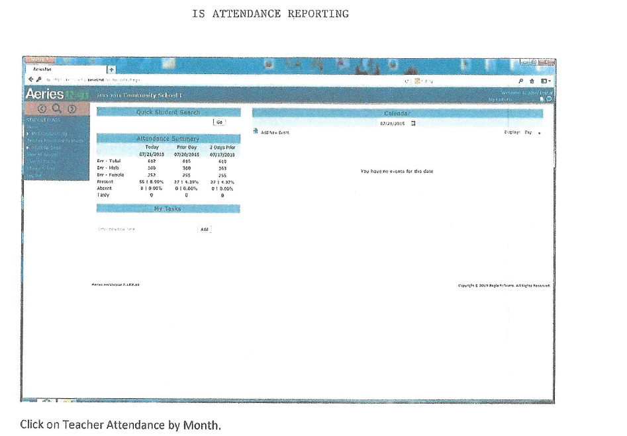

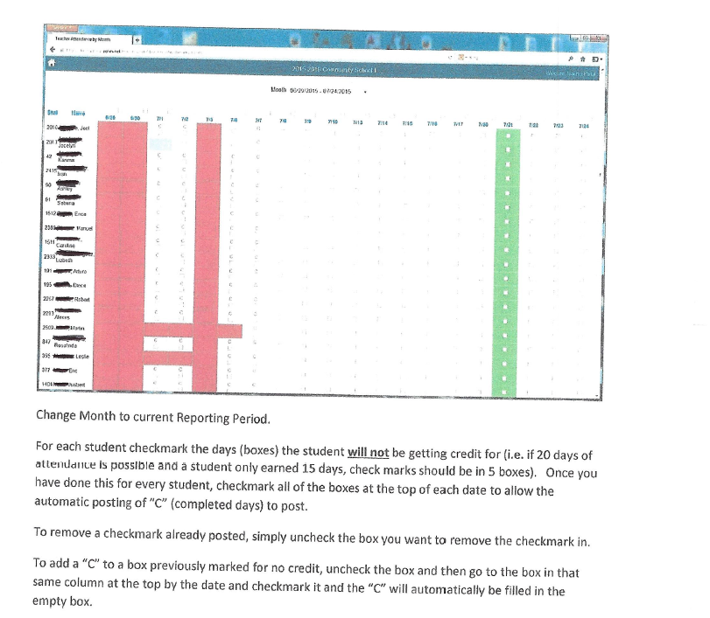

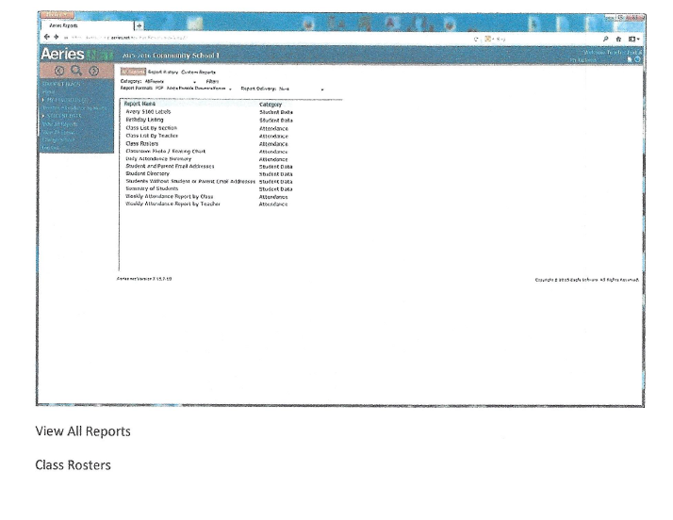

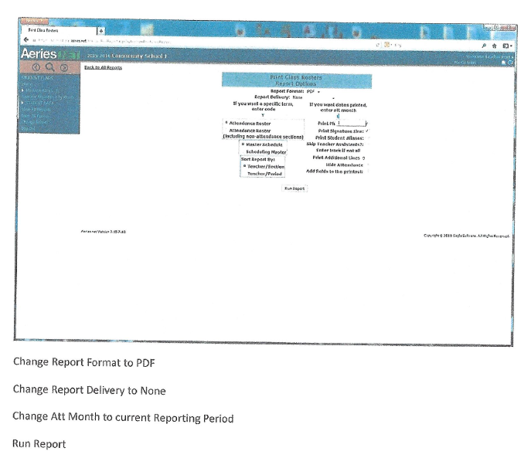

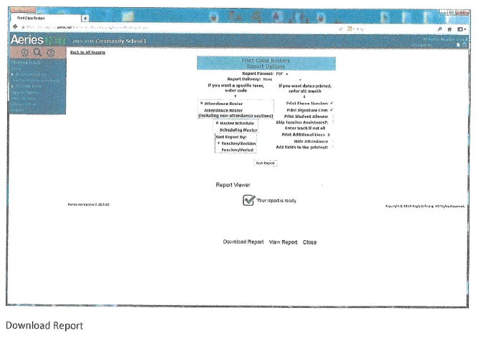

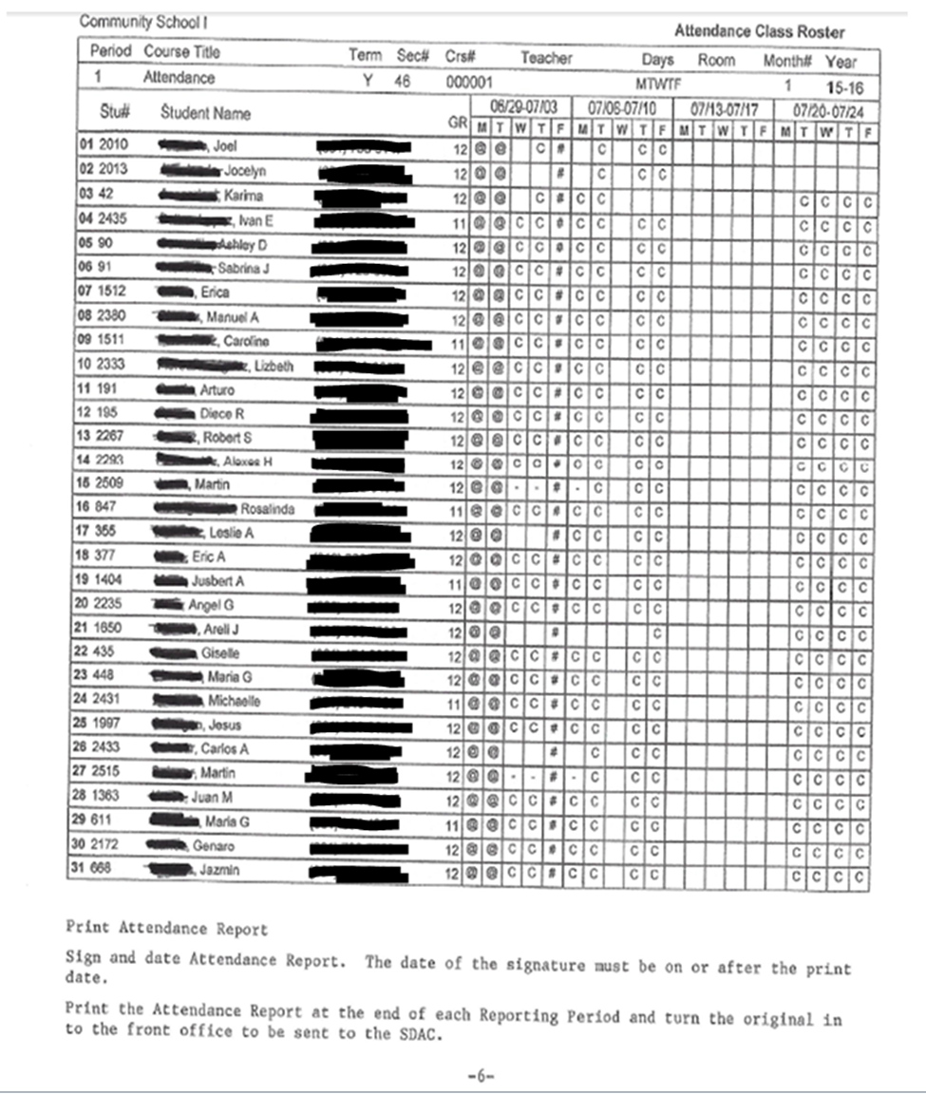
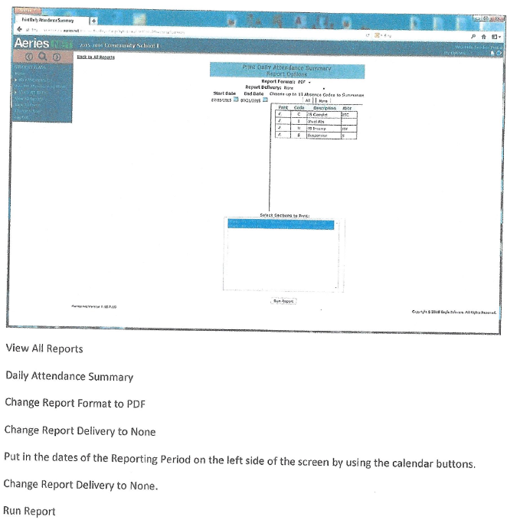
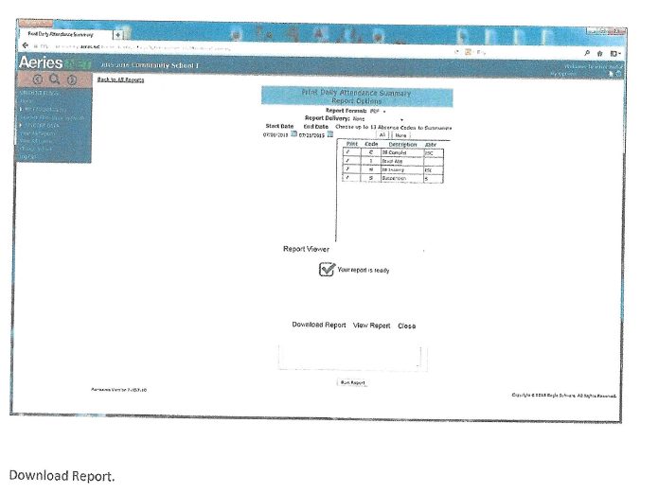

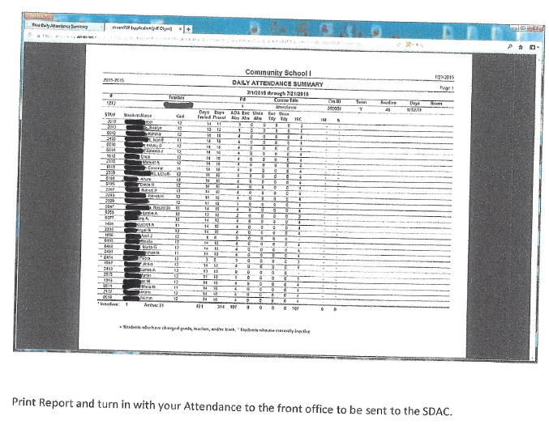

Attendance Reporting Classroom
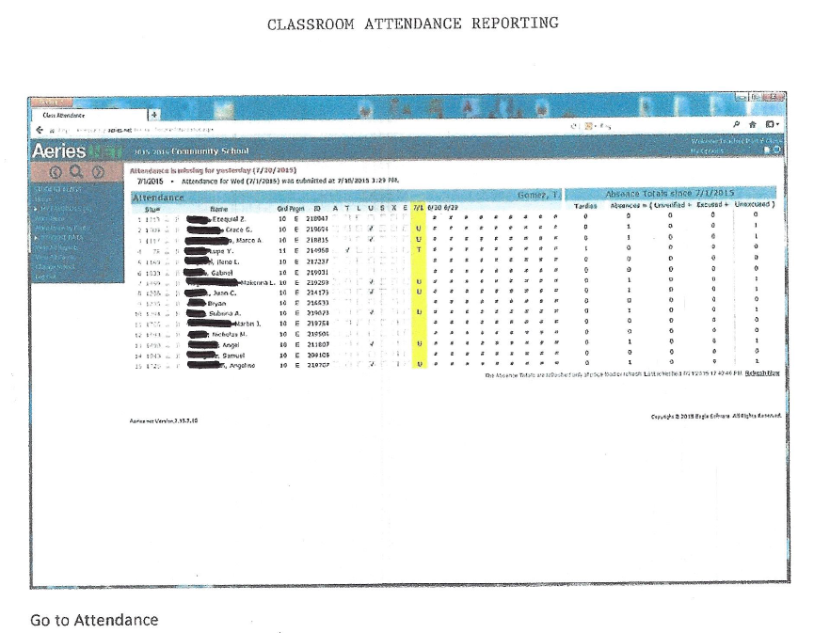
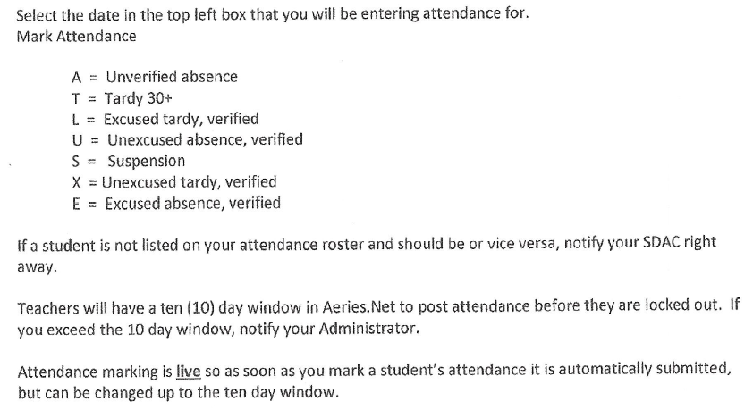
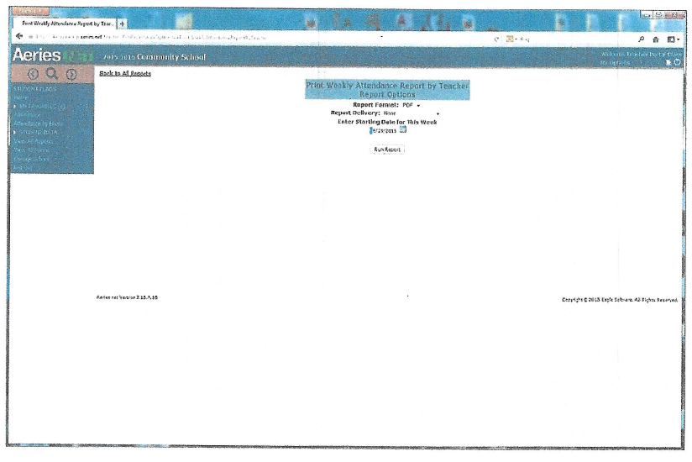
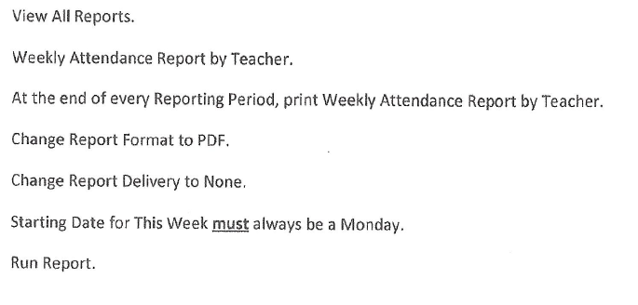

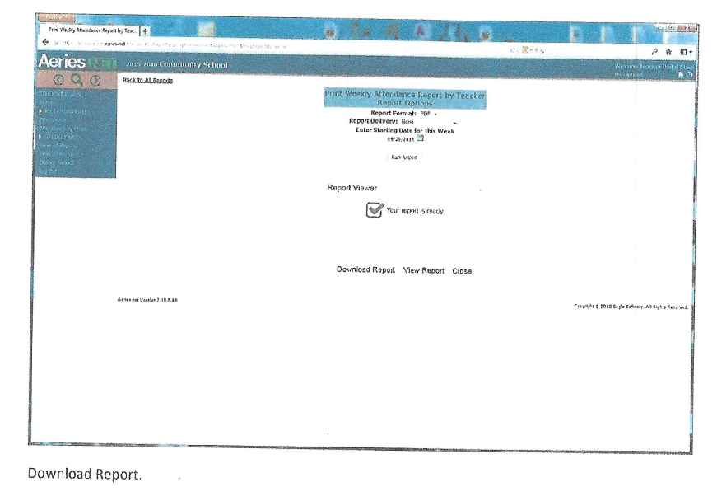

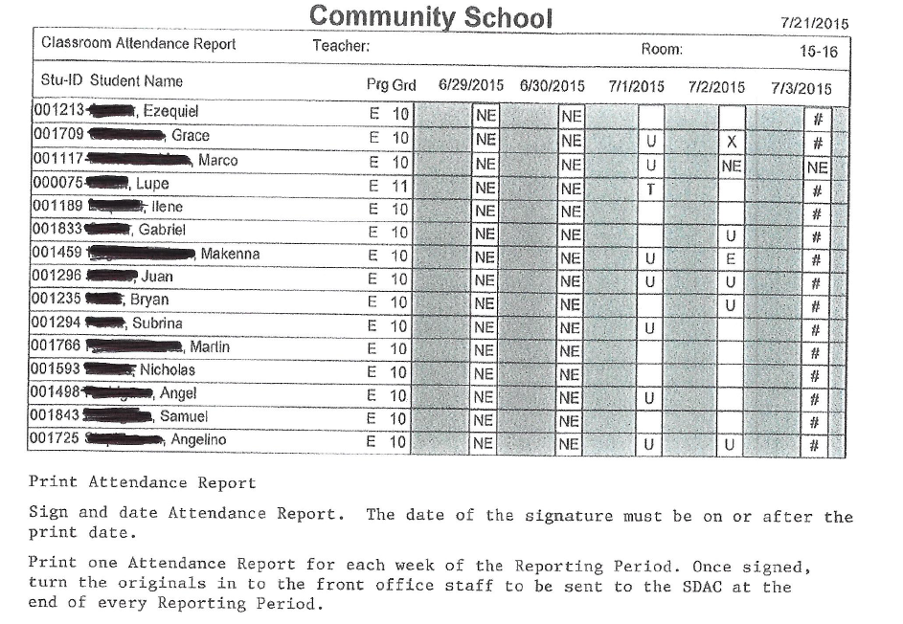

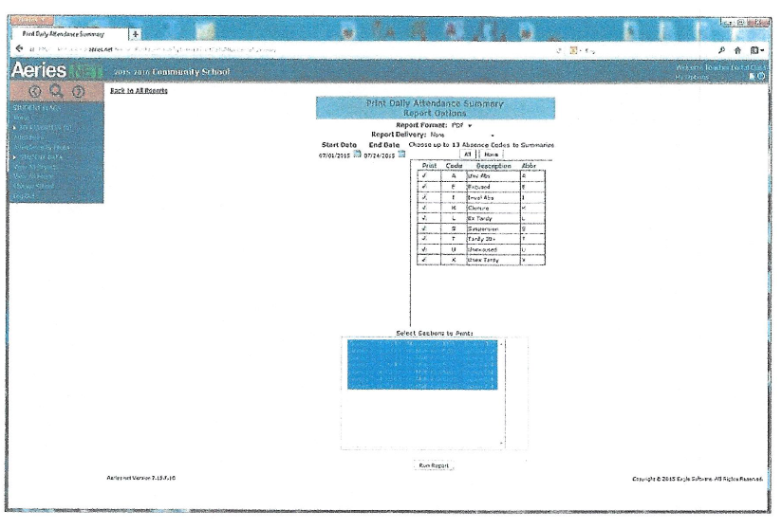

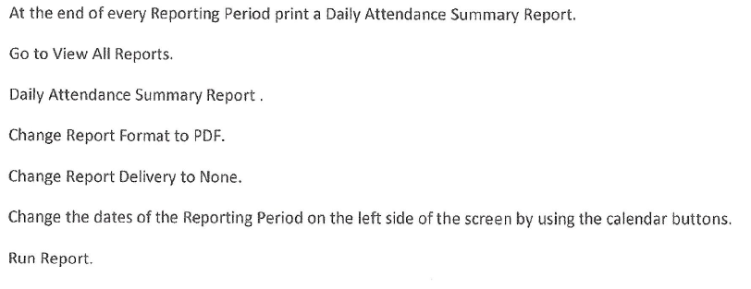

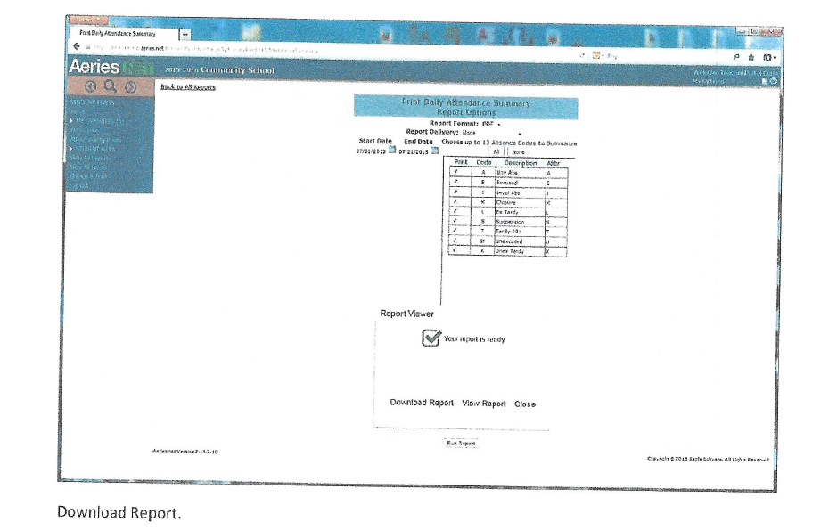

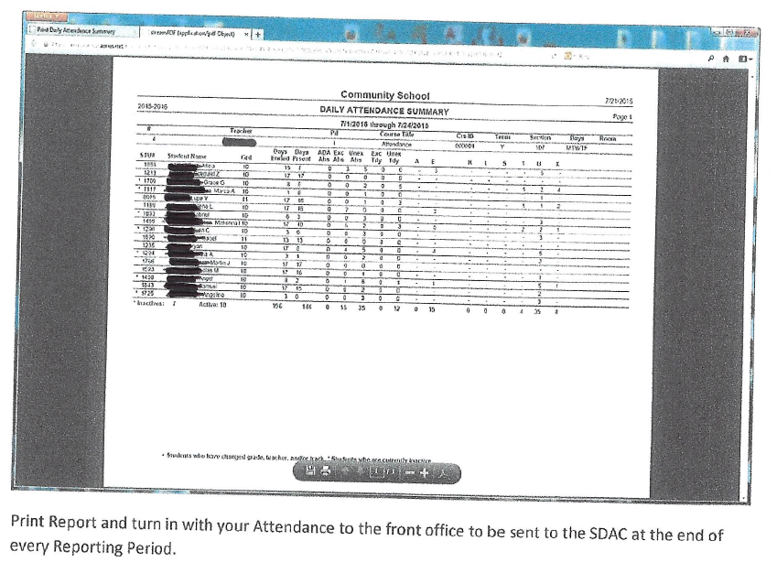

Policy for Concurrent Enrollment
Education Code 48800 states that districts may determine which students may benefit from academic enrichment or vocational work. The purpose of the code is to provide educational enrichment for a limited number of eligible pupils. Students may be authorized, upon recommendation from the principal of the school that the student attends, and with parental consent, to attend a community college as a special part-time student and to undertake one or more courses of instruction offered at the community college level. The following conditions apply.
- Participation in a concurrent college enrollment is to provide an educational enrichment opportunity and is not intended to accelerate a student’s program through high school (E.C. 48801).
- The educational enrichment opportunity will usually result in request for concurrent enrollment in courses currently not offered by the approving school.
- Pupils shall continue to be enrolled in the minimum day as required by law (E.C. 48801).
- Prior approval must be obtained from the director, following a request from the principal and parent or guardian.
- Pupils must be classified as juniors or seniors. Both age and current credit status determine grade level standing.
- After consultation with appropriate college representatives and or college catalogues, the program director will determine which courses will be considered for concurrent enrollment and whether they will apply to high school or college credit.
- Credit for the coursework shall be awarded at the rate of 3 1/3 semester periods for each credit hour earned in college (California Code of Administrative Regulations, Title V, Section 1630).
- A maximum of two college courses per quarter or semester will be approved for high school credit, never to exceed 12 semester credits (E.C. 76001).
- The total of high school credits earned through the combination of concurrent and Alternative Education school enrollment are subject to all accelerated credit policies.
- Pupils must demonstrate the ability, desire, and motivation to profit from collegiate instruction.
- Pupils will continue to be responsible for their own transportation.
- All fees will be paid by the pupil or the pupil’s family.
Procedures
- Teachers, parents, and pupils identify a need for concurrent enrollment for the purpose of academic enrichment in courses not currently offered at the school of enrollment.
- Pupils should obtain information from the community college on specific concurrent enrollment procedures and forms.
- Pupils should review community college course offerings.
- Pupils should complete college form and receive prior written permission from parents or guardian, if pupil is less than 18 years of age.
- Pupil and parents or guardian request consideration for concurrent enrollment by completing the Concurrent Enrollment Request form and forwarding to the principal.
- If approved, the principal sends the concurrent enrollment form to the director for approval.
- The program director will initial each course name and number.
- Upon completion of coursework, pupil is responsible for grade report and transcript to be delivered to the school of attendance for inclusion on the high school transcript.
- Coursework completed at the college must be the same coursework on the Concurrent Enrollment form signed prior to enrollment in classes.

Graduation Policy and Process

Preliminary Graduation Check
A Preliminary Graduation Check is completed when students are within 40 credits from graduation, including any credits on the Master Agreements or Classroom Credit Reports that have not yet been posted. Preliminary Graduation Checks are only completed for students who are expected to graduate with Alternative Education.
The Preliminary Graduation Check is considered a contract. Graduation requirements are set by our governing board and are not negotiable; therefore ensure all Preliminary Graduation Checks are consistent with guidelines. A Preliminary Graduation Check must be submitted by February 1st for every currently enrolled student in order to be eligible to participate in the graduation ceremony.

Final Graduation Check
When a student has completed all of the course credit requirements identified in the Preliminary Graduation Check, a Final Graduation Check will be completed. A copy of the Preliminary Graduation Check will be included in the Final Graduation Check for review. It is very important to ask student and parent how the name should appear on the High School Diploma and to get a minimum of two good phone numbers for the student. Attach this information to the Final Graduation Check. When the Final Graduation Check has been signed by all three reviewers, the recommendation for high school graduation will be made to the Kern County Board of Education by the student data attendance specialist.

Graduation Check Process
Court and Community School transition counselors complete the initial review of all Graduation Checks initiated at sites for which they are responsible and perform the following tasks.
- Obtain all transcripts associated with coursework completed by the student and attach those transcripts to the Graduation Check request. If no official transcript is on file it should be noted on the Preliminary Graduation Check and is a requirement for the Final Graduation Check.
- Review every course on the transcripts to determine that there is no duplication of course credit, all courses are acceptable to apply towards graduation, and which courses meet specific subject area requirements
- If there are special considerations associated with an Individual Education Plan for special education students that should be noted on the Graduation Check and appropriate documentation should be attached to the Graduation Check.
The transition counselor will sign and date the Graduation Check when the review is complete, and it will be forwarded to the principal for review. The principal will complete a thorough review of the Graduation Check packet, since the principal has primary responsibility for all Graduation Checks.
When the principal has completed the Graduation Check, the principal will sign and date the Graduation Check and return it to the transition counselor.
- For Preliminary Graduation Checks, a copy of the packet will be forwarded to the teacher of record. The original will be kept in the student’s main file, and a copy will be forwarded to the student data attendance specialist and uploaded to AERIES.Net.
- For Final Graduation Checks, a copy of the packet will be forwarded to the student data attendance specialist for a final review and approval.
- When a Final Graduation Check is completed, a request for a High School Diploma will be forwarded to the Kern County Board of Education and the completed Graduation Check packet will be returned to the last site where student attended and placed in the student’s file.

Timeline
It is important that there be a balance between accuracy and efficiency in the process of reviewing a student’s progress towards graduation. There are four dates on the Graduation Check Request: the request date, the principal designee review date, the principal review date, and the student services review date. There should be no more than seven calendar days between each step of the process and no more than three weeks for the entire process to be completed.

Additional Information
- The principal will have primary responsibility for making sure that all Graduation Checks are accurate. The three levels of review offer the principal support in making sure that any recommendations to the Kern County Board of Education are supported by required coursework and test results.
- Any questions relative to transcript analysis should lead to feedback from program directors and, if necessary, the division administrator.
- When a Final Graduation Check is completed, a final and complete high school transcript should be completed for the student and included with the High School Diploma.

Student Eligibility for Graduation Ceremony
Students who are eligible to participate in the high school graduation ceremony must meet one of the following criteria.
- Will have 220 credits with all subject area minimums met by graduation day
- Has official transcripts on file from other districts with no outstanding fines
- Will be within 10 elective credits of having 220 credits by graduation with all subject area minimums met by graduation day
- Has official transcripts on file from other districts with no outstanding fines

Field Trip Policy
Field trip requests need to be screened carefully at the site level prior to submission to the director for final approval. Please follow these guidelines prior to submission.
Purpose of Field Trip
Field trips should be of an educational nature and be connected to the K-12 standards. Field trips to amusement parks, nightclubs, restaurants, or rock concerts will likely be denied and should not be submitted to the director. Appropriate destinations include zoos, museums, art galleries, or historic or geologic monuments. Please remember that tax dollars are used to support these trips. Please use good judgment when deciding if the trip is connected to the curriculum. Providing real life learning skills is not a reason to take a field trip that is not aligned with curriculum or to an appropriate location.

Level of Supervision
The general rule for Alternative Education Field Trips has been to follow a 1 to 5 ratio, with 1 staff member to 5 students. This ratio may be adjusted up or down depending on the nature of the student population but can be used as a general guide. Staff is defined as employees and not as spouses, parents, or other volunteers. Staff should NEVER take students alone on field trips for liability and safety reasons. All supervisory staff need to be reminded that students should never be unsupervised during a field trip. Please ask staff to use good judgment when sending students to use the restroom.

Fiscal Impact
Principals will look at the total cost of the field trip, factoring in meals, substitute costs, travel and admission fees. If staff requesting the field trip needs additional staff to provide adequate supervision, principals need to recognize that getting substitutes creates a challenge and a budget impact. There are a number of field trips allowed each year at this point; however, it is wise to balance the requests among your programs and your staff.

Emergency Contact
Please make sure that at least one staff member has a functioning cell phone for emergency contact.

Parent Permission Forms
Please set up a procedure to ensure that all students on the field trip have a signed and dated permission slip on file at the school site, not on the trip. It is the principal’s responsibility to ensure that all students on the trip have parent permission. Copies of the permission form with parent contact information should also be taken on the field trip.

Alternative Activities
If a student does not return the permission slip for the field trip, there must be an educational alternative provided for the student.

Timelines
Please allow 3 weeks if you are requesting a bus. There is a form called Transportation Request Form that is submitted to the director for budget approval and then sent to transportation for bus scheduling.

Forms Needed
- A narrative from the teacher or staff requesting the field trip addressing all of the above issues. You may want to develop your own document. This form could be used doubly as a request and then as the attachment to the parent permission slip so parents know when the bus or van is departing, the time for the return and any expectations such as special clothing or meals.
- Field Trip Request Form: This is a transportation form and is used only if a bus is needed.
- Parent Permission Forms signed by parents prior to field trip departure.

Kern County Superintendent of Schools recognizes that school-sponsored field trips and excursions are important components of a student’s development. With that in mind, please be reminded that all field trips or excursions with students must follow the Field Trip Policy, including the pre-approval process. Even if the student is 18 years of age or older and the event takes place after school hours are concluded, adherence to the Field Trip Policy is mandatory.

Please use good judgment if planning or participating in any off campus activity that is not school-sponsored, yet may involve students at our schools. Please remember that if you plan or participate in such an activity, parents may associate you with the office and could incorrectly assume any such activity is sponsored by KCSOS. It is your obligation to accurately inform parents as to your role in the activity and to ensure parents understand that the activity is not school-sponsored.

Outdoor Physical Education Policy
As part of the curriculum, students are expected to learn to exercise in a variety of weather conditions. Students should make every effort to dress appropriately for outside activities. The guidelines below were designed to assist staff with determining appropriate activities for a variety of weather conditions and assist students with dressing appropriately for outdoor activities.

Community School Guidelines
- All physical education teachers need to be consistent regarding inside and outside classes.
- Decisions will be made based on the current weather and may change from period to period.
- If teachers would like to hold class outside at a time when the weather restricts outdoor activities, they would need prior administrative approval.

Heat
- All classes will remain indoors when temperature reach 100 degrees or higher. Alternative activities include Health Education courses and indoor fitness activities.
- When outside during higher temperatures, 90-100 degrees, proper precautions will be taken, including frequent water breaks, every 20-25 minutes, and lower exercise intensity level. Teachers and support staff will monitor students closely.
- Students should dress appropriately for the heat. Long pants, sweats, jackets and sweatshirts are to be discouraged during physical activity in the heat. If students are not dressed appropriately, provide more frequent water breaks and extra precaution should be exercised.
- Sunscreen or other protective clothing may be allowed during Physical Education.

Air Quality/Smog
- All classes will remain indoors when the Air Quality Index reaches 201 or higher.
- Classes may be held when the air quality is between 100-150, however any student who has respiratory problems or complains of difficulty breathing should be provided an alternate activity or moved indoors.
- The Daily Air Quality forecast can be found at www.valleyair.org under Air Quality information and should be checked each morning prior to outdoor activities.

What to do When the Air Quality is Poor
- Physical education instructors are encouraged to develop lesson plans in accordance with the outdoor activity schedule. Instructors should be prepared with alternative sports and exercises that can be performed on poor outdoor air quality days. These alternative activities and exercises should include a reduction in intensity and duration or be modified to be performed indoors (www.valleyair.org).
- Permitting no physical activity should be the last consideration

Rain
- Students will remain indoors during heavy rain.
- Students may remain outside if the rain is light enough so students are not wet for their next class.
- Students may want to consider wearing older shoes.
- Administration along with teacher input will make decisions regarding damp or wet group and if the activity will be safe.

School Safety

Safe School Vision
Alternative Education is committed to providing a safe learning environment for all students and staff, which is free from discrimination, threats, bullying, and harassment.

Radio Codes and Protocols
All Community and Court School campuses are equipped with staff radios. The purpose of staff radios is to improve staff communication and promote safe instructional environments on campus. In the past each site has maintained site-specific radio codes and procedures. Due to staff movement and the increased use of substitute staff working at multiple sites in Court and Community, schools will be aligning radio codes on all campuses. This alignment is also identified in the Student and Staff Safety Goal# 4 in the 2015-16 LCAP. In an effort to achieve consistency, all sites should abandon their current radio codes and begin to train staff and utilize Common Language/Clear Text for all radio communication.
Examples of Common Language/Clear Text
Common Language/Clear Text | Old Codes
Fight  Restroom Break  Immediate Assistance  Lockdown  What is your location? | 415  J34  T-1  T-6  J20 or 21

When using the radio, hold the radio away from your mouth and depress the button. After pausing one second, speak clearly and calmly communicating your message in Common Language/Clear Text. Please remember your audience when utilizing the radio, as radio communication will be overheard by parents, students, partner agencies and colleagues. Radio reception is not always limited to the site. Always keep communications work related and professional in tone and content.

Role of Campus Supervisor
The role of the Campus Supervisor is found in the job description; however, duties may differ from site to site. Common responsibilities of the Campus Supervisor are to provide supervision of students before and after school, provide campus security check-in of students, supervise classroom rotations, restroom and emergency restroom breaks, provide detention supervision, and assist the Administrator and Lead Teacher with student discipline concerns.

Student Movement
Students should be supervised at all times. All school staff members are responsible for supervision duties. Classified staff have both before and after school supervision while certificated staff have afterschool supervision and additional supervision as needed. When school starts, the morning supervision staff should escort students to the instructional environment. At dismissal the afternoon supervision staff should monitor student movement to ensure students do not loiter and they leave campus in a timely manner.
During school hours if a student is sent out of class for any reason, the Paraprofessional from that class or the Campus Supervisor, with a staff radio, should escort the student to the appropriate location. This allows for the certificated staff member to remain within the instructional setting. At times this requires staff to be alone with students in transit. Staff responsible for escorting students should make a radio request for additional support if they have a safety concern.
To limit the times when staff are alone with students it is important for teachers and paraprofessionals to use prep time to ensure that necessary lesson plans and preparations are made prior to the school day beginning.

Students Leaving Campus
When students are excused to leave campus or choose to leave without permission they are to remain away from campus. In both instances parents have been communicated with and are aware that their student is in route home or to another location that the parent has identified. These students may have exhibited a behavior issue on campus or are having problems with another student. If a student returns after being dismissed, staff should immediately contact the Campus Supervisor to address the student. The student and his or her location should be identified for the Campus Supervisor so he or she can address the student, reminding student not to return to campus and that the parent is expecting student to be in transit home. These students are trespassing, and if they are not willing to leave, the administrator should be contacted for further support. Law enforcement may be called if the student chooses to not leave campus.
Students who have received approval to leave campus for non-behavior related reasons or who have been dismissed for the day and then return to campus should be identified by staff, including their location, and the Campus Supervisor should be called to address the student and find out why he/she has returned. If the student will be staying at school, the Campus Supervisor will conduct check-in procedures again.

Important Note: Emergency Situation
There may be an emergency situation that has forced the student to return to campus seeking safety and support. Campus Supervisors should remain sensitive to this potential scenario when responding to students returning to campus.

Students Leaving Campus for Confidential Medical Appointments
CA Ed Code 46010.1 allows students to leave school for confidential medical appointments. All staff members who may be aware of a student exercising this right, must keep the information confidential. In addition, clinics may call the school to relay messages to students that test results are back or they need to pick up prescriptions because a student does not want a parent to know. This must also be kept confidential.
46010.1
Commencing in the fall of the 1986-87 academic year, the governing board of each school district shall, each academic year, notify pupils in grades 7 to 12, inclusive, and the parents or guardians of all pupils enrolled in the district, that school authorities may excuse any pupil from the school for the purpose of obtaining confidential medical services without the consent of the pupil’s parent or guardian. The notice required pursuant to this section may be included with any other notice given pursuant to this code.

Before and After School Supervision
It is the philosophy of Alternative Education that ensuring a safe learning environment is an integral part of the educational program. While students are on campus all staff is diligent in maintaining a high level of supervision of students.
Before and after school supervision presents a more challenging task due to the need to balance the needs of our students, staff and community partners. Education Code 44808 states in part no school district, city or county board of education, county superintendent of schools, or any officer or employee of such district or board shall be responsible or in any way liable for the conduct or safety of any pupil of the public school at any time when such pupil is not on school property. Exceptions include transportation, school sponsored event, failure to exercise reasonable care under the circumstances, or assumption of such responsibility.
The following represents guidance to the level of recommended supervision before and after school to maintain a safe educational environment for our non-residential court and community school programs.

Routine Supervision Before and After School
Staff may be assigned to provide line of sight supervision before and after school. Staff should stay on or near the perimeter of the school campus while providing this supervision. If a problem occurs off campus and within the line of sight supervision, staff should do all of the following:
- Contact school site via radio with instructions to contact additional school personnel and, if appropriate to the situation, law enforcement.
- Use verbal techniques and cues to try to minimize the problem.
- Use good judgment to protect students.

Prior Knowledge of Unsafe Conditions
If staff or administration becomes aware of a potentially dangerous situation involving students on the way to or from school, the following actions should be taken, as appropriate to each situation, to exercise reasonable care and caution:
- Interview student to gather information
- If circumstances justify, notify parents to let them know of a potential problem and encourage them to pick up their students early or later
- Contact probation to request special patrol of the area, especially if known students are on formal status
- Keep suspected students after school or drive them home
- Contact law enforcement as needed

Handling Complaints from the Community
If a community member or neighboring business complains about student misbehaviors near the campus, administration should conduct an appropriate investigation of the complaint. The investigation pursuant to Ed 44807, holding pupils accountable for their conduct on the way to and from school, provides school administration an opportunity to mitigate future complaints, be a good community partner, and observe students to gather information for the investigation and the alleged misconduct.

Discipline: Education Code
The board of Trustees, in support of public education, believes that the conduct of students attending Alternative Education must establish a climate conducive to the furtherance of educational opportunities for all students. To assure this aim, the people of the State of California have empowered local boards of education to regulate the conduct of students.

- EC 35291- The governing board of any school district shall prescribe rules not inconsistent with law or with the rules prescribed by the State Board of Education, for the government and discipline of the schools under its jurisdiction.
- EC 48908- All pupils shall comply with the regulations, pursue the required Course of Study, and submit to the authority of the teachers of the school.

In order to have an environment, which enables both teachers and administrators to effectively provide for a safe and sound education for all students, a certain standard of behavior is expected from all students. The purpose of rules and regulations on any school campus is to assure that all students have equal access to all educational opportunities. Students who fail to comply with these rules and regulations will be counseled, reprimanded, suspended or expelled and/or arrested as the laws are applied.

- EC 48900.5-Suspension shall be imposed only when other means of correction fail to bring about proper conduct. However a pupil, including an individual with exceptional needs, as defined in Section 56026, may be suspended for any of the reasons enumerated in Section 48900 upon a first offense, if the principal or superintendent of schools determines that the pupil violated subdivisions (a), (b), (c), (d) or (e) of Section 48900 or that the pupil’s presence causes a danger to persons or property or threatens to disrupt the instruction process.
- EC 48915 (a)- Except as provided in subdivisions (c) & (e) the principal or the superintendent of schools shall recommend a pupil’s expulsion for any of the following acts committed at school or at a school activity off school grounds, unless the principal or superintendent finds that expulsion is inappropriate, due to the particular circumstances. (1) Causing serious physical injury to another person except in self-defense. (2) Possession of any knife, explosive, or other dangerous object of no reasonable use to the pupil. (3) Unlawful possession of any controlled substance listed in the HS code, except for the first offense for the possession of not more than one ounce of marijuana, other than concentrated cannabis. (4) Robbery or extortion. (5) Assault or battery, as defined in sections 240 and 242 of the Penal code, upon any school employee.
- EC 48915 (c) -The principal or superintendent of schools shall immediately suspend pursuant to Section 48911, and shall recommend expulsion of a pupil that he or she determines has committed any of the following acts at school or at a school activity off school grounds.
- Possessing, selling, or otherwise furnishing a firearm.
- Brandishing a knife at another person.
- Unlawfully selling a controlled substance listed in chapter 2, (commencing with Section 11053), of Division 10 of the Health & Safety Code.
- Committing or attempting to commit sexual assault defined in subdivision (C-4) of Section 48915 or committing a sexual battery as defined in subdivision (N) of Section 48900.

Causes for Disciplinary Action

Violations Relating to Persons
Abuse-Physical or verbal attack on district employee or student (EC 44810, 48900 a, and PC 71, EC 48915 A-5)
Assault and Battery-Assault or battery upon another student or upon school personnel; threat of force or violence toward school personnel, at any time or place related to school attendance or functions (EC 44014, 44810, 48915 a-1 & a-5; PC 240-243, 245).
Defiance, Disrespect, etc. Insubordination or defiance toward school employees, either in language or action (EC 48900 k; 48908).
Electric listening or Recording Device- Use of, without prior consent of the teacher and principal is prohibited (EC 51512).
Extortion/Robbery-Taking possession from another person by threat or force (EC 44014, 44810, 48915 a-4, and 48900 g; PC 240, 241, 524).
Fighting-Involvement in fighting either in groups, gangs or as an individual on school premises or elsewhere under authority of school personnel (EC 32210, 44807, 44810, 48900 a).
Forging-Forging notes, signatures, excuses or other school documents (PC 470; EC 48900k).
Hazing-Committing any act that injures degrades or disgraces any fellow student or person attending the institution (EC 32050-32052).
Keys-Illegal possession, unauthorized use or duplication of keys to school buildings or premises (PC 469).
Receiving Stolen Property-Knowingly received stolen school property or private property (EC 48900 1)
Secret Clubs-Membership on school campus is prohibited (EC 4900 k).
Stealing-Stealing school property or from persons while on school property or at school sponsored events (EC 19911, 35291, 44807, 48900 g; PC 484-485).
Sexual Harassment-Unwelcome sexual advances, request for sexual favors, and other verbal, visual, or physical conduct of sexual nature made by someone from in the work or education setting (EC 48900.2; PC 212.5).
Tardiness/Truancy Late to class, missing class or classes illegally (EC 48260-48262).
Vehicles Failure to observe posted traffic and parking regulations (VC 21113, 42001)
Other Offenses Serious infractions of behavior standards, not identified above, inimical (unfavorable, hostile) to the welfare of the school, including buildings, property, staff, students or other personnel during the school day or while in attendance at school functions (EC 48212, 48900 a-o)

Violations Relating to Persons
Dress Regulations – Improper attention to personal cleanliness or neatness of dress (CAC 302).
Lewd or Lascivious Acts – engaging in or performing lewd or lascivious acts on school grounds or at school sponsored activities (PC 314).
Profanity and Vulgarity - Continual or habitual use of profanity or vulgarity (CAC 300; EC 48900 1).

Violations Relating to Campus Disturbances
Loitering - Persons on school premises unlawfully (PC 635g).
Picketing – Persons posted to affect the school (PC 407, 409).
Sit-ins, Walk-offs, etc. - Violations of rules governing lawful assemblage on school grounds or at school events, failure to disperse (PC 407, 409, 416, 602 j, p, 626.4, 626.6, 626.8).
Trespassing/Forced Entry – Trespassing or forced entry with respect to school buildings or school events (EC 32210, 44810; PC 602 p, 626.8).
Unauthorized Visitors – Persons who come into any school building or onto any school ground or adjacent areas without lawful business thereon (EC 44810; PC 626.8, 647 b, 653 g).

Violations Relating to Prohibited Items
Alcohol – Use or possession of alcohol on school campus or at school sponsored events (B&PC 25608, 25658, 25662; CAC 14251; PC 647 e, EC 48915 A-3, 48900 c).
Drugs/Narcotics – Use, possession or sale of narcotics or other hallucinogenic drugs or substances on school grounds or elsewhere under the authority of school personnel (EC 48915 a-3, c-3, 48900 c, H&SC 11350, 11353, 11354, 11359, 11361, 11377, 11378, 11380; PC 647 e). Offered, arranged or negotiated to sell any controlled substance, alcoholic beverage or intoxicant of any kind, and the sold, delivered, or otherwise furnished to any person liquid, substance, or material in lieu of the substance (EC 48900 d; H&SC 11382).
Drug Paraphernalia – Possessed, offered, arranged, or negotiated to sell any drug paraphernalia (EC 48900 j; H&SC 11364).
Electric Signaling Devices – Possession or use of any electronic signaling devise while at school or elsewhere while under the authority of the school except for health reasons when prescribed by a licensed physician (EC 48901.5).
Tobacco – Use or possession on school premises or elsewhere while under authority of school (EC 48900 h, 48901).
Weapons or Threat Thereof – Possession, sale, or furnishing of any firearm, knife, explosive, or other dangerous objects of no reasonable use to the pupil at school, or at a school activity off school grounds (CC 1714.1, 1714.3; EC 48915 c-1 & A-2, 48900 b; PC 245, 626.9, 626.10, 653k, 12020, 12025, 12301).
Search and Seizure – Personal or private property on school grounds, adjacent to the school, or while under the authority of school personnel is subject to search by school officials (EC 49331; H&SC 11364.7, 11471).

Violations Relating to Property
Bomb Threats – False reports that a bomb or other explosive has been placed in the school buildings or on school grounds (LC 3367; PC 148.1).
Defacing or Damaging School Property (Vandalism) – Acts which endanger life of the students, employees, or visitors or result in damage to school buildings, school property or possessions of students, staff members or visitors; parent/guardian is responsible for payment of damages (CAC 305; CC 1714.1; EC 19910, 48900 f, 48904; GC 6201, 53069.5, 530696; PC 451, 452, 595, 594.5, 605j).
Fires, Explosives, or Threats Thereof – Fires or explosives which threaten or cause serious damage to human life or property on campus or at school sponsored events; parent/guardian is responsible for payment of damages (H&SC 12304-12306; PC 451, 452; EC 48900 a, 48915 A-2, 48904).

Reference Abbreviations
B&PC = Business and Professional Code. CAC = California Administrative Code.
H&SC = Health and Safety Code. LC = Labor Code.
CC = Civil Code. VC = Vehicle Code.
EC = Education Code. PC = Penal Code.
GC = Government Code.

Disposal of Seized Property
Current Board Policy recognizes that incidents may occur which jeopardize the health, safety and welfare of students and staff and which necessitate the search of students, including backpacks, lockers, vehicles, and seizure of property by school officials. (See Search and Seizure Board Policy approved 8/14/01.) This policy does not dictate what an administrator or designee should do with seized property. This policy statement provides guidelines for administrators or designees.
Weapons
When weapons are found, law enforcement may be notified in some cases. The weapons should be given to the appropriate law enforcement agency upon their request, after school officials have photographed the weapon and added a written description of the weapon to be placed in the student file along with the name of the law enforcement official to whom it was given. If for any reason law enforcement does not confiscate the weapon, it should be destroyed before being discarded and careful documentation of the destruction noted in the student file.
If the Administrator or designee makes a determination that law enforcement should not be called due to the weapon falling into the category of “dangerous object of unknown use to the student,” then the administrator or designee will make the judgment call regarding return of the object to the parent. Such items may include family property such as pocket knives. Clear communication between the school site and parent is needed at this point to ensure that a second weapon infraction does not occur. If it does, the property will be seized and not returned.
Weapons are treated as evidence for expulsion proceedings and/or for the police report. When the case is adjudicated by the courts and/or Probation Department, parents may retrieve their property.
Drugs and Paraphernalia
In cases when large amounts of drugs are found, law enforcement is notified. The drugs and paraphernalia should be given to the appropriate law enforcement agency upon their request, after school officials have photographed the items and added a written description of them to be placed in the student file along with the name of the law enforcement official to whom it was given. If law enforcement does not respond, the drug may be maintained in a locked and secure area until released to the Probation Department. If the Probation Department does not choose to take the drugs for testing for a petition, the school site may dispose of them in the following manner. One school official will dispose of the item with another school official present as a witness. Documentation of the disposal process will include the names of the school officials that disposed of the property and be kept in the student file.
Contraband
Candy, gum, eye drops, matches and other contraband may be disposed of after the contraband has been recorded and a reasonable discipline action is taken with parental notification. Hats or belt buckles with a gang affiliation may be returned to the student upon the first offense or to the parent on the second offense. Clear documentation in the student file should be maintained including a note that these items are not allowed and further infractions may result in their seizure. In general, contraband is destroyed. A strict chain of custody is used for identification and storage of valuable items such as IPODs, cell phones, video equipment, etc. Parents may retrieve their property, as these property items will not be destroyed.
Cash
Cash in large amounts may indicate criminal activity. If large amounts of cash are seized, get as much information as possible from the student as to the source of the cash. A second staff member should witness the counting of the cash and its careful storage. If a determination is made not to contact law enforcement, the parent should be contacted immediately for pick-up. Careful storage and documentation should be followed.

School Safety Resources: High Emotion/Escalating Behaviors

Dealing with Anger and Extreme Agitation

Items to Remember
- There are different kinds of anger
- Anger is the emotion most people are worst at controlling
- Anger is energizing
- Anger builds on anger
- Anger that reaches the point of rage or violence moves individuals to a point where they are unforgiving and beyond reason. Their thoughts may involve revenge or reprisal regardless of the consequence.

The earlier in the anger cycle you intervene, the more effective the intervention will be.
- Allow a “cooling down period.” During this period, the following techniques may prove helpful
- Distraction
- It’s hard to stay angry when you are having a good time
- Exercise and Relaxation
- Change the high arousal state to low
- Write Down Thoughts
- This allows release and can be challenged and re-evaluated in a calmer state
- Venting

Anger is generally not a good form of expression. It feels satisfying but generally pumps up the arousal state. It is better to step away, cool down, and then reevaluate how to deal with a situation.

Procedures for an Escalating Student

Step 1
- Verbal Redirection
- Talk about something else – change topics
- Offer choice of alternative assignment if that is the trigger
- Ask what they want to do
- Ask if they need to talk
- Ask if they need a break
- Ask if they need to talk to someone else, another staff member or parent if applicable
- Have another staff member talk to the student, if there is another staff member who may have more success with the student.
Step 2
- Separation from classroom activity (Could be included in Step 1)
- Ask if they need to take a walk
- Could mean that the other students leave the classroom with the Paraprofessional and do an activity in another location such as next door, the library, cafeteria
- Move to a previously designated area for time-away.
Step 3
- Call the student’s therapist, if applicable, as a possible assist or at least to log the situation
- Call the parents as an assist to bring the student down
Step 4
- If student becomes minorly assaultive/throwing small things, evade items
- Continue to try and redirect
- Offer a choice as to how the escort will take place – Walk to a specified location on their own or be escorted by campus supervisor
Step 5
- If student continues to escalate call for assistance from the Campus Supervisor and/or additional site support team.
Step 6
- Law Enforcement may be called if the student continues to escalate or stay at the top of the crisis cycle for over 30 minutes or less if they are endangering others, self-injurious, self-abusive, disassociating with self, or any type of psychotic episode.

Additional Notes
- A staff member will remain with the student during the de-escalation phase. Once a student and staff member determine the student is calm, the staff member will discuss replacement behaviors, etc.

Conflict Mediation Guidelines

When there is a conflict between two students, there should be a meeting to resolve the conflict. The meeting should include both students involved in the conflict as well as a mediator who, at a minimum, is familiar with the concept and procedures of conflict mediation.

Ground Rules
- Do you both agree to not interrupt when someone else is talking?
- Do you both agree to no physical fighting in this meeting?
- Do you both agree to keep everything that is said in this room confidential?
- Do you both agree to no name calling or profanity?

State Both Sides
- Give me your side of the story. (student tells his/her side of the story and student and moderator paraphrase. . . “What I hear you saying is . . .”)
- Do you have anything to say in your defense?
- Do you want to admit to this? Do you understand why this is not okay?
- Do you have anything against him/her? Did he/she do something that caused you to do this?

Students agree to the following
- Apologize
- Get along
- Squash the rumor if others talk about him/her.
- To keep what was said in the meeting confidential and not to discuss it with other students

Possible Final Comment
For this particular issue, “I could have (include possible consequences: suspension, step, parent conference) but I want you to be able to solve problems on your own and learn from your own experiences.”

Four Common Reasons Students Fight

- Saving Face
- Many students will sacrifice their personal safety to maintain dignity or to protect their reputations, especially when peers are present.

- Defending Property or Territory
- Students may sacrifice safety or even endanger lives to gain or maintain possession of objects that seem to have little value.

- Fear (Fight or Flight)
- Fear is both an emotional and physiological response, which can impair rational thought.
- The body reacts by fleeing or fighting.

- Testing the Pecking Order
- Jealousy over status can provoke one to challenge another.
- Understanding the reason for the fight is especially helpful in terms of anxiety level because it can help you chose a supportive response which addresses the person’s underlying concern and keeps the crisis from escalating further.
- Before a conflict becomes physical, the participants usually engage in preliminary verbal and nonverbal exchanges. These exchanges are signals for you to intervene.
- Many times, the participants do not really want to get into a physical confrontation. They are waiting for you to give them an opportunity or excuse to walk away.

Do Not Ignore the Warning Signs

- Get assistance as soon as possible.

- Remove the audience.

- Approach calmly and confidently, but avoid rushing in.

- Create a distraction, if appropriate shout, blow a whistle, blink the lights, drop a book.

- Use firm and rational verbal and nonverbal behavior (body language, eye contact) and para verbal communication (monitor how you say what you say)

- Remain non-judgmental.

- Set and enforce reasonable limits.

- If necessary, separate the participants and give them time to calm down.

Managing a fight can be dangerous and frightening. In combative situations you may not be able to prevent all injury, but you can minimize injury.

Suggestions for Breaking up Fights

Most fights can be stopped by a loud, firm/stern voice. Give specific commands.

- Radio for help – Fight in Room 5

- Evaluate the situation
- How many students are involved?
- How big are the students?
- Are weapons present?

- Defer to rules, not personal authority. Use a non-threatening manner. Students may perceive authority as a direct threat.

- Stay away from the middle. Remember that you are not required to place yourself in danger or a situation that may cause injury.

- Before going into a fight, remove your glasses. Use a controlled response. Don’t challenge students or “get in their face.”

- Avoid physical force, if possible. Use the Bear Hug technique, if needed, to break up the fight. Move immediately to a neutral area. Try to keep student upright and walk him/her to a fence or wall.

- Separate the aggressor and the victim. Remove the aggressor, if possible, and then return to the victim. Dismiss the audience.

- Get medical attention, if needed. Ask students if they were injured during altercation. Document responses. Provide protection and support for victims.

- Report incident; debrief relevant teachers; describe the incident in writing; notify parents. Include in report the student’s statement of injury or non-injury. Major incidents may dictate critical analysis to determine what was effective and what might be handled differently.

Common Triggers for Threats and Threatening Behaviors towards Staff

- Saving Face/Being Disrespected
- Many students will sacrifice their personal safety to maintain dignity or to protect their reputations, especially when peers are present.

- Feeling like they have been singled out by the teacher or the staff member
- Many students respond negatively when being singled out by the staff, especially when others are exhibiting the same behavior as the student who has been singled out.

- Feeling like they have no choice or they have been backed into a corner, Fight or Flight
- Dependent on the situation. Fear is both an emotional and physiological response, which can impair rational thought. The body reacts by fleeing or fighting/threatening
- Understanding why students make threats is especially helpful at the anxiety level because it can help you chose a supportive response which addresses the person’s underlying concern and keeps the crisis from escalating further.
- Many of the factors that affect students in regards to fighting are the same when it comes to creating threatening situations.

- Don’t be the trigger of the situation, and don’t escalate a situation.

- Ask; don’t demand.

- Don’t single out.

- Provide options, and don’t back the student into a corner when trying to correct unwanted behaviors.

- Use firm and rational nonverbal behavior (body language, eye contact) and para verbal communication (monitor how you say what you say) when speaking with students. Don’t be sarcastic or condescending.

- Don’t make it personal or take it personal.

- Remain non-judgmental.

- Promote a fair and equitable classroom environment with clear expectations of student behaviors and procedures.

- Continuously reteach expectations and procedures (PBIS). This will help to avoid any confusion that may lead to an escalating situation in class.

Handling Threats from Students

- Call for assistance immediately if the student is engaging in threatening behavior and is currently in your class.

- Do not continue to engage the student and avoid posturing because, at this point, you are the focus of the student’s attention and anger.

- Remove the audience, if possible.

- Once student is removed or the incident is over, write up an incident report detailing your account of the incident. Please include detailed information regarding events leading up to the incident. Turn in incident report to Campus Supervisor and Administrator as soon as possible.

- If you feel the threat is a credible or valid threat and you are fearful for your safety, you may contact the authorities to file a report.

- Campus Supervisor and Administrator will investigate the threat and determine appropriate action.

Resources: Behavior Intervention

Classroom Management Tools
The following intervention tools and strategies should be practiced consistently to avoid common mistakes in the classroom such as the following: nagging, punishing, lecturing, threatening, explaining, power struggles, and revenge.

Problem Solving Steps
- Ignore it, if minor and not disrupting others, and address with student later
- Talk it over respectfully with the other person
- Agree with the other person on a solution
- Put it on the agenda for a class meeting

Act, don’t talk (Use the tongue in your shoe; continue walking)

Give Information (It’s time for…)

Describe What You See (I notice…)

Use Ten Words or Less (Stick to the issue. Make a reasonable request. Wait for a response.)

Say How Would You Feel with an I-Message (I feel…because…and…I need/would like…)

Give a Limited Choice Where All Options are Acceptable and Appropriate (Would you like to pick up the paper now or in the next few minutes?)

Ask, Don’t Tell. What, Why, How?

Put Everyone in the Same Boat (I see you are all having trouble/difficulties . . . Avoid singling out a student.)

Follow Through (Say what you mean and mean what you say; Take action with kindness and firmness.)

Redirection Questions (How many of you think it’s too noisy for people to concentrate? How many do not?)

Do Nothing/Natural Consequences (You don’t have to respond to every inappropriate question or behavior.)

Say No With Dignity and Respect

Positive Time Out (Kids do better when they feel better. Time out doesn’t have to be punitive.)

Behavioral Intervention Techniques

- Build a relationship with each student.
- Give choices you would be okay with if chosen.
- Identify, focus on, and reinforce the positive attributes of the student.
- Use humor (Not sarcasm!)
- Look at self-esteem. Could you increase student self-esteem in a creative way?
- Make them responsible for a specific job, for example lunch duty, passing out books, supplies, letting them decorate something in the room, helping another student.
- Before the student walks into the room in the morning or after break, stop him/her outside and get him/her to commit to appropriate behavior.
- Hurdle Help when a student is struggling with work.
- Teacher does a problem or two for the student and talks him/her through it
- Student does a problem for teacher and talks the teacher through it
- Student completes a problem while teacher watches
- Teacher directs student to complete two problems, while the teacher helps someone else
- Broken Record
- For students that have a hard time following directions continue to repeat the direction in a monotone voice until they respond.
- Encouraging Independence
- For those students that want all your attention on every assignment, in every subject, allow them help on 2/5 assignments. They have to budget the assistance that is available for assignments they really need help with.
- Rushing through Work
- Charge points for mistakes
- Percent correct or lose a privilege
- All work must be checked before free time. They have to earn back your trust.
- Conflict Resolution
- For those peers that have continual disputes, use conflict resolution over and over until they learn to solve their own problems. Staff remains neutral.
- Avoid Sitting Time-Out - This penalizes students and teachers and is one of the least effective methods of behavior intervention. Have students do jobs or restitution as consequences.
- Help Student Save Face
- Some students are never going to admit they did something wrong or say they are sorry, which could lead back into a power struggle.
- Could they do something nice for the teacher or the peer to make amends?
- For student not buying into the program or class have a staff member start establishing a relationship with student by bringing a special item like a picture, magazine article, or something the student is interested in, so student begins to feel noticed.

Strategies for Providing Attention/Recognition

Interpersonal Acts
For Children
Smile Good work
Pat on the Shoulder Good job
Pat on the back ______ is a hard worker today, good for you
Wink Much better
Nod That’s the way
Push on swing You should show this to your parents
Wow! That’s perfect
Assistance You’re doing well
Eat with children Watch what he did; do it again
Saying (adding reason) Show the class your _____
Very good Wow, look at ___work
Yes You look nice today
Great I can really tell that ____ is thinking
Nice ____ is sitting quietly and doing the work;
Fine Fantastic good for him/her
Excellent ____ just earned another point by sitting
Unbelievable quietly
Atta-girl, atta-boy ____ has all of the supplies on the desk and is
Far out ready to go; good!
That’s correct It’s nice to see the way ____ raises
Marvelous his/her hand when he/she wants to share
You really pay attention well This whole row is sitting quietly, great!
That was very nice of you

For Youth
Smile Okay
Nod Exactly
Laugh (with, not at) Thank you
Positive comment on appearance That’s interesting
Pat on back Right
Handshake I agree
Ask student to demonstrate Good idea
Ask student to explain Fantastic
Assist when requested Unbelievable
Signal or gesture of approval You are really creative, innovative
Saying (adding reason) Keep up the good work
Very good You’re really improving
Yes You’re really becoming an expert at this
Great ___ has gotten his materials and has
It really makes me feel good when I started to work already; good going!
see so many of you hard at work Thank you ___ for remembering to
That’s a thoughtful thing to do raise your hand

ABC’s of Crisis Intervention / Behavior Response

- Assess Student Condition
- Be Aware of Possible Triggers and Previous Concerns
- Cooling Measures
- Redirection
- Choice
- Self Control Time
- Self Talk
- Self Walk
- Deflect Physical Danger
- Evade Danger, Possible Class Clearing
- Follow Behavior Plan, if applicable
- Get Help, Notify Administrator
- Have Meeting and Review Incident
- IEP Meeting if Needed
- Joint Effort with Parent, Site Personal, and Student
- Keep Reviewing Plans
- Let Therapist or Wrap Around Support Personnel Know, if applicable
- Meet with Student and/or Parent to Discuss Options in Behavior
- Never Put Yourself or Others in Danger
- Observe for Possible Patterns and Triggers
- Parental Involvement in Plan
- Question if Additional Agency or Legal Involvement is Needed, Feasible, and Possible
- Reinforce Good Behavior
- Safety First
- Trust Your Judgment
- Understand Your Student
- View the Situation with an open Mind
- Wait and Watch Before Responding
- EXtend your options to include more support
- You are in Control and You are the Role Model
- Zip Up Your Emotions and Actions, Respond before Reacting

Strategies for Addressing Behaviors
Matching Intervention to Behavioral Function
Function of Behavior Potential Interventions

Escape/Avoidance For Task Avoidance
Assess Comprehension of Instructions
Reteach and/or Reinforcement for Compliance
Teach How to Seek Help
Teach Acceptable Alternatives to Escape
Reinforce for Absence of Problem
Initially Remove/Reduce Task Demands and
then Gradually Introduce/Increase Demands

For Social Avoidance
Pair Social Attention with Strong Reinforcers
Reinforce for Compliance
Reinforce for Absence of Problem
Teachers Should Avoid Removing the Assignment or requesting time-out

Attention Seeking For Attention Seeking
Increase Attention for Appropriate behaviors
Withhold Attention for Problem Behavior
Teach Acceptable Alternative for Obtaining Attention
Use Time-out as Last Resort

Teacher Should Avoid
Verbal Reprimands, Interruption Response - Redirection

Access to Material Rewards For Access to Material Rewards
(Material, Activity, or Food) Deny Access
Teach Acceptable Alternatives to Obtain Access
Provide Frequent, Non-contingent Access
Use Penalties, Fines, or Time-out as Last Resort

Teacher Should Avoid
Access to Material, Activity, or Food Following Problem behavior

Self-Reinforcement For Self-reinforcement
Increase Access to Alternative Sources of Reinforcement
Interrupt/Redirect Inappropriate Behavior
Reinforce When Behavior is Appropriate and When
Problem Behavior is Absent or Reduced

Teacher Should Avoid
Withholding Attention

School Safety Resources: Behavior Intervention Strategy Matrix

Emotional and Physical Well-being
Behavior | Interventions
Deliberately harms self or damages own property or clothing. | Remove the student from the group or activity until he/she can demonstrate appropriate behavior and self-control.
 | Write a contract with the student specifying what behavior is expected (e.g. not engaging in self-destructive behavior) and what reinforcement will be made available when the terms of the contract have been met.
 | Provide the student with a quiet place to work.
 | Teach the student appropriate ways to deal with anxiety, frustration, and anger (e.g. move away from stimulus, verbalize unhappiness, choose another activity)
 | Maintaining a consistent daily routine.
 | Talk to student about ways of handling situations successfully without conflict (e.g. walk away from situations, change to another activity, ask for help etc.)
Teach the student to think before acting (e.g. ask themselves “What is happening?”
“What am I doing?”
“What should I do?”
“What will be best for me?”
Reinforce the student for engaging in appropriate behavior:
- give the student a tangible reward (e.g., classroom privileges, passing out materials, five minutes of structured free time)
- give the student an intangible reward (e.g. praise, handshake, smile, etc.)
Demonstrates self-destructive behaviors | Provide the student with positive feedback which indicates he/she is successful, important, respected, etc.
 | Teach the student appropriate ways to communicate displeasure, anger, frustrations, etc.
 | Avoid discussions or prevent stimuli in the environment which reminds the student of unpleasant experiences/sensitive topics (e.g. divorce, death, unemployment, alcoholism, etc.)

Inappropriate Behaviors
Behavior | Interventions
Exhibits sudden or extreme mood changes. | Provide the student with as many social and academic successes as possible.
 | Inform the student in advance when a change at school is going to occur (e.g. change in routine, special events, and ending of one activity and beginning of another, etc.)
 | Intervene early when there is a problem to prevent a more serious problem from occurring.
 | Write a contract with the student specifying what behavior is expected (e.g. consistent and appropriate behavior) and what reinforcement will be made available when the terms of the contract have been met.
 | Teach the student appropriate ways to communicate displeasure, anger, frustration, etc.
Does not participate or demonstrate an interest in classroom activities or special events that are interesting to other students. | Give the student the responsibility of helping another student in the group.
 | Ask the student questions that cannot be answered yes or no.
 | Try various groups to determine the situation in which the student is most successful.
 | Demonstrate the student’s opinions, responses, suggestions, etc.
 | Teach the student appropriate ways to interact with peers in classroom activities (e.g. share materials, problem-solve, take turns, converse, etc.)
 | Do not punish the student for not participating in classroom activities or special events.
Interrupts the teacher or other students | Communicate with the parents (e.g. notes home, phone calls, etc.) to share information concerning their child’s inappropriate behaviors. The parents may reinforce the student at home for waiting his/her turn to speak at school.
 | Maintain a full schedule of activities. Keeping the student occupied should prevent interruptive behaviors from occurring.
 | Encourage the student to develop awareness of himself/herself and those around him/her. Have the student periodically step back and ask himself/herself, “Am I interrupting others?”
 | Talk to the student before beginning an activity and remind him/her the importance of listening and not interrupting.
 | Teach appropriate social rituals (e.g., say, “Excuse me,” before interrupting; wait until someone stops speaking to begin talking, etc.)
Does not demonstrate the ability to control temper | Teach and encourage the student to use problem-solving skills:  - identify the problem  - identify goals and objectives  - develop strategies  - develop a plan for action,  - carry out the plan
 | Provide positive feedback which indicates he/she is successful, important, respected, etc.
 | Preventing frustrating or anxiety producing situations from occurring (e.g. give the student tasks only on his/her ability level, give the student only the number of tasks that can be tolerated in one sitting, reduce social interactions which stimulate the student to become physically abusive, etc.)
 | Make the student aware of the natural consequences for becoming easily angered, annoyed, or upset (e.g. loss of friendships, injury, more restrictive environment, legal action etc.)
 | Do not force the student to interact or remain in a group if he/she is likely to become angry, annoyed, or upset.
Becomes physically aggressive with teachers | Be mobile to be frequently near the student.
 | Teach the student alternative ways to deal with situations which make him/her frustrated or angry (e.g., withdrawing, talking, etc.)
 | Facilitate on-task behavior by providing a full schedule of activities. Prevent lag time from occurring when the student would be free to engage in inappropriate behavior.
 | Provide the student with as many high-interest activities as possible to keep him/her from becoming physically aggressive toward teachers.
 | Avoid arguing with the student (e.g., calmly deliver consequences without reacting to the student’s remarks).
 | Deliver directions in a supportive rather than a threatening manner (e.g., “Please finish your math assignment before going to recess,” rather than “You better turn in your math or else!”)
Verbally or physically threatens other students or teachers | Maintain consistent expectations and daily routine.
 | Have the student question any directions, explanations, or instructions he/she does not understand.
 | Reduce activities which might threaten the students (e.g., announcing test scores ranges or test scores aloud, making students read aloud in class, emphasizing the success of a particular student or students, etc.)
 | Provide the student with a selection of optional activities to be performed if he/she becomes angry, annoyed, or upset by an assigned task.
 | Maintain a positive/calm environment (e.g., positive comments, acknowledgment of success, quiet communications, etc.).
 | Reduce the emphasis on competition and perfection. Repeated failure and frustration may cause the student to become angry, annoyed, or upset.
Fights with other students | Teach the student problem-solving skills:  - identify the problem  - identify goals and objectives  - develop strategies  - develop a plan of action  - carry out the plan
 | Teach the student alternative ways to deal with situations which make him/her feel frustrated or angry (e.g., withdrawing, talking, etc.).
 | Do not leave a lot of unstructured time for the student.
 | Explain to the student that it is natural for conflict situations to occur. What is important is how he/she reacts to the situation.
 | When the student has responded inappropriately to a conflict situation, take time to explore with him/her appropriate solutions which could have been used in dealing with the problem.
Ignores consequences of his/her behavior | Intervene early when there is a problem to prevent a more serious problem from occurring.
 | Have a student review the consequences of his/her behavior with someone he/she trusts. Have the student consider different choices he/she could have made and the different outcomes.
 | Have the student list pros and cons of an action and determine if the pros outweigh the cons before he/she takes action.
 | Show interest in the student (e.g. acknowledge the student, ask the student’s opinion, spend time working one-to-one with the student, etc.)
 | Make certain the student understands that consequences naturally follow behavior. You do not make the consequences happen; it is his/her behavior that makes the consequences occur.
Does not demonstrate appropriate behavior | Allow a transition period when changing environments so the student can make adjustments in his/her behavior.
Speak to student to explain
- what he/she is doing wrong (e.g. failing to adapt his/her behavior to the immediate environment) and
- what he/she should be doing (e.g. adapting his/her behavior to the immediate environment)
Establish free time rules:
- Find an activity
- Work or spend time quietly
- Remain in assigned areas
- Put materials away when free time is over.
Review rules often. Reinforce students for following the rules.
 | Instruct the student in the appropriate behavior for each environment in which he/she is expected to function successfully.
 | Teach the student strategies to deal with controlling his/her temper in various environments (e.g. stop and count to ten, walk away from the situation, look for a friend, look for a teacher, etc.)
Needs immediate rewards, reinforcement, or gratification to demonstrate appropriate behavior | Have student maintain a chart representing his/her own appropriate behavior for success if recognized.
 | Provide the student with positive feedback which indicates he/she is successful, competent, important, valuable, etc. (e.g. provide social reinforcement in place of tangible reinforcement).
 | Provide reinforcement at routine intervals so the student learns that reinforcement is delayed by forthcoming (e.g., free time, end of the day, Friday afternoon, etc.)
Fails to comply with teacher or other school personnel | Structure the environment so the student remains active and involved in appropriate behavior.
 | Maintain visibility to and from the student to keep his/her attention when verbal questions/directions are being delivered. The teacher should be able to see the student and the student should be able to see the teacher. Make eye contact possible at all times.
 | Maintain consistent rules, routine, and general expectations of conduct and procedure.
 | DO NOT “give in” to the student when he/she is arguing and demanding. If you do, the student will continue to argue and demand things to get his/her own way.
 | Do not give directions to the student from across the room. Go to the student, get his/her undivided attention, and tell him/her what to do.

Interpersonal Relationships
Responds inappropriately to praise or recognition from other students or teachers | Model appropriate ways to respond to inter-actions with other students or teachers.
 | Praise or recognize the student in private. The public aspect of praise or recognition is often the cause of the inappropriate response.
 | Distribute praise or recognition equally to all members of the class.
 | Treat students with respect. Talk in an objective manner at all times.
Speak with the student privately to explain
- what the student is doing wrong (e.g. behaving inappropriately when recognized by others, and
- what the student should be doing (e.g. saying “thank you,” smiling, etc.)
Makes inappropriate comments to teachers | Teach the student appropriate ways to communicate displeasure.
 | Reduce stimuli which contribute to the student’s derogatory comments or inappropriate gestures (e.g., music, visuals, conversations, etc.)
 | Treat the student with respect. Talk to the student in an objective and professional manner at all times.
 | Do not ignore the student inappropriate behavior. Ignored behavior may increase in frequency and may lead to contagion on the part of other students.
 | Use language that is pleasant and calming for the student when interacting with him/her to avoid stimulating the student to make inappropriate comments.
Physically hurts other students or teachers | Be mobile to be frequently near the student.
 | Facilitate on-task behavior by providing a full schedule of activities. Preventing lag time from occurring when the student would be free to engage in inappropriate behavior.
Evaluate the appropriateness of the task to determine
- if the task is too easy
- if the task is too difficult
- if the length of time scheduled to complete the task is adequate.
Physically hurts other students or teachers | Reinforce those students in the classroom who demonstrate appropriate behavior when interacting with other students.
 | Avoid arguing with the student (e.g., calmly deliver consequences to reduce the likelihood of the student becoming upset by what he/she considers unfair treatment.)
“Gets back” at other when he/she feels that someone has wronged him/her | Use role play to explore situations in which someone tries to repay “a wrong with a wrong”. Discuss the situation, and arrive at positive alternatives which could occur rather than revenge. Explore the benefits the “wronged person may realize by choosing positive responses rather than revenge.
 | Provide outlets for the student who expresses and/or acts upon thoughts of revenge (e.g., art work, diary writing or self-recording, etc.).
 | When a dispute occurs, meet with both parties separately and privately to hear each side of the story. Help each party to identify positive alternatives to problem-solve. Working together, determine a positive course of action which would eliminate the need for revenge by anyone.
 | The student who is sensitive to failure and who may voice or attempt retribution, needs your careful monitoring. Offer positive alternative activities instead of ongoing activities when the student indicates signs of frustration or overstimulation.

Listening
Needs verbal questions and directions frequently repeated | Instruct the student to write the assignment’s information down on paper, to help him/her remember.
 | Assess the degree of task difficulty to determine if the student will require additional information, time assistance, etc., before assigning a task.
 | Do not accept “forgetting” to listen as an excuse. Make the student accountable for missed information.
 | Deliver information to the student on a one-to-one basis or employ peer tutoring.
 | Deliver questions and directions in written form.
Does not listen to or follow verbal directions | Assess the quality and clarity of verbal directions, explanations, and instructions given to the student.
 | Deliver directions, explanations, and information using vocabulary that is within the student’s level of comprehension.
 | Be consistent in expecting the student to listen to and follow directions. Do not allow the student to fail to follow directions one time and expect directions to be followed the next time.
 | Communicate clearly to the student when it is time to listen to verbal directions.
 | Give verbal directions before handing out materials.

Motivation
Indicates that he/she does not care or is not concerned about performance, grades, report cards, graduating, consequences of behavior, etc. | Reinforce the student for showing an interest and participating in school activities:  - give the student a tangible reward (e.g., classroom privileges, passing out materials, five minutes of structured free time, etc.) or  - give the student an intangible reward (e.g., praise, handshake, smile, etc.)
 | Show an interest in the student (e.g., acknowledge the student, ask the student’s opinion, spend time working one-on-one with the student, etc.)
Establish classroom rules:
- Work on-task
- Work quietly
- remain in your seat
- finish tasks
- meet task expectations
Review rules often, reinforce students for following the rules.
Is not motivated by rewards | Conduct a reinforcer survey with the student to determine his/her reinforcer preferences.
 | Communicate with parents to determine what the student finds reinforcing at home.
 | Provide a wide variety of reinforcers for the student at school. Use the reinforcer survey to determine the student's interests or motivation.
 | Provide reinforcers that are social in nature (e.g. extracurricular activities, clubs, community organization)

Rules and Expectations
Does not follow classroom rules | Structure the environment so that the student remains active and involved while demonstrating acceptable behavior.
 | Be a consistent authority figure (e.g., be consistent in relationships with students)
 | Post rules in various places, including on the student’s desk.
 | Teach student direction-following skills.
 | Intervene early to prevent the student’s behavior from leading to the inappropriate behaviors of others.
 | Provide the student with a list of rules and/or behavior expectations.
Uses obscene or profane language | Make certain you do not curse. If you curse, the student will learn to do the same.
 | Establish a rule (e.g., no cursing). This rule should be consistent and followed by everyone in the school environment. Talk about the rule often.
 | Make certain to intervene early when the student does curse, before cursing becomes an established part of his/her speech.
 | Make certain those who are expressing thoughts and feelings without resorting to obscene/profane language are positively reinforced.
 | Encourage the student to express thoughts and feelings carefully and thoughtfully. Praise the student for self-expression without using obscene/profane language.

Resource
House, S.N. (2002). Behavior Intervention Manual: Goals, Objectives, and Intervention Strategies. Columbia, Missouri: Hawthorne Educational Services, Inc.

