The idea is pretty simple and there’s lots of variations. Try out a few and run some tests to see which one works best!

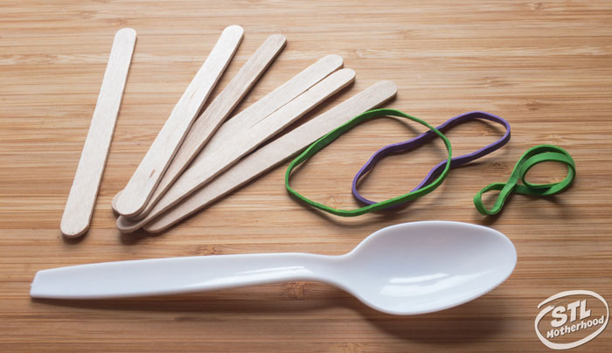
This design is easy and the spoon holds your projectile pretty well. It only takes 3 rubber bands, which is especially handy if you’re rummaging through your junk draw to find crafting supplies.
Let’s begin!
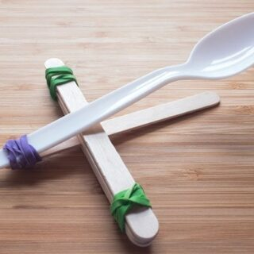

Materials
- Craft sticks (they also come in cool colors)
- Spoons
- Rubber bands
- Foil (makes great ammo)

Instructions
- Take 5 sticks and stack them, securing one end with a rubber band. You'll need to wrap the rubber band around several times to make it nice and secure. 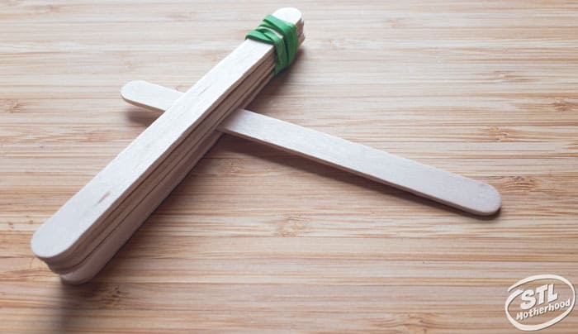
- Slide one more stick between the bottom stick and the rest of the stack.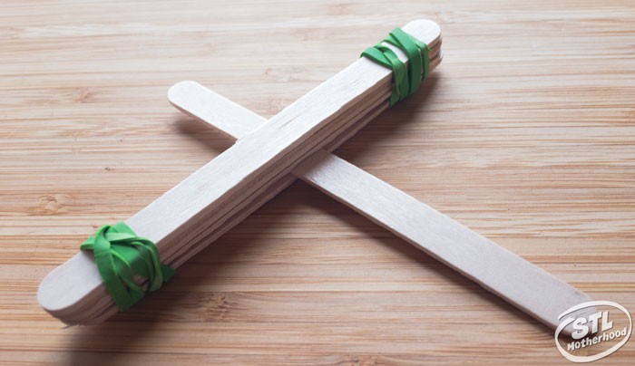

- Secure the other end with a rubber band.
- Place the spoon on top, and attach the end of the spoon to the end of the single stick with the last rubber band.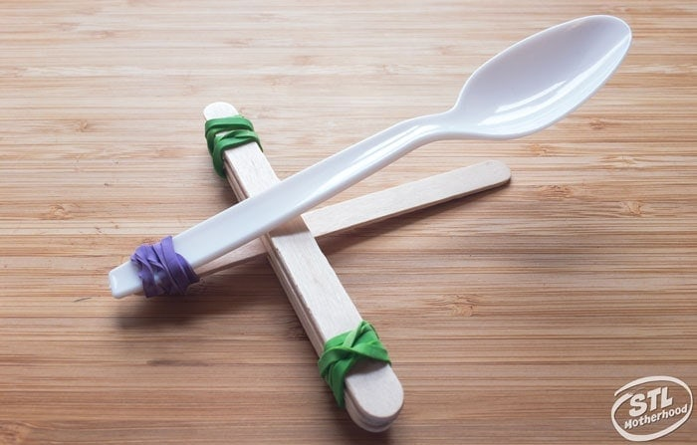

Notes
Crumpled balls of foil and small marshmallows make excellent projectiles for this style of catapult.

Make Projectiles for Your Catapult
You can experiment with different kinds of projectiles for your catapult–really anything that can fit on the spoon will work, wads of paper, super balls, foam balls, foil balls or rocks (if you’re outside).
Because this is meant to be an indoor project, I recommend making aluminum foil balls. They have just the right amount of weight to travel far, aren’t round enough to roll under the couch and won’t hurt anything that accidentally gets in the way.
Marshmallows are also great for catapult flinging!
Enjoy! This catapult has a lot of upward thrust–not a very good distance shooter. It’s great for younger kids to build because it’s so very simple.

