KERN COUNTY CONSORTIUM SELPA

SUPERINTENDENTS’ EXECUTIVE COUNCIL

February 25, 2019 9:00 AM
AGENDA

1300 17th Street – CITY CENTRE
3rd Floor, Room 318
Bakersfield, CA 93301

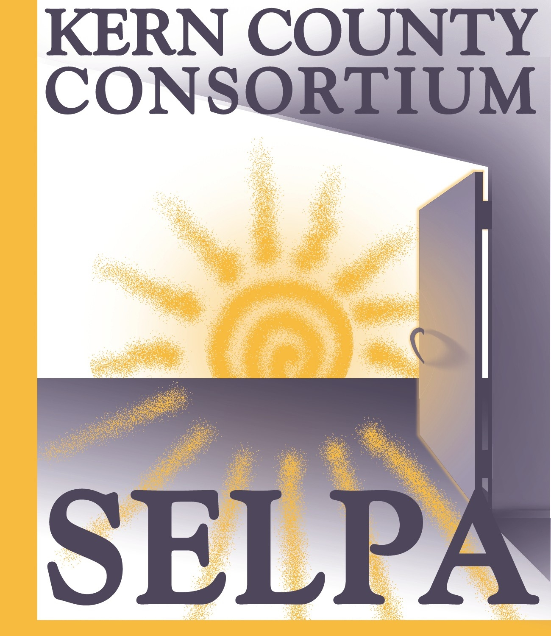

CORRESPONDENCE

Letter from the Wasco Union School District requesting reimbursement of the Moderate Mental Health Intervention funds from January – July of the 2017-18 school year.

APPROVAL OF MINUTES

Review and approval of January 14, 2019 minutes

PUBLIC COMMENT

The Kern County Consortium SELPA Superintendent’s Executive Council (“Council”) welcomes comments from the public at appropriate times during the meeting. The public may address the Council concerning items on the agenda as those items are taken up prior to discussion and deliberation by the Council. The public may also address the Council on items not on the agenda, but within the jurisdiction of the Council, at the time designated.

To conduct Council business in an orderly and efficient manner and allocate available time, each speaker must fill out a speaker card at the beginning of the meeting stating the speaker’s name and the subject to be addressed.

Please wait to be recognized by the meeting Chair. Comments should be addressed to the Council as a whole and not to individual Council members or staff. Unless otherwise determined by the Council, each person is limited to 3 minutes per item. If multiple speakers wish to speak on a specific item, the total time allotted will be 20 minutes.

Speakers should be aware that they may incur legal liability for statements made at a Council meeting, particularly if the comments are not related to Council business.

INFORMATION ITEMS

- Unduplicated CASEMIS Report for 12/1/2018
- Program Transfer Informational Chart

- PIR Training and Focus

- Proposed Change of Date for April, 2019 meeting – Request to Cancel Meeting

- Proposed SEC Meeting Dates 2019-20 School Year

- SELPA Procedural Manual Changes: Next meeting is March 5th

- SELPA Local Plan to LEA Boards - Update

ACTION ITEMS

- Review and action on the Program Transfer by Norris School District for the 2019-20 school year.

- Review and action on the Program Transfer by Panama-Buena Vista Union School District for the 2019-20 school year.

- Review and action on the Program Transfer by Rio Bravo-Greeley Union School District for the 2019-20 school year.

- Review and action on the Program Transfer by Rosedale School District for the 2019-20 school year.

- Review and action on the Program Transfer by Wonderful College Prep Academy, both Delano and Lost Hills sites - for the 2019-20 school year.

- Review and action on the Wasco Moderate Mental Health Interventions reimbursement for the 2017-18 school year.

- Review and action on the proposed canceling of the April, 2019 meeting.

- Review and action on the Proposed SEC Meeting Dates for the 2019-20 School Year.

COMMITTEE MEMBER COMMENTS

ADJOURNMENT

NEXT MEETING

March 18, 2019 9:00 a.m.
KCSOS Conference Room 318

An individual who requires disability-related accommodations or modifications, including auxiliary aides and services, in order to participate in the Superintendents’ Executive Council meeting
should contact the SELPA Office. (Government Code 54954.2)

Any materials required by law to be made available to the public prior to a meeting of the Superintendents’ Executive Council can be inspected at the following address during normal business hours:
Kern County Consortium SELPA Office, 3rd Floor, KCSOS Building
1300 17th Street – CITY CENTRE, Bakersfield, CA 93301

