KERN COUNTY CONSORTIUM SELPA

SUPERINTENDENTS’ EXECUTIVE COUNCIL

October 15, 2018 9:00 AM
AGENDA
1300 17th Street – CITY CENTRE
3rd Floor, Room 318
Bakersfield, CA 93301

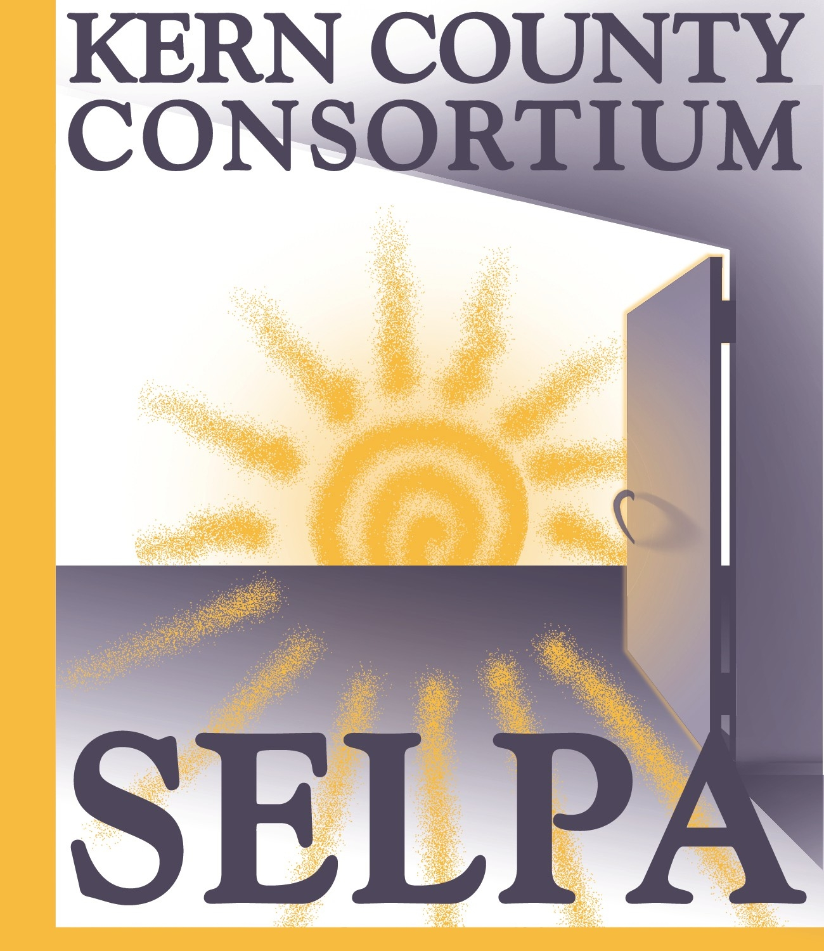

CORRESPONDENCE

None

APPROVAL OF MINUTES

Review and approval of May 21, 2018 minutes

PUBLIC COMMENT

The Kern County Consortium SELPA Superintendent’s Executive Council (“Council”) welcomes comments from the public at appropriate times during the meeting. The public may address the Council concerning items on the agenda as those items are taken up prior to discussion and deliberation by the Council. The public may also address the Council on items not on the agenda, but within the jurisdiction of the Council, at the time designated.

To conduct Council business in an orderly and efficient manner and allocate available time, each speaker must fill out a speaker card at the beginning of the meeting stating the speaker’s name and the subject to be addressed.

Please wait to be recognized by the meeting Chair. Comments should be addressed to the Council as a whole and not to individual Council members or staff. Unless otherwise determined by the Council, each person is limited to 3 minutes per item. If multiple speakers wish to speak on a specific item, the total time allotted will be 20 minutes.

Speakers should be aware that they may incur legal liability for statements made at a Council meeting, particularly if the comments are not related to Council business.

INFORMATION ITEMS

- SELPA Personnel Changes:
- Program Specialists: Lisa Holle, Jennifer Rivera; Karris Brilee has resigned
- Mental Health Clinicians: Laura Dodge, Joshua Stuart

- Area Center Representatives for 2018-19: Welcome Area Center #7 Representative – Aaron Haughton
- Fiscal Reports due to the State by November 15th:
Excess Cost Workbook
Table 8
SEMA/SEMB
Subsequent Year Tracking Sheet
- Compliance Monitoring Timelines and Updates
- Initial Program Transfer Requests for 2019-20
- SELPA Accountability Reporting (“LCAP”) Coming in the next year or so – Direction will be needed
- New SELPA Annual Budget Plan – will be piloted this year in addition to previous plan
- Changes to Teacher Credentialing being rolled out
- Data changes for Special Education on the horizon
- SELPA Lead Grant Information

- Aurora Update: Brian Cortez
- APE Challenge and Solution in a District
- Community Advisory Committee (CAC) Update:
Planned Parent Trainings:
Date | Time | Room | Workshop Title
1/11/19 | 10am – 1pm | 318 (3rd Floor) | Preparing For and Understanding the IEP and Your Role
2/20/19 | 10am – 1pm | 318 (3rd Floor) | Understanding Assessment and Its Role in the IEP Process
3/20/19 | 10am – 1pm | 318 (3rd Floor) | Knowing Your Parent Rights and Who to Turn to For Help

- Review Area Center Change Options and Provide Input

- Review Local Plan Suggested Revisions and Provide Input

- Review Fiscal Advisory Committee Suggested Input for Allocation Plan

ACTION ITEMS

- Review and action on recommendation for legal fee reimbursement request from Kernville Union SD for $10,000.00 dated 7/30/18 and received 8/2/18 to be included in the 2017-18 requested funds total that will be paid as a pro-rata share of the legal funds available.
- Review and action on recommendation for legal fee reimbursement request from Edison Elementary for $15,422.80 dated 7/11/18 and received 7/16/18 to be included in the 2017-18 requested funds total that will be paid as a pro-rata share of the legal funds available.

COMMITTEE MEMBER COMMENTS

ADJOURNMENT

NEXT MEETING

November 19, 2018, 9:00 a.m.
KCSOS Conference Room 318

An individual who requires disability-related accommodations or modifications, including auxiliary aides and services, in order to participate in the Superintendents’ Executive Council meeting
should contact the SELPA Office. (Government Code 54954.2)
Any materials required by law to be made available to the public prior to a meeting of the Superintendents’ Executive Council can be inspected at the following address during normal business hours:
Kern County Consortium SELPA Office, 3rd Floor, KCSOS Building
1300 17th Street – CITY CENTRE, Bakersfield, CA 93301

