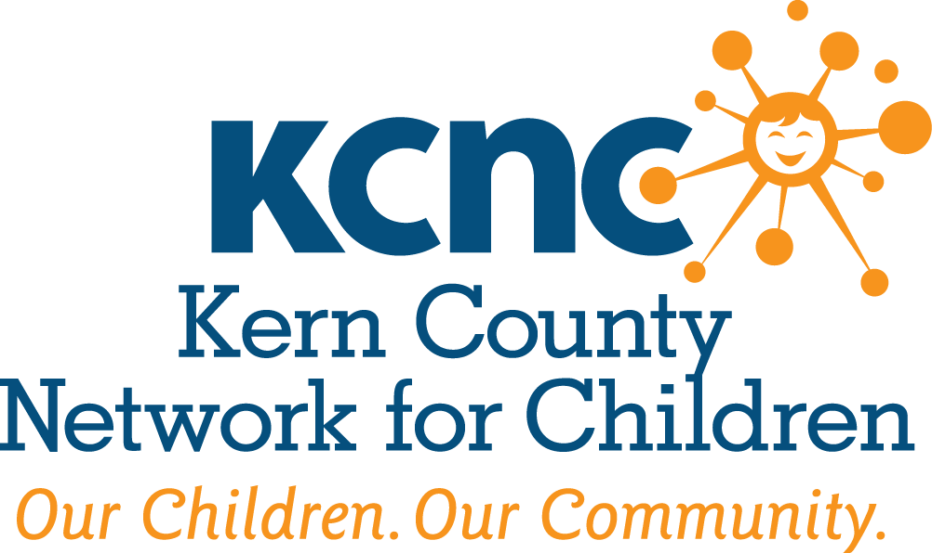

KERN COUNTY NETWORK FOR CHILDREN
LEADERSHIP DEVELOPMENT TRAINING PROGRAM

2020 APPLICATION FORM

Applications accepted Tuesday, October 1, 2019 thru Friday, November 1, 2019

Applications must be mailed or hand delivered to the KCNC office no later than noon Friday, November 1, 2019. Faxed, emailed or late applications will not be accepted.

What is the mission of the Kern County Network for Children?
The mission of the Kern County Network for Children is to protect and enrich the lives of children in Kern County through the commitment of all community partners by helping to build and sustain healthy families.

We believe in:

- Personal responsibility and family self-sufficiency as the cornerstones of resilient, stable communities;
- Grassroots solutions to local problems;
- Empowering local residents to address common concerns;
- Locally-based, accessible services;
- Program accountability and delivery of cost-effective services

What is the Leadership Development Training Program?
The program focus is on skills-training to build the strength of local organizations and nurture natural leaders in communities where they are already engaged in local collaborative groups and citizen action mobilization efforts. The Leadership Development Training Program includes fifty-six (56) hours of instruction time in nine (9) subject areas: public speaking, time management, community meeting facilitation, conflict resolution, community mobilization, resource development, media/marketing and legislative advocacy. A non-refundable $120.00 participant fee to cover the partial cost of class materials and meals is due upon acceptance into the program.

Program Goals:

To Educate: Participants will increase their understanding of both public issues and human relationships.
To Mobilize: Participants will learn to lead effectively in areas of community health and well-being.
To Organize: Participants will develop a network of allies and links to other citizen action groups with common interests and issues.

Kern County Network For Children Leadership Application Checklist

In order for you application to be accepted the following must be completed/included in the application.

Completed

Page 3. Contact Information / Section I

Page 4. Section II

Page 5. Section III

Page 5. Section IV.

Page 5. Section V. (Current resume; letter of recommendation)

Page 6. Section VII.

Page 8. Participant Agreement Form

KERN COUNTY NETWORK FOR CHILDREN
LEADERSHIP DEVELOPMENT TRAINING PROGRAM

2020 Application

Please be brief in your responses. Finalists will be selected and interviewed based on application material submitted. Class size is limited. Applications accepted Tuesday, October 1, 2019 thru Friday, November 1, 2019.

Name
(First) (Last)

Home Address
(Number) (Street) (City) (Zip)

Work Mailing Address
(Number) (Street) (City) (Zip)

Home Phone Number Work Phone Number

Email Address Number of Years in Kern County

Do you expect to be living in this area in 3 years? (Please check one) Yes ____ No ____

- EMPLOYMENT

Current Employer Job Title

Briefly describe your responsibilities:

- ORGANIZATIONS / ACTIVITIES / COMMUNITY INVOLVEMENT

What community activity or organization have you been most involved in and why?

Please list in order of importance to you, other community, civic, professional, business, religious, social, athletic and other organizations of which you have been or are a member.

Organization Dates of Membership

What do you consider your most significant personal or professional accomplishment and why?

What are your areas of particular interest for leadership involvement (e.g., education, human services, government, religion, etc.)?

Why would you be a good candidate for the Kern County Network for Children’s Leadership Development Training Program?

- GENERAL

What do you hope to gain from participation in the Training Program, and how do you expect to utilize your leadership experience?

- REFERENCES

Please provide the names, titles and phone numbers of three professional references that can be contacted by the screening committee.

- ADDITIONAL MATERIALS

- Please provide a current resume.
- Please provide at least one letter of recommendation.

- CLASS TOPICS

The Leadership Development Training Program includes fifty six (56) hours of instruction time in nine (9) subject areas:

- Introduction to public speaking
- Effective time management
- Effective meeting facilitation
- Strategic planning
- Conflict resolution
- Community mobilization
- Resource development
- Media/marketing
- Legislative advocacy

All trainers and/or presenters are individuals with expertise in each topic area.

- CLASS SCHEDULE

The Kern County Network for Children’s Leadership Development Training Program requires participation on the following dates from 8:30 a.m. to 4:00 p.m. All classes will be held in Bakersfield at the Larry E. Reider Education Center located at 2000 ‘K’ Street.

**Thursday, January 30, 2020 & Friday, January 31, 2020 Friday, April 24, 2020

Friday, February 28, 2020 Friday, May 29, 2020

Friday, March 27, 2020 Friday, June 26, 2020

Thursday, July 16, 2020 - Graduation

In addition to the above dates, class members will be required to work on a class project during and outside of class time.

**All classes will be held on Fridays with the exception of the first class meeting, Thursday, January 30th. Lunch is provided for participants during each class session, if you have dietary needs please let us know once you are accepted into the program.

VII. PARTICIPATION

In order for the Kern County Network for Children’s Leadership Development Training Program to accomplish its stated goals, the full participation of each individual is necessary. Because acceptance in the Program is a competitive process, class requirements include:

- More than one absence during the program year will result in being dropped from the program.
- Late arrival or partial attendance at any session in excess of three occurrences will result in being dropped from the program.
- Participation in a class project during and outside of class time.

A non-refundable $120.00 participant fee to cover the partial cost of class materials, presenter fees and meals is due upon acceptance into the program. Participation in the Kern County Network for Children’s Leadership Development Training Program must have the support and commitment of your employer, if not self-employed. Please have your employer sign below.

The applicant has my support and permission to participate in the Kern County Network for Children’s Leadership Development Training Program.

(Signature of Employer) (Date)

(Please Print Name & Title) (Phone Number)

Upon receipt and review of your application, oral or written notification will be given to you regarding the status of your application by Friday, November 1, 2019. Applicants will be contacted for a final interview to take place the week of December 2, 2019. Class size is limited.

I understand the purpose of the Kern County Network for Children’s Leadership Development Training Program, and this application does not ensure my acceptance in the class. If selected to participate, I will devote the time required. (Please sign below)

(Applicant’s Signature) (Date)
As a matter of policy, the Kern County Network for Children’s Leadership Development Training Program does not discriminate among applicants and participants on the basis of gender, race, religion, sex, national origin, color, age, handicap or sexual orientation.

- APPLICATION DEADLINE

Applications must be received in the Kern County Network for Children office no later than noon, Friday, November 1, 2019. Faxed, emailed or late applications will not be accepted.

Mail completed applications to:

Kern County Network for Children
Leadership Development Training Program
1300 17th Street
Bakersfield, CA 93301

or

Hand Deliver applications to:

ATTN: Alexis Shaw
Kern County Network for Children Dream Center
801 19th Street
Bakersfield, CA

A non-refundable $120.00 participant fee is due upon acceptance into the program, or no later than January 30, 2020 to cover the partial cost of class materials, presenter fees and meals. Checks should be made payable to:

Kern County Network for Children
Checks may be hand delivered and/or mailed to the address above.

Should the $120.00 participant fee pose financial hardship to any potential applicant, a class scholarship may be requested.

Kern County Network for Children Leadership Development Program
Participant Agreement Form

- ATTENDANCE
AS A STUDENT YOU ARE EXPECTED TO ATTEND ALL SEVEN (7) CLASS SESSIONS

A policy has been established for emergencies that as a class member you are allowed to miss up to a maximum of one (1) day before being dropped from the class.

- Late Arrival: Late arrivals that exceed 10 minutes, of the morning or afternoon session you will be charged with a ½ day absence.

- Partial Attendance: If you miss a portion, in excess of 10 minutes, of the morning or afternoon session you will be charged with a ½ day absence.

- Missed Session: If you are not able to attend a session all day you will be charged for 1 day absence.

- TUITION – IS NON-REFUNDABLE
Cost for the program is $120.00. If you are accepted into the program the tuition must be paid by the first class session in January. There are a limited number of partial scholarships available. If selected are you in need of financial assistance?
____ Yes ____ No

- TEAM PROJECT
The Kern County Network for Children Leadership Development Program Experience includes a “community project”. The project will: Create a forum in which small subgroups of the KCNC Leadership Class will work closely together towards a common, self-identified goal.

I understand that the “community project” will demand a commitment of time outside of the given class curriculum and lack of participation in my team’s project can result in being dropped from the KCNC Leadership Program at KCNC’s discretion. _____ Please initial

- NOTIFICATION OF ACCEPTANCE
Notification of your acceptance to the KCNC Leadership Development Program will be made by mail in December after the interviews.

I understand the purpose of the Student Agreement Form and the information contained therein. I further understand that the failure to complete and sign this form gives KCNC permission to withdraw my application for consideration.

SIGNATURE DATE

