Midway Elementary School

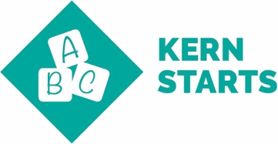 | Kindergarten Readiness- Children Enter School Ready to Learn  Transitional Kindergarten is focused on preparing students for Kindergarten. The small class size and adult to student ratio of 1 to 8 gives ample opportunities for students to be ready to read and complete math problems. Social interaction occurs with a TK-K combo class and students are learning expectations of K when entering TK. Early first instruction with CompuCat, one on one site words, and repetitive instruction.
 | 3rd Grade Literacy and 5th Grade Math Proficiency: Children read at grade level by the end of 3rd grade and demonstrate core math proficiencies by the end of 5th grade. 15 to 1 student to teacher ratio plus aides in the classroom which lends itself to differentiation of instruction Diagnostic done continuously due to small group ratio: small classes can meet the needs of all students, reteach and extended learning opportunities, higher expectations, ability to slow down the curriculum from 5to 8 days as needed for student learning
 | 8th Grade Literacy and 5th Grade math Proficiency.: Students demonstrate reading and math proficiency by the end of 8th grade. Cold reads, running records, mid-chapter and performance assessments, with writing mentor sentences, Writing City, and bubble maps as writing proficiency. Math includes strong first instruction with reteach, and moving from 5 to 8 days of instruction units.
College and Career Readiness: High school students graduate ready to succeed.
Not applicable to K-8 school.

