Midway Elementary School

Collaboration of Calendaring events, activities, curricular benchmarks, etc. are completed as a full staff and remains in the staff lounge for reference.

High Parent Participation in activities throughout the year.

The Tiger Way is seen throughout the school as a reminder to staff and students of the school’s vision for each person that walks on their campus.

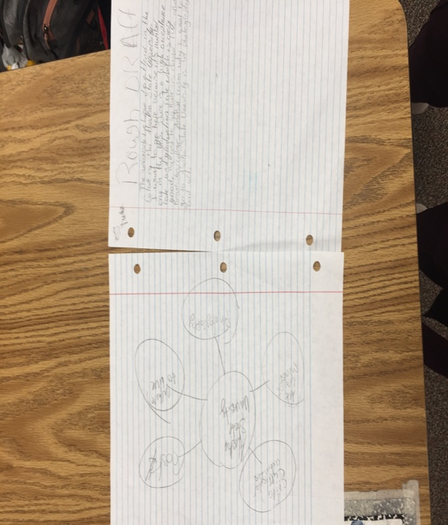
Bubble Maps and other graphic organizers are used as a pre-writing lesson.

