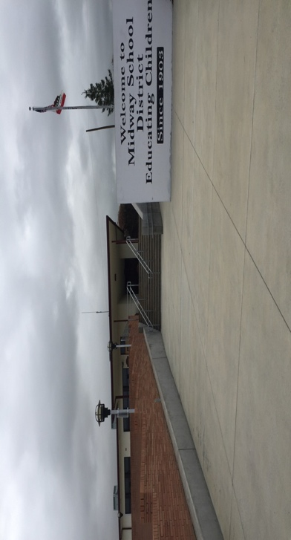
Midway Elementary School
“I stress to my teachers that they need to do an amazing job in the class and Mr. Q will take care of the rest. "
Designated 2019
3 Year Avg. Math -6.2 Below Standard
ELA 8.7 Above Standard
Midway School District
Kern County
Name of Principal/Superintendent: Al Quezada
259 F Street, Fellows, Ca.
(661)768-4344
Website: midwayschooldistrict.org
Date: January 29, 2020
Email: alquezada@midwaytigers.com
School Profile
Midway elementary School is a small rural school district on the southeast side of Kern County in a small oil town, established around 1903. The small K-8 school district reports total enrollment of 88 students (Data Quest, 2019-2020).
School Demographics
The student populations include 58% socioeconomically disadvantaged and 12 qualifying for special education services. The population is predominately white, with 77%, 17% of the students are Hispanic or Latino and 5% are two or more races or other. With such a small student population, individual accommodations are the main contributing factor to the students’ success.
Contributing Factors
15 to 1 student to teacher ratio plus aides in the classroom which lends itself to differentiation of instruction

- Diagnostic done continuously due to small group ratio
- Small classes can meet their needs of all students
- Reteach and extended learning opportunities
- Higher expectations
- Can’t hide from the teacher
- Ability to slow down the curriculum from 5 to 8 days as needed for student learning
- Allows for combo classes to be successful
Programs/Curriculum used to fidelity throughout all grades.
- Journeys-
  - Cold Reads
  - Running Records
  - Mid-Chapter and Performance assessments
- GoMath
  - Reteach
  - Moved from 5 to 8-day instruction units
Early First Instruction
- CompuCat used as a differentiation tool for math
- One-on-one site words
- Early subject matter exposure -Students learn from each other with combo classes – i.e. First grade instruction is heard and learned by Kindergarten students
  - Repetitive instruction- i.e. first grade students hear kindergarten instruction which layers their learning from possible lost units of learning and reminders of what was learned.
Writing includes
- Mentor Sentences- https://www.scholastic.com/teachers/blog-posts/mary-blow/17-18/Mastering-Grammar-with-Mentor-Sentences-Part-1/
- Writing City
- Bubble Maps

Communication/Collaboration
- Monday morning go over the week check in and time collaborate regarding students and share strategies.
- PLC across grade levels-First Wednesday of every month

Social Emotional Learning (SEL)
- The TIGER way- students come to class ready to learn
- Accountable recognition
- Go through expectations at the beginning of the year explains the rewards
- Students come to class ready to learn
- Student Recognition

- Strong community connection – The Community surrounding Midway school is very active in the success of the students. Contributing Factors

