Downtown Elementary

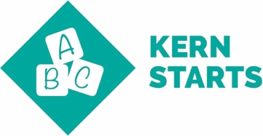 | Kindergarten Readiness: Children enter school ready to learn.  Students are tested prior to coming into kindergarten. Teacher meets with parents and reviews information. Learning plans are set for the students to best help the learning.
3rd Grade Literacy and 5th Grade Math Proficiency: Children read at grade level by the end of 3rd grade and demonstrate core math proficiencies by the end of 5th grade.
Pre and post data points are collected and notes growth in math and ELA. Guided Reading, classroom libraries, Technology – IPad/Osmo at primary level used daily as a center. Small group, leveled instruction , Appropriate center activities during rotations. Number Talks for deep math learning. Hands on math : Clothesline, Number Talks, and Math Tasks.

8th grade Literacy & Math Proficiency : Students demonstrate reading and math proficiency by the end of 8th grade.
Anchor charts, Hands on Math instruction to include Real World tasks. All genres of writing required for 7th and 8th grade students. RTI model used for students after CFUs. Daily posting of Learning Intentions and Success criteria in ELA and Math.
College & Career Readiness: High School students graduate ready to succeed.
Downtown Elementary offers Robotics Teams, Leadership/Government opportunities and Debate Club
Field Trips to Colleges
These help students with high school class choices.

