Downtown Elementary School

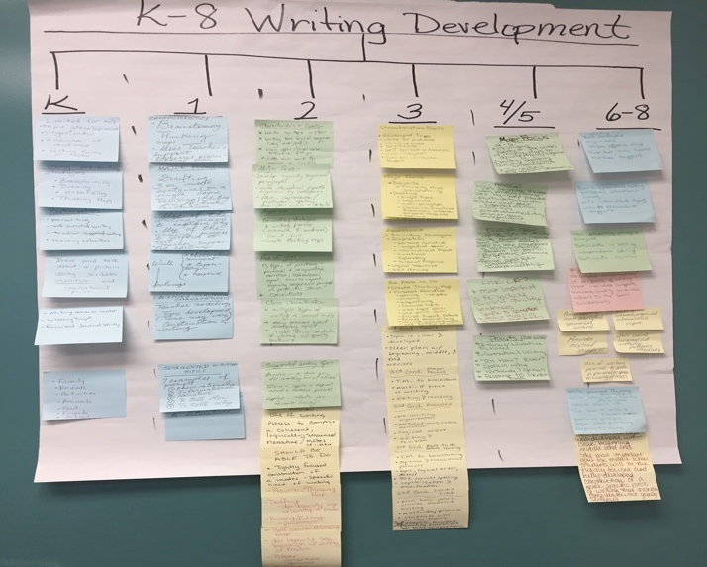 | Articulation from grade levels regarding writing expectations. Focus of Professional development/ collaboration includes time outside of contract hours- after school and Saturdays, with extra pay. Writing expected in every subject and in all genres.
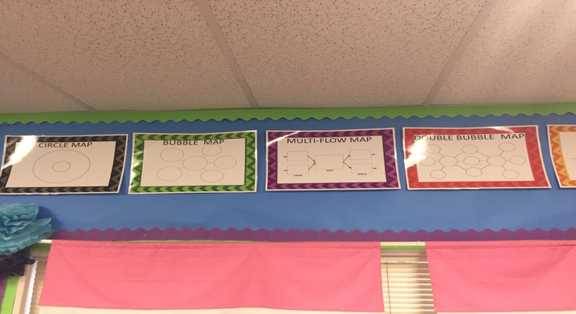 | Schoolwide Implementation of Thinking Maps (3-4 years in the making). Thinking maps used in writing, reading comprehension, history, science, and math. Number Talks, Clothesline math and other hands on math activities can be charted by using Thinking Maps.
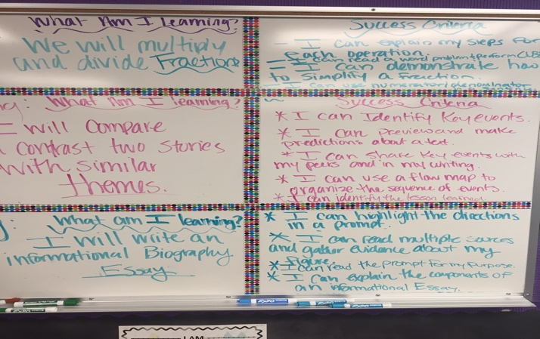 | Daily posting of Learning Intentions and Success Criteria in ELA and Math required in every class. Teacher Efficacy -All teaching staff have gone through John Hattie’s research by way of 3- year book study. Leadership team attended conference- Visible Learning for Teachers and Visible learning for Literacy.

