Cesar Chavez Elementary

 | School Goals are created in alignment with District Goals and 4 Key Priorities.
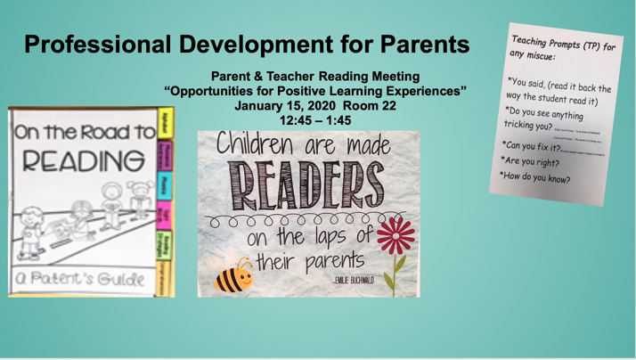 | - Modeled after the research of Irene C. Fountas and Gay Su Pinnell in their book, “Guided Reading: Responsive Teaching Across the Grades.”  - Academic Program Leader (APL), Community Readers (volunteers trained by our reading teacher), and a minimum of 4 parent volunteers per kindergarten class, 3 days each week. Additionally, teams of 6th grade peer tutors are deployed 2 days per week.
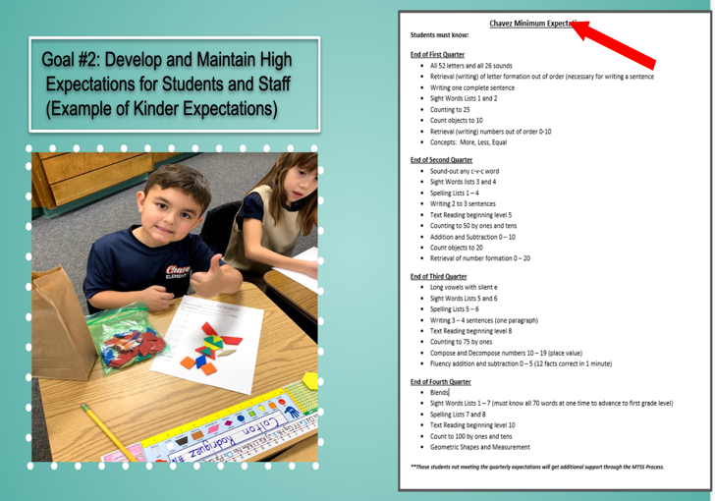 | High expectations for each student start in Kindergarten (Both Math and Reading). High expectations are also set for staff in terms of knowing standards and strategies for rigorous academics. Each grade level has a list of minimum expectations, which causes each grade level to the same articulated rigor.  Power Point Slides with more resources.

