Cesar Chavez Elementary School

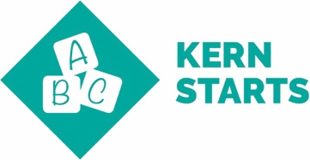 | Kindergarten Readiness: Children enter school ready to learn. Students may attend a pre-kindergarten program from home or on-site. The State pre-kindergarten program is offered by BCSD, and information given to parents from Chavez elementary school The Transitional Kindergarten program gives a readiness assessment – Core Growth- that is used to help the teacher differentiate the child’s learning program. Parent/student school-ready resources are offered and expectations given the spring prior to student enrollment.
 | 3rd Grade Literacy & 5th Grade Math Proficiency: Children read at grade level by the end of 3rd grade and demonstrate core math proficiencies by the end of 5th grade. High expectations for math and reading are set and kept from each grade level within each quarter with assessments given to analyze. Students are given help through a schoolwide Guided Reading program and researched based one-on-one support from trained adults and cross age class tutors. Block schedules are set with emphasis on math and reading. Number Talks and math manipulatives are used for conceptualization.
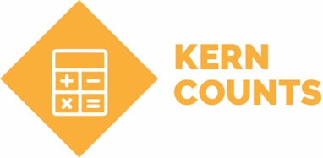 | 8th Grade Literacy & Math Proficiency: Students demonstrate reading and math proficiency by the end of 8th grade.  Not applicable to Chavez Elementary.
College & Career Readiness: High school students graduate ready to succeed.
Not applicable to Chavez Elementary.

