American Elementary School

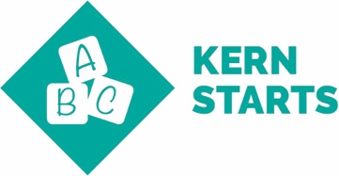 | Kindergarten Readiness: Children enter school ready to learn.  Universal Screening and Diagnostics for all students enrolling into school with a benchmark assessment. Transitional and Traditional Kindergarten students are given a kinder readiness assessment in the Spring prior to starting school. Student data is analyzed and reviewed by teacher and parents. If students show deficits, it is discussed with an action plan.
3rd Grade Literacy and 5th grade Math Proficiency: Children read at grade level by the end of 3rd grade and demonstrate core math proficiencies by the end of 5th grade.
Higher Order Thinking is a school wide focus within all subject areas, leading to proficiency levels. Rubrics and exemplars are set by collaborating teacher/administrator. Instructional Rounds repeated once a quarter with emphasis on watching for higher Order thinking by students as noted by DOK 3-4 (Webbs Depth of Knowledge).

8th Grade Literacy and Math Proficiency: Students demonstrate reading and math proficiency by the end of 8th grade.
Not applicable to American Elementary School.
College & Career Readiness: High school students graduate ready to succeed.
Not applicable to American Elementary School.

