American Elementary School – Becky Devahl Principal since July 1, 2019. Rob Bray prior principal for 10 years +

Date of visit: Jan. 7, 2020 @ 9:00 am

Interview with Becky Devahl:
“The child is the parents’ most prized commodity.”

Contributing factors to student learning outcomes:

#1

District System to School system and focus- Stay the Course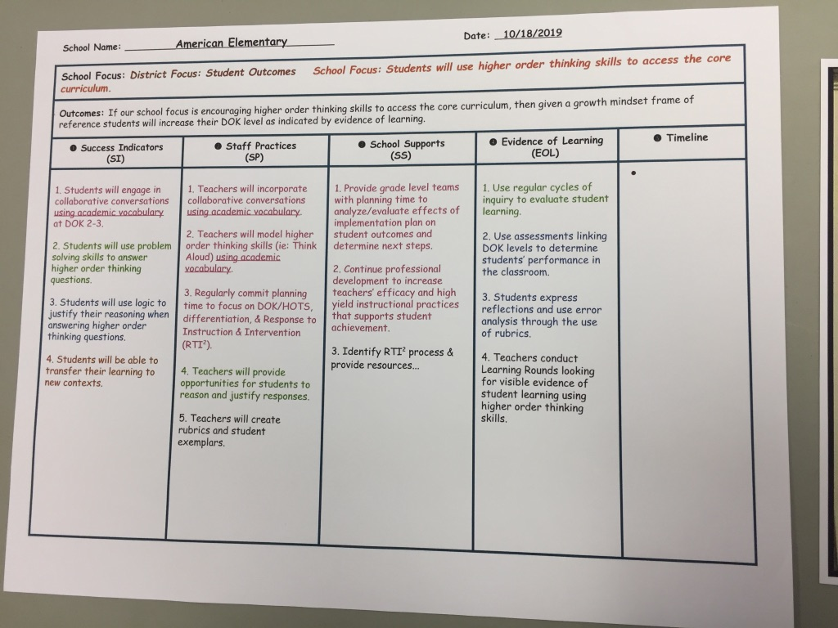

3-4 years with Innovate Ed to develop a system that includes sustainability. If then statements were created by leadership team and followed by the staff. American Elementary focused on using higher order thinking ( DOK 3 and 4).

Universal Screening for all students enrolling into school with benchmark assessments
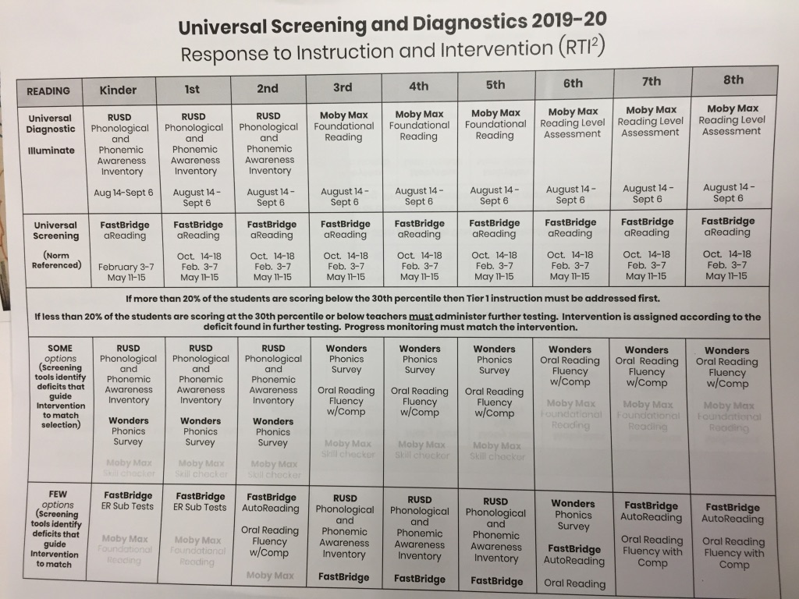
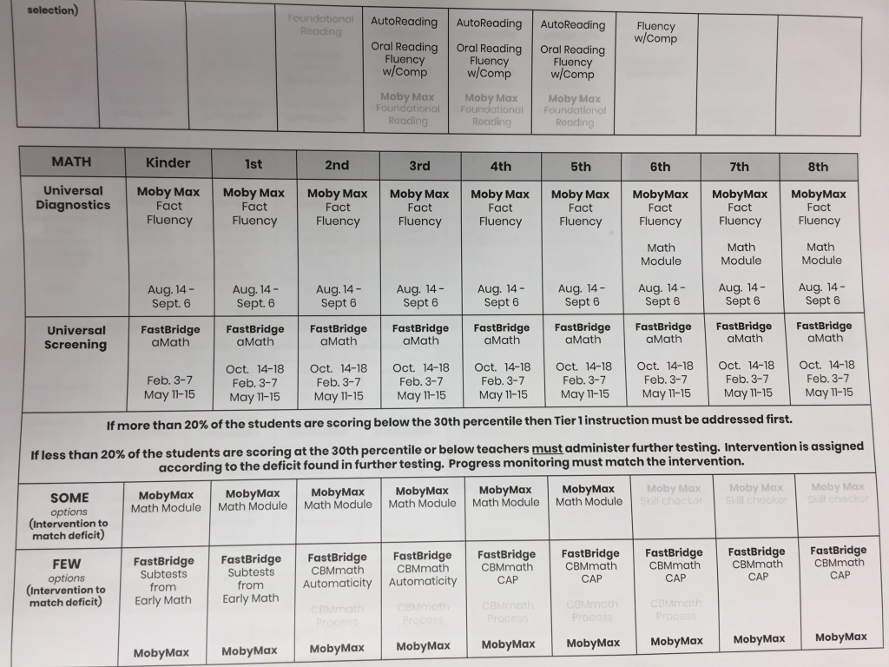
Cycles of Inquiry required every 6 weeks. Each grade level meets and goes over student evidence analysis protocol. Interim assessments - each grade level team meets and goes over student evidence/assessment analysis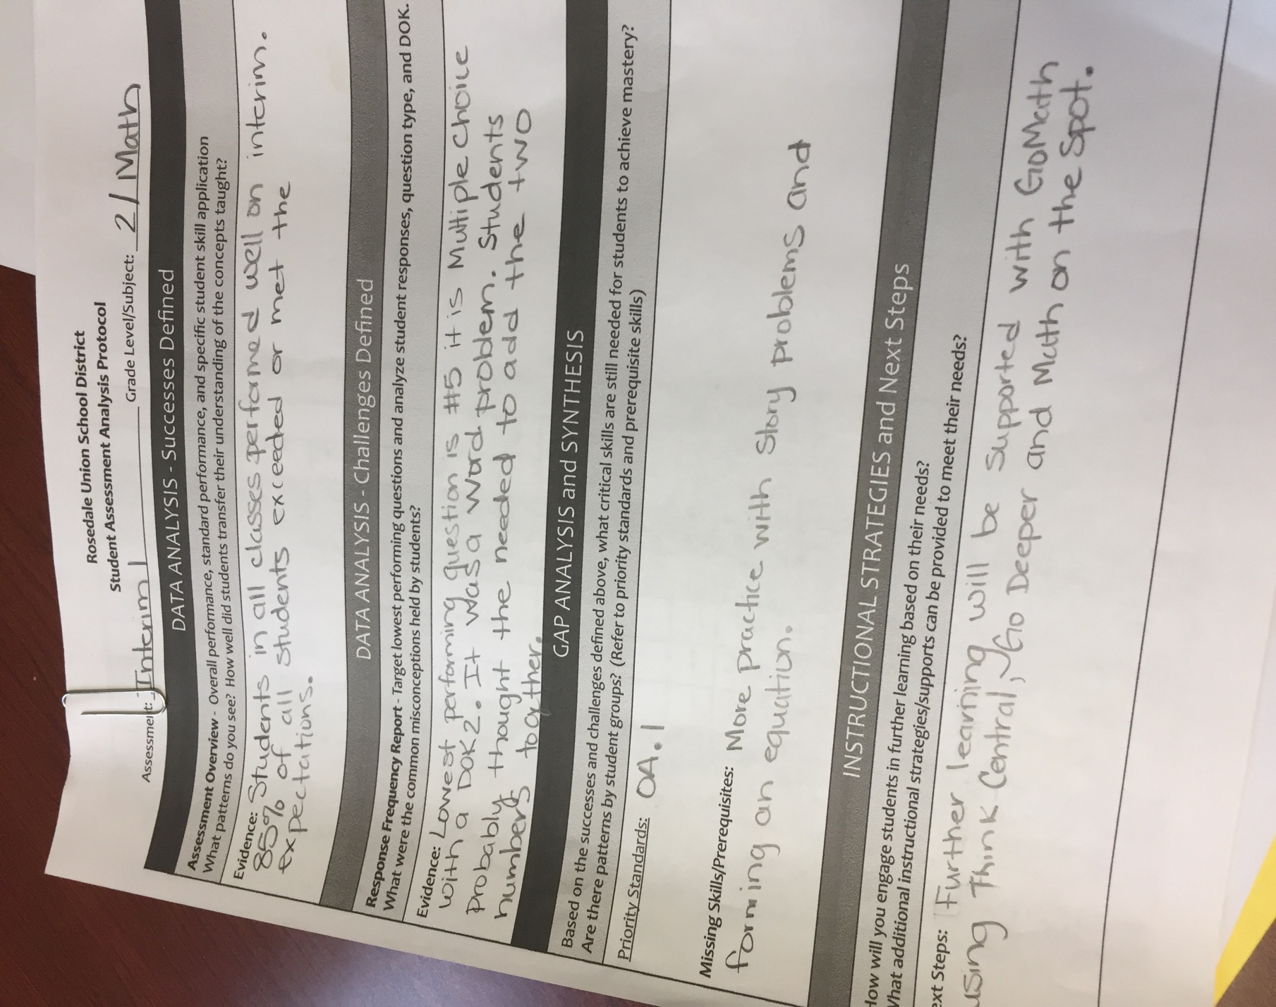
Completed during PLC – every Wednesday of early release. If more teachers need.

Glows and Grows are created by grade level team during PLC. If PLC time is not enough, then teachers by grade level can request a day out of the classroom to collaborate. 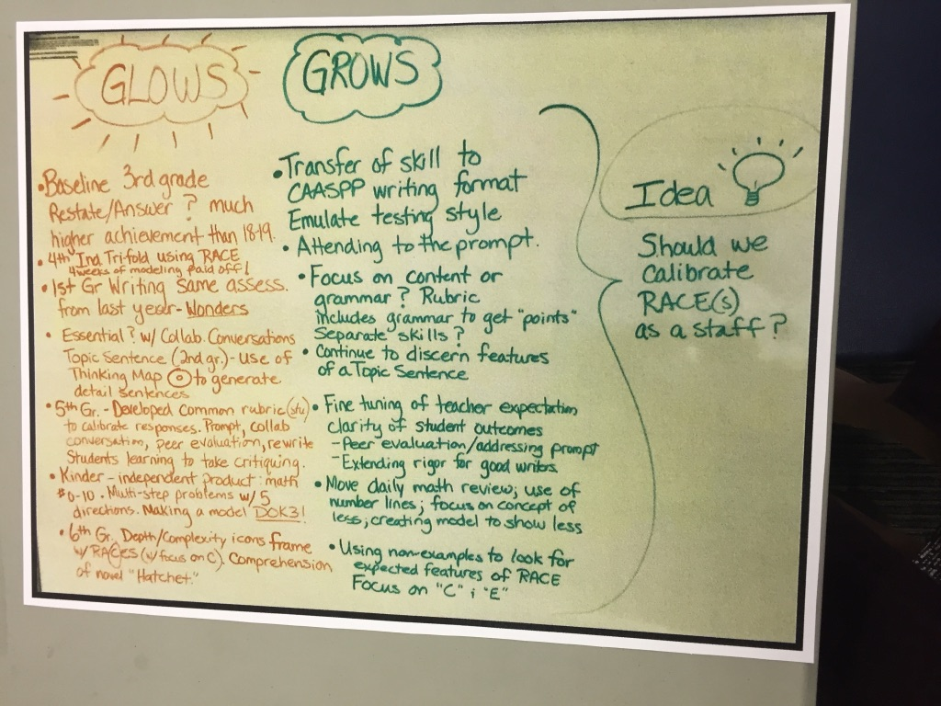

Staff meeting once a month that corresponds to evidence of student learning.

#2Quarterly Learning Rounds- School site teacher teams are formed ( see schedule). The students are observed under topics set within student focus set by school site.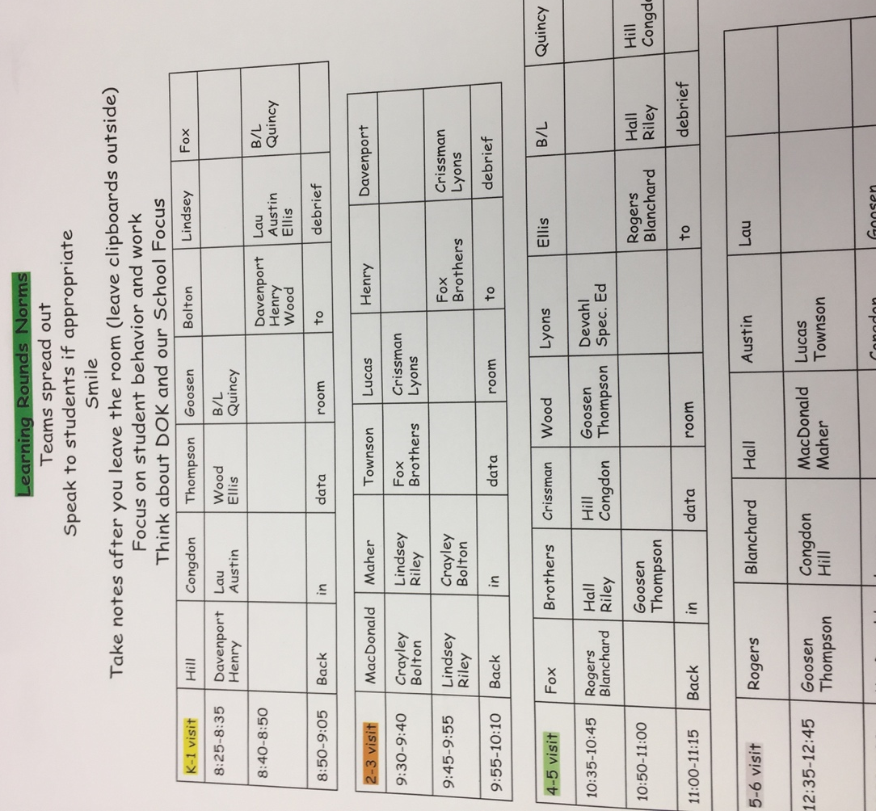 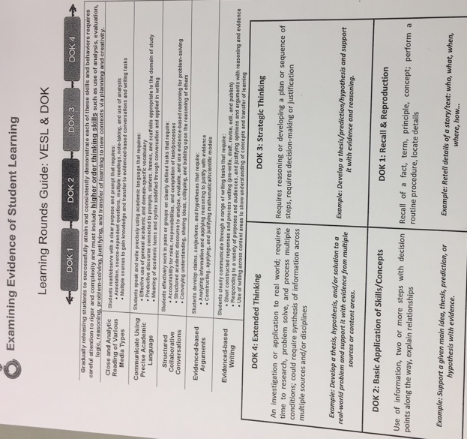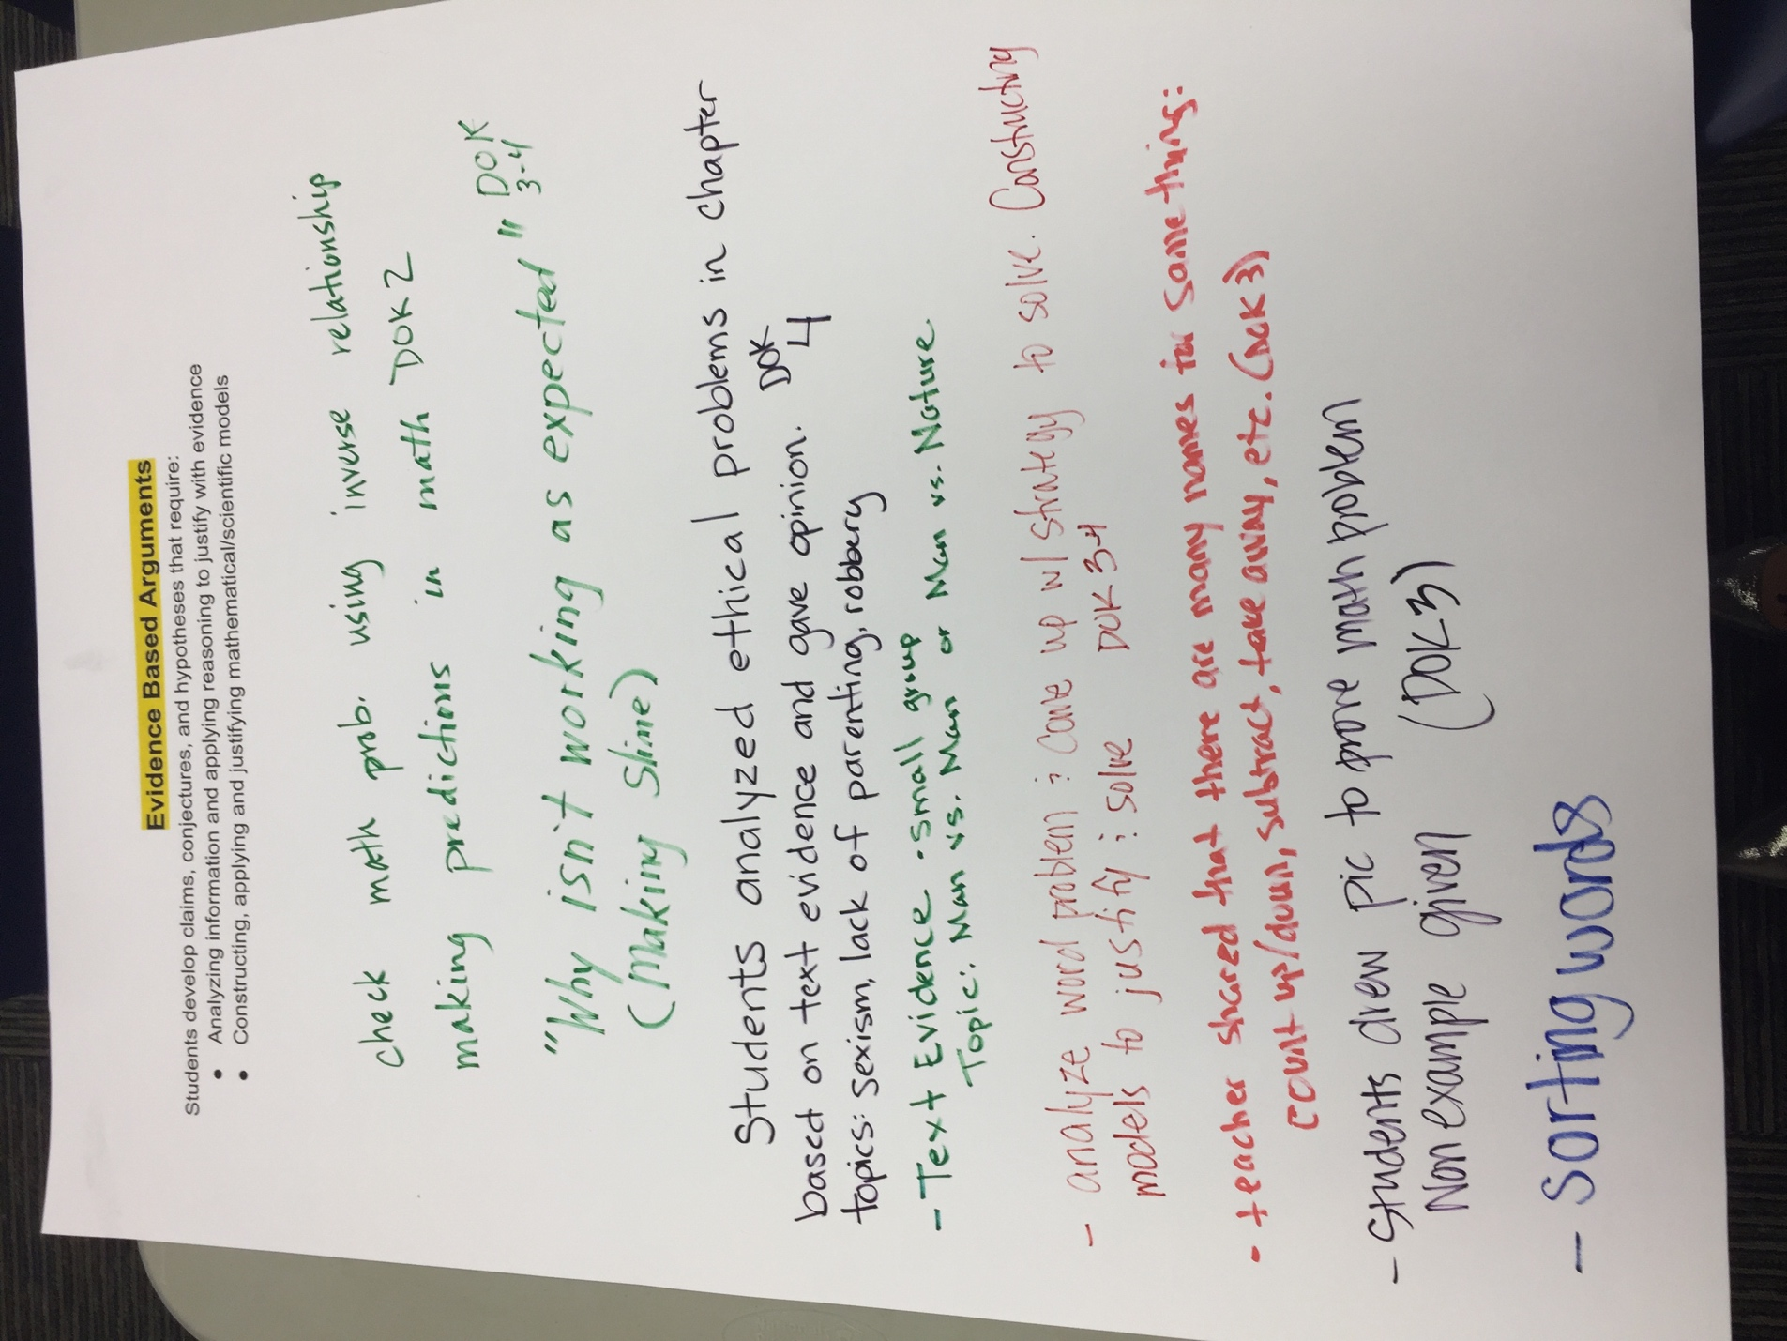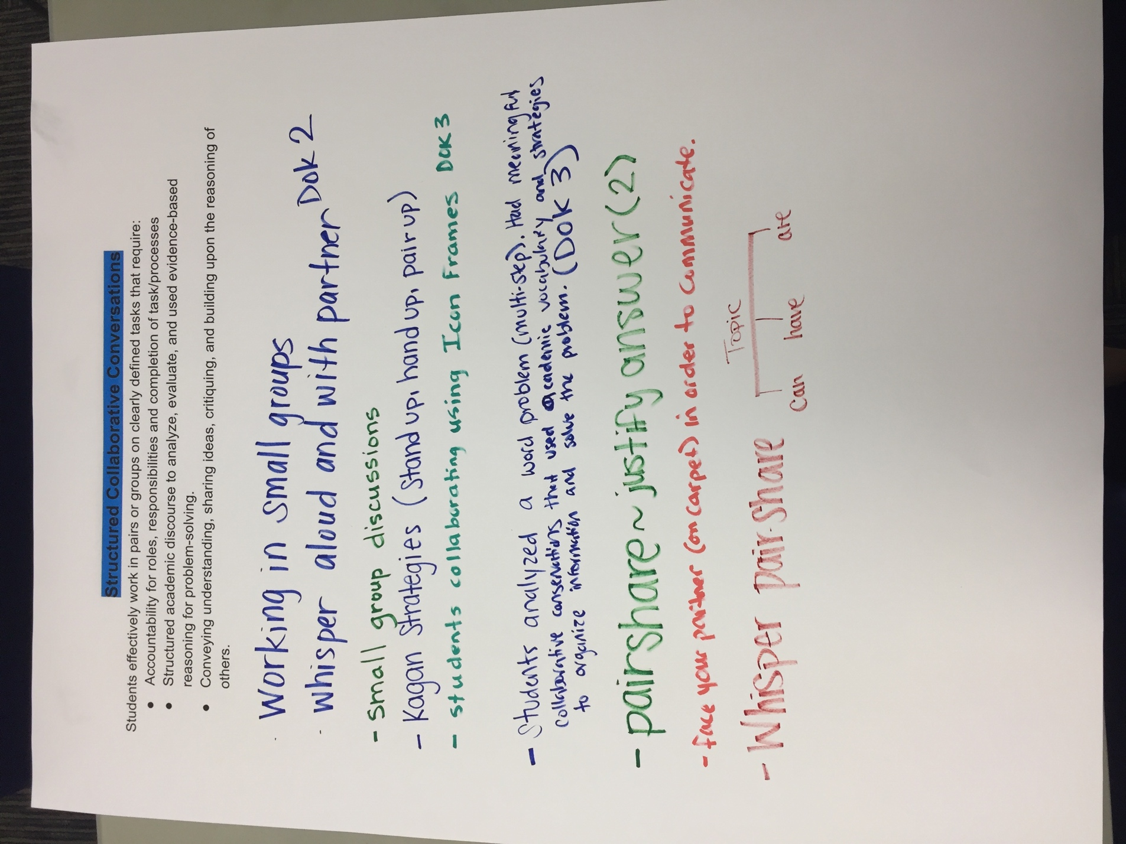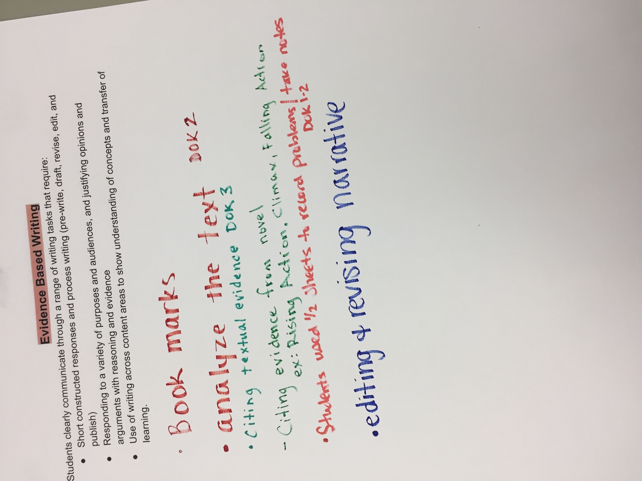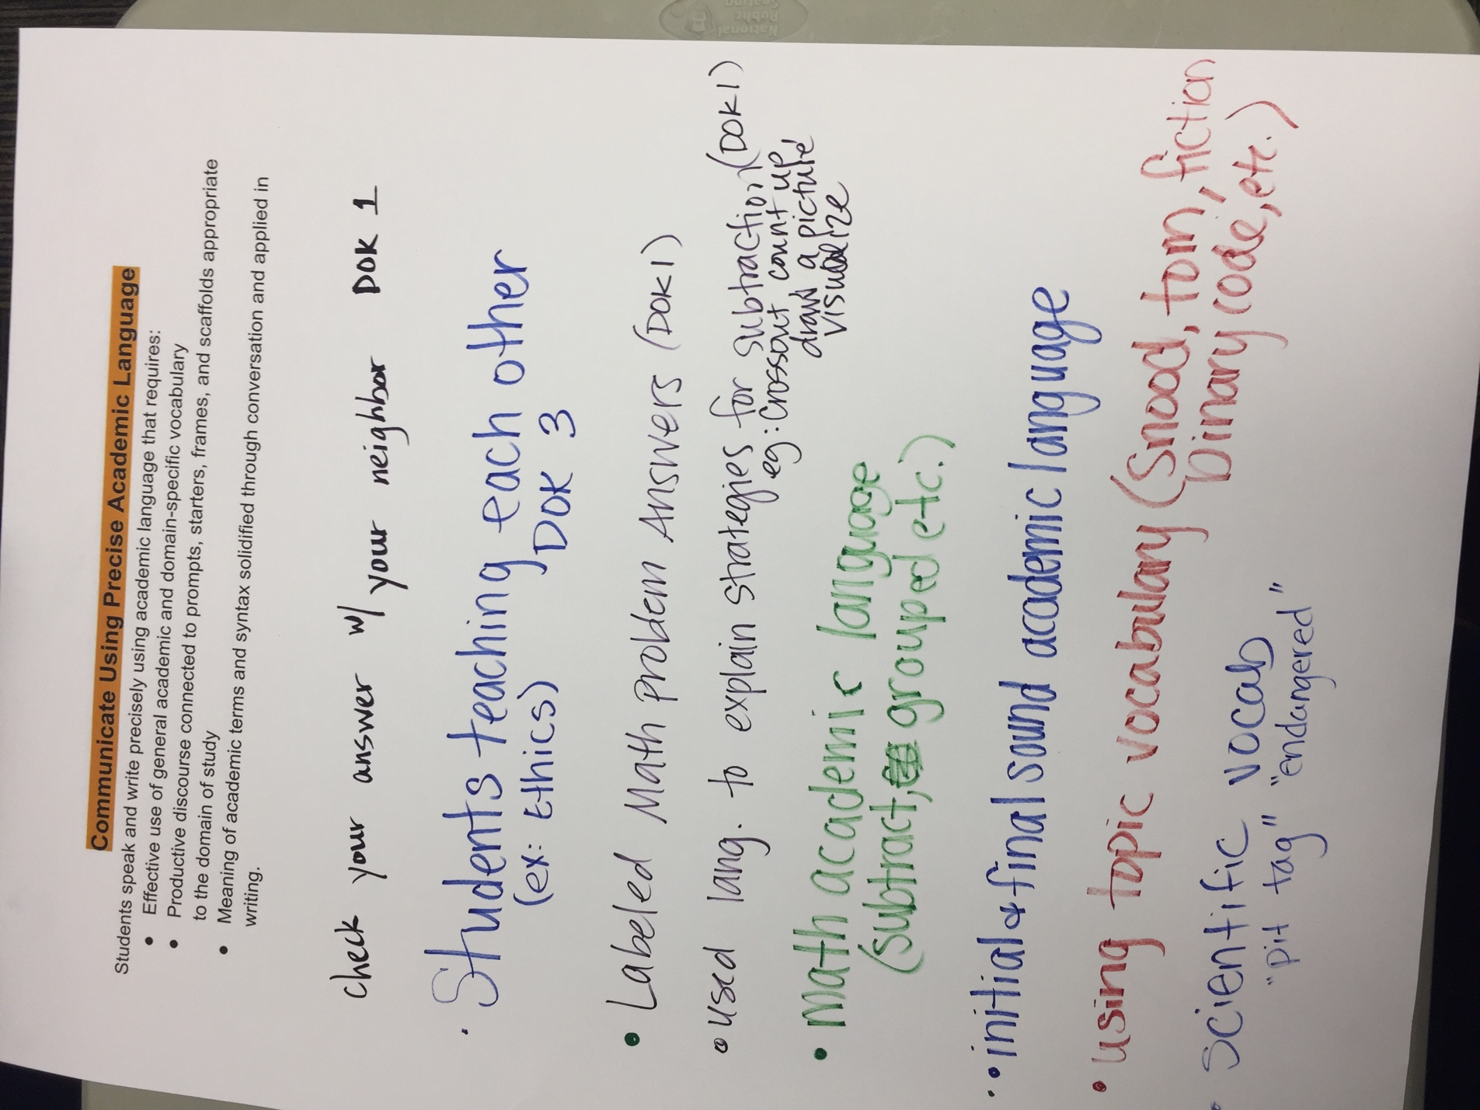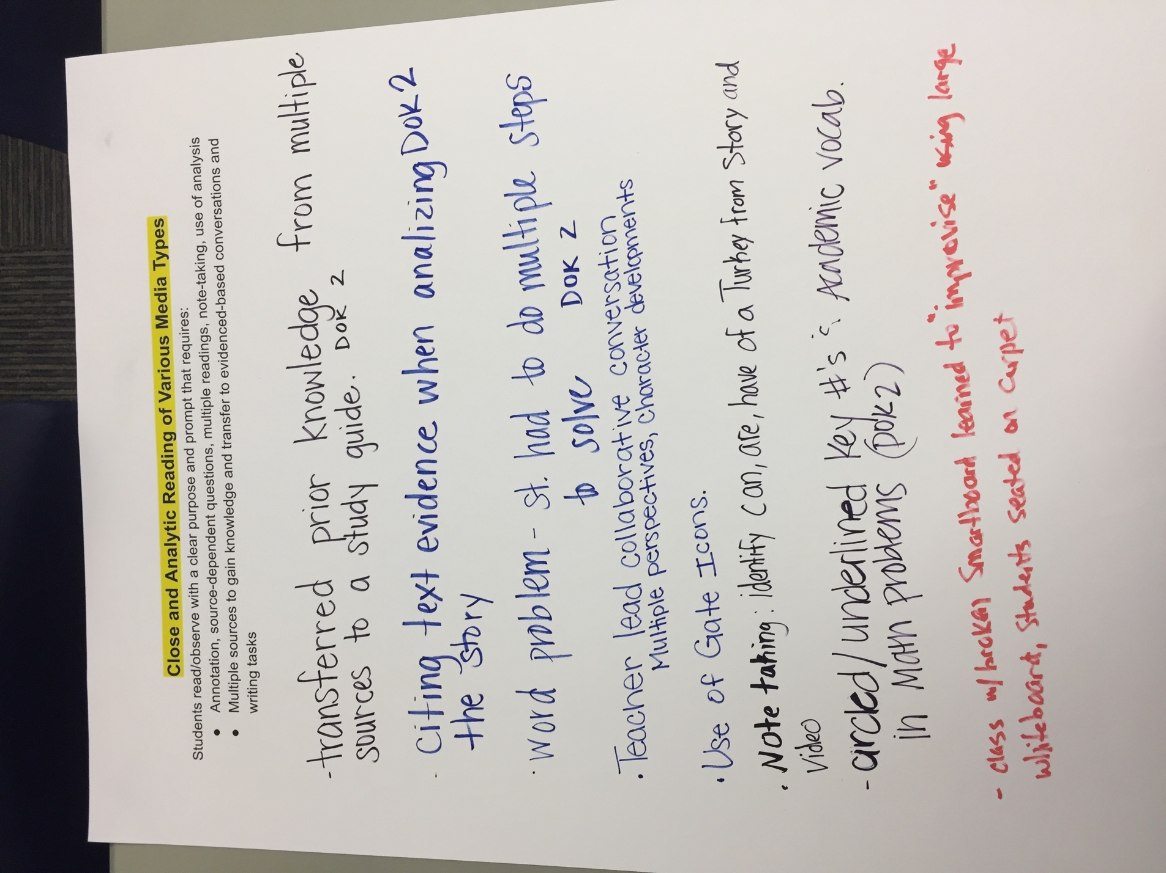
Teachers meet school wide to go over the learns from the Learning Rounds.
#3 The School Leadership team, including the school counselor dean, principal, lead teacher, are involved in a day of “data dive” . The strengths and weaknesses are observed and given to previous grade level ( i.e. weakness seen in 3rd grade, then data will be shown to 2nd grade) so that adjustments can be made in student learning outcomes.

#4 Intervention: School Wide Book Read 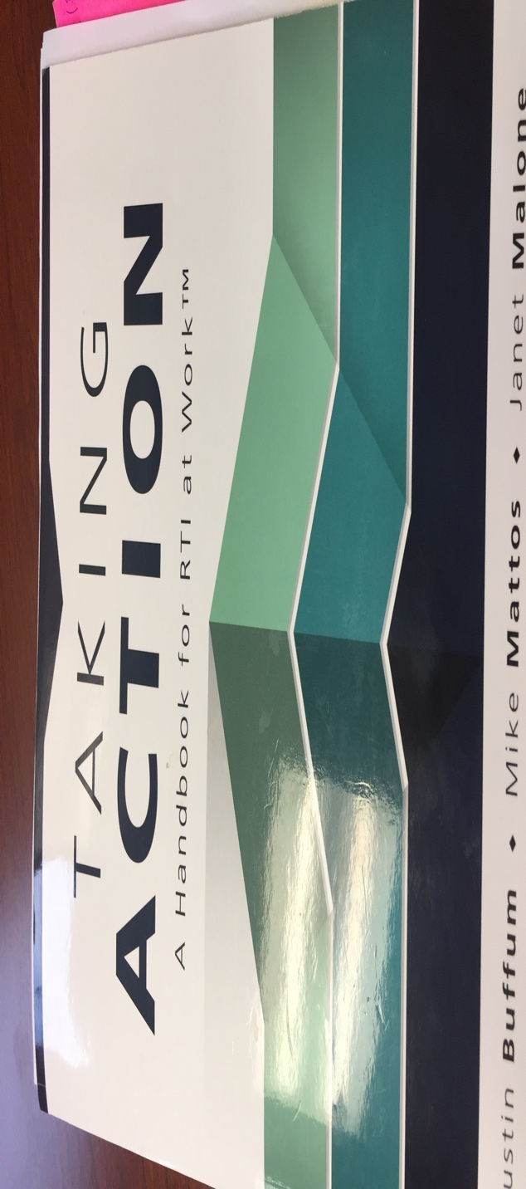

Previous thinking _ Where can we send student to have dedicated intervention outside of the classroom.

Now looking at MTSS model of having differentiation of instruction inside of the classroom.
Using a 30-minute shared/ common time, students who are struggling with the same power standards, as shown on the formative assessment, are given focused learning time with a teacher.

Social Emotional Learning – Psychologist on site, Dean , Restorative Justice – All administrative staff trained in “Don’t Suspend Me- Alternatives to suspension”.

Positive School Climate- All students come with expectation to high standards – behavior and academic. The culture is the same at home.

#5 Universal Screening for All students coming on to campus.

