American Elementary School
Designated 2019
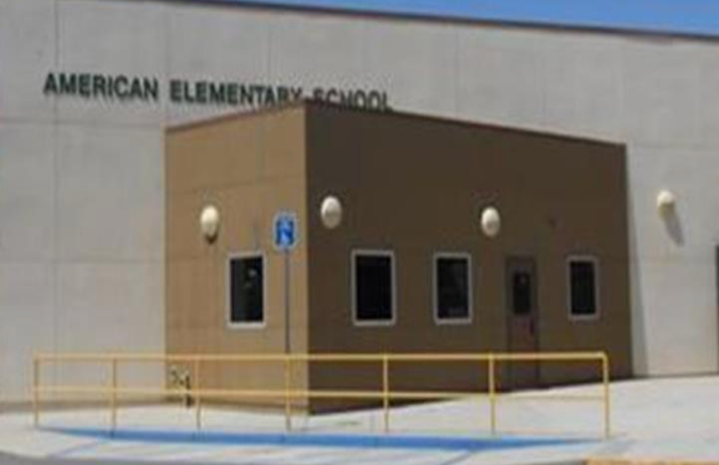
3 Year Avg.: Math 22.7 above standard
ELA 33.5 above standard
Rosedale Elementary School District
Kern County
Principal: Becky Devahl
800 Verdugo Lane, Bakersfield, Ca. 93312
661.587.2277
Website: https://www.ruesd.net/american
Date of Visit: 1/7/2020 @ 9:00 am
Email bdevahl@ruesd.net

“The child is the parents’ most prized commodity. “
School Profile
American Elementary is a suburban school with a population of 749 TK-6th grade students. Community involvement, rigorous standards-based core curriculum, and a safe, engaging, respectful learning environment, with a focus that surrounds students using higher-order thinking (HOT) skills to access the core curriculum. This involves giving each student what they need to be successful academically, emotionally, and socially. A growth mindset is at the forefront of American Elementary. The support staff includes music teacher, physical education teacher, nurse, dean, and Special Education team: Intermediate. Sp. Ed. teacher, SDC teacher, Primary Sp. Ed. teacher, and speech.
School Demographics
American Elementary 749 student population is comprised of 2 main populations: white – 45%, Hispanic / Latino – 38.2%. Subgroups within the population include English Learners-.06%, Students with Disabilities – 14%, and Socioeconomically Disadvantaged – 26%.

Contributing / Replicable Factors
District System to School System and Focus on staying the course, is the main contributing factor. The District Focus is Student Outcomes, School Focus : Students will use higher order thinking skills to access the core curriculum with set outcomes: If our school focus is encouraging higher order thinking skills to access the core curriculum, then given a growth mindset frame of reference students will increase their Depth of Knowledge (DOK) level as indicated by evidence of learning.
- School focus was developed alongside Innovate Ed for the last four years, which increased the sustainability of the program.
- “If -Then” statements were created by leadership team and followed by the staff.

Assessments include Universal and Interim. Universal Screening for all students enrolling into school with benchmark assessments. Cycle of Inquiry required every 6 weeks. Each grade level meets and review student evidence analysis protocol, student evidence, and assessment analysis.
PLC every Wednesday during early release. Above assessments/evidence reviewed as well as Glows and Grows. If PLC time is not enough , then teachers by grade level can request a day out of the classroom to collaborate.
- Staff meeting once a month that corresponds to evidence of student learning.
Quarterly Learning Rounds: School site teacher teams are formed. The students are observed under topics set within student focus se by school site. Observation notes are made public to the group during a meeting where teachers meet school wide to review the learnings from the Learning Rounds.
- Data Dive: School Leadership team, including school counselor, dean, principal, and lead teacher. Strengths and weaknesses are observed and given to previous grade level ( i.e. weakness seen in 3rd grade, then data will be shown to 2nd grade) so that adjustments can be made in student learning outcomes.

- Intervention: School Wide Book Read “Taking Action A Handbook for RTI at Work” Looking at MTSS model of having differentiation of instruction inside of the classroom. Use of a 30- minute shared/common time where students who are struggling with the same power standards, as shown on the formative assessment, are given focused learning time with a teacher.

- Social Emotional Learning – All administrative staff trained in “Don’t Suspend Me – Alternatives to Suspension”. School psychologist on site who works with students and staff on Restorative Justice strategies.

