American Elementary
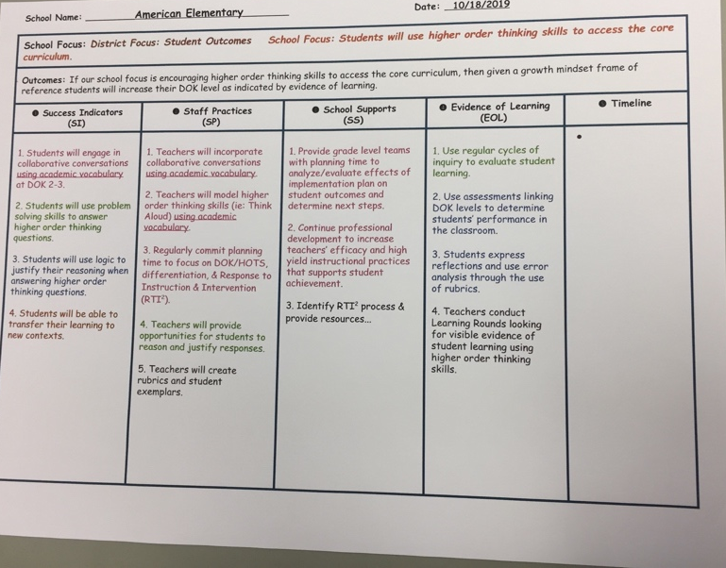
Rubric used for District and schoolwide focus with success Indicators , Staff Practices, School Supports, Evidence of Learning, and Timeline.

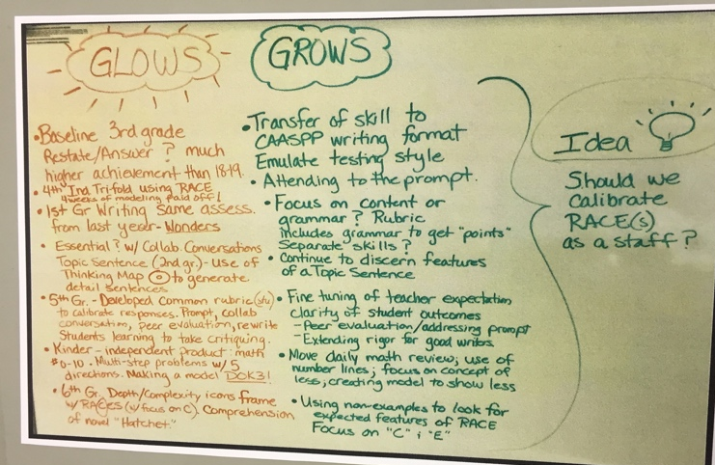
PLC – Grows and Glows include pluses and deltas by the grade level after review of evidence/data.

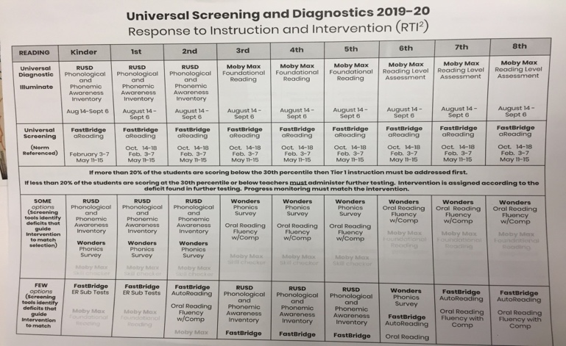
The image shows the assessment schedule and what will be assessed by grade level and testing window. This is a Districtwide schedule. Results of assessments are discussed in the PLC or grade level meeting.

